 | SandCastle 1 Condo Association  20000 Gulf Blvd.  Indian Shores, Florida, 33785| f. (505) 555-0156 |  |  | 7

Project status Report

Project Summary
Report Date |  | Project Name | Prepared By
November 9, 2025 |  | Phase II Restoration | Frank Frois

Status Summary
We are now past the half way mark on phase 2 of the SCI Structural Restoration Project. Work continues on multiple fronts. Work on the west side of the building is just about complete with the exception of the Gemstone waterproofing of the 06/07 risers and the replacement of the high impact windows to the owners suite. Without any weather or structural surprises, it appears that the building should be open at the end of January 2026.

Balcony Railings: As of November 9th, only 3 balcony railings needed replacing. By the time you get this report, all railings will have been installed.

Balcony Gemstone Waterproofing: Gemstone has starting applying the final waterproofing coating on the 08 stack on November 12th. The 8th stack is being done first so as to avoid dirt and dust from the replacement stucco application to the north wall. Once this is done, the stage will be moved to the 06/07 riser to start applying the final Gemstone coating. It is anticipated that all balconies will be completed by the end of November. Owners with units on the 06/07 and some 08 units should expect their balcony doors to be jammed shut.

Windows & Doors: The large windows on the Owners Suite overlooking the pool will be replaced closer to the end of November. The old windows and shutters will be removed and some concrete work will have to be done to the frame to accept the new hurricane high impact glass windows. During the installation, the pool and exit to the pool from the recreation room will be closed. We encourage owners to use the facilities at SCII when this is being done. The work is expected to take one week.
As we prepare to start painting unit doors, all replacement doors that have been contracted by owners must be installed no later than November 30th. If your door is installed after the contractor has painted all the units on your floor, painting of the door rests with the unit owner.

Painting: The west side (beach side) of the building has been painted. The 08/09/10 hallway walls and ceiling has been painted. The contractor will now start painting unit doors on the top floors starting in the next 10 days. Owners are reminded that their door will have to be open to ensure the entire door and frame gets painted. Doors should remain open for at least 4 hours to allow the paint to surface dry before closing/locking the unit. We will send out an email alerting owners of the day they need to have their doors open. Owners need to have their rental agents or arrange with someone to open the door. We need your cooperation to ensure we get all doors painted on a timely basis.

Walkways Waterproofing: Once the walkways & doors are painted, the sloping will be done and sealer applied. The final step is the Gemstone application. I anticipate this will get started on the 08/09/10 walkways in December. All work on the towers will have to be completed to avoid dirt and dust on the walkways. Owners will get an e-mail alert as to the date their floor is being done. Owners will not have access to their unit the day of the Gemstone application. The product will be surface dry in 4-6 hrs, but not fully cured for 48 hrs. No grocery or luggage carts will be allowed on a freshly coated floor for at least 48 hrs after application. The anticipated completion of the Gemstone walkway application is early to mid January 2026.
Garage Structural Repairs: This phase of construction is behind schedule due to the unexpected damage to several support columns. The 07/west column could not be repaired unless shoring posts where installed in 206/207,306/307 and 406/407 units. The shoring support posts were installed in the living rooms and balconies to support the weight of the building while the column was repaired. The column is now repaired and passed inspection. We'd like to thank owners for their cooperation in allowing access into their units to install the shoring posts.
The 02/east front column also needs repair. This column is by far in worse shape than the 07 column. Shoring the units above is not possible because the shoring posts line up in the hallway and kitchen of the units above. As you know, the hallway and kitchen has a false ceiling and to support the load, we would've had to cut holes in the hallway & kitchen ceilings to get to the concrete ceiling. The engineers came up with another way to rebuild the column by constructing a rebar cage around the column and pouring new concrete. This will add an addition 5-6 inches to the width of the column on either side. Since most parking spots have a 5" bollard on either side of the column for protection, removing the bollard and adding the extra width will not reduce the width of the parking stall. Instead of the bollard being re-installed, a rubber corner guard will installed.
There’s a lot of work still to be done in the garage and this is the only area of construction that might be delayed. I anticipate that some minor repairs will still be needed to be performed in the garage after the building re-opens in January. I don`t anticipate this will interfere with renters or parking.

Concrete & Stucco: The building had extensive stucco damage. The stucco had to be removed on all 3 towers because it was literally coming apart from the wall. Concrete repairs were numerous, Even a portion of the roof had to be peeled back to repair the concrete behind it. Now that the north & south towers are stripped, the contractor is starting to prep the walls to apply a new stucco coating. Work on the centre tower continues and it should be completed by the end of the month. We have consumed twice as much concrete that was originally budgeted. The amount of concrete damage and the poor shape of several garage columns were unexpected. After the restoration is complete, SCI will be structurally sound and in good shape for a number of years.

Entrance Canopy: The new entrance canopy drawings have been reviewed and approved by the engineer. The canopy is the same design as that installed at SCII. It extends 60` inches out from the entrance and has 2 downspouts on either side of the tower to take care of drainage. The Board plans to install 4 bollards along the front entrance directly under the canopy. This is to prevent large trucks from getting too close and damage the canopy. SCII has a similar design. The canopy will probably be installed once the tower is painted. I anticipate this will be done at the end of January.

Lobby Refresh & Exterior Cladding: The entrance lobby got a refresh the first week of November. The elevator wall is now a tile wall which will be easy to keep clean. The opposite lobby walls are made of fluted panels with marine grade aluminum wall bumpers. The materials used will take the wear & tear of luggage & grocery carts. The new SCI logo sign was also installed with LED back lighting.
The front entrance cladding will have to be done after the building canopy is installed. The material is in storage and it will be done as soon as I can get a crew to Florida for 3 days.

Parking: Parking continuous to be a problem. There are limited spaces and if owners are coming for a visit during Thanksgiving week, be prepared. The building continues to be an active construction site and parking spots are taken up by construction material and disposal bins. There are less than 10 parking spots available during the day. Please be reminded that there is no assigned parking. Park where you can find a spot.

Landscaping: The landscaping along Gulf Blvd. is now complete and it looks great. The new outdoor kitchen area on the south west side of the building is on hold for now. The contractor has the area fenced off with material and this part of the project will be completed once the contractor demobilizes. The landscaping area on the west beach facing is open and this is a great place to sit and enjoy the sunset while having a cold drink.

Next up-date will be mid December. By this time we will have a better idea on any potential delays and anticipated demobilization by our contractor. On behalf of the BOD, I’d like to extend to all owners a Happy Thanksgiving holiday.

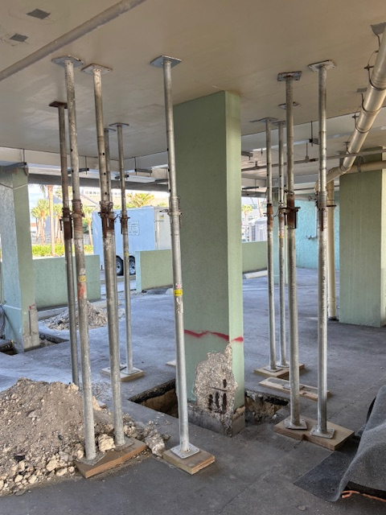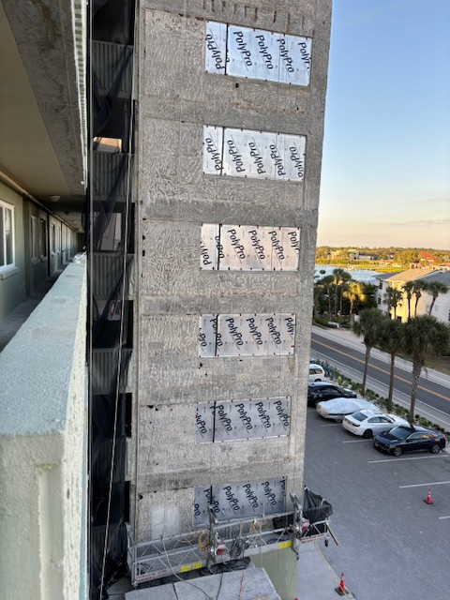
02 stack column needs rebuilding Stucco removed on centre tower
\

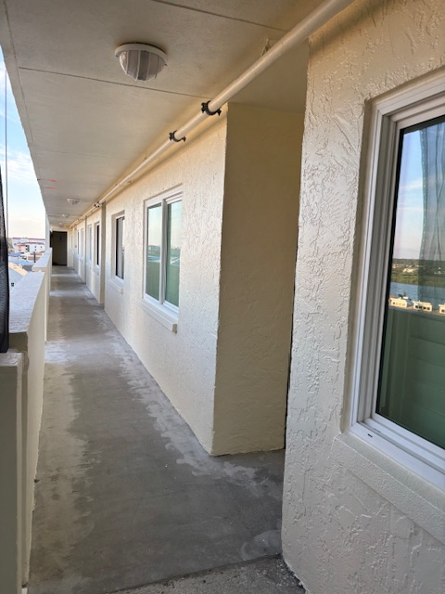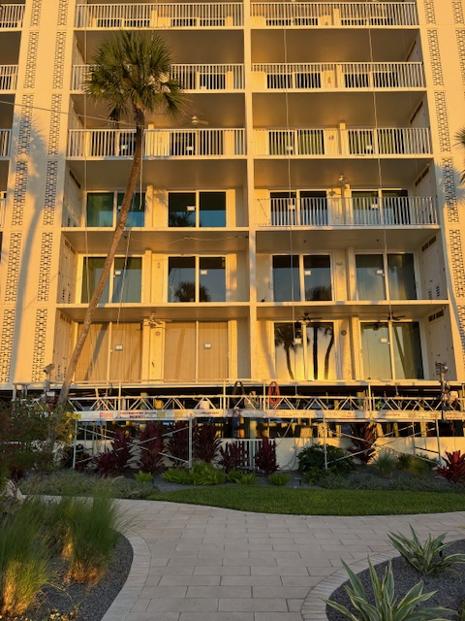
10th floor hallway painted Final balcony railings being installed

