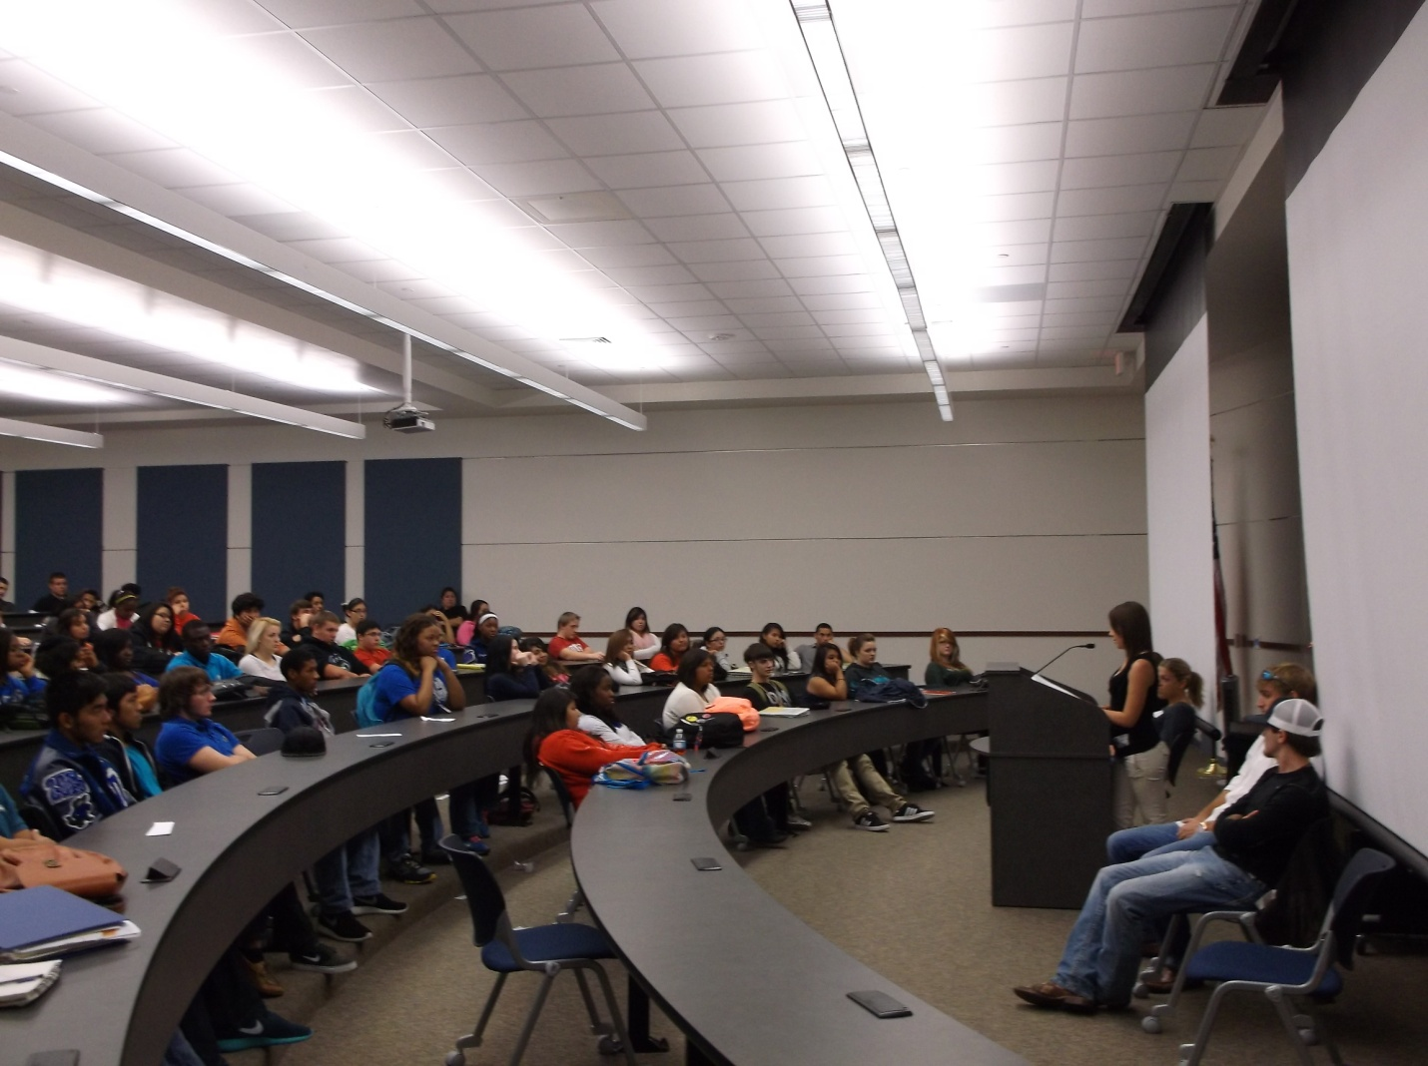***Abstinence Beats Recovery***

***Revised***

Collected by: John and Dot Overton

Edited by: Will and Allison Overton

www.equippingstudents.com

The cover photo is of an alumni of the Bay Area Recovery Center (BARC) addressing students at a local high school.

Dedication:

This book is dedicated to the men and women who are prisoners of alcohol and drug addiction, admit it, and seek recovery. The book consists of contributions and interviews with people that want to not only recover from their addictions but want to help others avoid the consequences they have suffered as a result of addictions. Though the names are fictional**,** the stories are true and factual as best they can be recalled by the contributors. AA stands for Alcoholics Anonymous and BARC stands for the Bay Area Recovery Center.

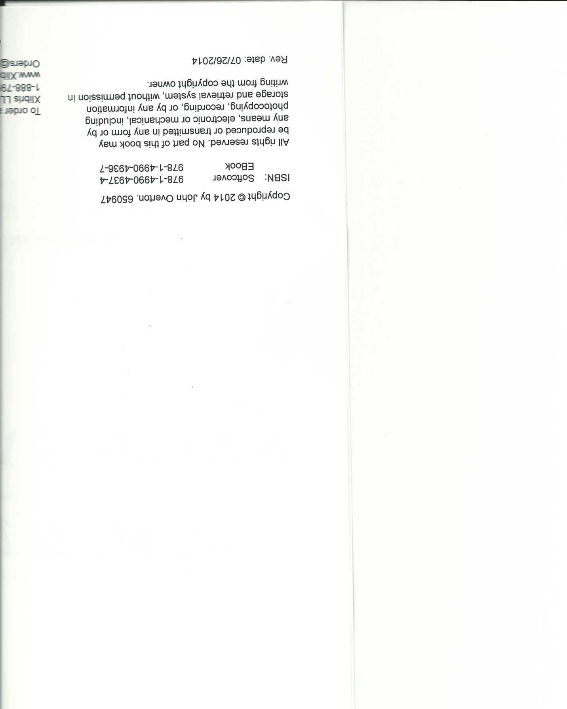

# Introduction

Alcohol and drug addiction is an international problem. It has created a market readily supplied by evil men addicted to greed. Those that profit from the traffic are far removed from those affected by it. Massive wealth is being accumulated by the suppliers funded by people of all ages and stations of life. While users are increasing the wealth of dealers, they are being impoverished in many ways by the consequences of addiction.

It is the writer’s, and each contributor's hope that these true stories will influence students, and parents of students to avoid experimenting with alcohol and drugs and entering lifestyles illustrated in these pages Our schools are the most vulnerable targets for irresponsible suppliers obsessed by greed and unconcerned about the extreme damage they are causing. Men and women of the Bay Area Recovery Center (BARC) speak to students in our public schools each year during their Red Ribbon Week of Addiction Awareness.

The following stories are like those shared with the students each year and hopefully by providing them in writing, more students, teachers, and parents will be able to better deal with the problems associated with substance addiction.

# Addicted, Overdosed and Almost Died

Hi, my name is Chuck and I am a 17 year-old alcoholic and drug user.

I started my addictive habit at age 13. My parents were not together when I was growing up and though I had brothers and sisters, we were not raised together.

I wanted to escape reality so when I entered intermediate school, I sought, and found drugs that really made me feel great!

As a result, I became addicted, overdosed, and almost died. I have spent time in jail and am now in recovery treatment.

I believe my addictions have resulted in me hurting my grandparents and my adopted sister the most.

During my public school years, I developed an attitude of not caring about anything and did not concern myself about my future. I am currently enrolled as a senior in public school.

Considering my choices and where they have led me, I strongly recommend that students think of their future and take a different path than what I have taken.

**A Loner that Did Not Fit In**

Hi, my name is Russell and I am a 17-year-old alcoholic and drug addict. I am an only child with a good upbringing. My parents are very religious but I rebelled against their strict lifestyle.

**Jpg 1 - Loaner**

I have always been a loner, I didn't fit in until I found friends that I could relate to. Unfortunately, they were the drug crowd.

Since I really wanted to fit in, I tried synthetic marijuana at age 14 because I thought it was legal and it is as easy to buy as candy from convenience stores.

During my school life, I felt rejected by most people, but I soon found acceptance with others who were like me. We did not do our schoolwork and skipped lots of classes.

My advice to students is to think of the future and ask yourself “where will I be if I keep living the way I am?”

**Do Not Start; EVER**

Hi, my name is Tim and I am a 17 year-old recovering drug addict. My love for drugs started the first time I got stoned. I was 14 the first time I smoked pot, and I didn't see the point because I didn't feel high. I'd been drinking for a year already and I liked alcohol. The first time I did feel stoned from weed, I dropped the bottle and picked up the pipe. That was the beginning of two years of hell! I thought my parents were idiots since I could "act sober" around them.

For the first few months of using, I didn't think pot controlled my life because I didn't smoke like everyone else. I just smoked on occasion. Once I got to high school, I saw getting high as a great opportunity to make friends. I eventually got into the stoner circle and began associating with people who used other drugs.

My parents knew what was up. My 1.6 grade point average was a big clue that I had something more important to do than homework. When I was caught dealing, my parents decided to raid my room.

They found everything I had on me. I didn't care! I got high the day after I was caught. So I was busted. Big deal! I promised to go straight, but I really didn't intend to stay sober. I thought I could stop anytime I wanted to, I just didn't want to.

I was caught shoplifting. My mom and dad picked me up and I got another slap on the wrist. I stopped getting high for about two months, but when I started again, it was like I had never stopped.

My home life was awful. I was in a constant battle with my parents, and my little brother was being hurt as a result of my selfishness. I thought I was the only person in the whole world.

I was using every day when everything finally hit the fan. I ran away and was caught one week later in Santa Barbara. I vowed to never use again. I told my parents that I had a problem, and I needed help. I began treatment a week later and stayed for a month. I have been out of treatment for six months and I haven't been high once. I have noticed a vast improvement in my life and it can only get better.

Therefore, if you are new to drugs and alcohol, the best advice I can give you is to not start, EVER!

**Don't Buy the Lie that Pot Is Harmless**

Hi, my name is A.J., I am 19 years old and I am an alcoholic and drug addict. I smoked weed for the first time the summer before eighth grade. I was really curious to see what it was all about. I had a few hits, but didn't really get stoned. Later, I smoked some more and got so high I didn't even know what was going on.

I jumped on the next chance to get high. The more I did it, the more I liked it. I loved the way pot played with my head. Finally, I got caught and was grounded and enrolled in a chemical dependency program. I still managed to smoke pot as close to the day of my drug tests as possible.

I tried all those purification concoctions, but my dad eventually found out. I was still determined not to let anybody rob me of my "God-given rights". So I continued to smoke, drink Bud, and get "dirty" drug tests.

My disaster struck when I was caught at school. My hearing with the school board to determine whether I am expelled or not will happen very soon. My eyes have been opened. Getting caught once can ruin your life. I'm getting my 30-day chip (for not using for 30 days) today. I hope to get many more chips. By staying sober, I am getting all of my privileges back.

As for school, I hope to be allowed back in. My major task is to stay out of trouble. To other kids, I would say to please don't buy the lie that pot is a harmless drug. There really are no harmless drugs.

**Please Take My Advice While You Still Have the Chance To Do So**

Hi, my name is Gerald and I am a 20 year old drug user.

**Jpg 2 - Advice**

I had a pretty much perfect, typical American blue collar family but at age 14 I started using drugs which were provided by family members and friends.

I graduated from hi school with A's and B's but I did act up to get attention. I started using drugs because I thought my "friends" would think that I was cool.

As a result of my coolness, I have gone to jail twice, have been sent to alternative school, lost almost all of my families' trust and now my family does not even like being around me.

The thing that has helped me the most in the recovery process is thinking that my family will one day be proud of me for overcoming the horrors of an addictive lifestyle.

In the way of advice to students, I would offer that doing drugs does not make you cool like I thought and it really hurts your family members to see you flush your life down the drain.

I know I can't but oh how I wish I could return to school, reject drugs, and keep playing sports. So please take my advice while you still have the chance to do so.

**Accept the Fact That You Are Loved**

Hi, my name is Jason. I am a 21-year-old alcoholic and drug addict.

My parents split up when I was 11 months old. Both remarried. I have two brothers, two sisters, and one step brother.

I started experimenting with drugs at age 11 and became seriously addicted at age 13.

I was able to get drugs from my stepbrother, other friends, and dealers. I drank alcohol also but drugs was always more of my thing. I started stealing beer and cigarettes from my mom and dad at around age 11.

I did complete high school. I enjoyed elementary school but in the sixth grade I started to rebel. I played football, but quit due to a shoulder injury. I barely graduated because drugs were more important to me than grades and that really showed.

I'm not sure why I started using but it was probably because I never felt like I belonged. Even though I know that I was loved, I didn't want to accept that love and I turned to drugs and alcohol to make me feel better about myself.

As a result of my addictive habits, my family has turned against me and I have lost my friends.

I have wrecked vehicles, picked up a felony conviction, DWI, scars, etc. and I have lost the relationships of being a son, brother, and friend I otherwise was capable of being.

I know that I have hurt my parents the most but I feel that I have hurt everyone that believed in me; friends, teachers, everyone, but most of all, I have hurt myself by throwing away opportunities that only youth offers.

God had helped me the most in my efforts to recover. When I look back, I now realize that He was always with me and I have never been alone. God was even carrying me when I was living life on my own terms.

I would advise students to be open and talk to someone you can trust. If you feel down and rejected, realize that others really do care and want to be helpful. If you take on a rebellious attitude like I did, you only make your situation get worse. You might not want to mind your parents or teachers, but please believe that you will have to mind someone (maybe your warden!) Don't be like me and find out from a rough experience.

I want to use my rough experiences to inspire kids of all ages to talk about their problems and not use drugs and alcohol to fill that hole inside. Accept the fact that you are loved.

Image _If You Can't Quit, Ask For Help

Hi, my name is **Tracey** and I am a 22 year old alcoholic and drug abuser.

I was 12 years old the first time I used drugs voluntarily. I tried marijuana one time and got scared. When I was 17, I began living on my own and thought drinking would be fun, exciting, and mature: that first night drunk, I took 4 Xanax bars and smoked pot.

**Jpg 3 - Ask for Help**

I felt like I lost myself for days. I continued to abuse my body with drugs and alcohol until the age of 22. I have two older sisters and two brothers. One of my brothers killed himself last year on drugs!

My source of alcohol came mainly from the opposite sex and people much older than me.

I barely graduated from high school and attended two semesters of college but dropped out to enroll in beauty school where I was able to complete the work I started in high school.

I got started drinking when I started living on my own. I was very angry at the time and blamed my problems on everyone around me. I thought I was very much a victim of my circumstances.

The results of my addiction caused me to ruin relationships, owe money, lose jobs, and have an abortion!

I'm sure I have hurt my family the most because of my addiction. I lost my identity and had no clue how to return to a normal life again.

After being in a recovery program, I realized that drugs and alcohol are no longer my solution. I've turned to God and that has helped me more than anything.

I would advise students that find that they cannot quit using alcohol and drugs entirely, to ask for help. I wasn't aware of how bad a situation I placed myself in until I almost couldn't get out of it.

**I'd Rather You Go to Jail than Come Back Home**

Hi, my name is **Jacob** and I am a 22 year-old drug and alcohol addict since age 17. I smoked pot almost every day, drank, and abused OxyContin and benzodiazepines. It was clear to my parents and sister that I had a serious problem. I didn't see it that way though. I just thought that I liked to party.

Even though I was in denial about my addiction my family started to take action. My parents sought answers from professionals and tried to find ways to prevent me from using. They drug tested me at home and demanded that I follow their rules and be accountable for my actions. Eventually, they got me into a local outpatient adolescent treatment program.

**Jpg 4 - Rather Be in Jail**

These early interventions helped me -- somewhat. My thinking changed from "I don't have a problem, I just like to party" to "Well, maybe I have a problem with pills". So I left the outpatient facility truly believing that I could give up the prescription meds, but still smoke weed and drink beer without a problem. I vowed to control my alcohol and pot use. But after only four or five days, I was back to my old habits and taking the pills again. Two months later I blacked out during a drug-induced haze and crashed my car into a tree. I was bleeding and missing my two front teeth, but I fled the accident scene. In the meantime, my parents received a late night phone call from the police. "We found your son's car totaled on the side of the road and there is blood inside, but we don't know where your son is."

Soon after, the police picked me up in the center of town and brought me to the scene of the accident where my parents and an ambulance were waiting. I begged my mother to sign me out of the ambulance for fear of going to the hospital and having everyone find out what was in my system. She looked at me, held her ground, and responded, "No, not this time. You need help."

Waking up in the emergency room and seeing my family in tears made me realize for the first time that I was not just hurting myself, but my addiction was tearing my family apart!

I agreed to attend a thirty-day inpatient program, but my goal wasn't to get sober. I felt I owed it to my family to at least go, and I feared legal charges from the accident. It was there that my family, sister, and a social worker held a meeting with me that I will never forget. They wanted me to go to a Treatment Center and spend a month at an inpatient chemical dependency rehabilitation program. I didn't want to go.

What changed my mind was when mom turned to me and said, "Jacob, I'd rather you go to jail than come back home because at least that way I'd know you were safe." That hit me hard. I entered rehab without a true resolution to stay sober because I still didn't want to stop using.

Walking into the treatment program and seeing people my age, who sounded like me and felt like me, affected me greatly. My thinking that "I'm too young to have a problem" was smashed when I saw that I was no different from the others. I began to realize I might not be as in control as I thought. My big breakthrough happened about fifteen days later when a counselor looked me straight in the eye and asked, "You really think you are going to leave here and go live in a college dorm and stay sober”?

"Sure, no problem" I replied, same as I always had. But, after leaving his office, I went back to my room, sat on my bed, and felt a sensation in the pit of my stomach that I never experienced. I'd spent the last several years thinking I was right, always believing my own lies. This time, for the first time in my life, I knew I was wrong. I could no longer deny that my beliefs and actions got me to this place and that my ideas were not going to get me out of this. I needed to ask for help. Today, I am looking towards a future that was almost cut short by drugs and alcohol. Most people don't get the second chance that I did.

I would advise any young people to look at yourself, and honestly ask where you are headed. To those who have never tried it, please don't. There is nothing in it worth the pain it will eventually cause.

# Don't Start an Addiction and Expect to Skip Its Pain

Hi, my name is **Lisa-Ann** and I am a recovered alcoholic and addict. My addiction started at age 14. I was an adopted child and raised as an only child. Loneliness was my constant companion. My father's job kept him away from home most of the time. My mother was a strict and very formal lady. I had everything that a child could want except for happiness.

When I was prescribed narcotic pain medication I immediately found that by taking a pill I felt pretty, was no longer lonely and I liked my mother. Life would never be the same from that day forward. It was soon after the introduction of narcotics that I discovered alcohol. With the combination of the two, my world was great. The days turned into weeks, weeks into months and months into years. Through the years, I had developed many habits from Heroin to Cocaine.

During this time I had a son, James. My parents had passed and his father left before he was born. We were all that each other had. My son spent most of his life seeing his mother in and out of treatment with no success. He was taken away from me and now I see that was a blessing. Life spiraled into the black abyss. Nothing mattered and my only prayer was to die soon.

In 2011, I found myself in a seedy motel, dying. The phone rang. To this day, I do not know how the phone call transpired but I was talking to a man that began describing my pain as if he knew exactly how I felt. He told me that I never had to be alone again and that I had a bed in treatment if I wanted it. Those words meant more to me than anything in this world. He said that God was on the way. Two women arrived to bring me home. They began to tell me their stories, which sounded like mine. I could see life in their eyes and love in their hearts.

I wanted what they had and they told me that I could have it if I followed a few simple steps. I soon arrived at the recovery center. This was the beginning of a life far greater than I could ever have imagined. I was given unconditional love and I learned how to give love.

One of the women that came to my motel room that night is and has been my sponsor. She took me through the 12 Steps of Alcoholics Anonymous and showed me how to apply these steps in my everyday affairs.

I now have a host of lifelong friends and a fellowship of brothers and sisters. We have discovered a common solution. I completed the program and have stayed clean and sober for over three years. I now can bring others home and give them what has been given to me. My relationship with my son has been restored.

We have a bond today stronger than ever before. My only wish is that others may find the peace and happiness that I have. You don't have to go down the hellish path I did. You can never start, and skip the pain of addiction. Don't do it!

Insert Image stab_pixabay_316655

**I Pulled a Knife and Swung at MY Dad!**

Hi, my name is Dick and I am a 21 year-old recovering alcoholic and drug addict. I started smoking cigarettes at age 11 and at age 12 I started getting into alcohol and hanging out with gang members. At age 13 I started smoking marijuana and at age 14 I started doing hard drugs.

**Jpg 5 - Knife**

The progression of getting deeper and deeper into addictive habits is so subtle but sure!

One day I pulled a knife and swung at my dad. Luckily, I missed. I love my dad because he is the person who brought me into this world. I now realize that if it weren’t for him, I wouldn't be here. When I was using, I had a lot of problems. My dad and I got into a fight and we were hitting each other. The cops came and I tried to jump over the wall in my backyard. The cops grabbed me and put me in handcuffs. My mom and dad had to decide whether to send me to juvenile hall. Mom was for it but dad said no. I was released but that didn't stop me from using drugs.

When I was in the seventh grade, I got arrested for possession and use of marijuana. I was kicked out of school for a year. After that year, I didn't go back. I was kicked out by my parents and during four years of life on the streets I hung out with my homies, getting drunk and doing dope every day.

I have now been drug free for almost a year. I finally came back to school where I am succeeding in my studies and life in general. I realize how that doing dope is not cool. I want to complete high school and go to college to become an attorney.

I hope my story touches somebody's heart, and I hope that whoever reads it will realize that doing drugs is not the way to go.

Insert Image 03_pixabay-258631

**My Advice to Students is to Not Run From Your Problems**

Hi, my name is Trevor and I am a 25 year old alcoholic and drug user.

I was raised in a very loving family along with two brothers and a sister. I was probably given too much freedom to make my own choices. As a result, I have made many wrong ones. My family provided me with all the things I needed and I knew who God was but I just didn't act like it. I was for sure taught right but I would not acknowledge God for lack of a spiritual foundation. I became very selfish and non-communicative.

My addictive habits started at age 13 since I was able to get drugs and alcohol from friends, family members, at parties, bars, clubs, and the street.

I dropped out of school in the 11th grade. I was trying to do good, but didn't care enough. I wanted to party instead of study and focus on the things that really mattered. I ignored things like getting an education, helping family members and other people. Rather my focus was on the ladies and drugs.

I suppose it was really peer pressure that is the blame for my starting my addictive lifestyle.

I thought that a fun life only comes from wild party life. I did not practice a personal relationship with my family, friends, and God and I was running from all my problems.

As a result of my addictions, I almost died. My family and friends lost all trust in me. I lost communications, love, and time. Through isolation, I learned to keep going and be the man I was born to be. I found true life in Jesus Christ and sobriety.

I have seriously hurt my family, myself, and everyone else around me.

I credit my recovery progress to renewed faith in God. I am now being honest with myself and accepting the things I can't change.

My advice to students is to not run from your problems and try to cover them up with drugs. Communicate your problems with other people no matter how hard things get. Always get up and try again.

If I could repeat my youth, I would keep my personnel relationship with God and help others in every way that I could.

Insert Image family_pixabay_216825

**Think About the Life Waiting On You**

Hi, my name is Thaddeus and I am a 26 year-old alcoholic and drug addict. I started my addictive habits at age 12. My father was dead and my mom had a mentally and physically abusive boyfriend. My three brothers and sisters would not speak to me.

Marijuana became available to me from one of my brothers and some friends. I started using the marijuana to escape boredom and just fit in with the crowd.

I then returned to marijuana to escape the pain of having to live with my family and schoolmates who tended to reject me.

Once I became dependent upon the drug, I started stealing money and anything of value, which I pawned for the funds to support my habit. School life was hard for me and I felt ashamed and embarrassed, so I skipped classes often. This resulted in me missing my opportunity to properly prepare for adulthood. I became a very self-centered and argumentative person, even with my mom.

My lifestyle led to seven years of imprisonment and that led to the breakup with my girlfriend who took the children when she left me. I know that I can't, but if I could relive my youth, I would avoid that first joint which blew up into an uncontrollable blaze. I would listen to and obey my parents and older people who have been where I am going. I would also advise other young people to think about the life that is waiting for them. Their choices now will determine if they end up like me; homeless, broke and in a recovery center unprepared for a good job, or in a position to enjoy a free and quality life.

**Only High School Graduate In My Family**

Hi, my name is Jack and I am a 27 year-old drug addict. I am the youngest of four children; one brother and two sisters. My parents remain married to this day.

**Jpg 6 -Only Family Graduate**

I went to high school and though I experimented with drugs a few times, I did not start using during my school years. In fact, I am the first and only high school graduate in my family.

My parents, especially my mom, are very proud that I completed my education. I made average grades and participated in our church choir and several school activities. I worked during my high school years and was what would be considered a good and moral boy.

My addiction actually started after graduation when I was 19 years old. It started as an innocent social experiment with my girlfriend. She is a smart and studious person with a 4.00 grade point average and is preparing for a nursing career.

We tried marijuana and enjoyed the euphoric highs it provided. Marijuana and powder cocaine were easily available from our friends and one of my cousins. I worked in a bank and was doing very well with my own apartment.

We partied and enjoyed having friends over. When we did get together, we smoked pot with no thought of the impact it was going to have on our lives. We remained confident that we could handle and control the use of drugs. The use of pot gradually led to stronger drugs like powder cocaine.

My girlfriend became pregnant with our first daughter who is now nine years old and is being raised by her mom. Drug use affected my work performance and I lost my good job at the bank. When she became pregnant with our second daughter, now six years old, she left me because of my drug habit. She has been able to continue life without becoming addicted and will be receiving her degree this coming December. We still communicate but she is not willing to reconcile with me because she cannot trust that I will be able to kick the addiction.

I want to tell all students to not let anyone interfere with your dream. Do not experiment with drugs even though your best friends try to assure you that everyone is doing it and it will not become addictive.

I have wanted to stop for years now, but the drugs are controlling me rather than me controlling them. Take the attitude of helping others rather than becoming someone in need of constant help.

**From High School With Honors and Baylor University.**

Hi, my name is Peterand I am a 27 year-old alcoholic and drug addict. I started my addictive habits at age 13. I grew up in a wonderful, affluent family; the son of two lawyers and the oldest of three children. Marijuana had always been a part of my addiction, but pain pills, and later heroin, were what brought me to my knees.

I've always had trouble being at ease, and marijuana helped me greatly in that regard. Knee troubles are what started the pain pill addiction, and when those ran out, heroin use was seemingly my master! As a result of my addiction, I have lost my fiancé, several jobs, and trust from those I love the most. I have served jail time coupled with a decade of being on probation. I believe I have hurt my fiancé, family, and myself the most.

My school life was good. I graduated from high school with honors, and later went on to graduate from Baylor University. Though you may be able to do well in school and in your jobs, don't think that you are exempt from the attraction and ultimate enslavement of addiction.

My advice to students is to not be afraid to ask for help. Do what you know is right, and not what others are telling you that you ought to do.

It is only by the grace of God that I am still alive and not locked up. Many of my addict friends are dead or doing hard time. Don't waste your days with foolishness! Try your best to live to your potential and do God's will.

**Grandmother Took Me In**

Hi, my name is Charles and I am a 28 year-old drug user. My parents split when I was a child and I lived with my mom and sister, until I was 12 years old. My mom loved to party and was away much of the time. She was a hard worker and provided us with such essentials as clothing, food, and a roof over our heads. I spent many weekends with my dad who was a welder but his job caused him to move often. I moved in and stayed with dad from the ages of 12 to 16.

After that, my grandmother took me in and I lived with her for about 11 years until she passed in early April of 2014. I know that my actions hurt her more than anyone. She loved me dearly and unknowingly was enabling me with funds that I used to support my addiction.

I started using marijuana in high school at age 15 because I wanted to be accepted by the boys and girls I grew up, and ran around, with. One of the girls in our group was dating an older man who smoked pot and she was able to provide all of us with it. My first experience with pot was like floating on a cloud and I loved it. Lots of my friends in high school were using pot and I wanted to fit in.

My habit grew to the point that I only went to school to get high. I had a small truck and I would go to class just long enough to get credit for attending before going out to my truck. Girls and boys would fill it up quickly and we would drive to our secluded spots and get high the rest of the day.

We would return to school just in time for the parents to pick up my friends. Most parents were aware of what we were doing but just ignored it because they did not want to believe their child would use drugs. When powder cocaine became available, I started using it and left school. I started using crack cocaine at age 21.

As a result of using drugs, I have lost everything; family, friends and am now homeless and broke. I resorted to a lifestyle of stealing to pay for my habit. I was never caught with dope but was too high to report to my probation officer and as a result was admitted to the Texas Dept. of Criminal Justice.

I feel that I have made very poor choices and would advise students to stay away from boys and girls that you even suspect are users. The pressure to be accepted is too risky. I am now homeless, broke, and in a recovery program as a result of my choices and my "old friends" are no longer around. The girl that introduced me to crack cocaine passed away from an overdose.

**Taken To Church Every Sunday**

Hi, my name is Robbyand I am a 32 year-old drug user. I was raised by my grandmother from ages 16 to 21. My mom had two boys and two girls and grandma helped her by taking me into her home. She took me to church every Sunday and really tried to raise me properly. My dad separated from us when I was about 4 years old.

**Jpg 7 - Taken to Church**

I attended high school in Houston and was the running back on the freshman football team, and I was good at it.

I got in trouble and was expelled when I was a sophomore. When I was 17, I asked a man that my dad knew to provide me with crack to sell. I sold $400 the first night by just standing on the street and cars would drive up and ask for crack. I made my living by selling until I was 21 years old when I got caught and sent to Allred, which is in the Smith Unit penitentiary, for three years. I had access to marijuana while I was in prison and used it during those years. I went back to selling PCP and cocaine when I got out and started using on a regular basis.

I have now been in prison twice, suffered a stroke, and have lost everything. Everyone has lost their trust in me and none of my old friends want to be around me. Relationships with my 12 year-old son and his mother are so strained that they don't want me to be around them. I am homeless, broke, and in a recovery program all as a result of selling and using drugs.

I highly recommend that students trust in God, stay in school and stay away from gangs, users, and sellers. Try to hang out with positive thinking peers that are serious about their future.

**Smoking Pot Was "Cool" in High School**

Hi, I am Jackson and I am an alcoholic and addict. I always wondered, what kind of person becomes an addict? Someone with a lot of friends? Someone who is different from the rest, estranged from the popular crowd, with only a few friends? Or someone with no friends at all? The point I am trying to make is anyone can become an addict.

The way I figured this out was by becoming an addict myself.

I used to be a guy who was always in the popular crowd. Right before I began high school, I started being shunned by most of my friends.

I had never lived with the fear that I had no friends, so I did almost anything to keep the two good friends I still had. One of the things I did was try pot for the first time. This was a big change from the way I lived when I was younger. I was an athlete, and the last thing I thought I would get into was drugs. Drugs prevented me from being the best athlete I could be.

I continued to smoke pot because that was what my new "cool" friends were into. I began to use even harder drugs. The next three years were filled with many highs and lows, and everything seemed so superficial, including my friendships. This made me sad and depressed. I believe this was my "rock bottom". I realized that I could not live this way. There was one problem: I could not stop the routine of using drugs. It took being arrested twice, losing my license for two years, and my lawyer suggesting I go to treatment for my addiction.

Since I have started treatment, my attitude and actions have changed and so has my direction in life. Please do not start using any type of drug. It always leads to nowhere!

**Stop Before You Are Unable to Stop**

Hi, my name is Darvin and I am a 39 year-old recovered addict in training to become an Addiction Counselor. I went through the Bay Area Recovery Center (BARC) eighteen years ago after my third stretch in prison.

**Jpg 8 - Stop**

I had been drinking alcohol since I was 13 years old; and when I say drinking, I also mean marijuana, pills, inhalants, hallucinogens, narcotics, cocaine, methamphetamines, and just about anything I could get my hands on. I used uncontrollably.

My drug of choice was whatever you had in your pocket. I would try anything that might hold the possibility of keeping me from feeling like me.

My life was a confusing and debilitating mess. Having spent much of my youth and early adult life in institutions and having absolutely no life skills, I was lost, but refused to ask anyone for directions. Now I know that I refused to ask directions because I had no clue where I was headed.

During my third prison stint, I was offered a chance for parole if I agreed to go into treatment. I agreed, and even admitted that there might be a few things here and there that I might improve upon, and that if I could just get myself on solid footing I could live my life as others do. When I walked out of the doors of prison for the third time, I was socially handicapped. I had never owned a vehicle, identification, or a social security card. I had never worked a single day. I had never played a positive role in the life of another human being nor had I ever done a good deed unless I expected something in return. I had no idea how to do the simple things we take for granted, like pay bills, see a doctor, obtain credit, or fill out an application.

I said I was an alcoholic. At one time, I did, indeed, believe that I WAS an alcoholic. I knew I had gotten way out of hand, and I could relate to the phenomenon of craving and the incessant need for more. However, I was no longer that person. I was no longer an alcoholic. I just had to remember not to do the things that always caused me trouble; like whiskey, speed, and cocaine.

I knew if I could just stick to beer and pot everything would be okay. Of course I had to be really careful smoking pot as I was subject to random and scheduled drug test by my Parole Officer. I came up with one brilliant plan after another in my feeble attempts to be high at all costs.

I started working at a real job, I got my first car then my first apartment. It looked like my plan was coming to success. But then my plan failed. The beer led to whiskey, the whiskey led to cocaine. Jobs were lost, drug tests failed, warrants issued, cars wrecked, people hurt, children abandoned, more trips to treatment and jail. For the next ten years I repeated this process again and again and again. I ended up homeless, wandering the country without a penny to my name, shoplifting to eat, sleeping in abandoned homes, under bridges or right on the sidewalk! I was one of those who have left the world and ceased to take part in life.

Even though each day was a new lesson in futility, I held tight to this delusion and it allowed me to continue feeding my illness. In reality, the illness of alcoholism was just playing me like a cheap fiddle. In 2008, I was lying in an alley, wallowing in self-pity when a well-dressed man stopped and began talking to me about Alcoholics Anonymous. He was an attorney and on his lunch hour. He was also a recovered alcoholic with many years of continued sobriety.

I went to the meeting and something happened. After the meeting I stayed and rested on a picnic table until the next meeting. I had nowhere else to go. This went on for a week. I was still homeless and far from well; mentally and physically.

For the first time in my life I had reached a point where I wasn't worried about what others thought of me or how others viewed me. I had no need to be cool, tough, funny, or sarcastic. I was just a drunk who needed to get well and did not know how. I was willing to do anything and to listen to others.

After five years of sobriety, I feel like I am at the beginning of a wonderful journey. Every day life reveals new joys, and even new challenges.

With the guidance of a loving God, good direction from trusted friends, and a daily application of spiritual principles, I am able to meet these things head on with dignity and calm acceptance

To students; please don't start no matter what, and if you have started please stop now before you are unable to stop. You don't want to be sitting in a rehab institution at 39 years old like I did.m02_pixabay-69287

**I Threw Away My Opportunities for Drugs and Alcohol**

Hi, my name is Franks and I am a 44 year old recovered alcoholic and drug user.

I grew up in a wonderful, "tight knit" family. Unfortunately, my biological father was an alcoholic and my mother was forced to divorce him when I was 4 years old.

I have a younger brother and we really enjoyed a very close family of grandparents, aunts, uncles, cousins and a step-dad. We benefited from a very successful business that was started by my grandfather.

I drank my first beer at age 12, smoked my first joint at 15, did cocaine, and ate my first mushrooms and acid at age 18.

I attended private schools from Kindergarten through the 12 grade. I graduated from high school and went on to college in North Carolina.

During my freshman year, I acquired my first DWI. I received my second DWI during my junior year. I was a Dean's list student and a member of the National Honor Society.

I participated in college athletics and became the President of my fraternity.

I drank and drugged throughout my college years. I graduated with a 4 year BS degree in Business /Communications. I minored in Marketing and Accounting. I graduated in 1993 at the age of 23 and went to work in Marketing and Accounting as an account executive. By age 25 I was in full blown addiction to booze and cocaine! I was out of a 5 1/2 month Tox center only two days when I tried heroin. I was 28 years old then.

**Jpg 9 - Opportunity**

I made and lost millions of dollars, went through 8 or 9 rehabilitation centers, acquired 6 or 7 DWIs shook hands with Presidents and stole from my family. I traveled the globe and experienced things that most folk only dream of.

I also begged for food, lived on Park Avenue where I literally bothered people from underneath park benches. To say that my life then was truly like Dr Jekyll and Mr. Hyde would be an understatement.

I know that I have hurt many along the way but obviously, I've hurt my family the most. I had everything going for me but threw away my opportunities for drugs and alcohol. I now know that I have hurt myself tremendously.

Fortunately, from 2005 through the present, I have enjoyed a complete transformation. I have gone through a 180 degree turn-around. The bottom line on my life's account is that God, the 12 step AA program, and people that care for me have brought about a radical change in my life's direction. My relationship with Christ sustains me now.

**Avoid the Mistakes That I Have Made**

Hi, my name is Kevan and I am a 46 year old addict.

My mom was an alcoholic and I grew up by myself. My brother and sister lived with an aunt. I always thought that I had a decent childhood.

I had a ready supply of alcohol from older people. I hung out in bars and friends bought me beer at stores. I also stole from my parents and grandmother. I started drinking when I was eight years old to show off

I made good grades in school until in the 8th grade when I discovered marijuana. That is when I started on a downward spiral. I made it to the 11th grade but dropped out to get a GED.

My drinking continued for the next 39 years. There were brief times of sobriety then I would be incarcerated. For fourteen years I was in and out of penitentiaries resulting in the loss of cars, family, money, homes and most of all my pride. I feel that my family was hurt the most as a result of my poor choices.

The thing that has helped me most with my recovery efforts is to be honest with myself. Until I was able to admit that I am an alcoholic, there was no hope.

My advice to students is to avoid the mistakes that I have made, get a good education so you will be able to provide for yourself and your future. Determine what God's intentions are for you. He will do more good for you than you will be able to do away from Him.

**Don't Be a Fool like Me**

Hi, my name is Leslie and I am a 47 year old alcoholic

I was raised in a large family of five brothers and three sisters. Our home life was like a tumbleweed in a whirlwind! Most of the members of my family are alcoholics! I started drinking at age 14 because it was available to me from relatives, friends, parties and bootleggers.

I was able to graduate from high school but my school life was like a big toe jamming on a table leg. I could never progress without getting into some kind of jam.

I started drinking because I wanted to blend in with my cousins and friends but the results were disastrous. Everything I loved and liked, I hurt. My ex-wife has probably been hurt the most by my addiction. I have put her through a lot of mental, emotional and physical pain.

The thing that has helped more than anything else in recovery is obeying the Alcoholic Anonymous instructions about getting my attention off of myself and working to help others. Truthfully, the most important help has been God! I have come to realize that no matter how bad my past choices have been, He continues to love me and has provided the way for my restoration.

My advice to students is to not be a fool like me. The ones I wanted to blend in with are no longer around. I now face a very lonesome and uncertain future for lack of preparation and I can't restore what I missed in school. Being cool now seems so ridiculous but, of course, it is too late for me. It is not too late for you. Take full advantage of the opportunities your schoolteachers are trying to help you with so you will be prepared for life.

I would like to apologize to all that I have hurt and start all over having God at my side and this time with no Alcohol.

**Don't Think You can Control the Uncontrollable. -- You Can't!**

Hi, my name is Willy and I am a 47 year old recovered drug and alcohol addict.

My addictive habits started at age 17. Though I was raised in a wonderful family in a love filled home, I experimented with friends. I had access to alcohol and drugs from my peers, friends and my cousins.

My Father died in a construction accident when I was ten years old. My awesome mother raised me along with a brother and a sister in such a way that we had opportunities for a good future.

I completed high school and was enrolled in Vanderbilt University as a Pre-Med student but had to drop out and go to work as a result of my poor choices among which resulted in my girlfriend becoming pregnant.

As I reflect on my past, I have haunting memories of 23 years of alcohol and opiate dependence. I see clearly how I have hurt my parents, family, wife, and certainly myself. I have to credit my relationship with caring people and God for my recovery. There is no way to reset life's clock and correct the mistakes made during younger years.

I would advise students to trust your conscience or spirit and never start using. We are created with an inner ability to know right from wrong so respect your responsibility of choice by making good choices.

If and when I had the power of choice to use drug's or not, I made a lot of the wrong ones.

As I continued to make wrong choices, I lost the power of choice in whether to use drugs or not. I went from an 18-year-old Pre-med student to being in a state prison 18 months later as a result of opiate and alcohol dependence.

When I use the word dependence, I really mean dependence, once the addiction has set in; it controls you rather than you retaining the ability to choose not to use it.

I have wasted 23 years of fighting additions and addictions always won. I went through nine treatment attempts and three trips to prison before I surrendered the fight. Then I simply cried out, "God help me; either help me or take me!"

I was finally in a spot where I would rather die than to continue under the control of other substances. Fortunately for me, I was taken to the Bay Area Recovery Center (BARC).

I was finally in a state of hopelessness in my life where I realized that I do not have a clue what is best for me! I then became teachable and willing to listen, follow direction from others, and learn.

The 12 steps taught by Alcohol Anonymous are so powerful that they will work in spite of us rather than because of us. They have certainly worked for me! Faithful obedience to the 12 steps have impacted my life for the better. I was a guy that could not stay clean and sober for a season. I could not pull off a summer without ending up either in jail or a treatment center. But now I am past that and am living a quality life helping others that need the process that God used to rescue me.

So, make wise choices, listen to caring friends and advisors rather than fooling yourself into thinking that you can control the uncontrollable. -- You Can't!

**There is No Way to Undo the Damage of Addiction once it Has You!**

Hi, my name is Jamie and I am a 50 year old mother and recovered alcoholic and drug user.

I was the only girl in a family with two brothers. We were not a close family and for some reason, I was always jealous of my oldest brother. I never seemed to be able to measure up to his level of acceptance in our family.

**Jpg 10 -Damage**

I developed a rebellious spirit at an early age and started stealing liquor from my parent's cabinet, which was always available. Then I started stealing money from Mom's purse to buy drugs. Around the 9th grade, I lost all ambition and interest in life. I just did not care anymore. I started drinking and using on a regular basis to fit in with the crowd. That made me feel that everything was OK.

As a result of what became addictive habits, I became even more careless and irresponsible. I now know that years of my life have been wasted and my kids have been hurt due to my frequent and prolonged absence. I have also lost so much due to legal issues. My entire family has really been hurt and I expect my mother has been hurt the most. Of course, I realize now how much damage I have done to myself.

Finding God has given me courage and ability to trust and gain a desire to "clean house" and make amends. I finally have a purpose in life to carry this most profound message to others like myself.

If the reader is struggling with the temptation to fit in by resorting to alcohol and drugs just because your peers are doing it, please think ahead and avoid this trap and remain sober. There is no way to undo the damage of addiction once it has you!

# Conclusion:

Though alcohol and social drugs are offered in an attractive manner and promoted as the cool thing to do in order to be accepted, they result in lifestyles of poverty, homelessness, and ruined relationships. The contributors to this book tell a common story; ***"It is much better to abstain from addictive habits than it is to try to recover from them."***

Every student is convinced that he or she can handle alcohol and drugs, and know with certainty that they will never become addicted. A careful reading of each of the contributions to this book will show that these addicts felt the same way! There is no way to tell in advance, who will become an addict and who will not. Appetite for intoxicants can become overwhelming and uncontrollable.

One of the contributors to this book, who was handling sobriety well and was giving talks to students about the blessing of avoidance, has relapsed! We have lost track of him. One of the things he would tell students was that the slick and colorful beer ads which always seem to include lots of happy girls in bikinis will not be found in prison. He knows this to be true due to crimes he committed in order to pay for his addiction.

Others have recovered and are doing well in life, some have relapsed into deep addiction or committed suicide.

We know that some readers will ignore the warnings of this book but we would really like to hear from you if the book has helped you. Please contact us at dotnjohn@comcast.net.

Copies may be purchased from the publisher, Amazon.com or Barnes and Nobel over the Internet or ordered in their stores.

**Book Summary:**

***Twelve Steps to Recovery***

1. Admit that I am powerless over alcohol and drugs.
2. Believe that a Power greater than me can restore me to sanity.
3. Make a decision to turn my will and life over to the care of God.
4. Make a searching and fearless moral inventory of myself.
5. Admit to God, to ourselves, and to another human being the exact nature of my wrongs
6. Be entirely ready to have God remove all my defects of character.
7. Humbly ask Him to remove my shortcomings.
8. Make a list of all persons I have harmed, and be willing to make amends to all of them.
9. Make direct amends to each person where possible, except when to do so would injure them or others.
10. Continue to take personal inventory and when wrong, promptly admit it.
11. Seek through prayer and meditation to improve my conscious contact with God, praying only for knowledge of His will for me and the power to carry that out.
12. Having had a spiritual awakening as the result of these steps, I try to carry this message to alcoholics and to practice these principles in all of my affairs.

Page 60, Alcoholics Anonymous

This book is for students from the 6th grade through college. It is also for the parents and teachers of students. It is a compilation of true personal stories contributed by alcoholics and drug addicts. These stories are like those being shared with students at public school assemblies. The contributor's desires are to influence students to prepare themselves for a quality life rather than waste their lives on destructive, addictive habits. When the addicts understand that they can volunteer to speak to students or write their stories for students, they have readily responded. Be prepared to enter into some very dark and depressive situations as you read the graphic but true experiences of addicts.

**You do not want to go there!**

The authors have been teaching a Christian Discipleship course to addicts for the past six years and place emphasis on AA steps 2 and 3 as the way to recover from addictions.

He (Jesus) Himself bore our sins in His body on the tree, so that we might die to sins and live for righteousness; by His wounds you have been healed (1 Peter 2:24, NIV).

Our prayer is that copies of these stories will be added to all school and public libraries.

**About the Authors:**

John and Dot Overton are a Christian couple married for 63 years. John is a retired NASA engineer, Dot is his faithful helpmate, and Jesus is their Lord. They teach a weekly Christian Discipleship course to addicts in recovery.

**About the Editors:**

Will and Allison Overton, John and Dot's grandson and grandaughter, are Baylor University graduates. Will has a Bachelor of Arts degree in Professional Writing and Sister Allison has a Bachelor of Arts degree in Linguistics.

**Books by the Authors:**

**Abstinence Beats Recovery - Revised**

A compilation of true stories provided by Alcoholics and Drug Addicts about how they got started and the consequences they have suffered. A book written to warn students of the perils of addiciton.

**Let's Change the World**

A process for becoming a co-worker with Christ to Change the World. Matthew 28:18-20 is your mandate to go and make Disciples of Christ of all nations and Jesus will always be with you.

**Let's Change Your Church**

A process for becoming a co-worker with Christ to change your church into an Obedience Driven Church. Your church's mission is to change the world.

**Let's Change Your School**

A process for students to become co-workers with Christ to Change their schools and start a sustained global Christian Discipleship Movement.

**Let's Change You**

A process for sharing Christ's yoke, to be transformed, and start a sustained, global Christian Discipleship Movement.

**Let's Change Your Thinking About Sex and Marriage**

How parents and the church must train children about God's reason for sex. Godly sex must be taught from early childhood through marriage.

I highly endorse this book. These stories are typical true accounts of the life of hopeless addicts seeking freedom. Our prayer is that these books will get into the hands of students and parents of students. Help us place them in school and public libraries.

I pled guilty to a murder charge, to avoid a death sentence. I am still serving a life sentence for the State of Texas, but I am also serving life for Christ. I served 35 years, 10 months, and 7 days in the Texas Prison System,. I was confined continuously from the age of 18 to the age of 54, and released on November 19, 2014.

God delivered me from prison because I learned His Word and lived it for years while serving time. Since released, I have been a co-laborer with John and Dorothy (Mammy) Overton at the Bay Area Recovery Center (BARC).

Now twice licensed as a minster for preaching the Gospel, I join John and Mammy every Monday night to disciple the men who are struggling with addictions. I have had the honor of baptizing 67 of these men since 2016.

John teaches how to live an abundant life in Christ and I witness that shackles and chains not only *can* be broken but ***will*** be broken through serving God and following His instructions.

John Dainwood author of ***SUICIDE Passport to Heaven or Hellfire Condemnation***