

***Student Manual***

***Prepared by: Equipping Central***

*www.equippingstudents.com*

***John Overton***

***January 2017***

# Introduction to Student Sessions:

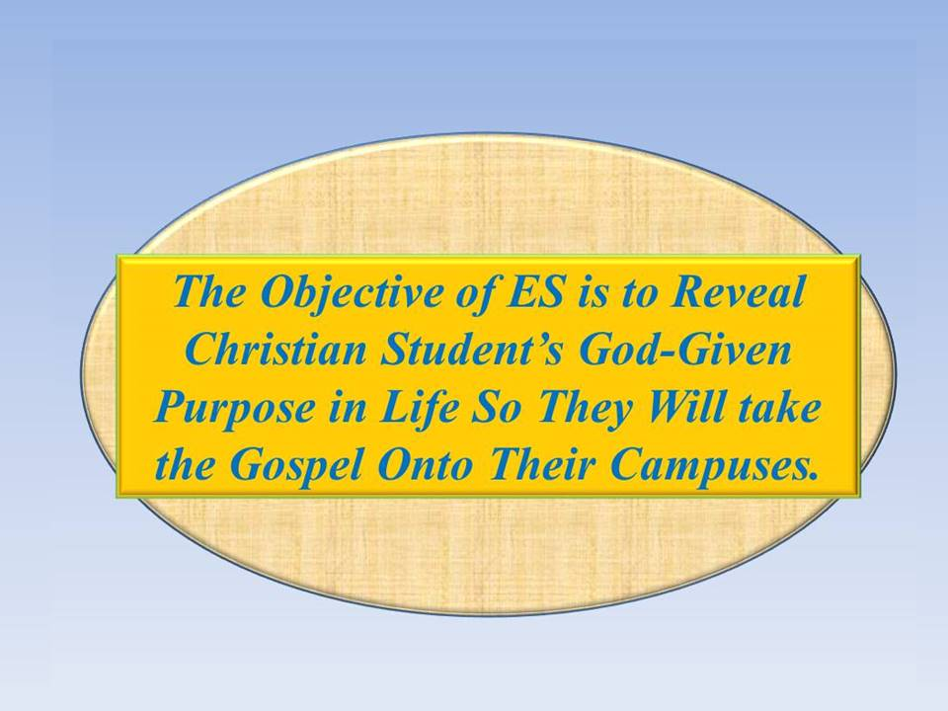We must never lose sight of our ES objective, which is to equip students to know their purpose as Disciples of Christ so they will take the Gospel onto their campuses. Our strategy is to disciple a small group of students that will take the Gospel of Christ onto their school campus and start a sustained global spiritual revolution. Proverbs 3:6, "***Seek God's will in all you do, and He will show you the path (Purpose) of life***" will be our theme through the entire ES discipleship course.

Our ultimate goal is to start a sustained discipleship movement that will spread from campus to campus throughout the world.

Student Session 1

This first ES session is the most important of all. The adult teacher and the students need to become well acquainted and be willing to be very transparent with each other.

The session is designed to make sure you are not just religious but are a true Christian. ***Know Your Purpose*** is our first topic and we will camp here until the group has demonstrated that their faith in Christ is indeed authentic.

The commitment expected of each student must be clearly understood and agreed upon. If you commit to all eight sessions, you will be presented with a Study Bible, ES binder with journal, and pen. You will need to bring your ES binder, and pen to all ES sessions. You may bring your study Bible if you want. You may prefer to use your smart phone if available.

Opening Prayer:

An adult will facilitate each ES session, the students must realize that they are being held accountable for the ES process and assistance to the teacher will be expected of each student. The teacher will lead in the first session opening prayer and students will assist in opening all future sessions. The focus of the prayers will be on your schools and your personal spiritual growth. Specifically pray for the other students, teachers, parents, administrators, cooks, janitors, etc. of your school.

The adult will serve as an encourager to assure you that you can know your purpose and be Christian leaders.

The teacher will either rotate the opening amongst the group or ask more than one to pray. All should know that this is part of their training. Public prayer may be awkward for some initially but this is their learning laboratory.

**Q: Why should a student lead in opening prayer?** _______________________

__________________________________________________________________

How Are You Doing Spiritually?

The adult teacher will lead in this part of Session 1 by sharing his/her relationship with Jesus. Then each student will be asked to share their relationship with Jesus. You should tell about your Bible study and prayer time. If you are not yet practicing a daily time of Bible study and prayer, it is OK to say so. If you are, however, your brief share time will be encouraging to the others.

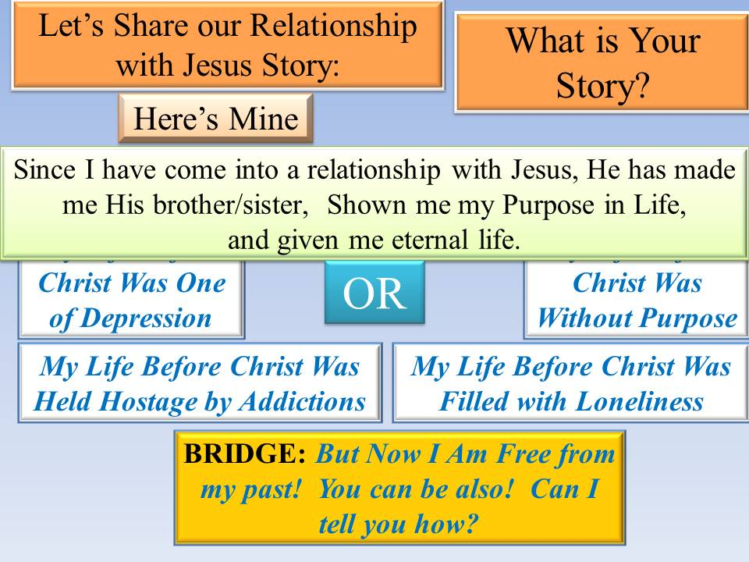It will be proper at this opening session to admit that you have questions or doubts about the effectiveness of your devotional time. Emphasis must be placed on being honest. Some of the statements about how you are doing spiritually may identify a need for personal follow-up.

**Q: Why do you think students new to ES should reveal how they are doing spiritually?**

___________________________________________________________________________

___________________________________________________________________________

Use ES1 form in your ES binder to write your story. Keep it very brief. Also, use form ES2 to list names of students that you know are away from God. Keep your forms in your binder, you will make revisions later.

## Accountability Time:

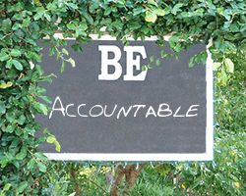The teacher will use this time during Session 1 to explain to the group about weekly goal setting and accountability. Examples of goals to accomplish next week will be identified. Those present will be asked what they think of as future goals.

Each group member will be assured that they will be expected to share the results of their goals at the next meeting.

**Q: Why is it important to be accountable for accomplishing and reporting goals?___________________________________________________________**

**Q: What are some goals you will be expected to set and accomplish after you graduate?**________________________________________________________

## Vision Casting:

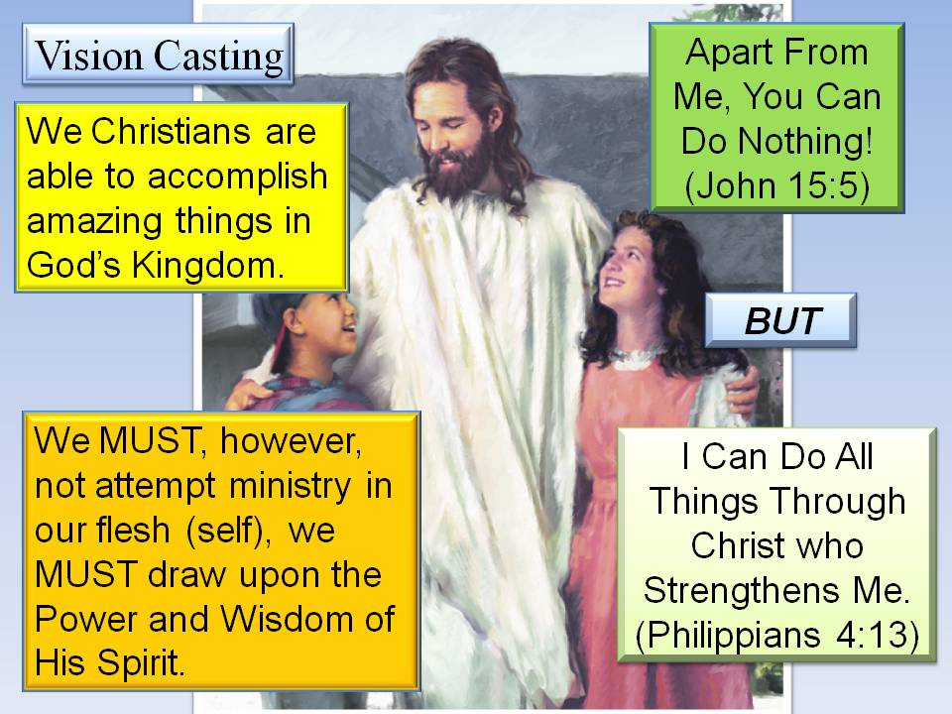The adult teacher will make a brief presentation of encouragement and assurance that the members of the group ***can*** accomplish their goals and bring about a spiritual revolution in their school.

Biblical principles, verses, parables, and illustrations will always be used during these times of casting positive vision for the group. Emphasize John 15:5 and Philippians 4:13.

During the first session, the group will be told about how to treat "selfishness".

The group will be assured that they are not expected to accomplish great spiritual goals alone but to learn to depend upon Christ for their strength.

Jesus said, "***I am the True Vine; you are the branches. If you remain in me and I in you, you will bear much fruit,... apart from me you can do nothing***." **John 15: 5**

Q: What did Christ mean when He told us to take up our cross daily and follow Him? _____________________________________________________________

__________________________________________________________________

NOTES:

## Brief Discipleship Lesson: The first Discipleship lesson will be on *Know your Purpose*.

Do you know what your life purpose is? If not, would you like to know? The Bible tells us that we can and should know our purpose in life. You should be preparing now, while a student, to fulfill your purpose. God has a purpose for you and you need to prepare for the vocation that will pave the way to fulfill that purpose.

Christianity is a lifestyle rather than a legalistic religion. As long as you hold on to your life for yourself, you will never know your (His) purpose. Jesus said, "***He that loses his life for me shall find it***." That is, whoever will give up his own life for Jesus' sake shall find the purpose for his life. It may be an engineer, pilot, farmer, welder, wife, Dad, businessperson, writer, etc.

True Christian faith is very specific. It is not faith in a moral system, an organization, other people, or a program. It is confidence that Jesus is who He says He is and assurance that He will do everything He has ***promised*** to do. Only He reveals a person's purpose for being created.

Authentic Faith is believing that Jesus is the Son of God and His sacrificial death has been accepted by God the Father as payment in full for your sins. Your purpose is then more clearly identified as you advance as a disciple or follower of Jesus.

Care must be given in the way you pray. If you pray for things to get from God that He has not promised to provide, then you can become disappointed in God and your faith in Him may falter. An upcoming session on spiritual disciplines will instruct you in the proper way to pray and expect to have our prayers answered.

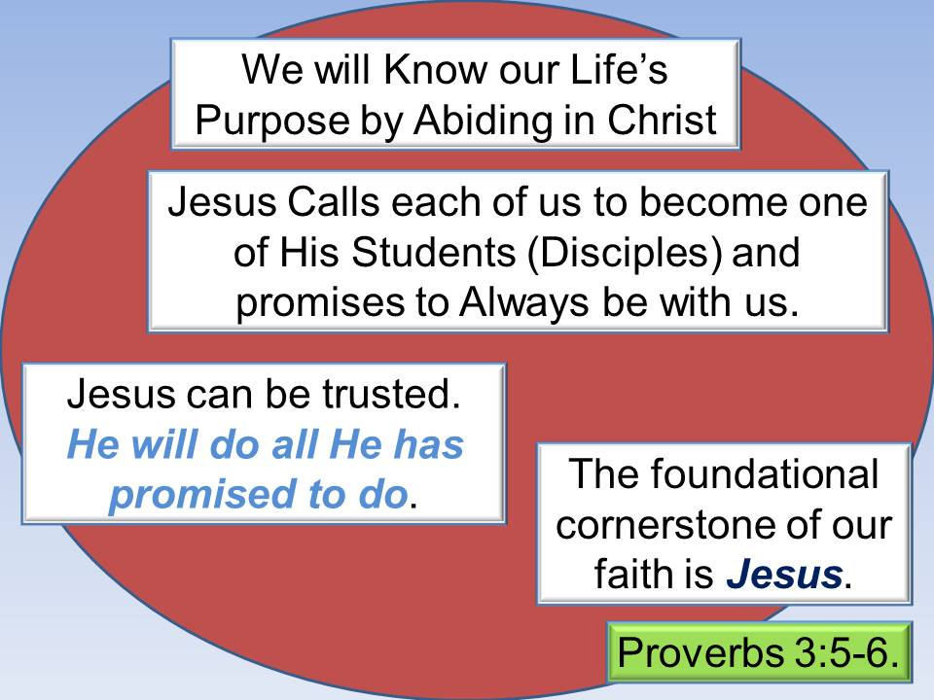Your faith must be based specifically upon a relationship with the person: Jesus. Authentic faith requires you to accept what has been promised though you may not understand it. This is one of the most difficult parts of being an effective Christian since we have been taught to only trust in those things that we understand.

It helps if you realize that God is infinite and you are not. You are finite and unable to comprehend all spiritual things. You are therefore instructed to not depend upon your understanding but to trust that your infinite Heavenly Father knows what is best for you.

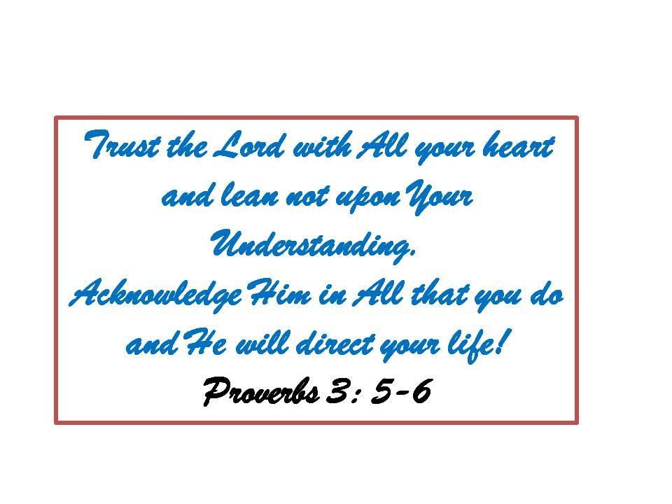Students are learners preparing themselves for a quality adult life (i.e. Farmers, Pilots, Housewives, Engineers, Plumbers, Writers, etc.) Learning your purpose in life and how to live with authentic faith is the best preparation a student can make for the future. God promises to direct your life if you trust Him with all of your being.

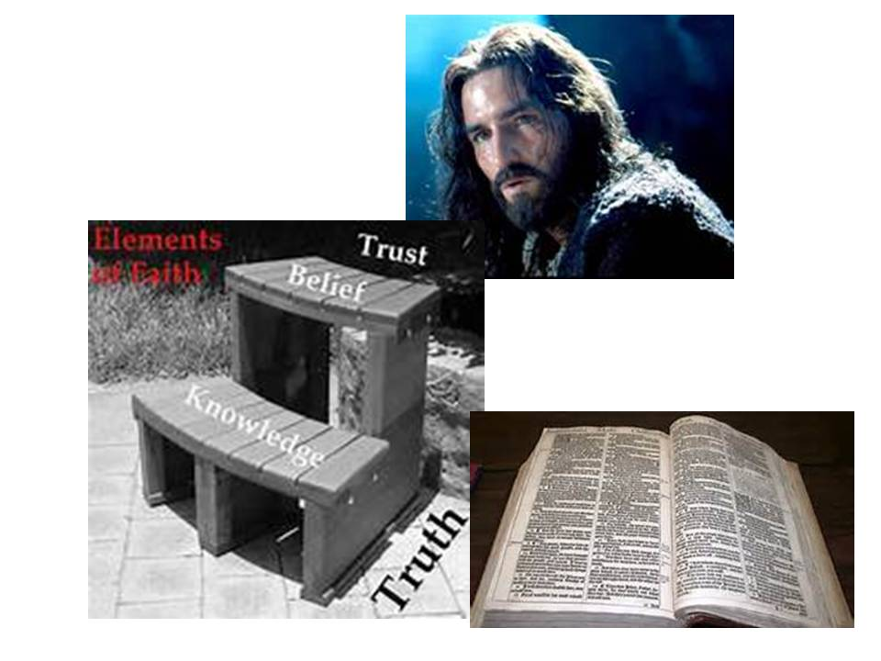Progressive faith is built upon a process like 1) Gaining truthful knowledge from studying the Bible, 2) Believing what the Bible tells us, and 3) Trusting that God will respond with what He has promised.

**Q: Why do you think that God insists that we faithfully trust Jesus?** ____________________________________________________________________________________________________________________________________

## Goal Setting:

The final part of Session 1 is to set goals for the upcoming week. The teacher will assure the students that he/she promises to also set weekly goals and be prepared to discuss the results at each ES session.

There are six specific goals to be set following the first meeting: 1) Select a ***Secret Place***, 2) Start daily, dated journal entries; 3) Start reading a chapter of the Book of John each day; 4) Add to the list of students you know to be away from God; 5) Revise your brief story about your relationship with Jesus; and 6) memorize Proverbs 3:5-6.

***"Trust the Lord with all your heart and lean not on your own understanding, Acknowledge Him in all your ways and He will direct your paths."*** Proverbs 3:5-6.

**Q: Why do you think it is important to set spiritual goals?** ____________________________________________________________________________________________________________________

# Reminder:

You will be asked to share with the group about how you accomplished your goals at next week's meeting.

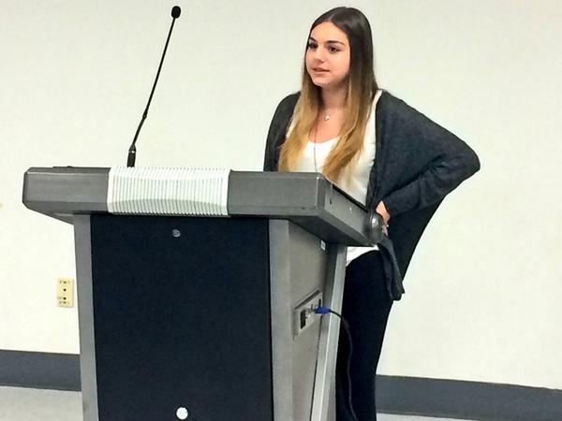

Our Discipleship topic for our next meeting will be ***Spiritual Disciplines.***

Be sure to bring your ES Binder, Journal, and Pen. It will not be necessary to bring your Study Bible unless you just want to.

Dismiss in Prayer

NOTES: