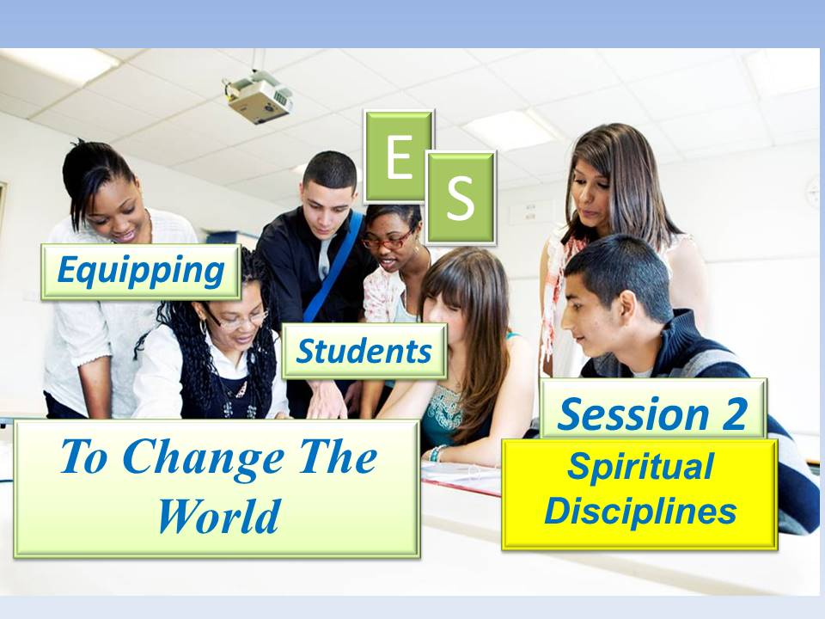

***Student Manual***

***Prepared by: Equipping Central***

*www.equippingstudents.com*

***John Overton***

***January 2017***

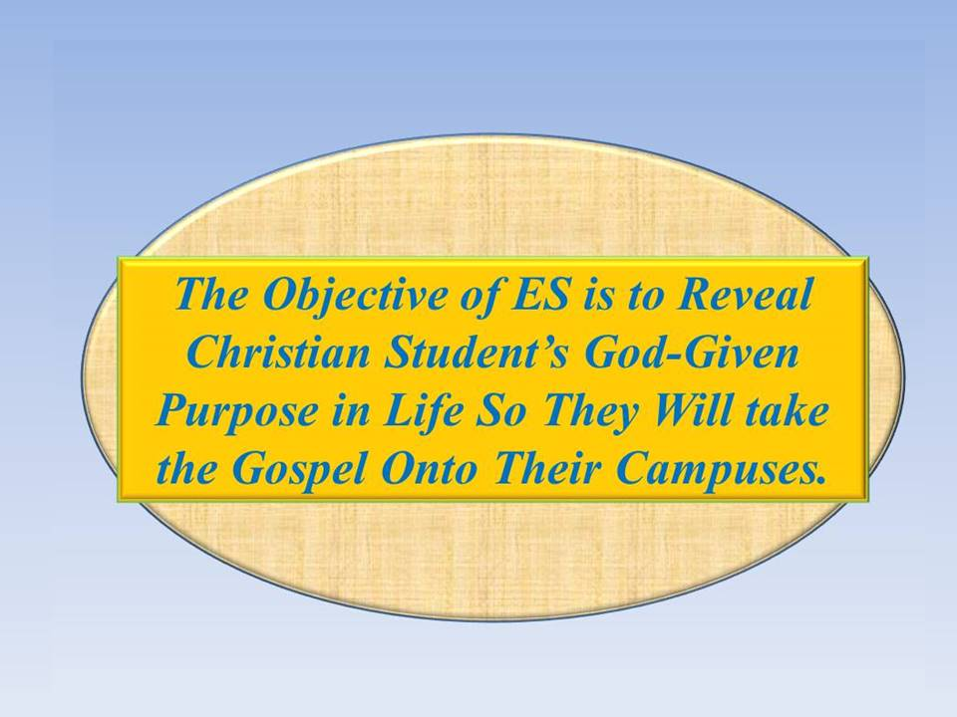**Student Session 2**

We must never lose sight of our ES objective, which is to equip students to know their purpose as Disciples of Christ so they will take the Gospel onto their campuses.

Be sure to bring your ES binder and pen to all of the following sessions.

Starting with the second ES session, students will be appointed to serve as teacher assistants. The attending adult will serve as the session teacher as well as encourage and coach the student assistant. Different student assistants should be appointed for each ES session.

Q: What are we trying to accomplish? ___________________________________

__________________________________________________________________

**Opening:** The teacher will inform the students that prayers for the accomplishment of God's will are always answered. It is God's will that you know your purpose in life and that no one perish.

Leading in opening prayer will be accomplished by students and the focus of the prayers for session 2 will be the identification of additional names of students known to be away from God. Each student will also ask to be empowered by the Holy Spirit to complete the entire ES course. Prayers are like voice messages to God. The Father paid for the message by God, the Son, Jesus.

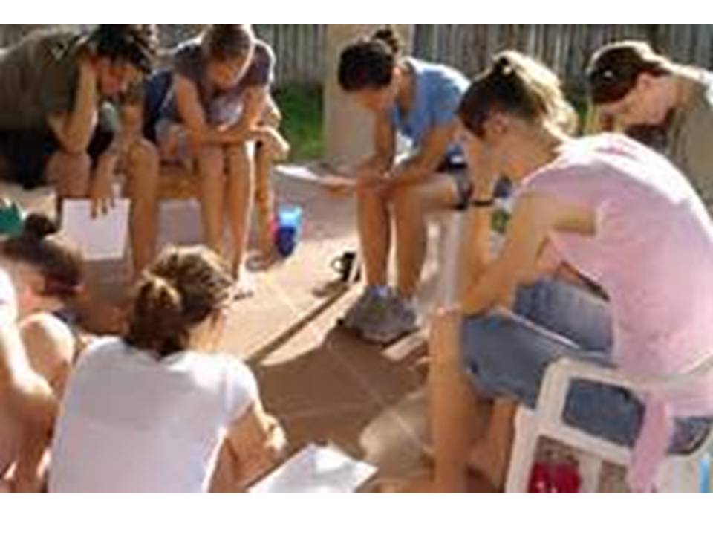Students opening in prayer will be rotated amongst the group or more than one will be appointed to pray. All should know that this is part of their training

## How Are You Doing Spiritually?

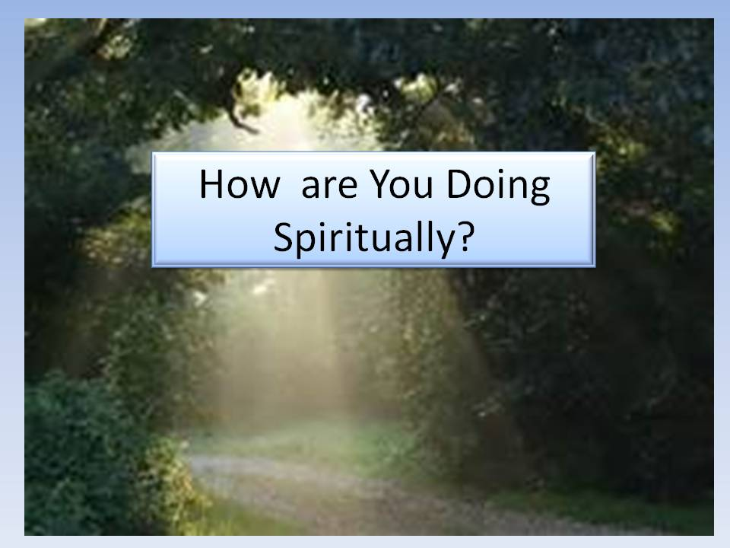The teacher will ask each student to share with the rest of the group how they are doing spiritually. They will be specifically asked to share about their relationship with Jesus. Sharing may have to be limited to only one to two students.

The teacher must be time conscious and not let any one speaker dominate this part of the ES session.

Q: Why should the teacher care about the time used during the sharing time? _________________________________________________________________

_________________________________________________________________

**Accountability Time:**

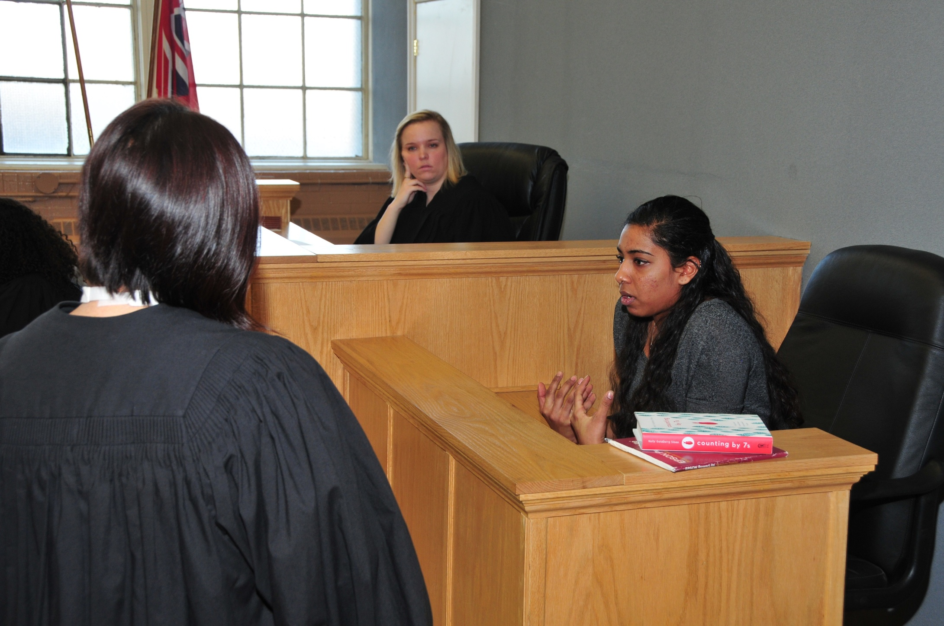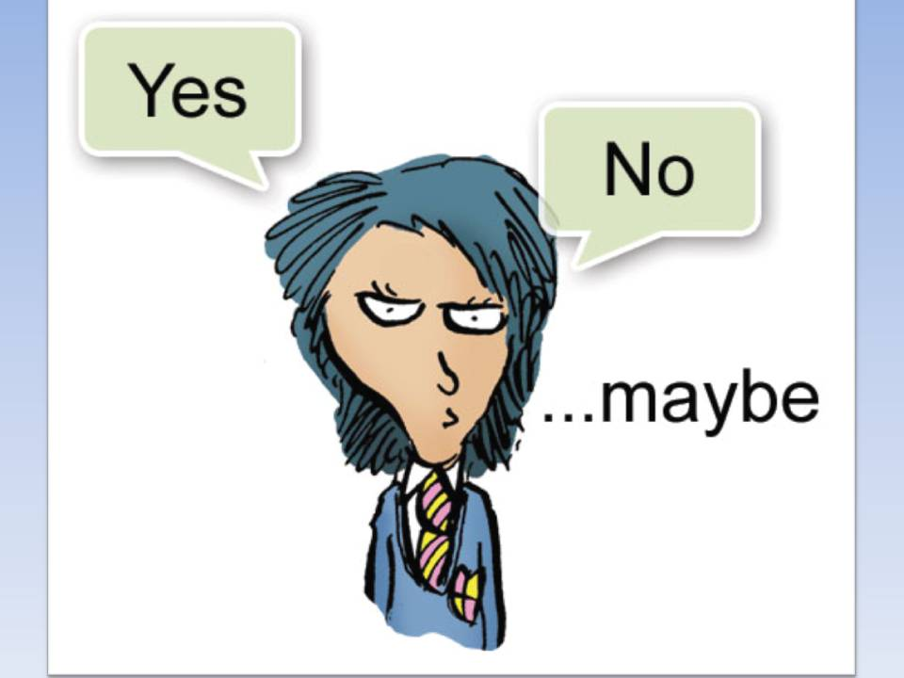The teacher will designate specific students to share with the group about their progress with their goals during the past week. Students will never be asked for accountability in a way that can be answered by a single word. Students will always be prompted to use sentences to share how they accomplished their week's goals.

The teacher will ask selected students to tell where their Secret Place is located and have them tell what they learned from the chapter of John read this morning. Students may use their Journal as a reminder. How many days have you made entries in your Journal? How did you identify students known to be away from God that have been added to your list?

Tell your brief Story and repeat Proverbs 3:5-6.

**Q: Why should the students have to answer with sentences rather than a single word?** ____________________________________________________________

____________________________________________________________

**NOTES:**



Vision Casting:

The teacher will provide encouragement to the group, assuring them that they ***can*** make a spiritual impact on their school(s). Basic to the Christian life is the belief that the Bible is the source of Truth and that you should build your life on the teachings of the Bible. Using your secret place to study the Bible and pray is the way to receive power to learn your purpose in life and accomplish your goals.

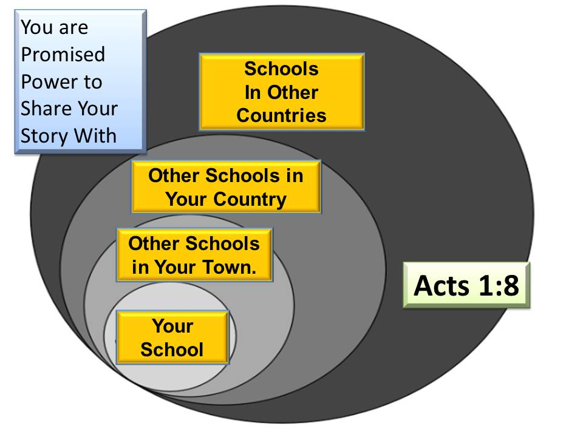The Bible assures you that you are not to attempt your Christian deeds alone; you are empowered by God in the Person of the Holy Spirit to carry out the commissions and commands that God calls you to do. Acts 1:8 informs us that our Christian influence is to grow beyond ever expanding boundaries. You are not to become a Christian and wait until you die and go to heaven. You are to have an active life as a co-laborer with Jesus until your die so you will be accumulating rewards for eternity.

Too often, we get discouraged and fail to tell other students our story. That will happen if you do not wait and depend upon being empowered by the Holy Spirit. That is why it is necessary to use your Secret Place to practice the disciplines of daily Bible study, prayer, and journaling.

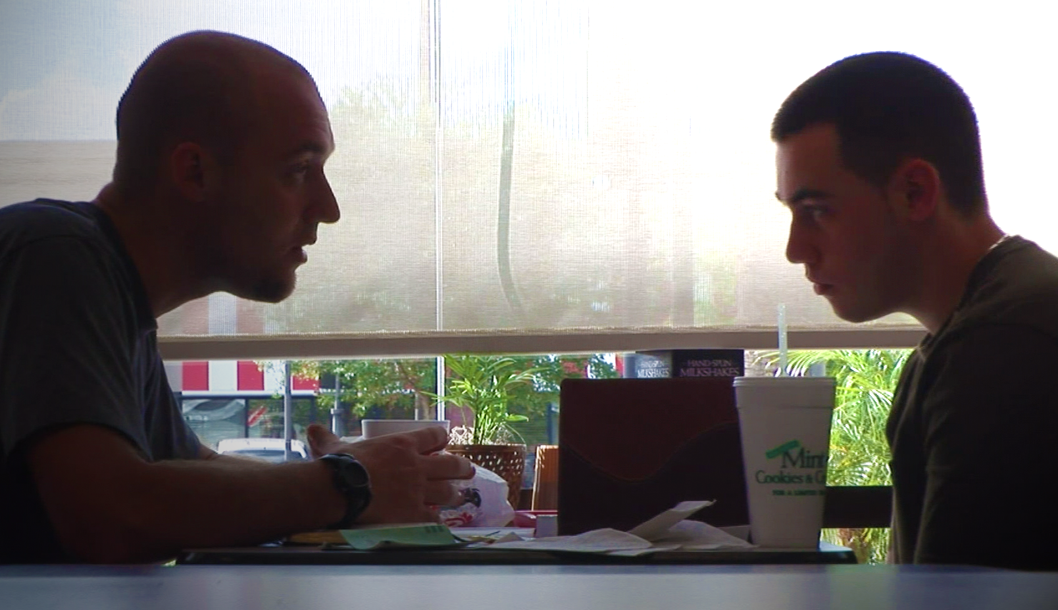The group is to depend upon Christ for their strength. This will require much discipline.

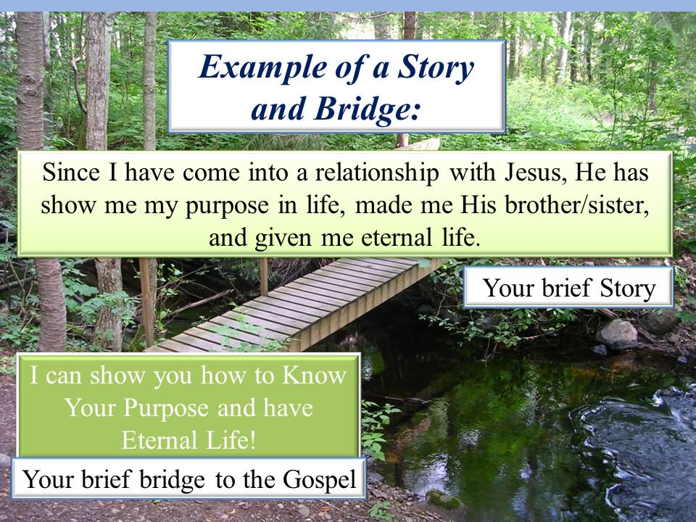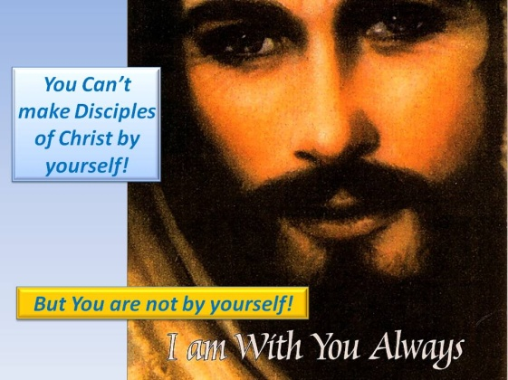You will learn to use a very simple, three-step process of; 1.) Telling our story, 2.) Bridging it to the Gospel, and 3.) Cite John 3:16 as the Gospel in future sessions.

Q. What is the big advantage of studying the Bible for you?

____________________________________________________________

____________________________________________________________

The Gospel (Good News) can be summed up by a single scripture: John 3:16. Most people know this scripture. Recite it in your mind often.

Regroup into pairs and briefly practice this simple three-step process. Use your Story and Bridge you have written in your ES binder if it will help.

***That was simple wasn't it?***

Now let's rearrange in different groups of two or three and 1.) Tell our story, 2.) Bridge to the Gospel, and 3.) Recite John 3:16.

This process must be kept simple and easy to remember. Recite the process in your mind often imagining that you are sharing it with someone on your list of students.

## C:\Personal Stuff\Church\Discipleship\Lost Sheep Ministries\ES\ES - Eight Student Sessions\ES - Session 2 - Spiritual Disciplines - JPG\Slide23.JPGBrief Discipleship Lesson: The second Discipleship lesson will be on Spiritual Disciplines.

We will major on three Christian disciplines during this coming week:

1) Daily Bible Study,

2) Daily Prayer, and

3) Daily Journaling

In your own words, write what you think a **Disciple is** ______________________________

_________________________________________________________________

**What does discipline mean?** _________________________________________

_________________________________________________________________

**What do you have to do to become a Disciple of Christ?** __________________

__________________________________________________________________

## C:\Personal Stuff\Church\Discipleship\Lost Sheep Ministries\ES\ES - Eight Student Sessions\ES - Session 2 - Spiritual Disciplines - JPG\Slide27.JPGGoal Setting: The final part of Session 2 is to set eight goals for the upcoming week: 1) Start using your *secret place* daily to 2) Continue daily Bible reading (continue with the book of John), 3) Journal and date your impression of the Bible chapter you read, 4) Continue a daily time of prayer, 5) Add to your list of students known to be away from God, 6) Review your brief story about the results of your authentic faith in Jesus; 7) Write your bridge to the Gospel, and 8) Memorize Acts 1:8. *"You will receive Power when the Holy Spirit comes upon you and you will be my witnesses to the ends of the earth"*



**Reminder:**

You will be responsible for reporting the results of your goals for the week.

Bring your ES binder and pen next week.

Our next Discipleship topic will be on ***Moral Boundaries***.

**NOTES:**