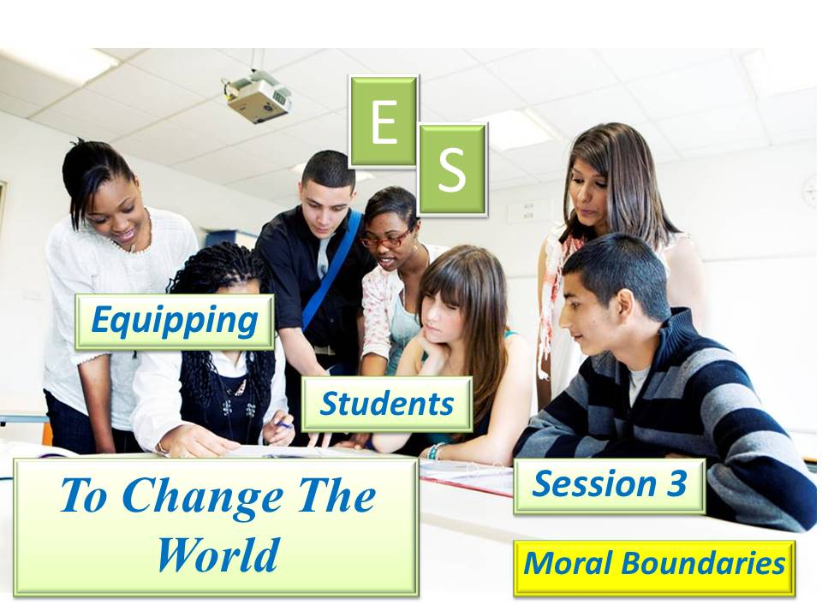

***Student Manual***

***Prepared by: Equipping Central***

*www.equippingstudents.com*

***John Overton***

***January 2017***

**Student Session 3 - Moral Boundaries**

By session 3, the group should be aware of their purpose in life and their role as Christian disciples. They will likely still feel inadequate and that is OK because they are in training. Each should be given assistant roles in the conduct of the sessions though they may resist it and may not do a very good job at it. Experience is what they need to transform them from being a consumer Christian to being a Disciple of Christ.

Q: What are we trying to accomplish? __________________________________________________________________________________________________________________________

A group member will be appointed to be the teacher assistant for this session. The adult teacher must perform the teaching role and be available to encourage and coach the student assistant (s.)

**Opening:**

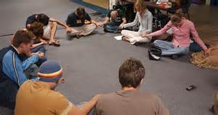The student assistant will lead in opening prayer. He/she should decide the format of prayer for the session. Public praying may be new to the group members and some may hesitate but this is part of their discipleship training. Student led prayer will be the opening for future ES sessions. Prayer emphasis for session three should be for the members of the group and their classmates.

**How Are You Doing Spiritually?**

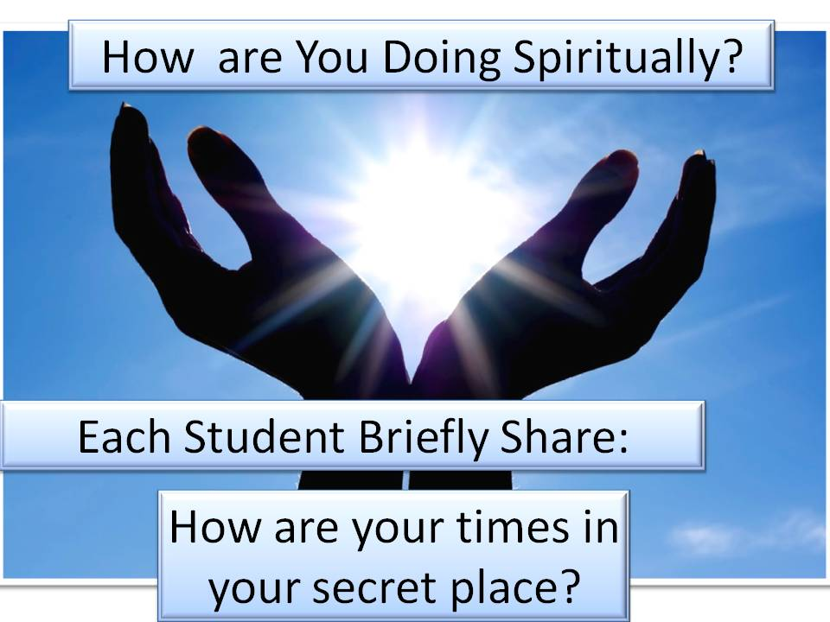The teacher will ask each student to share with the rest of the group about how they are doing spiritually. You will be asked to tell about your secret place and how you are using it. During this important part of session three, the teacher must be alert to keeping the sharing time on the topic. Due to inexperience of the group, it will be very easy to get off the subject. Tactfully reminding those sharing to bring their time to close is a part of both the teacher and student discipleship training.

**Accountability Time:**

The teacher will use this Session 3 time to designate specific students to share with the group about their progress with their goals during the past week. Accountability questions should always be answered with sentences and the teacher should never accept a one-word answer. Again this is part of ES discipleship training.

By session 3, the group members should know that they will be expected to share the results of their goals at the next meeting. ***Selected students will be asked:***

1. Share some things you journaled this week in your secret place.
2. Which chapters of the Bible are you studying? How do you truly feel about spending time reading the Bible?
3. Share how you met the names you added to your list.
4. Tell how confessing known sins affect your time in prayer.
5. Quickly recite your story, bridge, and John 3:16.
6. Why do you think John 1:14 says "The Word became human and dwelt among us?"
7. Recite Acts 1:8

Q: What are some things you have given up to make time to study your Bible, pray, and journal daily? ____________________________________

___________________________________________________________



**Vision Casting:**

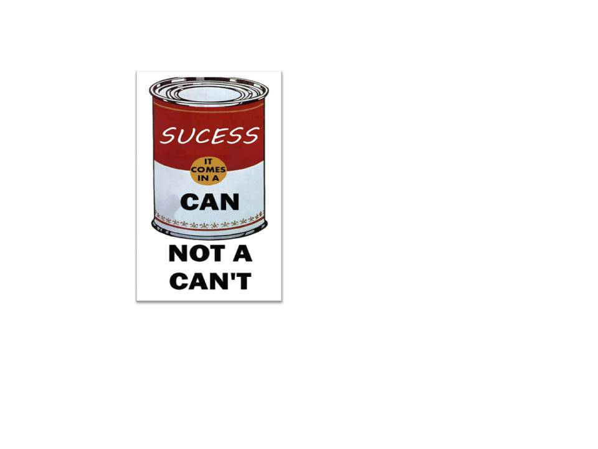The teacher will reassure the group that they ***can*** make a spiritual impact on their school. Our attitude determines our accomplishments and failures in life. Having a "Can-Do Attitude" really helps to be obedient to Jesus and accomplish great things in His Kingdom.

Just because something has not been done before should not be accepted as a reason for not believing it can be done now. All great discoveries are the result of individual's ***Can-Do*** Attitude. The greatest barrier to success is the fear of failure. The hardest part of any voyage is taking the first step.

We all have our limits when we act alone, but we have a promise from the Bible that we can do all things through Christ.

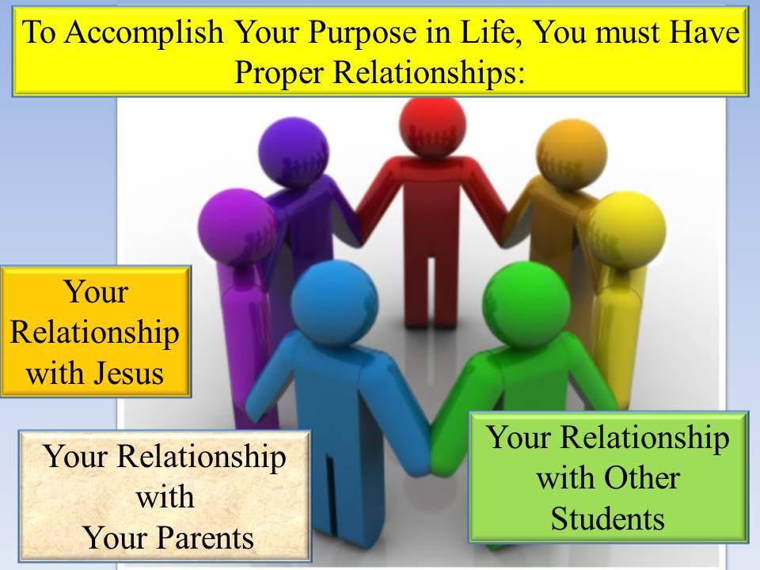**Brief Discipleship Lesson:** The teachers will lead the third and fourth Discipleship emphasis, which will be on Moral Boundaries. A *moral code* is a system of morality (according to a particular [philosophy](http://en.wikipedia.org/wiki/Philosophy), [religion](http://en.wikipedia.org/wiki/Religion), [culture](http://en.wikipedia.org/wiki/Culture), etc.) and a *moral* is any one practice or teaching within a moral code. An example of a moral code is the [Golden Rule](http://en.wikipedia.org/wiki/Golden_Rule), which states that, "One should treat others as one would like others to treat you".

Christianity is about proper relationships; your relationship with Jesus, parents, and with other students. Developing proper relations with the other sex must start early in life.

Christian families are designed to teach you proper relationships. Student's relationship with parents starts your proper relationship with God. If you feel that your family has failed you in this regard, you should vow to do better for the next generation.

The Bible is clear about the boundaries that are best for you. Though the culture often teaches otherwise, these boundaries are not set to prevent students from enjoying life. Indeed, they are proclaimed so you can enjoy a quality, free life.

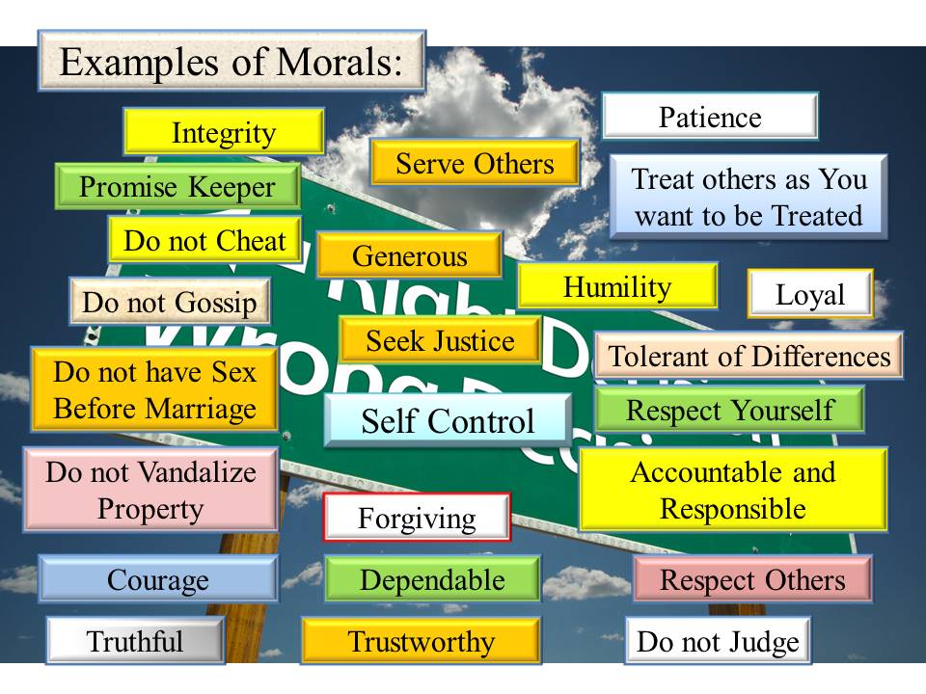We will look at several examples of morals that Disciples of Christ should maintain.

***Boys remain here and girls follow your female teacher to another room to complete this discipleship lesson.***

**NOTES:**

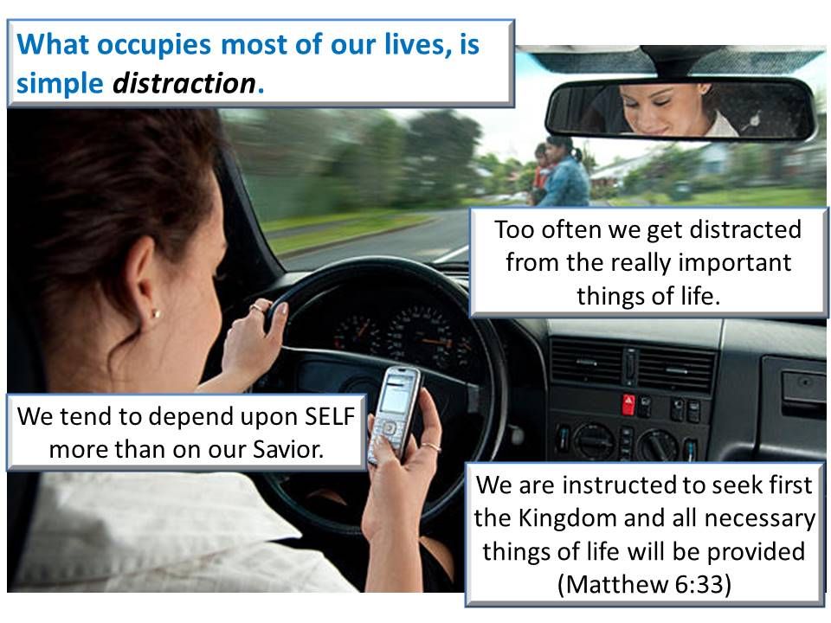God created and still owns and controls the universe. God has established His rules for the proper operation of His universe. Each of you have been created by Him with a God-given purpose.

Unfortunately, you live in a culture that has grossly perverted the rules God has established for your benefit. Your spiritual enemy, Satan, places temporary temptations in your life to draw you away from your purpose and the quality lifestyle that God has planned for you.

Peer pressure is used to tempt you to cross your God established boundaries. You can be distracted from God's purpose for our life by many things. Unless you practice daily communion with Jesus, you will succumb to selfish distractions

Girls are more effective in holding to moral boundary lines of life. This especially applies to drugs, alcohol use, and sex.

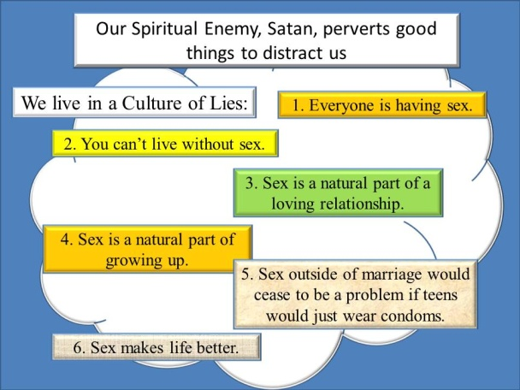You have a free will and are able to make good or bad choices. The choices you make now will have long lasting effects such as qualifications for the work force, college, marriage, future families, and eternity.

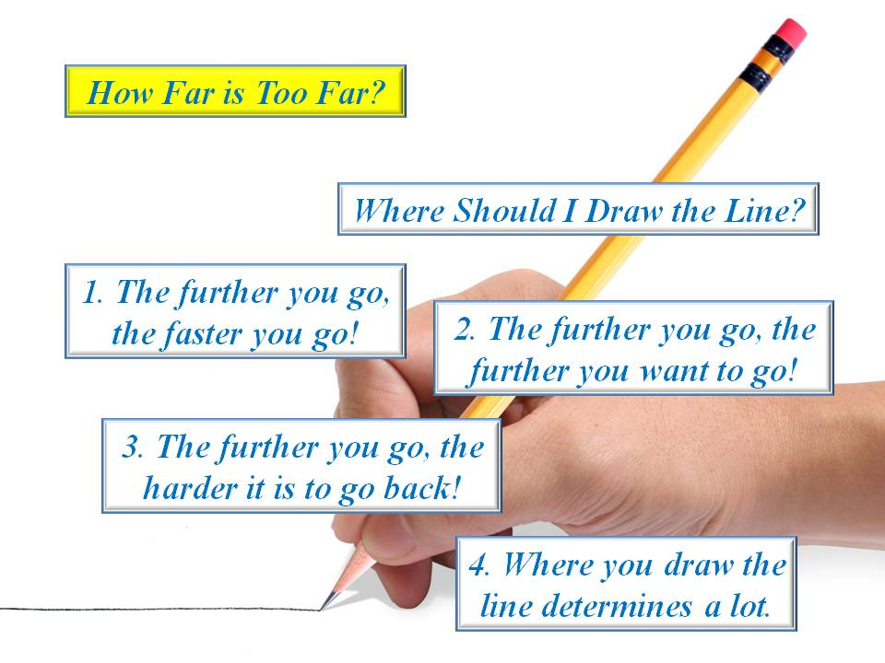

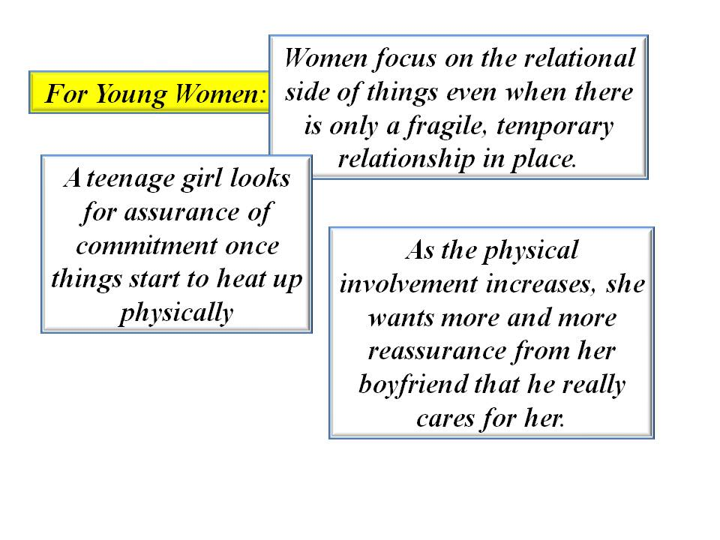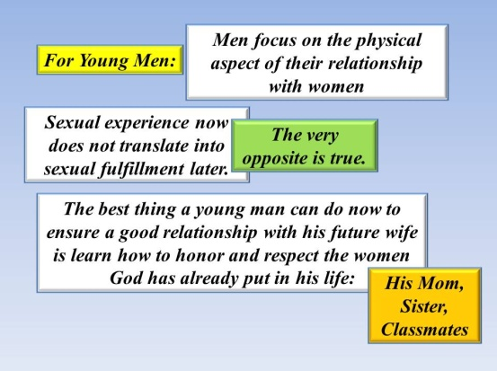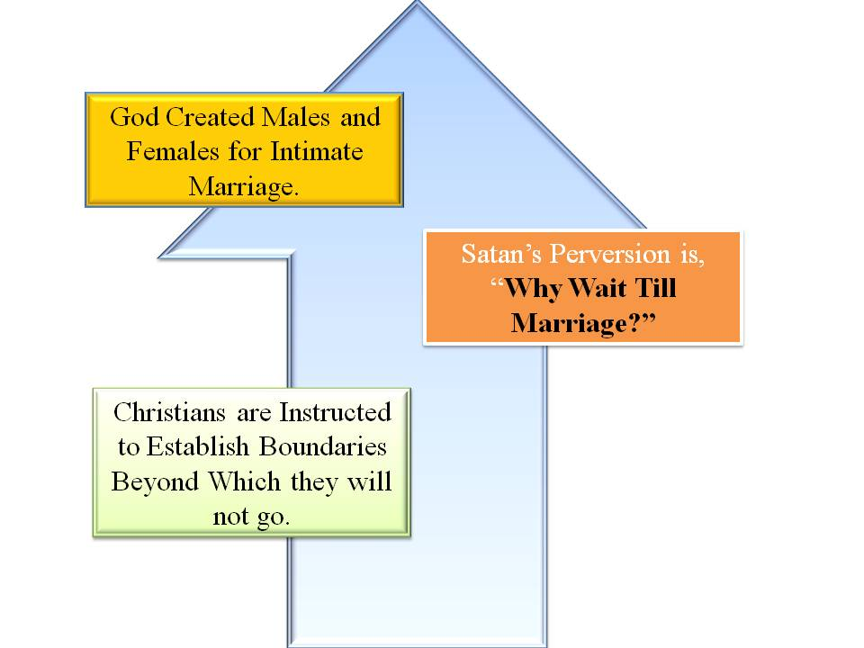There is a difference in sex drive following puberty and the female is more inclined to hold the line beyond which she will not cross though peer pressure may suggest otherwise. God's purpose for this physical characteristic is to cause a mutual attraction between males and females for marriage.

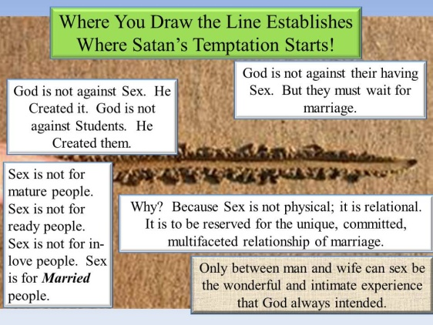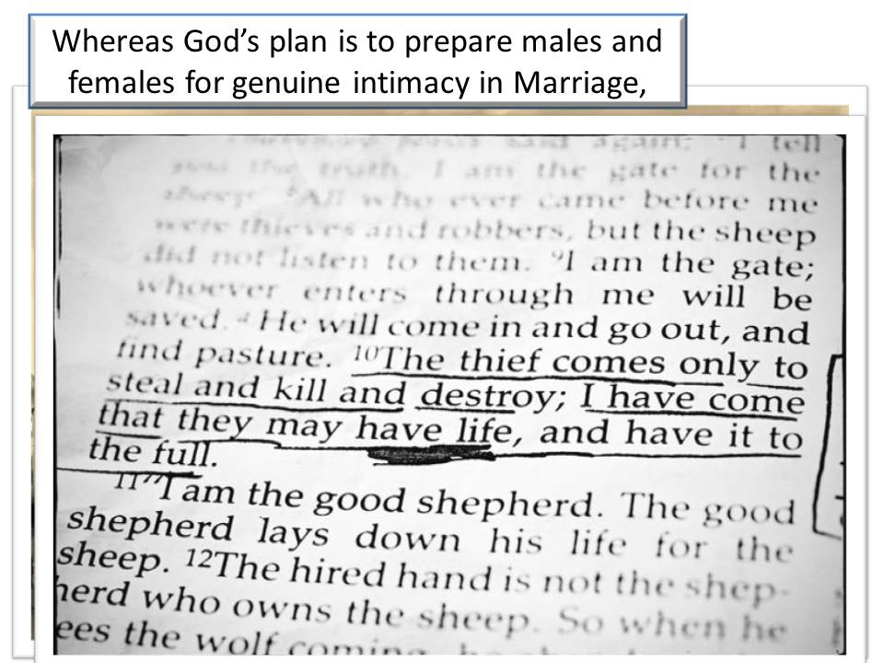

***Girls will rejoin the boys now for the conclusion of our third ES session.***

**Goal Setting:**

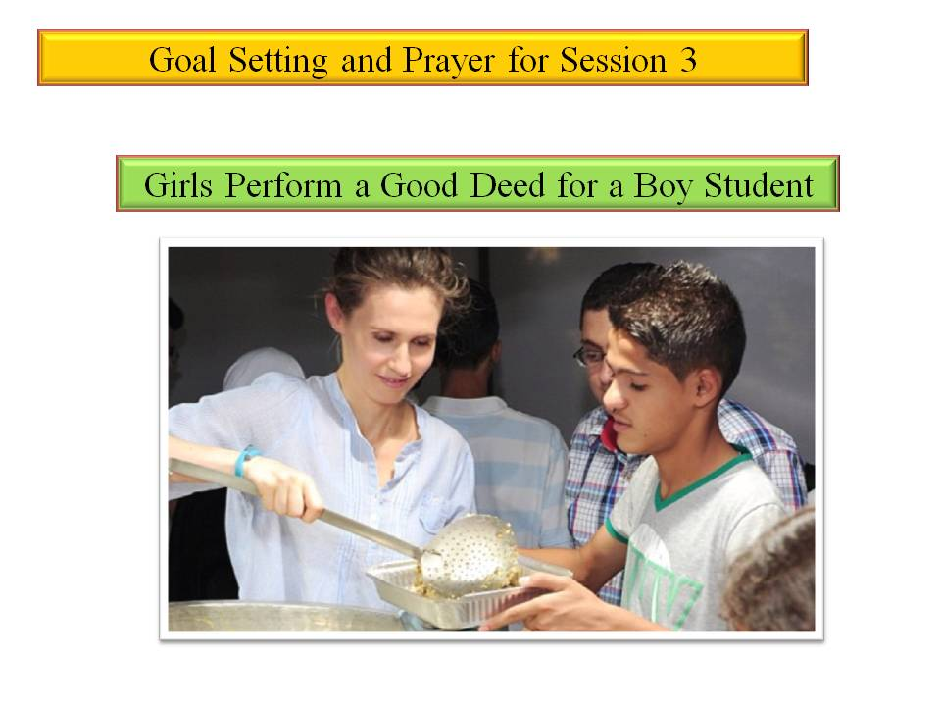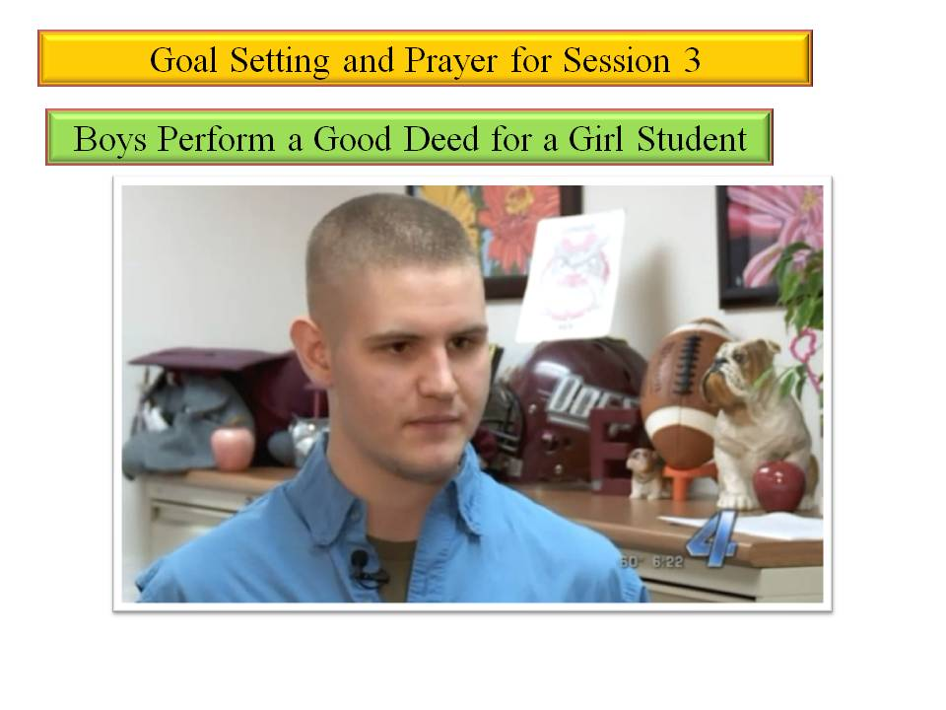The final part of Session 3 is to set goals for the upcoming week. There are six specific goals to be set for the week: 1) Do a good deed for a student of the opposite sex; 2) Continue daily Bible study and dated journaling; 2) Continue a daily time of prayer; 3) Pray specifically for those on your list and for your classmates; 4) Tell your brief story about the results of your faith in Jesus to one on your list; 5) Meditate on your bridge to the Gospel; and 6) Memorize Philippines 4:13. ***"I can do all things through Christ who strengthens me"***

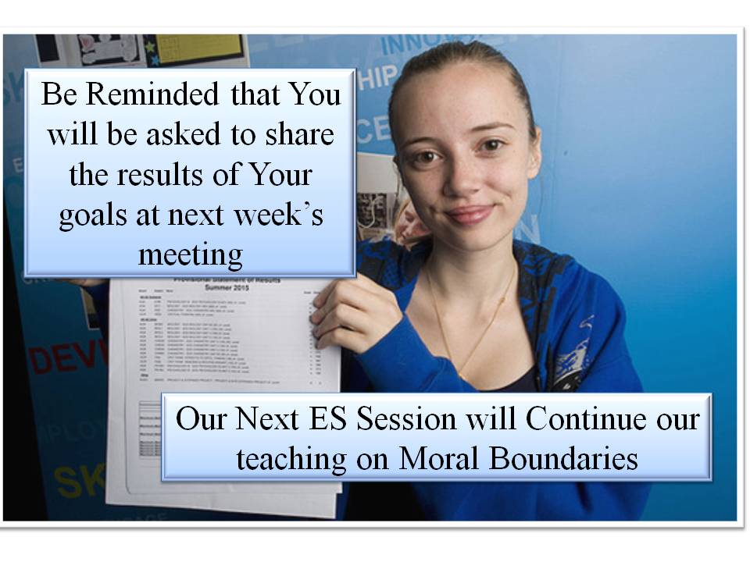***REMINDER:***

You will be asked to give an account for how you accomplished your goals this week.

We will continue the Discipleship topic of ***Moral Boundaries*** at our next meeting.

Bring your ES binder, journal, and pen next week.

**Dismiss in Prayer**

**NOTES:**