

***Student Manual***

***Prepared by: Equipping Central***

*www.equippingstudents.com*

***John Overton***

***January 2017***

**Student Session 4**

Session 4 is a continuation of Session 3 on the topic of Moral Boundaries.

God created sex as a beautiful expression of love between a man and his wife. Satan has perverted sex into a powerful tool for his purposes: Evil. ES will use two sessions for this most important moral teaching since foundations for future Godly, homes will be established by these students.

Two adults will teach the Discipleship Lesson for session 4. During the Discipleship Lesson, the girls will relocate to a separate room to be instructed by a mature Christian woman while the boys will remain to be instructed by a mature Christian man.

**Opening:**

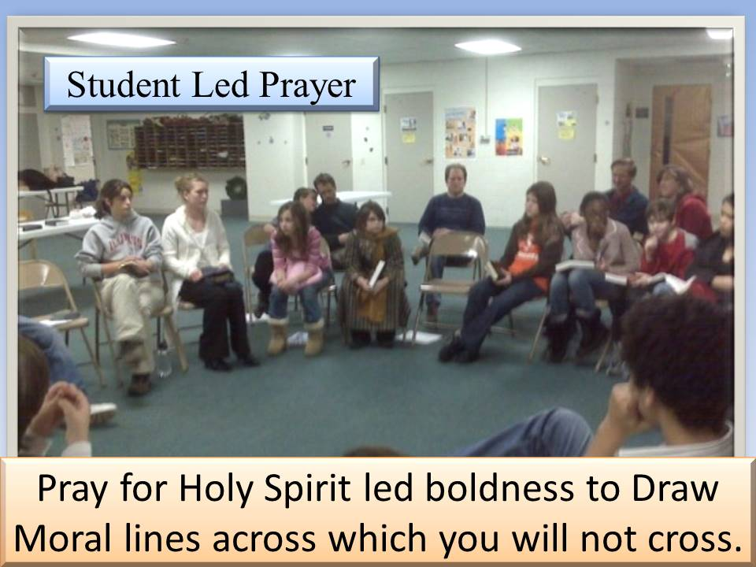Opening prayer will be accomplished by one of the students. By session 4, the group members should understand that an important part of their discipleship training will include public prayer and leading others to pray publically. Ask that the Holy Spirit will lead to bold moral lines across which group members will not cross. The format for the Opening of the 4th session will be determined by the student assistant.

## How Are You Doing Spiritually?

The teacher will choose different group members to share how they are doing spiritually. Students may need to be prompted to tell about their true feelings about spending daily time in communion with Jesus in their secret place. How is your daily time in your secret place equipping you for the day?

Is the new discipline something you look forward to or do you consider it to be an obligation that you should perform? Can you truthfully say that your personal, quiet time with God is helpful in coping with the issues of your life or not. You must always stress that these times of sharing be honest and truthful, never flavored with statements that sound good just to impress the other group members!

**Accountability Time:**

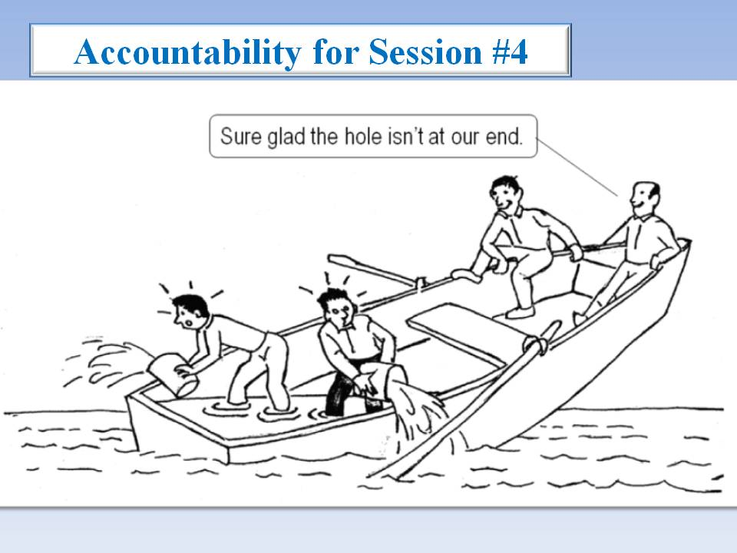The teacher will use this Session 4 time to call on different students to share about your progress with your goals during the past week. Remember, accountability questions should always be answered with sentences and the teacher should never accept a one-word answer. This is an important parts of the group discipleship training.

1) Share about the good deed you did this past week.

2) Tell about your Secret Place, and how you spend time studying the Bible, journaling, and praying each day.

3) How did the student you shared Your Story with respond?

4) Tell your Story and Bridge to the Gospel

5) Recite Philippines 4:13; (***I can do all things through Christ who strengthens me.)***

Q: Why should you do a good deed for someone of the opposite sex?

___________________________________________________________

___________________________________________________________

**Vision Casting:**

The adult teacher will reassure each of you that you can make a spiritual impact on your school through the discipline of ***Self Control***. This is one attribute of the Christian life that cannot be concealed.

Our natural inclination is to gratify *Self* and *Self* will dominate us. Radical Jesus instructed us to take up your cross of execution ***daily*** if you truly want to be a Disciple of His. Most students have never understood this radical command from Luke 9:23.

**NOTES:**

Self has an unquenchable appetite, which will lead a person into all sorts of addictions!

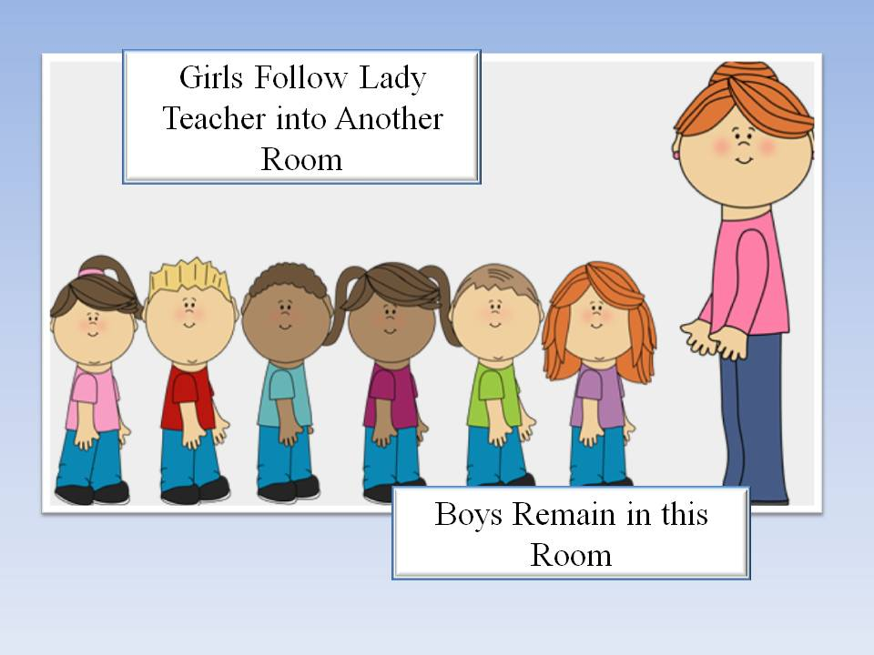You must depend upon the Holy Spirit daily to be most influential for Christ on your campus. Rather than being selfish, you should display the characteristics (fruit) of the Holy Spirit which is love, joy, peace, patience, kindness, goodness, faithfullness, gentleness, and *SELF CONTROL*.

Satan's greatest tool to ruin a person's Christness is ***PERVERTED SEX!***

As has already been taught, God designed boys and girls to go through a maturing phase called Puberty. His purpose for this physical characteristic is to cause mutal attraction between males and females for marriage and establishing Christian homes.

Whereas God's plan is to prepare males and females for genuine intimacy in marriage, Satan's plan is to steal, kill, and destroy the beautiful life God has in store for you by tempting you with instant gratification. (John 10:10).

Breakup of the nuclear family (Father, Mother, Children) results in all sorts of cultural dysfunctions morally and ethicly. The church is to counteract such disorder but if failing due to failure of families to obey Jesus' instructions for proper family life.

Failure in marriages has become the greatest hindrance to the spread of the Gospel. Satan knows that and starts early in student's lives to pervert what quality family life is intended to be.

Unless you are convinced that self must be delt with as Jesus instructed (death to self), Satan cleaverly and subtly temps with addictive habits of sexual perversion to destroy the foundations upon which intimate mattiage is intended to be built!

**Brief Discipleship Lesson:** The fourth Discipleship emphasis will be a continuation on Moral Boundaries:*Sex before Marriage - Self Control.*

How far is too far? Where will you draw the line? Where you draw the line is where Satan starts his temptations.

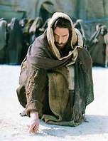God is not against sex since He created it and He is not against students since He created them as well. God knows it best for students and the Christian movement that they wait until marriage. Sex is for married people because sex is not physical; it is relational. It is to be reserved for the unique, committed, multifaceted relationship of marriage. Only between man and wife can sex be the wonderful and intimate experience that God intends.

God designed sexual attraction between males and females. As students age, this attraction increases and will go through a progression of stages.

Stage 1 may just enjoy being with each other.

Stage 2 may advance to showing affection by holding hands. Holding hands will likely advance to Stage 3 in which the boy embraces her by placing his arm around her shoulder and she permitting it.

As this progression continues, it is usually the female that determines where the limit or boundary will be drawn. The male is typically the more aggressive and the female more cautious. She will set the limits as she discerns if his intentions are being expressed because he cares for her rather than using her. Self control of both the boy and the girl cooperate with each other.

If the relationship continues unchecked, it will likely lead to more intimate contact beyond kissing. This is natural but must be controlled by both male and female.

NOTES:

**Goal Setting:**

The final part of Session 4 is to set goals for the upcoming week.

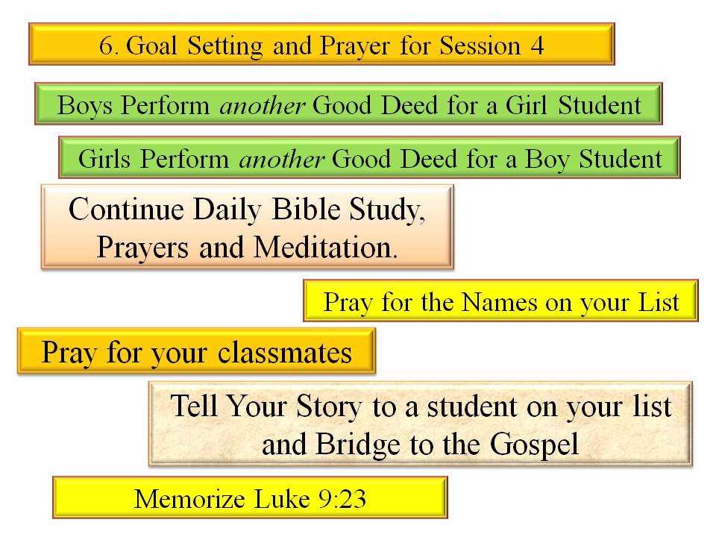There are six specific goals to be set following the fourth meeting: 1) Do another good deed for a student of the opposite sex; 2) Continue a daily Bible study and dated journal; 3) Continue a daily time of prayer; 4) Pray specifically for those on your list and for your classmates; 5) Tell your brief story about the results of your authentic faith in Jesus to one on your list and Bridge to the Gospel; and 6) Memorize Luke 9:23.

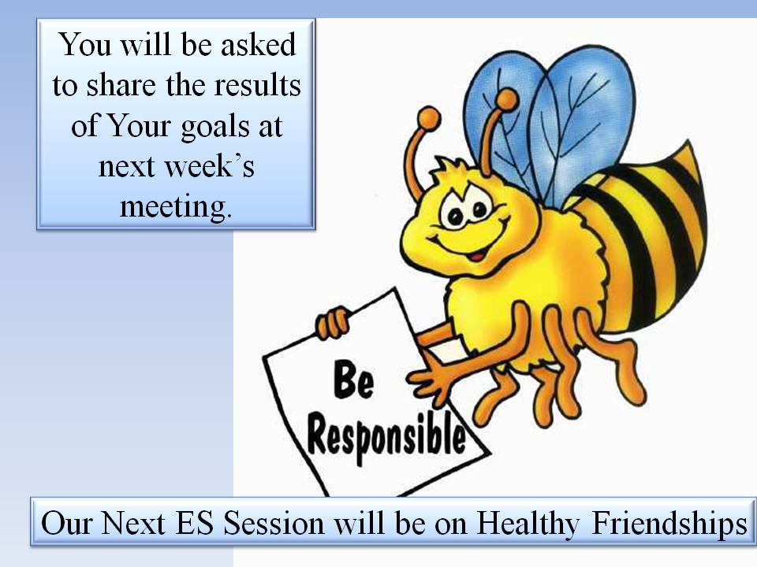***"Whoever wants to be my disciple must deny himself and take up his cross daily and follow me"***

REMEMBER:

You will be asked to share the results of your goals at next week's meeting.

Bring your Journal, ES folder, and pen.

We will study ***Healthy Friendships*** as our Discipleship topic next week.

**Dismiss in Prayer**