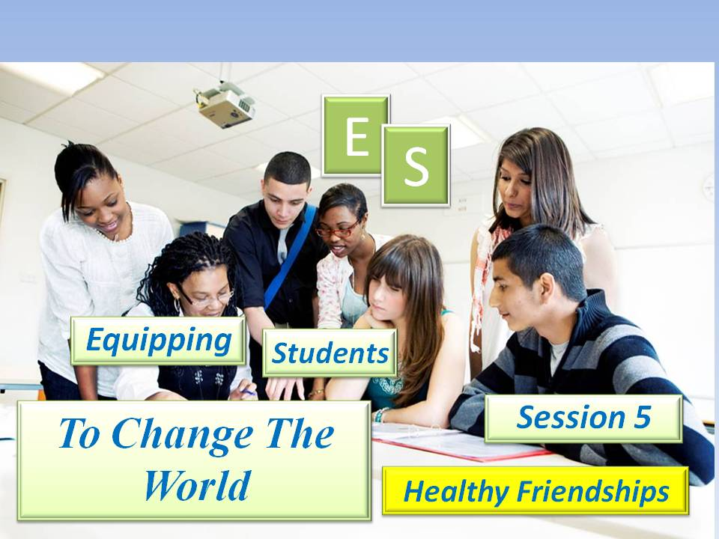

***Student Manual***

***Prepared by: Equipping Central***

*www.equippingstudents.com*

***John Overton***

***January 2017***

# Student Session 5 - Healthy Friendships

The direction students will take in life will be highly influenced by the friends they keep. For the Christian this is a balancing act between influencing others for Christ and being influenced by others for evil.

The Discipleship Lesson part of session 5 will be taught by an adult teacher and assisted by an appointed student group member. The group will ***not*** be separated by boys and girls for the remainder of ES.

Opening:

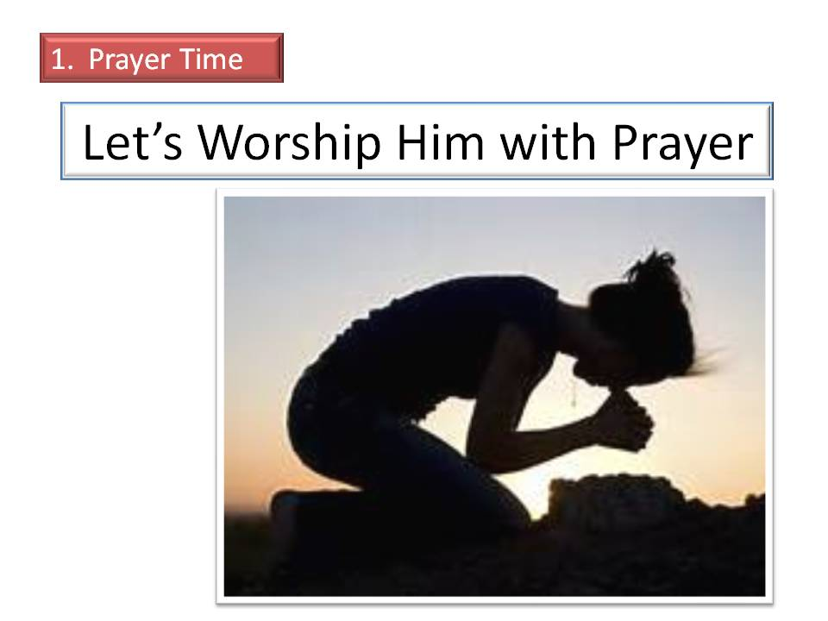The student assistant should lead the opening prayer time. By session 5, all group members will realize that their discipleship training will include public prayer and leading others to pray publically. The format for the opening of the 5th session will have each group member present take a few moments to be silent before the Lord and ask His Holy Spirit to energize the meeting.

Each member should pray for the students on their list and ask the Holy Spirit to remind them of additional names that are away from God.

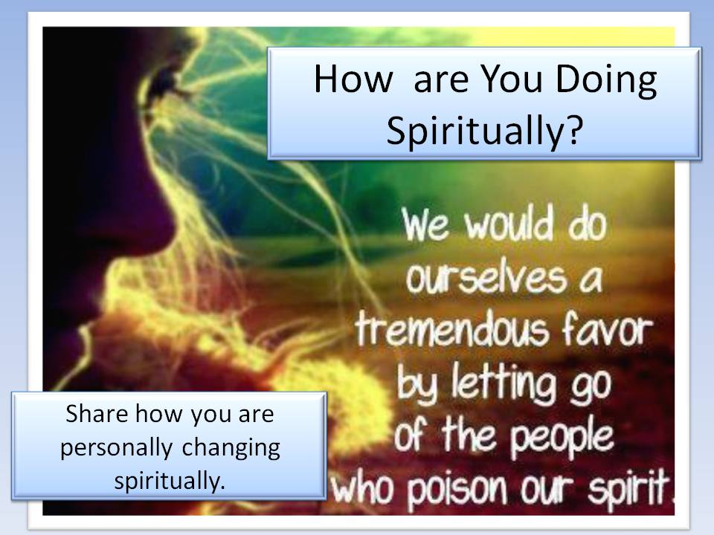The adult teacher will close this part of the ES session in prayer.

How Are You Doing Spiritually?

The teacher will choose group members that have not shared recently to share how they are doing spiritually. If they hesitate, ask them to share about their times of daily meditations (Bible study, prayer, journaling, etc.) in their secret place and how they are changing spiritually.

Accountability Time:

The teacher will use this time to call on different students to share about progress they made with their goals during the past week.

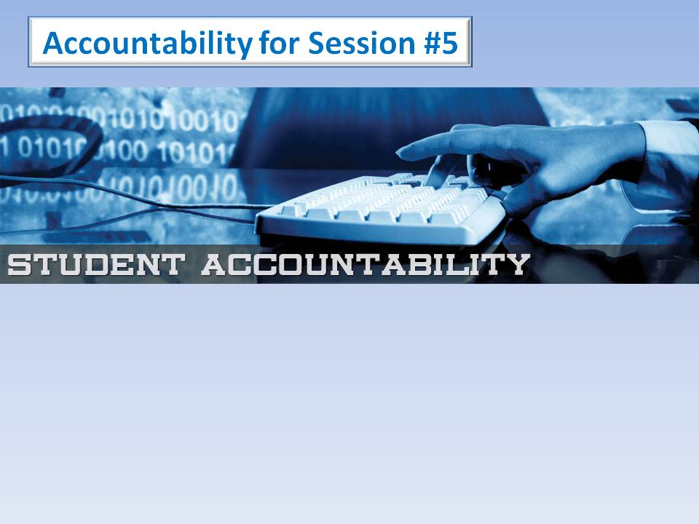1) Share about the good deed you did this past week and how they responded.

2) Tell the group about your time spent studying the Bible, journaling, and praying in your secret place.

3) How have some students responded favorably to Your Story?

4) Recite Luke 9:23; (***Whoever wants to be my disciple must deny themselves and take up their cross daily.)***

***Q:*** What does it mean to take up one's cross? _______________________________________________________________

Q: How often are we to deny ourselves? ______________________________

Q: Why? _______________________________________________________

Vision Casting:

The teacher will cast vision for the group about the permanent position they have in Christ. They have been equipped to bring others into the Kingdom. They are *Holy*, *Blameless*, and *Beyond Reproach*! Whether they feel like it or not

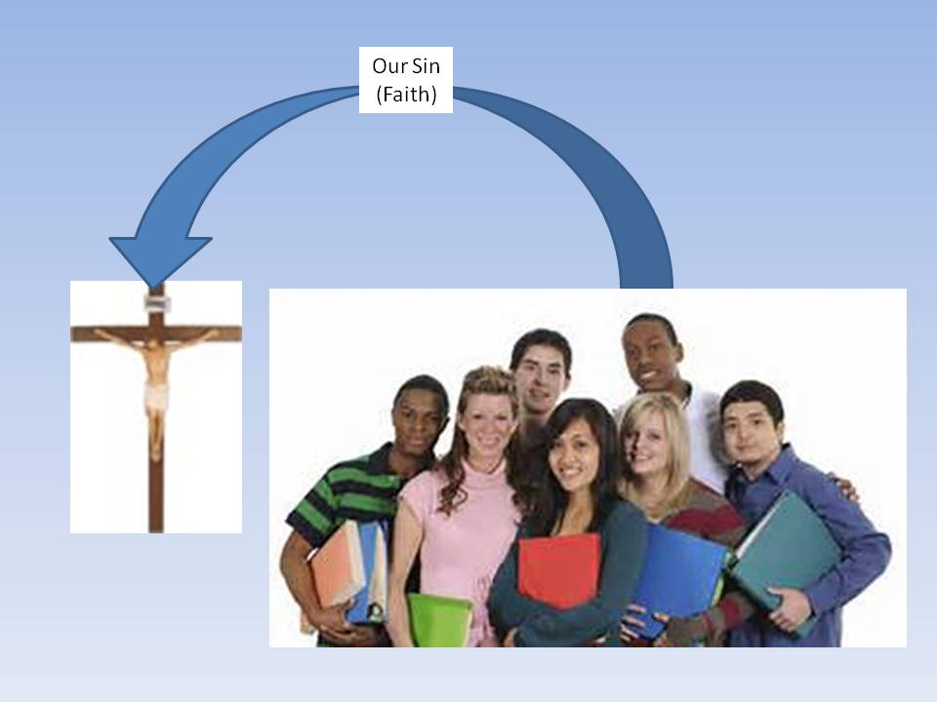***Yet He (Christ) has now reconciled you in His fleshly body through death, in order to present you before Him (God) holy and blameless and beyond reproach*** (Colossians 1: 22)

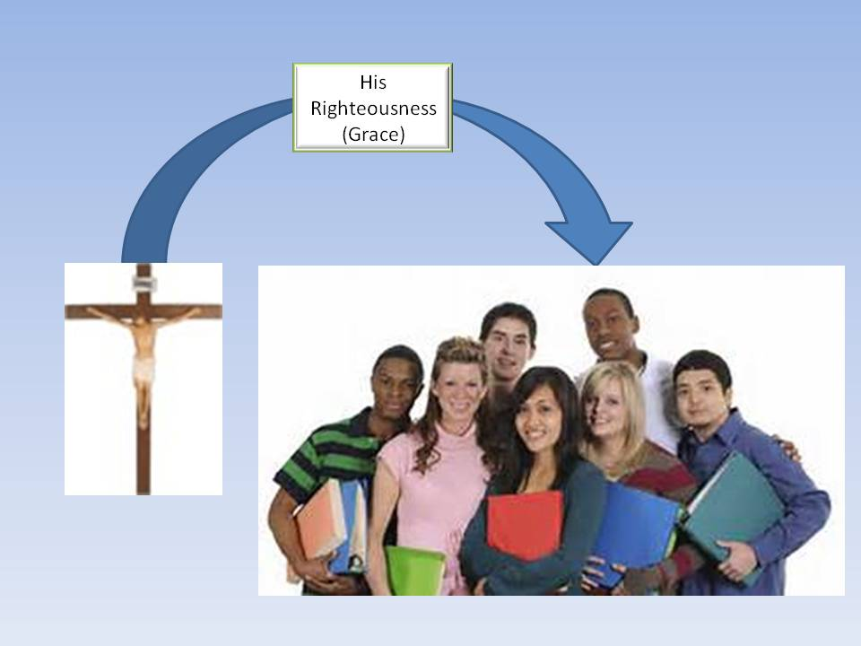Jesus has exchanged His righteousness for your sins. Since we are now ***Free*** from the penalty of our sins and the power of sin, we are commissioned and spiritually equipped to help other students enjoy the same freedom that we enjoy.

Jesus told Peter, a commercial fisherman, that he could become a fisher of men.

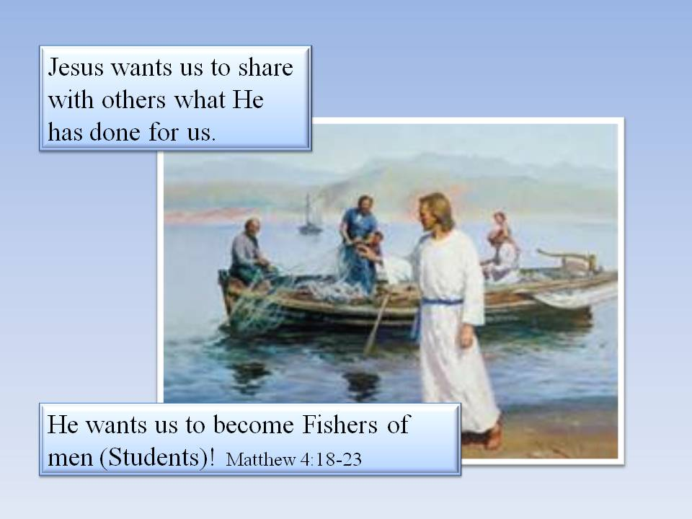As one with Authentic Faith, you too can be a fisher of men (students)! That has got to be the most awesome responsibility anyone can have. Like the fishermen and tax collectors that Jesus chose to be His Disciples, He has chosen you, a student, to continue sharing the Good News (Gospel), with those you know who are away from God; your fellow students.

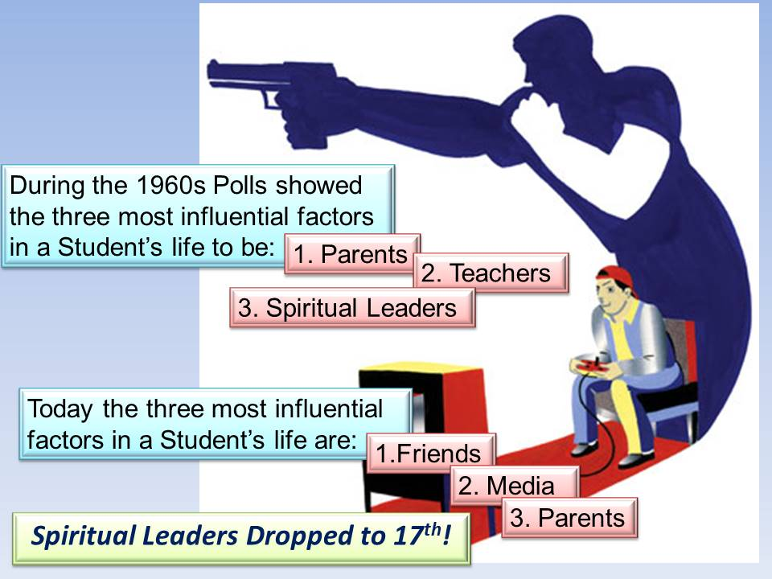

**Brief Discipleship Lesson - Healthy Friendships**

Your friends are the most influential people in your life. Cultural changes have elevated the role friends play in each student's life. Influence can be predominately from your friends to you or from you to those you select as friends.

To be an effective Fisher of Men, you must carefully accept others as your friends rather than reject them so your Christian influence will be affective.

During the 1960s polls showed the three most influential factors in a student's life to be 1. Parents, 2. Teachers, and 3. Spiritual leaders.

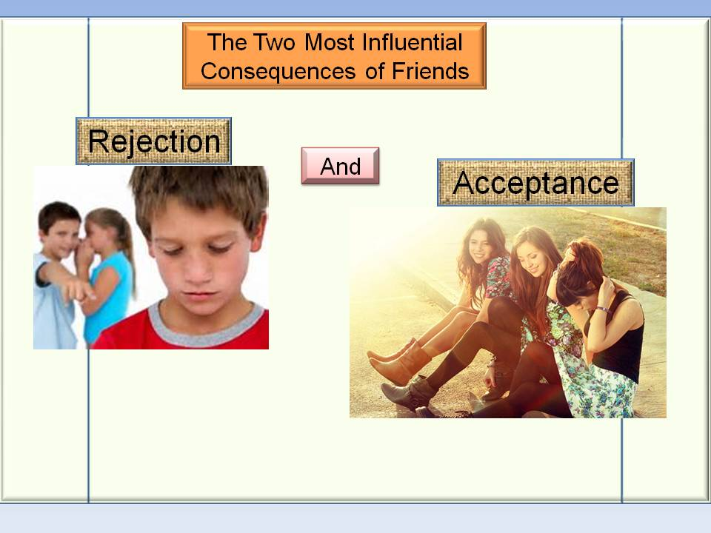Today the three most influential factors in a student's life are 1. Friends, 2. Media, and 3. Parents. Spiritual Leaders dropped to 17th!

Acceptance paves the way to influence. When students feel accepted, they drop their guard.

Students resist the influence of those that they feel do not accept them.

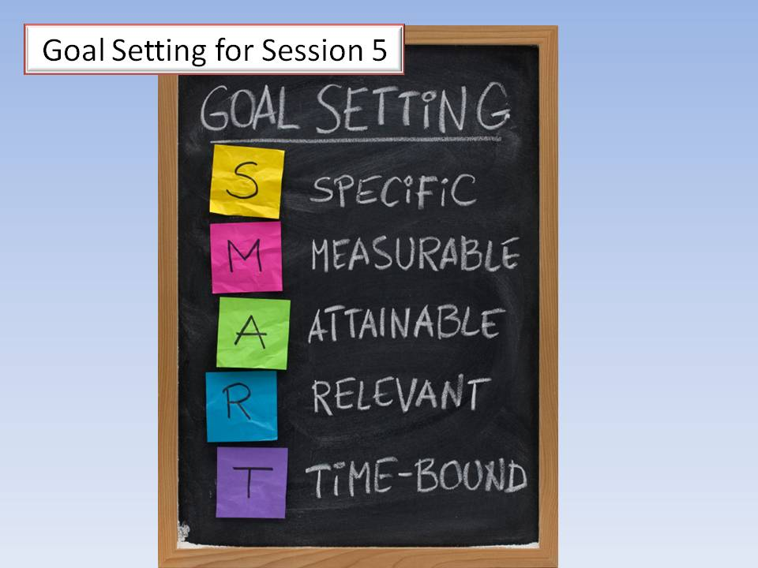Goal Setting:

The final part of Session 5 is to set goals for next week.

There are six specific goals to be set following the fifth meeting. 1) Prayerfully review your list of Students and add new names as prompted by the Holy Spirit; 2) Share Your Story with a Student that does not appear to have a friend; 3) Tell them about ES and ask if they would be interested in joining an ES group, 4) Eat lunch with a Student that is sitting alone; 4) Select an entry in your Journal to share with the group; and 5) Memorize Matthew 4:19.

***Jesus said, "Follow Me and I'll make you Fishers of Men."***

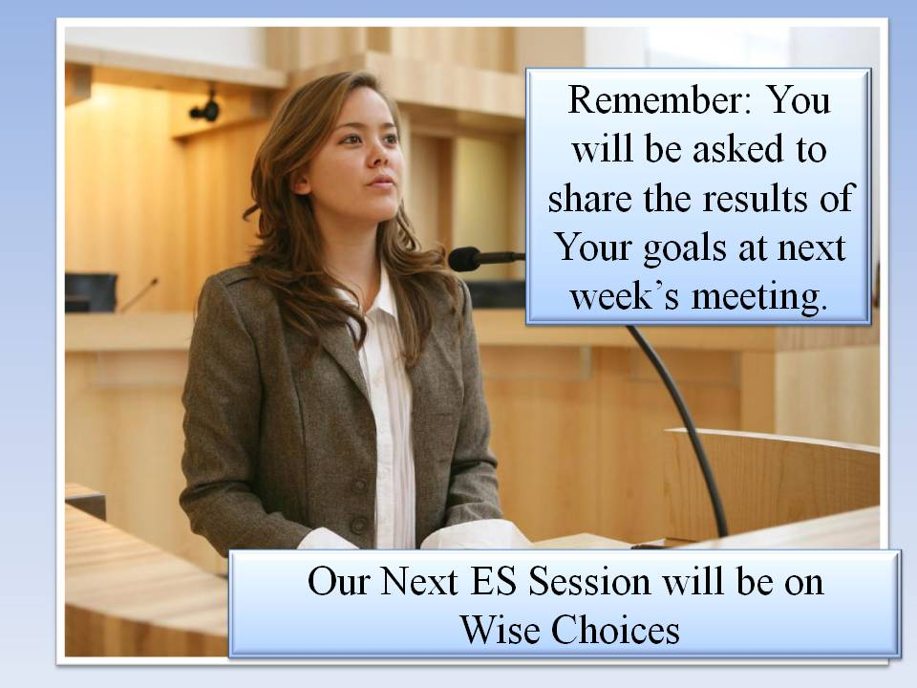**Reminder:**

You will be asked to share with the Group about your goals at next week's meeting.

Bring your ES folder, journal, and pen next week for our Discipleship session on ***Wise Choices.***

**DISMISS IN PRAYER**