`

***Student Manual***

***Prepared by: Equipping Central***

*www.equippingstudents.com*

***John Overton***

***January 2017***

# Student Session 6

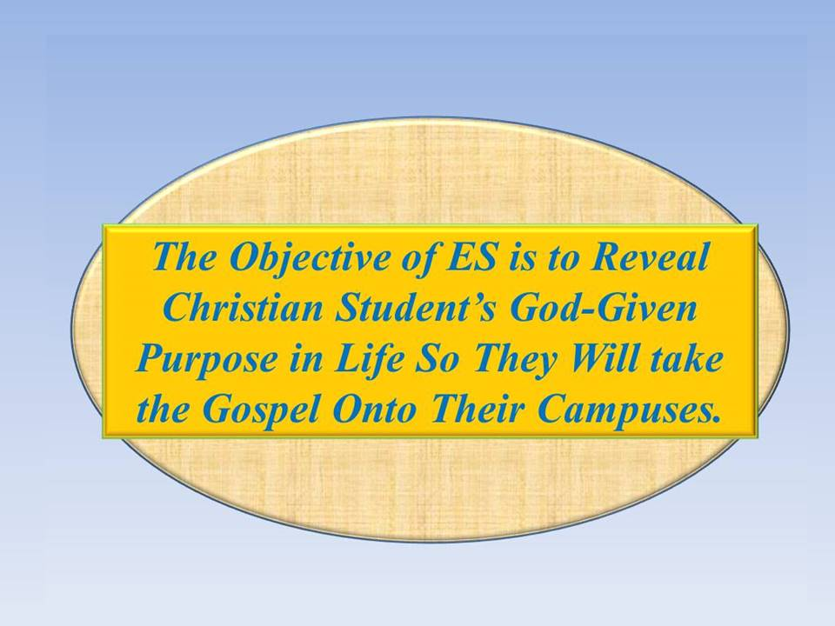Session 6 emphasizes Wise Choices. We all must make choices and our choices chart the course of our future, especially our eternal future!

The adult will serve as the primary teacher for this ES Session. A student assistant will be selected to help as part of their training.

**Opening:**

Freedom is Not Free! Someone paid a high price for our Freedom.

Others have made choices that we might be considerd un-wise but their choices has led to our benefit: We Are Free!

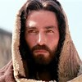The ES group should bow, close their eyes and be silent for a few moments just thinking about what military men of the past have endured (even died) to protect them and provide them with a free country; then allow their minds to focus on what Jesus did to provide us freedom from the penalty of our sins and from the power of sin.

* Being Abandoned
* Being Rejected
* Being Disappointed
* Being Falsy Accused
* Being Abused
* Being Tortured
* Being Executed as a common criminal
* Having the sins of the world (including all of yours) put on Him
* Having The Father Forsake Him

Living in a free country is wonderful but having eternal life with Christ is absolutely amazing!

The teacher will close this part of the ES session in prayer.

**How Are You Doing Spiritually?**

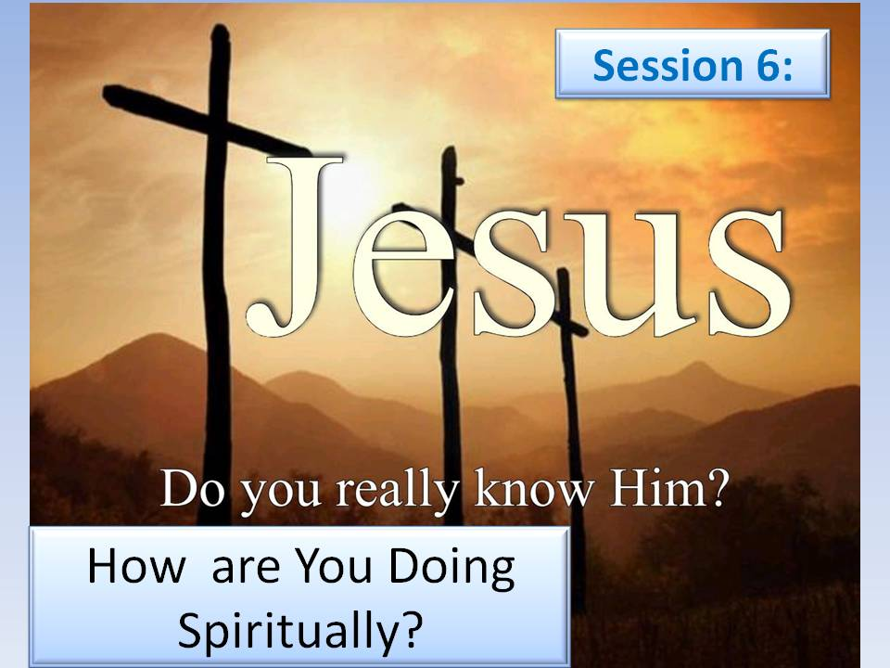The teacher will choose different group members to share how they are doing spiritually.

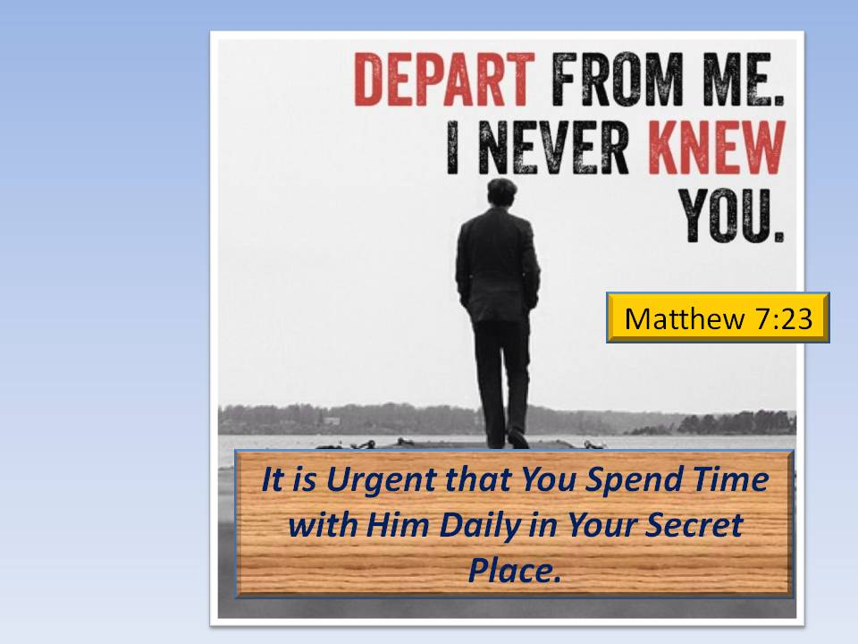By ES session 6, each group member should be accustomed to speaking openly about his or her spiritual walk with Jesus. If there are times of silence, the facilitator should refer to his/her ES manual and prompt the group member being called upon to speak about some of the previous sessions.

Are you and Jesus acquainted? Use your Secret Place to meet with Jesus daily. More important than knowing Jesus is assurance that He knows you. It is urgent that you spend daily time in your secret place in communion with Him (Matthew 7:23).

**Accountability Time:**

The teacher will use this time to call on different students to share about progress they made with their goals during the past week.

1) Share about your offer to have lunch with a student eating alone this past week and how they responded. Are they interested in taking a future ES Course?

2) Share some specific ways you pray for those on your list. How many are now on your list?

3) Briefly share one of your Journal entries.

4) How has adjusting your attitude toward others made you more attractive to students needing friends?

5) Recite Matthew 4:19; ***Follow me, and I will make you fishers of men"***

Q: What does it mean to be a fisher of men? _____________________________________________________________

__________________________________________________________

**Vision Casting:**

The adult teacher will cast vision for the group about the call to be a Visionary Disciple of Christ.

According to the Biblical teaching of Jesus, God the Father loves everyone and wants none to perish but for all to enjoy eternal life with Him. The alternative to eternal life with the Father is eternal death separated from Him in a horrible place called the lake of fire (Rev. 20:14).

All of our student peers are on a path destined for either eternal life with Jesus or eternity away from Him. The plan Jesus has implemented is not to use Angles but to use us to inform our student peers about our eternal destiny and bridge our Story to how they too can have assurance of salvation.

It requires vision on our part to believe that we can be used to rescue them. Such vision is only possible if we succeed in forsaking our selfishness and choose to obey Jesus' commission to go, make disciples, teach them to obey what we have been taught, and do so with the assurance that Jesus is always with us to encourage us and empower us to draw them into the Kingdom with us (Matt.28:18-20).

If His commission seems too much for us, that is where our choice to be a visionary kicks in. Remember that you can do all things through Christ who strengthens you.

Where there is no Vision, the people perish (Proverbs 29:18)



# NOTES:

# C:\Personal Stuff\Church\Discipleship\Lost Sheep Ministries\ES\ES - Eight Student Sessions\ES - Session 6 - Wise Choices - JPG\Slide12.JPGBrief Discipleship Lesson - Wise Choices:

Whenever students are faced with an opportunity, an invitation, or desire, they will typically pose the question, is there anything wrong with this? Their assumption is that if something is not wrong, then it must be right. If they have never heard a sermon against it, do not know any Bible verses condemning it, or see that other Christians are involved, their natural tendency is to conclude that it must be OK.

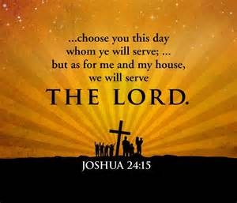Students are inclined to live life on the line. In other words, when they draw a moral boundary line, they tend to live very close to that line. Their behavior stems from their insatiable curiosity about how close they can get to sin without sinning.

* Can I date a non-Christian?
* How far is too far?
* What type of music can I listen to?
* Can I attend parties?
* Is it OK to have a tattoo?
* Is it all right for me to have a beer?
* Which movies are OK for me to see?

Each must realize that their choices affect not only themselves but their close friends as well. We are all accountable for our choices so we can enjoy a free and quality life if we make wise choices rather than foolish ones.

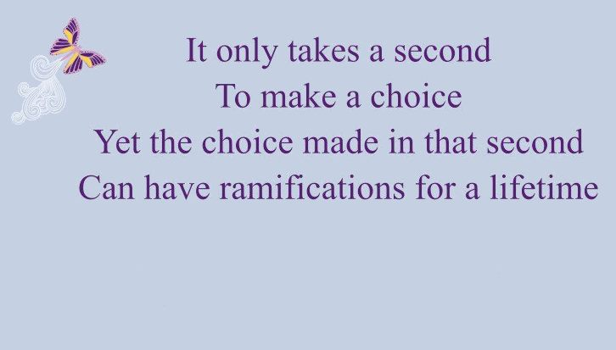We choose how we spend each day. Though others may try to persuade us to follow them, we will choose whom we will follow.

Jesus said, "***Follow Me and I'll made you Fishers of Men***."

In our case, we will follow Jesus and influence fellow students to follow us. We will become leaders for Christ.

**NOTES:**

# Goal Setting:

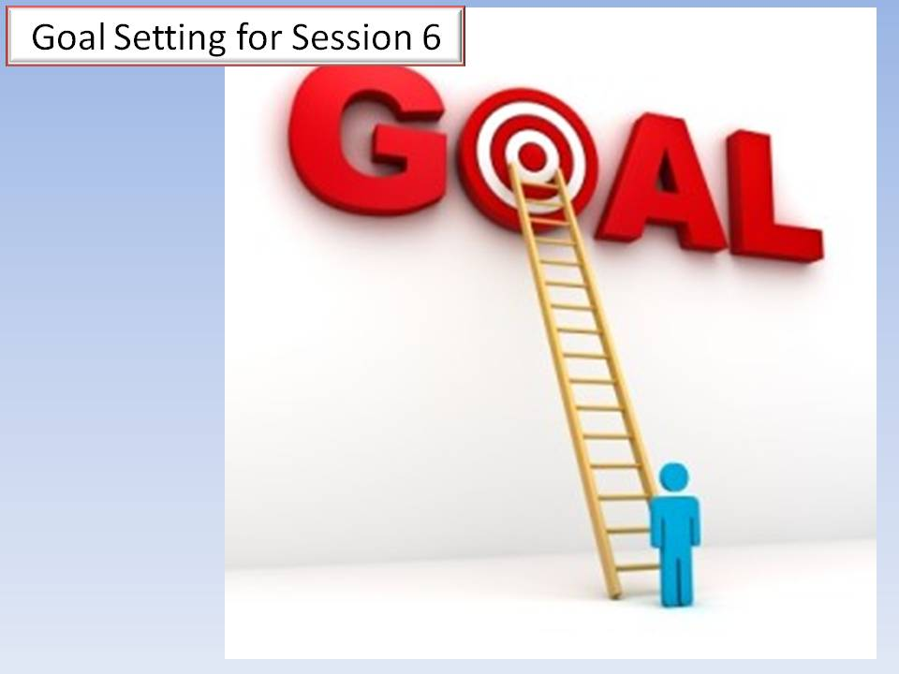The final part of Session 6 is to set goals for next week.

There are seven specific goals to be set following this ES meeting; 1) Boldly assume a leadership role with peer students, 2) Prayerfully review your list of students and circle names with which you will share Your Story; 3) Make some choice changes from foolish to wise; 4) Journal situations you face this week that tempt you to make foolish choices; 5) Pray for the ES Group's vision; 6) Start a list of students interested in joining an ES Discipleship group, and 7) Memorize Proverbs 29:18. ***"Where There Is No Vision, The People Perish"***

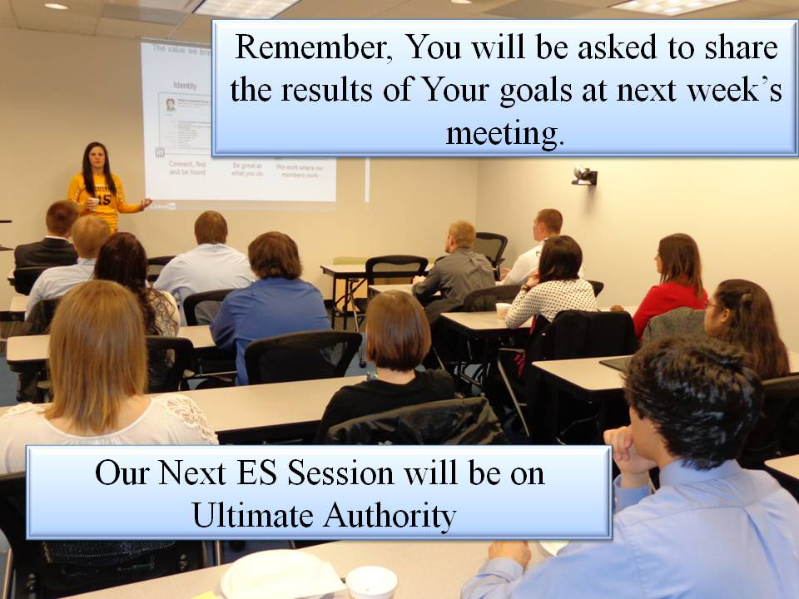

REMEMBER:

Be prepared to account for your goals this week at next week's session.

Bring your ES folder, Journal, and Pen.

Our Discipleship topic next week will be ***Ultimate Authority***.

**DISMISS WITH PRAYER**