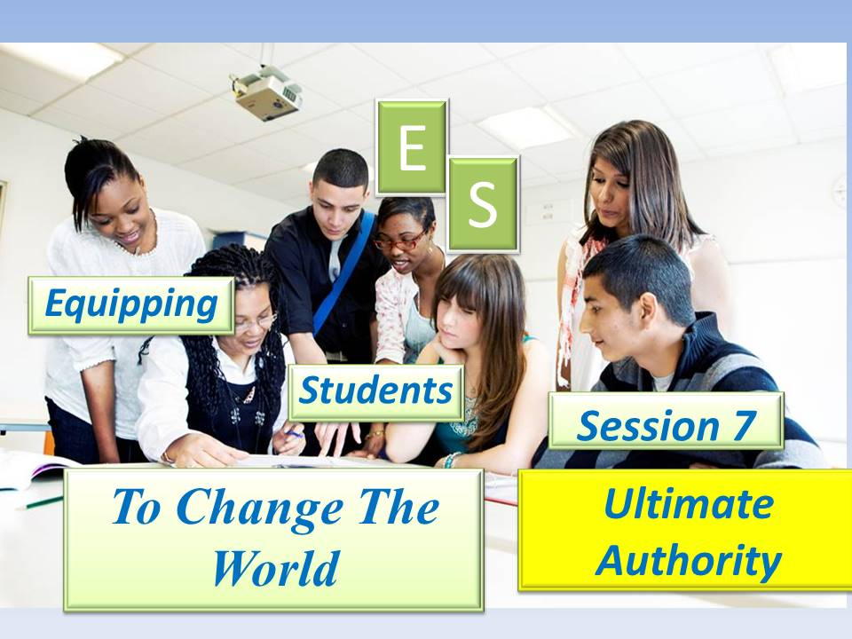

***Student Manual***

***Prepared by: Equipping Central***

*www.equippingstudents.com*

***John Overton***

***January 2017***

**Student Session 7:**

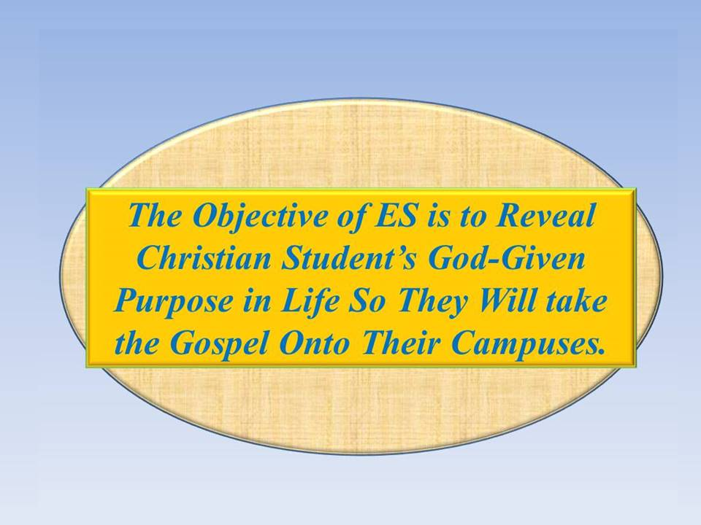Session 7 emphasizes Ultimate Authority. Strange as it seems, our best freedom comes from our obedience to authority. The group members should have a well-established disciplined life of daily Bible study, prayer, and journaling in their secret place by now. The teacher will appoint one of the students to assist with this session.

Opening:

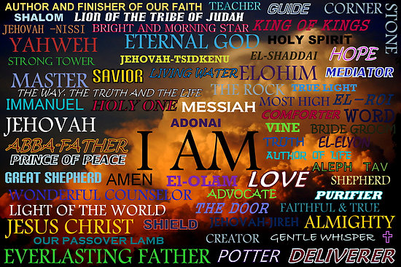During this brief time of meditation, think of the majesty and magnificence of God. As Creator, He owns everything in the universe. Though we address Him as Heavenly Father, the Bible refers to Him with many names. The Hebrew or Jewish name for the One God is Yahwah which translated into English is Jehovah.

The appointed student will close this part of the ES session in prayer.

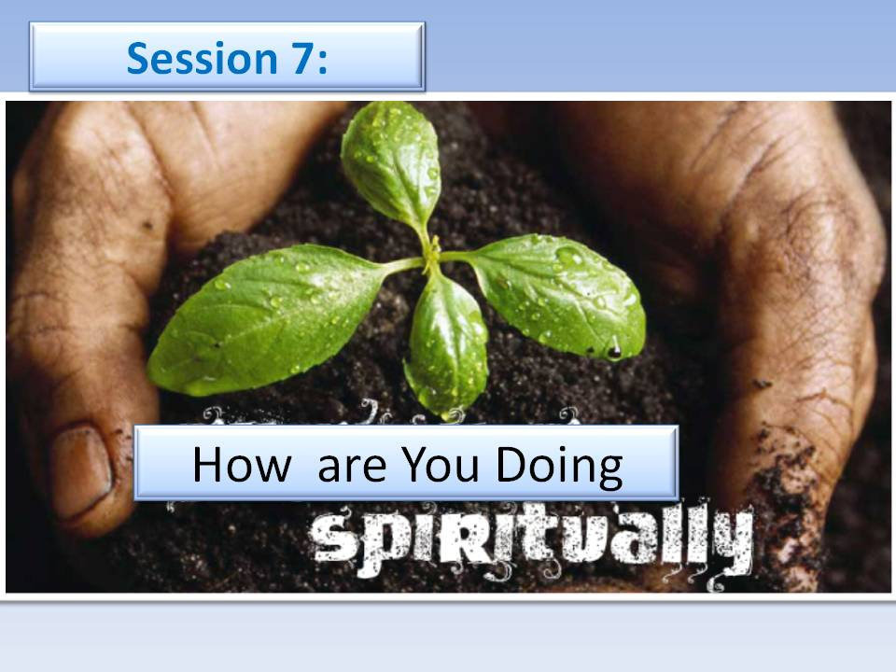

**How Are You Doing Spiritually?**

The teacher will choose group members to share how they are doing spiritually.

Do you believe you are growing spiritually? Explain.

How you believe you can grow more relationally with Jesus.

By ES session 7, each group member should be accustomed to speaking openly about their spiritual walk with Jesus. The teacher may need to prompt the students by asking questions about their daily times with Jesus in their secret place of the state of spirituality in their school.

# Accountability Time:

The teacher will use this time to call on different students to share about progress you made with your goals during the past week.

1) How have you chosen to take leadership with your fellow students?

2) Share how some of the Students on your list have responded to Your Story.

3) Tell the group about your list of students interested in joining an ES Discipleship group.

4) Share about your choice to make a Wise decision rather than a Foolish one.

5) Read or recall from your Journal about a situation where you were tempted to make a foolish decision.

6) How many names of students have you listed that are interested in joining an ES Discipleship class?

7) Recite Proverbs 29:18; (***Where There Is No Vision, The People Perish!)***

***Q.*** How will anyone perish if we fail to be visionary? __________________________________

______________________________________________________________________________

**Vision Casting:**

The teacher will cast vision for the group about being authorized by Christ to continue the work He started. It is awesome to realize that Jesus has delegated His authority to us.

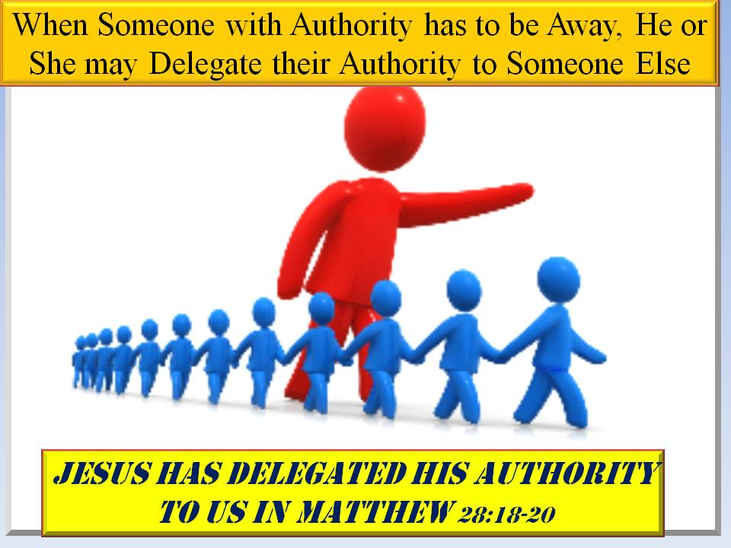If His commission seems too much for us, that is where our authentic faith in His promises must be leaned on. Remember that you can do all things through Christ who strengthens you.

He depended upon some uneducated fishermen, and tax collectors to carry on when He returned to be with our Heavenly Father. Surely, He will be able to depend upon you.

Student leadership is taking responsibility when you are sure you have the authority to do so. Jesus declared, "***All Authority in heaven and earth has been given to me***".

**Brief Discipleship Lesson - Ultimate Authority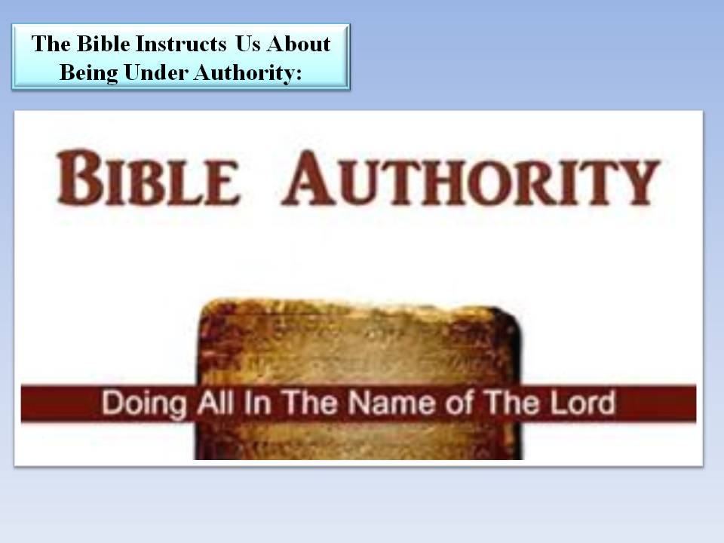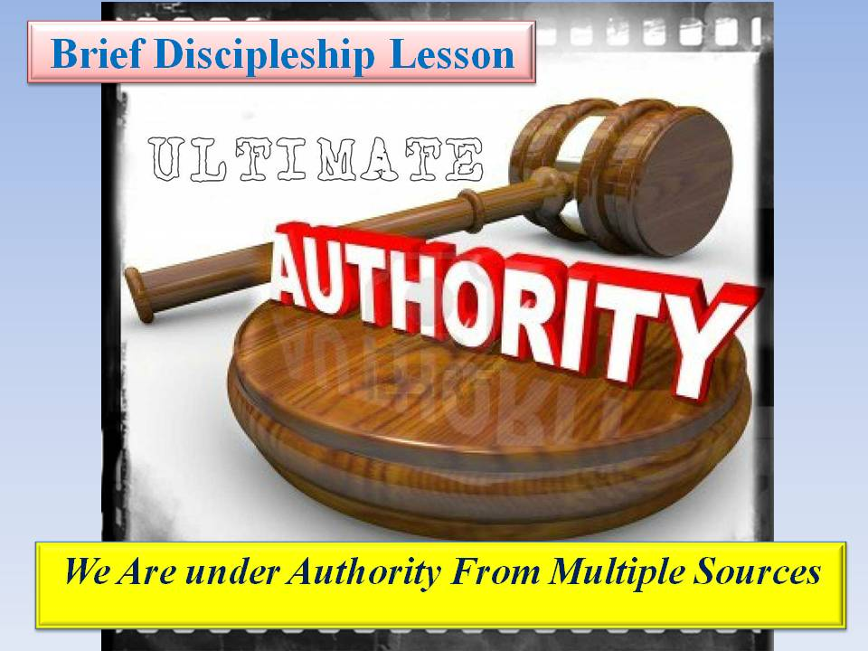:** You advance under stages of authority as you mature. As young children, you are under the authority of your parents or guardians. As you enter school, teachers are added to those having authority over you. If you participate in sports, then you should obey coaches that are in your life to help you become good team players. You really add a lot more who have authority over you once you are licensed to drive an automobile; police, judges and if you violate certain laws and are jailed, you have wardens that must be obeyed.

All of these with authority over you are placed in your life by God to prepare you for His ultimate authority. Jesus declared, "***All authority in Heaven and Earth has been given to Me.***" God has called others to have spiritual authority over you; Pastors, Youth Leaders, spiritual teachers.

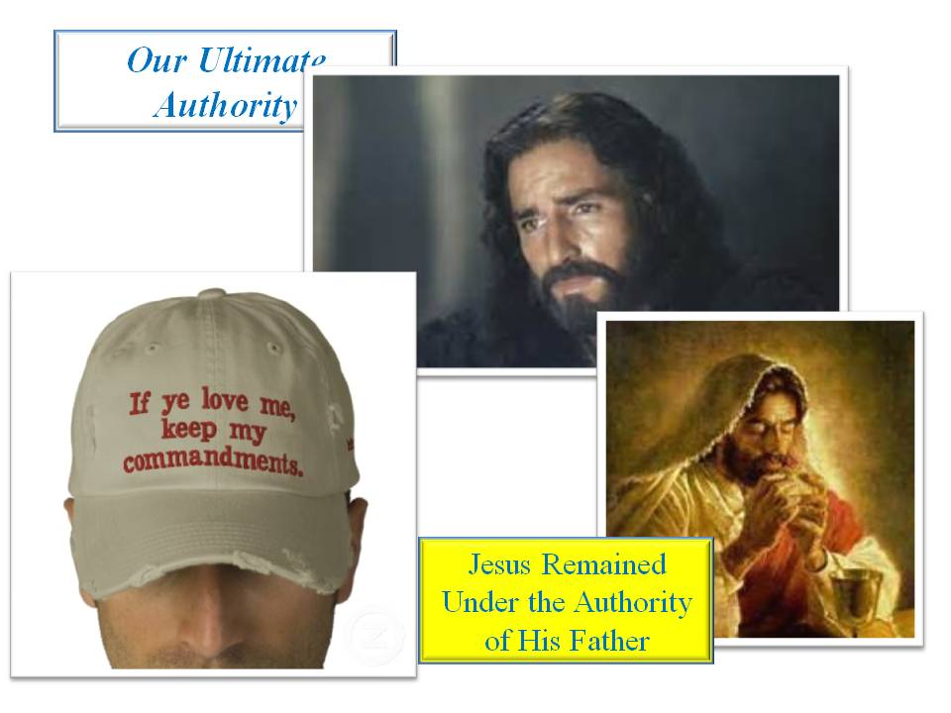If you wish to really enjoy a free life, you will obey those with authority over you. If you fail anywhere along the way, you attempt to chart your course through life alone or independently. This was the initial sin by Eve and Adam. They took forbidden fruit thinking that they would be like God and able to be independent choosers of what they believed to be right and wrong. Like them, you assume an attitude of not wanting anyone to tell you what to do!

You limit your freedom as you reject those with authority over you. If you ultimately end up under a jail warden, you have no freedom at all!

**Q. Why do we resist Authority? ______________________________________**

**________________________________________________________________**

# Goal Setting:

The final part of Session 7 is to set goals for next week.

There are six specific goals to be set following the seventh meeting: 1) Tell one of your teachers that you appreciate him or her; 2) Speak to your parent or guardian about how you are grateful for them; 3) Ask your parent or guardian to go with you to take some cookies to the police station; 4) If you attend church, let your Pastor or Youth Leader know that you love them; 5) As part of your prayers this week, Thank God that you can trust His authority over you, and 5) Memorize Matthew 28:18. ***"All authority in Heaven and Earth has been given to Me."***

**MY Story:** Since I have come into a relationship with Jesus, He has shown me my purpose in life, made me His brother/sister, and given me eternal life.

**Bridge to the Gospel**: I can show you how to know Your Purpose and have Eternal Life!

**The Gospel:** God loves you so much that He will forgive you of your poor choices, make you a child of His, and give you eternal life if you will trust Him (authentic Faith).

**Will you trust Him?**

# Reminder:

You will be asked to share with the group about your goals at next week's meeting.

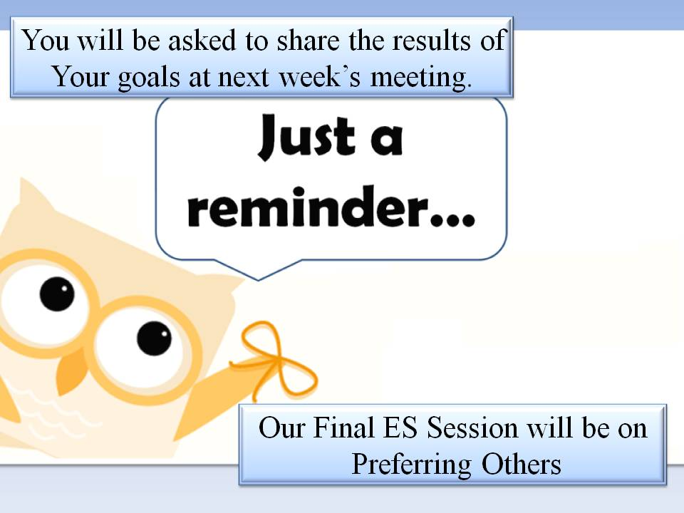

Bring your ES Folder, Journal, and Pen for our final ES Discipleship class, which will be on ***Preferring Others***.

**CLOSE With PRAYER**