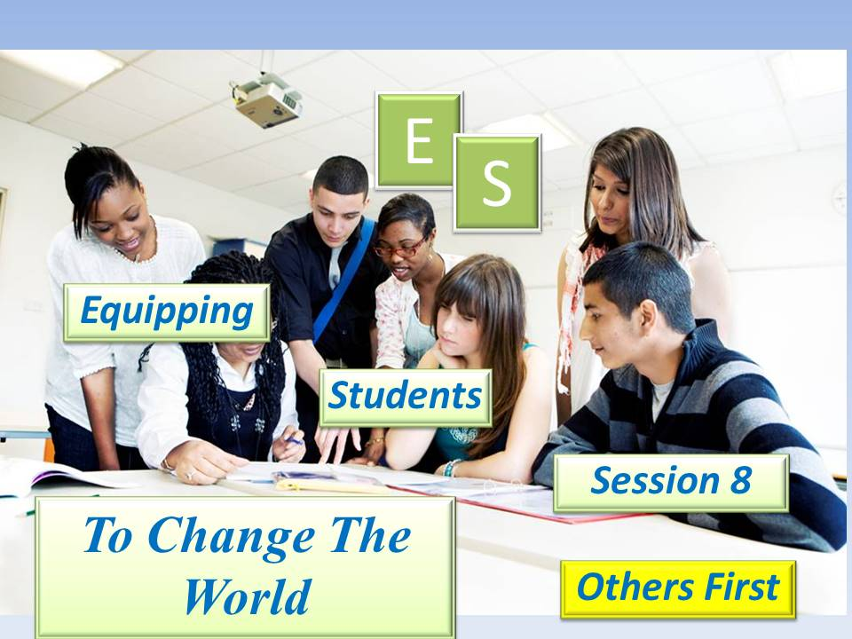

***Student Manual***

***Prepared by: Equipping Central***

*www.equippingstudents.com*

***John Overton***

***January 2017***

# C:\Personal Stuff\Church\Discipleship\Lost Sheep Ministries\EC - Change the World\ES\4. ES - Eight Week Student Sessions\ES - Session 1 - Know Your Purpose - JPG\Slide2.JPGStudent Session 8

Session 8 is our final ES class and our group will be recognized as Disciples of Christ that are fishers of men (students).

Opening:

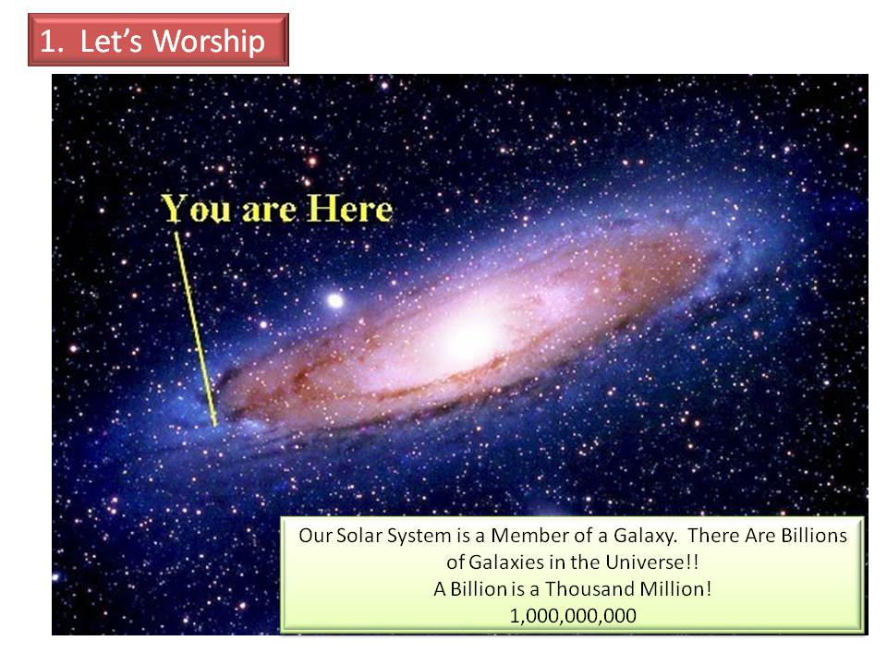During a brief time of meditation, think of the vast expanse of the universe. Our Earth is like a speck of dust floating around in the universe.

You are like a speck of dust floating around on a speck of dust in His universe. You are just one of 7 billion people, yet He loves you supremely!

The teacher will appoint a student to close this part of the ES session in prayer.

Q: Why do you think that God loved us while we were still self-centered sinners? ________________________________________________________________

**How Are You Doing Spiritually?**

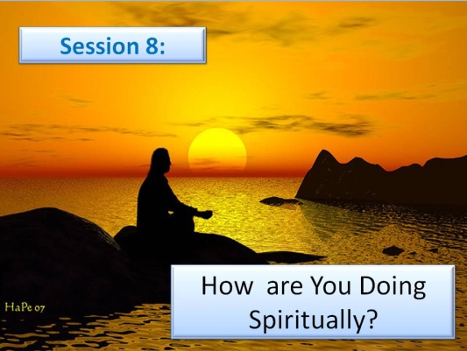The teacher will choose group members to tell how they are doing spiritually.

Speak openly about your spiritual relationship with Jesus. Considering God's majesty and your finiteness, what is your attitude toward Him?

The group members will be guided to discuss the spiritual state of their schools and how they are affected by it.

Based on your observations, will your school be better or worse for the next generation?

# Accountability Time:

The teacher will use this time to call on different students to share about progress they made with their goals during the past week.

1) How did the teacher respond to your expression of appreciation?

2) Tell the group about your parent's or guardian's reaction to your expression of gratefulness for them. How will you continue showing your gratitude to them?

3) Explain the process you went through to take cookies to the police station. How did those on duty respond? If you recognize the Police Officers you met at the station, how will you react to them in the future?

4) Share how you went about telling your spiritual leaders that you love and appreciate them. How did they respond? How do you plan to please them by serving in your school?

5) How do you feel now that you have thanked God for His protective Authority over you?

6) Recite Matthew 28:18; (Jesus said, "***All Authority in Heaven and Earth Has Been Given to Me").***

**Vision Casting:**

The teacher will cast vision for the group about rewards waiting on you in heaven.

A popular song declares that we can only imagine what heaven is going to be like (***I Can Only Imagine*** by MercyMe).

The deeds you perform in His name will accumulate rewards to be enjoyed for eternity. That is a very long time!

"***Behold, I am coming soon! My reward is with me, and I will give to everyone according to what he has done. I am the Alpha and the Omega, the First and the last, the Beginning and the End***." (Revelation 22:12-13)

Our natural inclination is to store up treasure here on earth but the Bible instructs us to be wise and store up treasure in heaven where it is eternally protected.

# Brief Discipleship Lesson - Others First:

To prefer others to yourself is counter-cultural. We not only have a selfish nature but our culture encourages selfishness. Jesus told us that He did not come to be served but to be a servant.

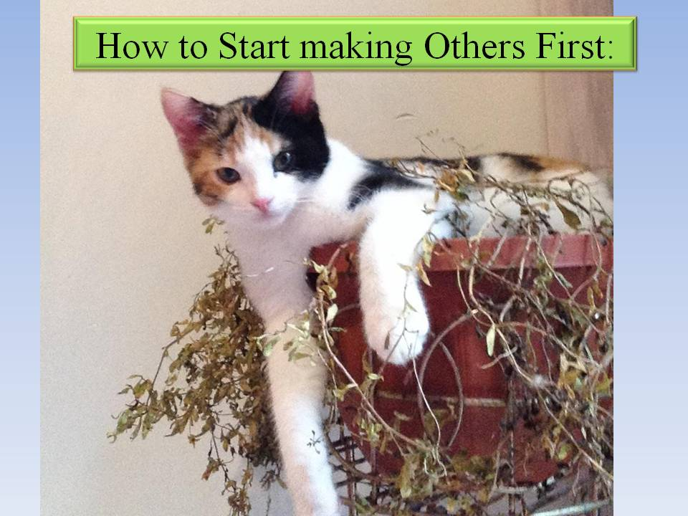He also instructed us to follow Him.

You start preferring others first by listening, remembering, asking, and praying.

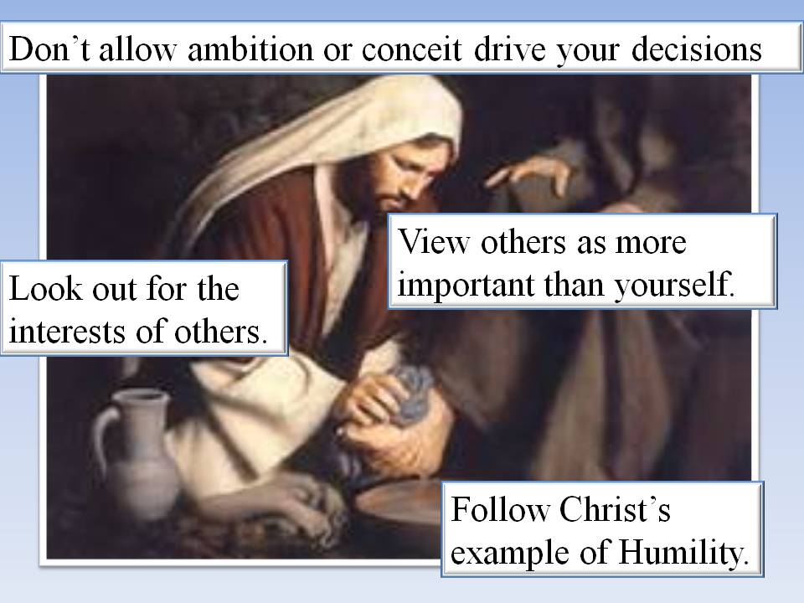

Q: Why did Jesus instruct us to put others first? __________________________

_______________________________

_______________________________

**Goal Setting:**

The final part of Session 8 is to set goals for next week.

There are six specific goals to be set following the last ES meeting: 1) Let others go ahead of you at lunch, 2) Offer to help a classmate with a tough assignment, 3) Invite another student to sit with you at lunch, 4) Volunteer to help a teacher, 5) Pay special attention to a non-ES student. Listen to what they want to talk about. Pray for them, and 6) Memorize Romans 5:8. "***God demonstrates His love for us in this: While we were still sinners, Christ died for us".***

# Congratulations:

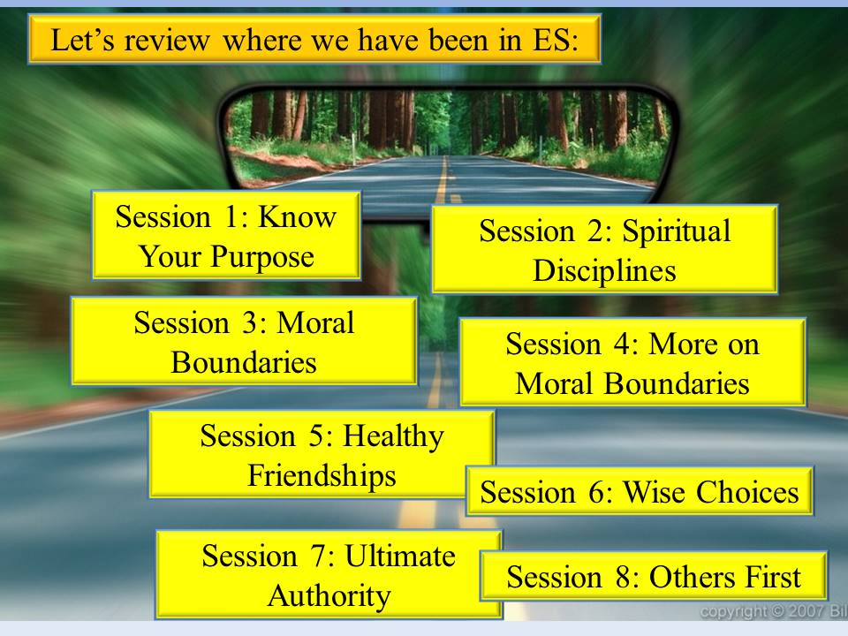You are now a Disciple of Christ equipped to be a fisher of men (fellow students). He has commissioned you to take the good news (Gospel) to all parts of the world starting in your school and then unto the farthest parts of the world.

You can do what God has called and equipped you to do.

Continue sharing your story with fellow students and refer those interested in joining an ES Discipleship group to your adult teacher. Be sure you provide a way to contact them (i.e. phone, email, etc.)

Continue to practice the daily disciplines of Bible study, prayer, and journaling in your secret place.

Remember, He never leaves you. He awaits you daily in your secret place.

528