Covenant Community Services, Inc.
PO Box 21545
Denver CO 80221
303 552-9027 – voice / fax
gail@ccs-denver.com

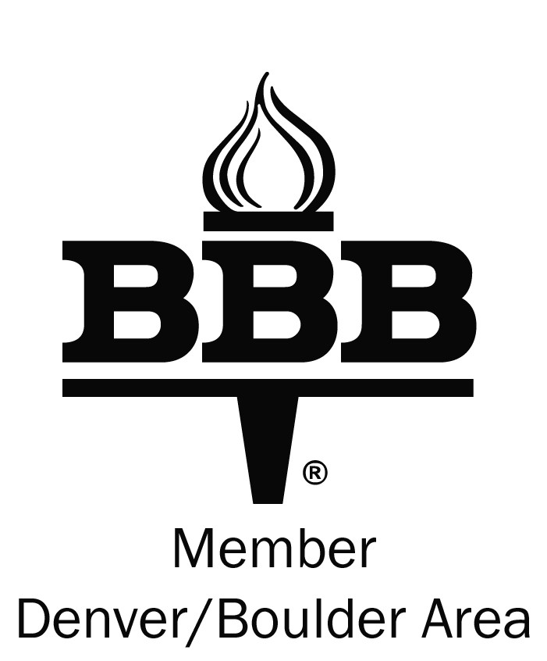

To increase safety in your community, CCS offers a voluntary program in which CCS notifies the resident in the case of an open garage door, or any other highly suspicious activity at the residence.
Information will remain confidential.

Please tear along dotted line
-----------------------------------------------------------------------
I voluntarily request that CCS notify me, regardless of time, if garage door is found open, or any other highly suspicious activity occurs at my residence. I understand that this information will remain confidential.

Crestmoor Park - Filing #2

Resident Name: ______________________________________________

Address: ____________________________________________________

Home phone #: ____________________ Cell #:___________________

Work phone #: ____________________ E-Mail: ___________________

Please fax to CCS at 303 552-9027
Or e-mail to gail@ccs-denver.com

