Organization Name: ___________________________________________________ County: ____________________
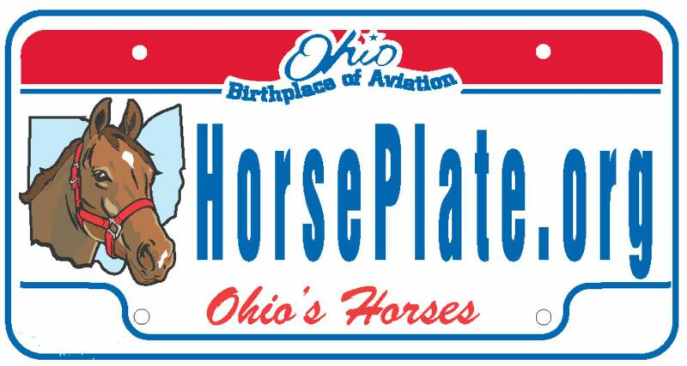
The Ohio Coalition for Animals
Grant Application
The Ohio Coalition for Animals awards grants to Ohio nonprofit organizations for the care of unwanted or neglected horses. Applications must be received via email each year between December 1 and December 31.
Name of Individual/Organization:
Incorporation Date (if applicable): EIN (if applicable):
Mailing Address:
City/State/Zip Code:
Web address:
Email Address of Organization:
Name of Contact Person:
Email of Contact Person:
Phone # of Contact Person: Other phone # for Organization:

Organization Mission:

Organization Activities & Programs:

How does your organization promote the horse plate?

For the past full year for which you have records, indicate months/years used to compute:
___________ to __________.

Employees: Full time _____ Part time _____ Volunteers _____ Total annual salaries: ___________
Income for Past Full Year: __________ Expenses for Past Full Year: ___________
Number of Acres: _____ Number of Stalls: _____ Total Capacity: _____
Approximate # of horses presently in your care: ______
Number of horses coming into your care in past full year: _____
Number of horses adopted from you in past full year: ______
Number of horses presently available for adoption: _____
Number of horses in rehabilitation to be eventually adopted: _____
Number of horses in permanent sanctuary care: _____
Number of horses in foster care: _____
Number of horses euthanized in past full year: ______ (this information is confidential and for needs assessment only)
Who owns the property used for the horses?
If the property is not owned by the applicant, is it rented/leased by the month or by the year?
Explain if necessary.

Brief description of policy on breeding:

Brief description of adoption policy:

Name of primary veterinarian: Phone of primary veterinarian:
Name of primary farrier: Phone of primary farrier:
Other references:
Name: Title/Relationship: Phone:
Name: Title/Relationship: Phone:

Required attachments:
1. Most recent 990, if filed. If no 990, most recent annual income/expense report.
2. List of grants received last year.
3. Name, email & phone # of all board members.
4. Adoption application & contract, if applicable.
5. IRS letter of determination of nonprofit status, if applying as a 501 organization.

Brief description of how you would use a grant (include amount of money needed for each aspect of the project):

By submitting this application, the signer attests that this information is true to the best of their knowledge, and agrees that the organization’s name and any other pertinent information may be used by the Ohio Coalition for Animals in promoting the horse license plate to the public and to increase interest in the mission of the Ohio Coalition for Animals.

Authorized Signature: _____________________________________ Date signed: ____________________

Applications must be received between December 1 and December 31 each year at ohioshorses@gmail.com

