**Bring health to children sick from contaminated water and poor sanitation through waterwell drilling - a healthy beginning**

Today, You gentle peoples of Uganda, we are commissioning clean drinking water and basic sanitation are critical to life to this region. Without clean water, families walk miles for water that makes them sick, spend their income on medication, and struggle to send their children to school. The global water crisis impacts 785 million people—[1 in 10](https://washdata.org/data/household#!) people—on the planet today. Plus, [1 in 4](https://washdata.org/data/household#!) lack access to a toilet, a critical element to overall health.

**The good news:** This is entirely preventable. We can end the crisis in our lifetime.

Each well provides for 75 families (~300 people) to have 10 gallons of fresh water per day. I completely work with volunteers and religious organizations to fund these projects. This provides for the basic drinking, cooking and cleaning water for each family.

**7 million Ugandans lack access to safe water** and 28 million do not have access to improved sanitation facilities. Further, due to disparities in water access in Uganda, urban people living in poverty pay as much as 22 percent of their income to access water from water vendors.

Our efforts change the lives of these rural peoples where the lack of infrastructure by local governments do not provide for safe water. They rely on gathering water from standing water sources or polluted rivers and streams for their basic needs.

[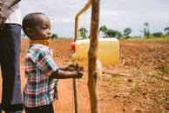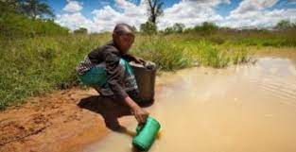](https://www.google.com/search?q=uganda+water+crisis&client=firefox-b-1-d&sxsrf=AOaemvKeaJ4XFTBf3ek6sKsnQcP-v8W9zA:1638878109140&tbm=isch&source=iu&ictx=1&fir=YVqD4yymojBtLM%252CM4d8mIwrlHxWSM%252C_%253BcFf8ayA6X-Hy5M%252ChfXtMtlzhCo0nM%252C_%253B7hCoze-BQb3p4M%252CM4d8mIwrlHxWSM%252C_%253Bvxys2S-b-OTFuM%252C6atacnVpm8VcdM%252C_%253BK5qCRJURoEqdhM%252C6atacnVpm8VcdM%252C_%253BncC_3qyOiw4EnM%252C6atacnVpm8VcdM%252C_&vet=1&usg=AI4_-kSCwI4OPYbOhO_FdyceaE-r7k1-2w&sa=X&ved=2ahUKEwiP1Znc0NH0AhV9HjQIHXUNA2oQ_h16BAgLEAE" \l "imgrc=YVqD4yymojBtLM)

[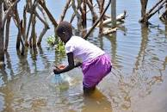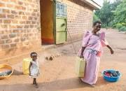](https://www.google.com/search?q=uganda+water+crisis&client=firefox-b-1-d&sxsrf=AOaemvKeaJ4XFTBf3ek6sKsnQcP-v8W9zA:1638878109140&tbm=isch&source=iu&ictx=1&fir=YVqD4yymojBtLM%252CM4d8mIwrlHxWSM%252C_%253BcFf8ayA6X-Hy5M%252ChfXtMtlzhCo0nM%252C_%253B7hCoze-BQb3p4M%252CM4d8mIwrlHxWSM%252C_%253Bvxys2S-b-OTFuM%252C6atacnVpm8VcdM%252C_%253BK5qCRJURoEqdhM%252C6atacnVpm8VcdM%252C_%253BncC_3qyOiw4EnM%252C6atacnVpm8VcdM%252C_&vet=1&usg=AI4_-kSCwI4OPYbOhO_FdyceaE-r7k1-2w&sa=X&ved=2ahUKEwiP1Znc0NH0AhV9HjQIHXUNA2oQ_h16BAgYEAE" \l "imgrc=cFf8ayA6X-Hy5M)

But, we can make a difference and today, we are commissioning the first of several wells to be installed in Uganda.  
We're working within local parishes and their schools and communities to install hand-pumps for clean water and introduce greater sanitation, two of the best ways to give kids better health and a better life. We (Bruce Newnan and a small group of friends) have come together to help in this crisis. 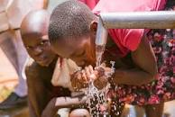

This year we built 6 wells (1 in Congo, 5 in Uganda) and are building a medical facility in the Congo.

These projects are just the start to provide clean water to local communities without going through the higher more corrupt funding mechanisms on on-line giving. Our direct foundation to Parish priest organization is establishing a funding mechanism whereby the flow of US$ to regions of the Congo and Uganda can be done without the politicians and corruption to siphon off much of the funds for identified projects.

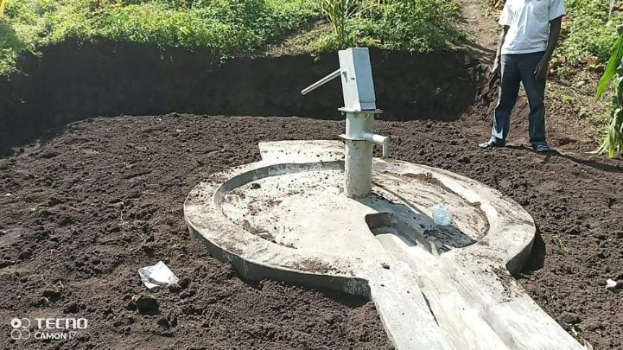

Water Well in Uganda very similar to one in Congo with Manual pump. We have already sent sufficient matching funds for another 5 wells in Uganda. If matched by the donations of my friends in the USA and UK, then the well will begin in mid 2022.

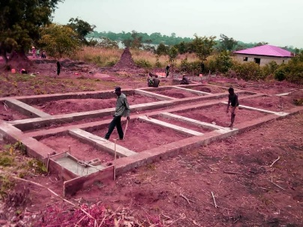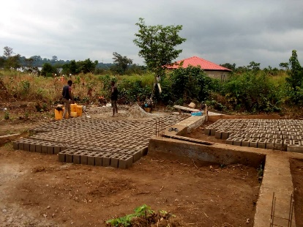

Phase 1 of 2000SF medical Facility foundation.

Walls are going up now!

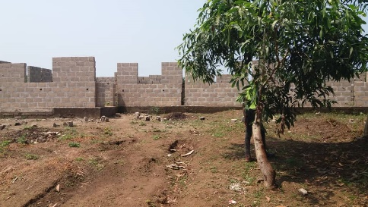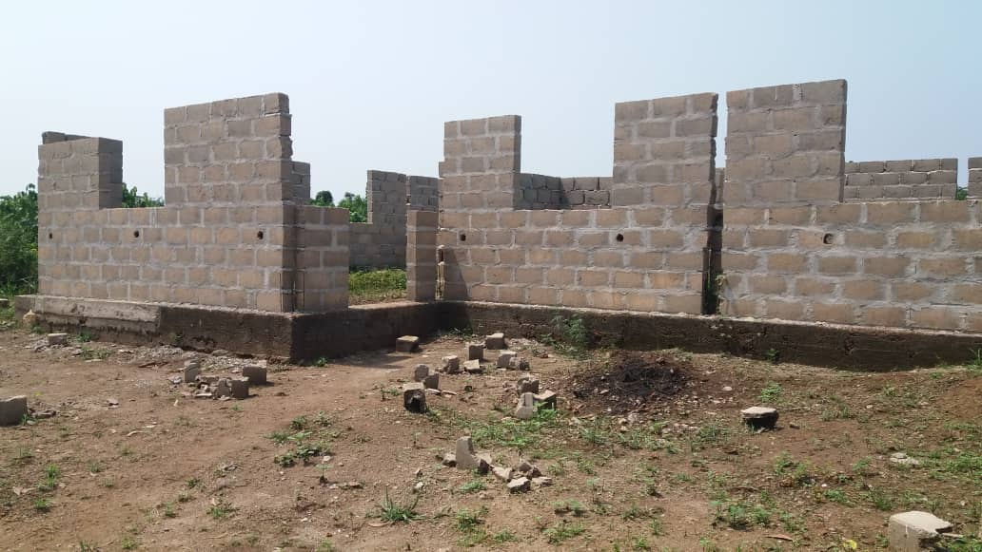

The Roof, Ceilings and inside walls are under construction in Early 2022 so that the Medical Facility building in the Congo can be completed. With your help we can go operational in early 2023 with nursing staff and visiting Doctors.

We have a long way to go but this can get done.

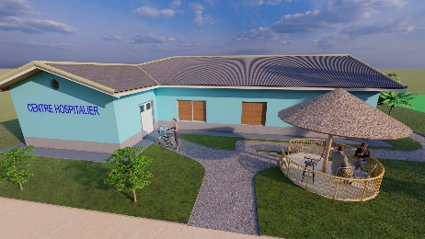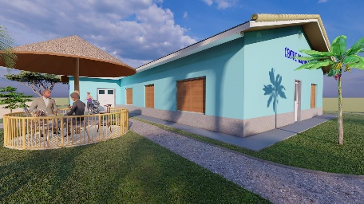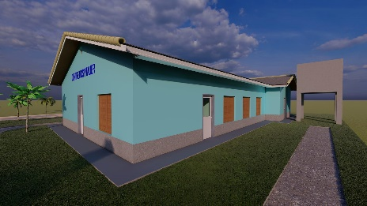

My heart go out to you the Uganda People. My hope that with clean water and closer medical facilities the lives of Thousands of Ugandans can live a productive and joyful life for the future.

I want to support the good people of this parish who supplied and carried out the gather of materials built locally and the manual delivery by many of you 1-2 blocks at a time to the site. I want to thank Fr. Jude and other religious that support the remote communities for the support his parish has provided and I hope to come out this next year to see the completion of our Well project.

My prayers and blessings go to the Peoples of Uganda and to the work of Fr. Jude.

May the wells provide new hope and peace to you – My peoples of Uganda.

Bruce Newnan Founder and CEO of Rural Clean Water Solutions, Inc a 501(C) 3 organization promoting the providing of safe water to rural communities.