**Viewing the Larger Picture**

**Clean water** is one of the most desperate needs of the poor in communities all around the world. A lack of usable water often means disease, hunger and suffering. Dirty rivers and streams are contaminated with unseen parasites or bacteria.

It was a terrible cycle. Unclean water was causing poor health and endless maladies. Illness left family members weak and unable to work or attend school. It made even simple chores difficult. Familes aren’t able to address the root cause of their problems. Local governments at the lowest level are usually either don’t have the resources to respond to the community need to provide village level infrastructure. Large governmental organizations are often ran by professional politicians who often work more for themselves than for their people they represent so that large non-profits are plagued by large administrative costs. Rural Safe Water solutions (RSW) work with Christian organizations to local need and flow moneys directly to local projects rather than send it to bureaucracies. Checks and balances are put in place to ensure projects get completed and commissioned for public consumption prior to handing over the control to local water councils for the maintenance and upkeep.

Simply put Clean safe water should be the right of all who live in community. RSW is trying 1 well at a time to change this cycle.

Your gifts support the building of wells and support systems at the lowest village level to change their lives. Wells, water filters, purification systems, and support structures make clean water available right in their communities.  As a result, families in the area now have easy-to-obtain safe water. They are no longer battling the illness and other side effects of water-borne diseases. And medical expenses and children’s absences from school have decreased dramatically.

Choose a gift below and bless a child, family or community with the gift of life!

Like so many other families in their village, all were plagued by poor health that interfered with school, work, and even basic household tasks important to survival. One example of RSW is the installation of a well within the school grounds in Uganda. This resource serves over 300 families and the school staff with adequate safe water for drinking, cooking and basic body cleaning. The school was so appreciative they had a celebration in an afternoon at the commissioning of the well including songs, dances and many letters of thanks.

## Safe Water in the Community

“We no longer spend all that time on water collection, so there is enough time to maintain other household chores,” says Nargis.

Hope for the Future

“ Quotes for thank you letters and from the Bishop.

(As for her family, she says, “We will continue to use safe water and live a healthy life by preventing diseases. Our dream is for our children to be able to go to school regularly, and be healthy and safe in the future.”)

From SafeWater.org

The United Nations recognized in 2015 Paris accord that water and sanitation is a basic human right.

https://www.unwater.org/what-we-do/inform-policies/

RSW is a registered United States 501(c )3 charity supporting the water and sanitation to rural areas that do not have the government infrastructure to support these goals. Our goal is to supply at the lowest level the barest essential water resource and basic water management to main the basic needs of clean water. We partner with Crhistian churches and parishes to provide water councils at the village level to identify the need and necessary sustainable support once resources are provided.

RSW is independent from municipal, provincial and federal governments and led by a Board of Directors.

<https://youtu.be/goT2xyX_OuY>

## ****Collecting Water Is Women’s Work****

And I can’t talk about the importance of water without acknowledging that **collecting water is women’s work.**

**Don’t believe me? Think about these facts.**

* **Women and girls shoulder the responsibility of water collection in 8 out of 10 households that access water beyond the home** ([UNICEF](https://www.unicef.org/publications/files/Progress_on_Drinking_Water_Sanitation_and_Hygiene_2017.pdf)).
* **Women and girls around the world collectively spend more than 200 million hours obtaining water for their families *every day*** ([UNICEF](https://www.unicefusa.org/stories/how-long-does-it-take-get-water-aysha-eight-hours-day/30776)). That’s 8.3 million days. 22,800 years. What else could they be doing with that time?
* **Girls under the age of 15 are twice as likely as boys to be responsible for collecting water** ([UN](http://www.un.org/waterforlifedecade/gender.shtml)).

The World Health Organization (WHO) also estimates that [35% of women around the world have suffered physical and/or sexual violence](http://www.who.int/mediacentre/factsheets/fs239/en/). And sending women and girls out to collect water increases their risk of suffering from sexual harassment or assault. Lack of sanitation facilities like toilets forces women to retreat into fields or secluded areas, making them even more vulnerable to sexual violence.

We say that women and children are vulnerable. It’s true. Does that mean that they are weak? Think again. Walking and carrying gallons of water miles and miles a day requires strength, endurance, and determination.

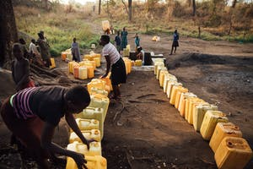

Women in Uganda line up jerry cans by a local water source.

## ****Water Can Be Scarce****

In many of the countries where FH works, water is scarce. And the face of water scarcity is an adult woman, and sometimes a young girl. She carries plastic buckets like the one Virginia used, or a bright yellow jerry can.

When she reaches her water source, she waits in line. If there’s a drought and resources are in high demand, Virginia tells us, neighbors fight for their families to get precious water. If they are lucky, they carry around 40 lbs of water (the weight of the 5 gallons that fit in a plastic bucket or jerry can) back home, continue with the household tasks, and wake up the next day to do it again.

## ****Water Is A Women’s Issue****

Yes, water is about health. [Every day, 1,000 children who aren’t even old enough to go to kindergarten ***die*** because of lack of drinking water, sanitation, and hygiene](https://www.unicef.org/sowc2016/).

But water is also about women–their work, personhood, and safety. What would happen if, instead of losing hours of a day collecting water and fearing for their own safety, the world’s women had the time and energy to attend school, invent solutions, start their own businesses?

**And what if water is what helps that happen?**

When you donate water through FH’s [gift catalog](https://www.fh.org/gift-catalog/?source=WZZZB1ZZZ&utm_source=carrie031618waterpost&utm_campaign=blog&utm_medium=blog), you help people who have already identified a lack of clean water as a big issue in their community. Donating a [water purification system](https://www.fh.org/product/water-purification-system), [water filter](https://www.fh.org/product/water-filter), or [water well](https://www.fh.org/product/community-well) lets you join a community in achieving justice for their children and women.

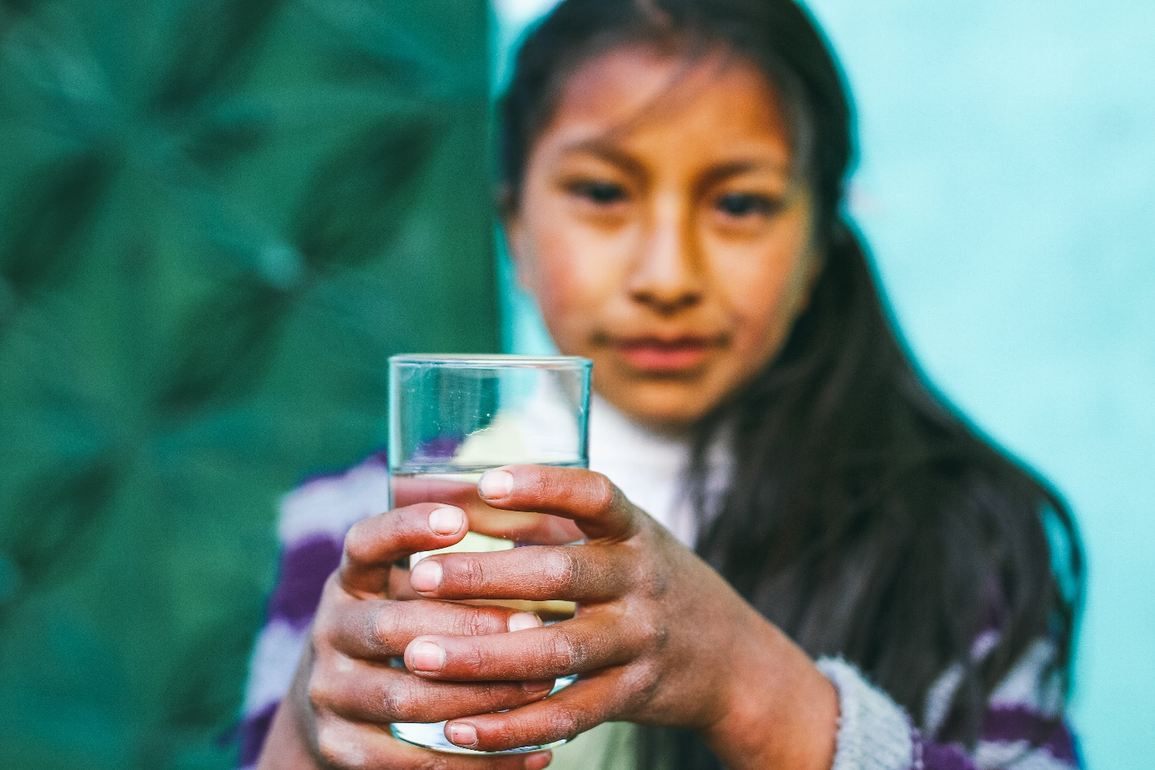

Girls in Chunchuymarca, Peru, once walked 20 kilometers to access water. Through FH, the community now has access to clean water.