California newspapers, February 7 - May 2, 1968
Keyword search of every paper in the California Digital Newspaper Collection for 1968 Mustang 8R01C142219
Prepared 27 October 2026. Replaces the Contra Costa Times-only edition. Images are captures of the archived page scans; yellow boxes are the archive's search highlights, not part of the original pages.

Scope and method
Your keywords were searched across every newspaper in the California Digital Newspaper Collection (CDNC) for February 7 to May 2, 1968: from the earliest known Rainbow ad to the day your car was sold. Relevant hits came from more than 20 papers, from Red Bluff to Los Angeles. Each possibly relevant hit was read, and every ad or article bearing on your car, its dealer or the Rainbow promotion was captured from the page scan.
No duplicates. When the same ad or article ran on several days or in several papers, it appears here once, with one image and a combined list of every appearance and its dealer. The earlier Contra Costa Times exhibits are kept, merged with their Concord Transcript and other-paper duplicates, and renumbered.
Limits. The computer-read text misses words, so a zero result is not proof of absence. The Concord Transcript, your dealer's home paper, is online only from March 1, 1968, so the Rainbow launch week (February 13-22) cannot be checked there.

Key findings
- The Rainbow promotion was advertised all over the West. Ford's two co-op ads ran on February 13-22 in at least 18 papers, signed by about 16 dealers from Red Bluff to Arroyo Grande (A1, A2). Dealer ads ran into March in Napa, Folsom, Hanford, Los Angeles, Ventura, Santa Rosa and Petaluma (A3-A11), and Rett-White sold "Rainbow Specials" in your county until April 18 (A12).
- Rainbow cars were sold as "special paint." One co-op ad promises "Save on special paint, only $13.90" (A2), Barber Ford captions each Rainbow car "Rainbow Paint" (A9), and a Hanford dealer lists a Mustang as "Special Paint" (A7). Your Marti report's "Special Paint" entry is what a Rainbow car would be expected to show, though special paint alone does not prove Rainbow.
- A dealer-listed Rainbow gold close to your car. Barber Ford, Ventura (March 1), listed a Rainbow "Candy apple gold" hardtop with a 289 V8, Cruisomatic and power steering, and a Rainbow hardtop with a black vinyl roof (A9). Rainbow cars ranged from 6-cylinder manual cars (A10) to optioned V8s, so your car's equipment fits the range.
- The hobby-list color names never appear. Spanish Gold, Black Hills Gold, Madagascar Orange, Dandelion Yellow, Beatnik Blue, Poppy Green, Razzle-Dazzle Yellow and Yummy Yellow return nothing in any paper; Spanish Gold hits are all carpets and treasure. The only 1968 Rainbow color names found are Barber's. A paint-code match is stronger evidence than a color name.
- Still no Rainbow ad from your dealer. No Earl Williams Ford or Concord Ford ad in any paper mentions Rainbow, special colors or special paint. But your dealer did run Ford's co-op ads for the Mustang Sprint and the West-only GT/CS under the Earl Williams name (B5, C2), and its home paper's launch-week issues are not online.
- Your dealer is confirmed as a San Jose district dealer. On April 9 Ford's San Jose district sales manager honored four Earl Williams Ford salesmen (B9), matching the DSO 72 (San Jose) on your car's record.
- Three names in spring 1968. The store's own ads switched to "Concord Ford" between February 23 and 29 (B1, B2), Ford's co-op ads and a March 7 city notice still said Earl Williams Ford (B4, B5), and a directory listing already read "SunValley Ford" on April 1-3 (B8), about six weeks earlier than the mid-May date in the earlier reports.
- People-leads. Staff while your car was in stock: Vaughn and Rawley Grable, Emery Erdy, Chuck Hillery, Ken Boyars, Don Head, Walt Madeiros, Dick Sargent, Ron Bradshaw, Lou Burmester (advertising himself on May 2, B12), Hugh Gildea (from April 17), J.P. "Jonesy" Jones (April 25), Dick Palmer and Robert Cope.
- A gold caution. Sunlit Gold, a regular 1968 Ford color, was sold on Mustangs locally (C3). Include it in the paint comparison alongside WT3822.

Keyword results, all papers
Hit counts are the number of newspaper pages matching each keyword across all CDNC papers, February 7 - May 2, 1968. Phrases in quotation marks were searched as exact phrases.
Keyword | Hits | What was found | Relevant?
"Rainbow Sale" | 6 | Ford co-op ads (Madera, Mill Valley, Auburn, Tracy) and City Ford, Highland Park. | Yes (A2, A8)
"Mustang Rainbow" | 8 | Co-op ads and dealer ads; Lafayette Ford in the Contra Costa Times. | Yes (A1, A2, A4, A8)
"Rainbow Mustang" | 0 | OCR splits it; the Bob West "Rainbow Mustang values" ad was found through "Rainbow." | See A6
"Rainbow colors" | 33 | Ford's large co-op ad in 7 papers ("10 special Western Rainbow colors"); the rest are clothing and household goods. | Yes (A1)
"Rainbow Specials" / "Rainbow Special" | 1 / 2 | Sanderson's Ford, Petaluma; Rett-White, Contra Costa Times. | Yes (A11, A12)
"Rainbow paint" | 1 | R.E. Barber Ford, Ventura. | Yes (A9)
"Rainbow of Colors" | 49 | Clothing, fabric and household ads in 13 papers; none found to be automotive. | No
"Special Rainbow Colors", "Rainbow Series", "Rainbow Roundup", "Special Rainbow Finish", "Rainbow Mustang Sale" | 0 | No hits. | No
"10 special colors" / "special colors" | 17 / 20 | Ford co-op ads in 16 papers, Lafayette Ford, and a St. Helena dealer. | Yes (A1-A4)
"500 only" | 46 | Ford co-op ads; the rest are unrelated sales. | Yes (A1, A2)
"special paint" | 43 | Maury Brennan Ford ($13.90), Bob Greene ("Special Paint" fastback), Barber Ford; other hits are house paint and unrelated. | Yes (A2, A7, A9)
"Candy apple gold" | 1 | Barber Ford's Rainbow Paint hardtop. | Yes (A9)
"Sunlit Gold" | 5 | Curt Carter Mustang (CCT and Concord Transcript), LTD (Ventura x2), Falcon (San Bernardino). | Yes (C3)
"Spanish Gold" | 25 | Carpets, furniture and sunken-treasure stories; none found to be automotive. | No
"Black Hills Gold", "Madagascar Orange", "Dandelion Yellow", "Beatnik Blue", "Poppy Green", "Razzle-Dazzle Yellow", "Yummy Yellow", "Color of the Month" | 0 | No hits for any of these. | No
"Whipped Cream", "Hot Pink", "Olive Green", "Swiss Chocolate", "Orange Ice", "Sierra Blue" | 345, 283, 180, 30, 8, 1 | Food, clothing, carpets, houses; none automotive. | No
"Earl Williams" / "Earl Williams Ford" | 27 / 14 | Your dealer in the Contra Costa Times and Concord Transcript; hits in other papers are other people of that name. | Yes (B1, B4, B5, B9)
"2395 Willow Pass" | 23 | Concord Ford and Earl Williams Ford ads in both Contra Costa papers. | Yes (B5-B13)
"Concord Ford" | 76 | Concord Ford ads and listings in both papers, Feb 29 onward. | Yes (B2-B13)
"Sun Valley Ford" / "SunValley Ford" | 0 / 3 | Directory listing, Concord Transcript Apr 1-3. | Yes (B8)
"Vaughn Grable" | 9 | Concord Ford staff lists in both papers. | Yes (B7, B10, B11)
"special finish", "limited edition", "spring colors", "flower color" | 11, 36, 497, 14 | Furniture, collectibles, clothing; one Napa "Limited Edition Mustangs" ad (A3). | A3 only
"Mustang" / "Mustangs" | 3,158 / 714 | Mostly classifieds, school teams and guitars. Searched together with the terms above to find the exhibits. | Yes (exhibits)

Contra Costa Times only (from the earlier edition)
The earlier edition's Contra Costa Times counts stand: "Rainbow" 82 pages (7 relevant), "Concord Ford" 32, "Earl Williams" 4, "2395 Willow Pass" 6, "Mustang" 206. Its exhibits are all included here.

Part A. The Rainbow promotion

Exhibit A1. Ford's large "Mustang Rainbow Sale - On now!" co-op ad
February 14-21, 1968 (seven appearances in seven papers) | Relevance: Direct: the promotion itself
Page links: CCT Feb 15 p. 13; Oakland Tribune Feb 14 p. 46; Los Gatos Times Feb 14 p. 12; Santa Cruz Sentinel Feb 15 p. 5; Roseville Press-Tribune Feb 15 p. 5; Napa Valley Register Feb 15 p. 16; Petaluma Argus-Courier Feb 21 p. 13
- What it says. "Mustang Rainbow Sale. On now! Limited-edition Mustangs in 10 special colors. And only for the West!" The body copy reads: "500 only, and only in the West ... in 10 special Western Rainbow colors. Hardtops, fastbacks, convertibles. Limited-time event." The first image is the Contra Costa Times copy; the second is the foot of the Oakland Tribune copy, which names no dealer and says only "See your Ford Dealer now."
- Every appearance found (one ad, shown once). Oakland Tribune Feb 14 (unsigned); Los Gatos Times Feb 14, signed Paul Swanson Ford, Los Gatos; Contra Costa Times Feb 15, signed Rett-White Ford (Walnut Creek) and Lafayette Ford; Santa Cruz Sentinel Feb 15, Al Cheney Ford; Roseville Press-Tribune Feb 15, Starr Ford; Napa Valley Register Feb 15, Sullivan Ford; Petaluma Argus-Courier Feb 21, Sanderson Motor Co.
- Why it matters for your car. This is Ford's own description of the program your car is believed to belong to: 500 cars, 10 colors, Western states only, all body styles. It ran on the day your car was built (February 14) and the day after. Paul Swanson Ford, which signed the Los Gatos copy, is the dealer of special order 72-1192 discussed in the main report, so at least one dealer holding a nearby San Jose district order number did advertise the Rainbow Sale.
- What it does not show. No copy is signed by Earl Williams Ford. Its home paper, the Concord Transcript, is online only from March 1968, so the launch week there cannot be checked.
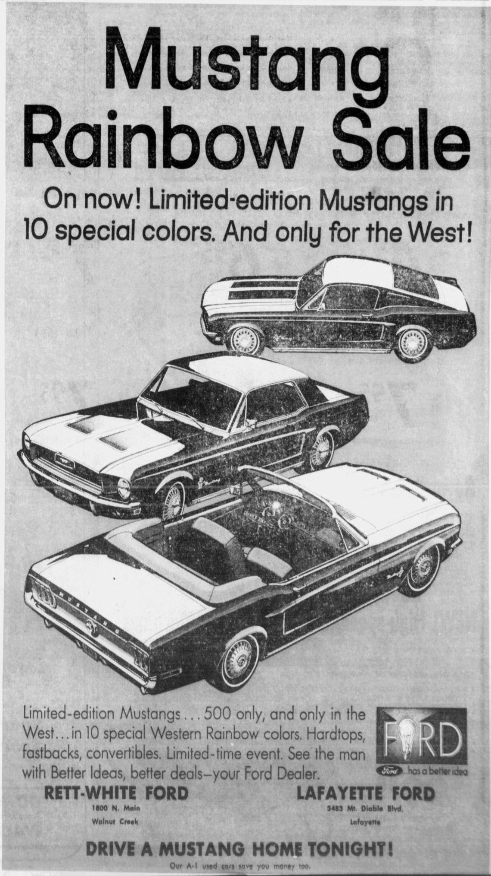
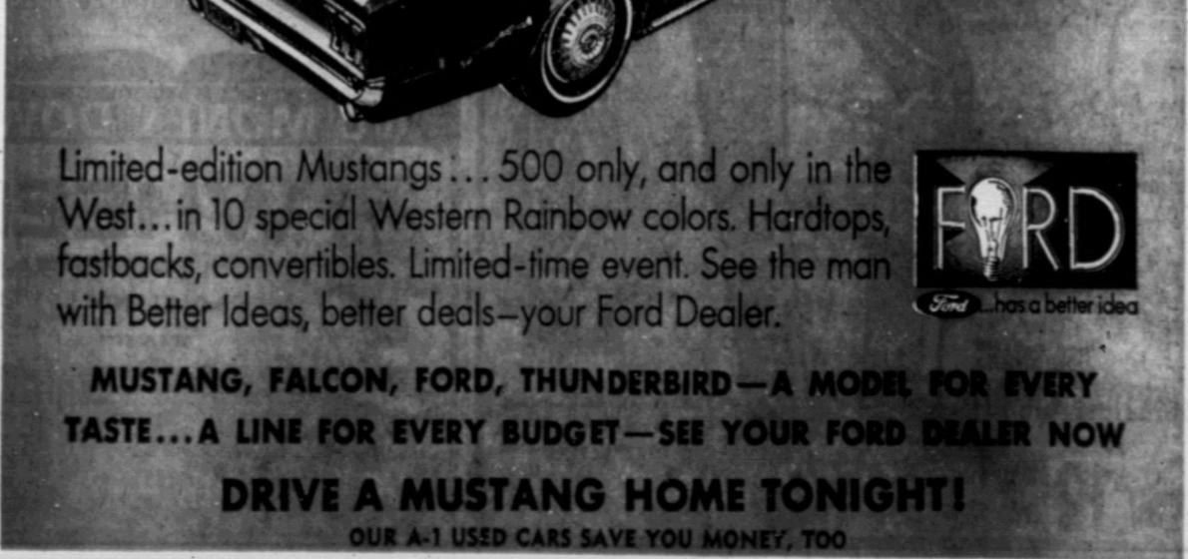

Exhibit A2. Ford's small "Mustang Rainbow Sale, 500 only - hurry for yours" co-op ad
February 14-22, 1968 (eleven appearances in eleven papers) | Relevance: Direct: the promotion; "special paint" price
Page links: Arroyo Grande Valley Herald-Recorder Feb 15 p. 7 (shown); Madera Tribune Feb 14; Mill Valley Record Feb 14; Red Bluff Daily News Feb 14 p. 10; Sebastopol Times Feb 15 p. 9; Cloverdale Reveille Feb 15 p. 6; Auburn Journal Feb 15 p. 27; Lincoln News Messenger Feb 15 p. 6; Folsom Telegraph Feb 15 p. 10; Tracy Press Feb 16 p. 7; Chico Enterprise-Record Feb 22 p. 10
- What it says. "Mustang Rainbow Sale. Limited-Edition Mustangs, 10 special colors! Only for the West! ... 500 only - hurry for yours. Mustang hardtops, fastbacks, convertibles, too ... 10 special colors. Only in the West. Limited-time sale."
- Every appearance found (one ad, shown once). Madera Tribune and Mill Valley Record Feb 14 (dealer line not legible in the scan); Red Bluff Daily News Feb 14, Hankins Motor Co.; Sebastopol Times Feb 15, Cole Ford Inc.; Cloverdale Reveille Feb 15, A. Lampson & Sons; Auburn Journal Feb 15, McLaughlin Ford Sales; Lincoln News Messenger Feb 15, a Lincoln dealer ("Charles ...", partly illegible); Folsom Telegraph Feb 15, Bob West Ford Sales (see A6); Arroyo Grande Valley Herald-Recorder Feb 15, Maury Brennan Ford (shown); Tracy Press Feb 16, Don Hardy Inc.; Chico Enterprise-Record Feb 22, the Ford dealer at 1240 Park Ave.
- Why it matters for your car: "special paint." The Arroyo Grande copy, from Maury Brennan Ford, adds a line found in no other copy: "SAVE ON SPECIAL PAINT, ONLY $13.90." That is a 1968 dealer stating that the Rainbow colors were sold as special paint, at a small charge. It fits your Marti report, which lists your car's paint as "Special Paint" under a DSO order rather than a regular color code. It does not prove your car is a Rainbow car, because other special-paint orders existed, but it shows that a Rainbow car would be expected to carry exactly that kind of entry.
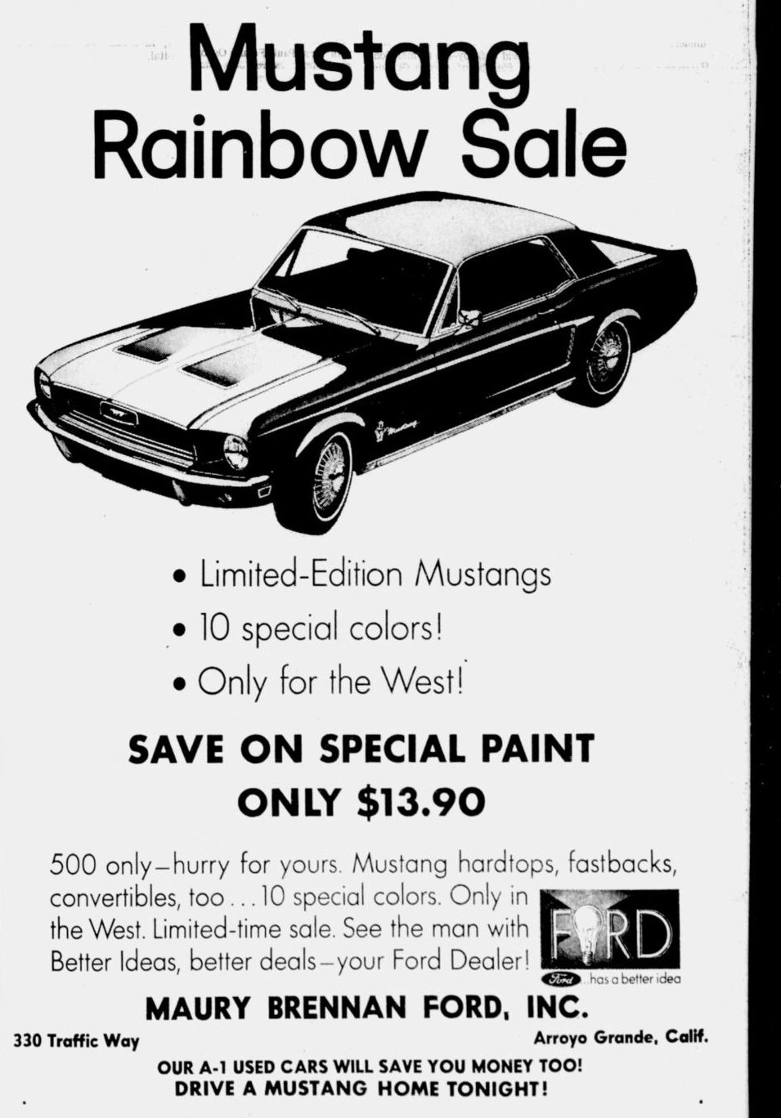

Exhibit A3. Sullivan Ford, Napa: "Mustang Rainbow Sale Now On!!!"
Tuesday, February 13, 1968 (front page) | Relevance: Direct: earliest dealer Rainbow ad in this window
Page links: Napa Valley Register Feb 13 p. 1; related: Napa Valley Register Feb 15 p. 15
- What it says. "Mustang Rainbow Sale Now On!!! ... Rainbow Special Prices," on the front page, the day before your car was built.
- Related ad, same paper. On February 15 (p. 15) a St. Helena Ford dealer (name garbled in the scan text, phone 963-2771) ran "Limited Edition Mustangs in 10 Special Colors!! Napa Valley's largest selection of Mustang hardtops & fastbacks ... 10% discount on our entire stock of 1968 Fords." Sullivan Ford also signed the large co-op ad (A1) that day.
- Why it matters. Rainbow cars were already in dealers' hands and being advertised on February 13. Your car, built February 14 and scheduled for February 16, was built in the same week the promotion opened.
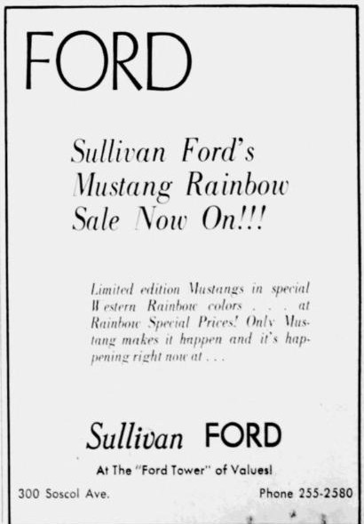

Exhibit A4. Lafayette Ford "'68 Mustang Rainbow Sale"
Friday, February 16, 1968 | Relevance: Direct: the promotion in your county
Page links: Contra Costa Times Feb 16 p. 41
- What it says. "'68 Mustang Rainbow Sale at Lafayette Ford. Get one now while they last starting at this very low price! $2487 ... Special prices, 10 special colors, Hurry! Limited supply!" The starting price includes radio and heater, tinted glass, whitewalls and vinyl bucket seats.
- Why it matters. This is the only dealer-written Rainbow ad in Contra Costa County at launch. The advertised base Rainbow car was modestly equipped. Your car, with SelectAire air conditioning, a vinyl roof and power steering, was far better equipped than this price-leader car.
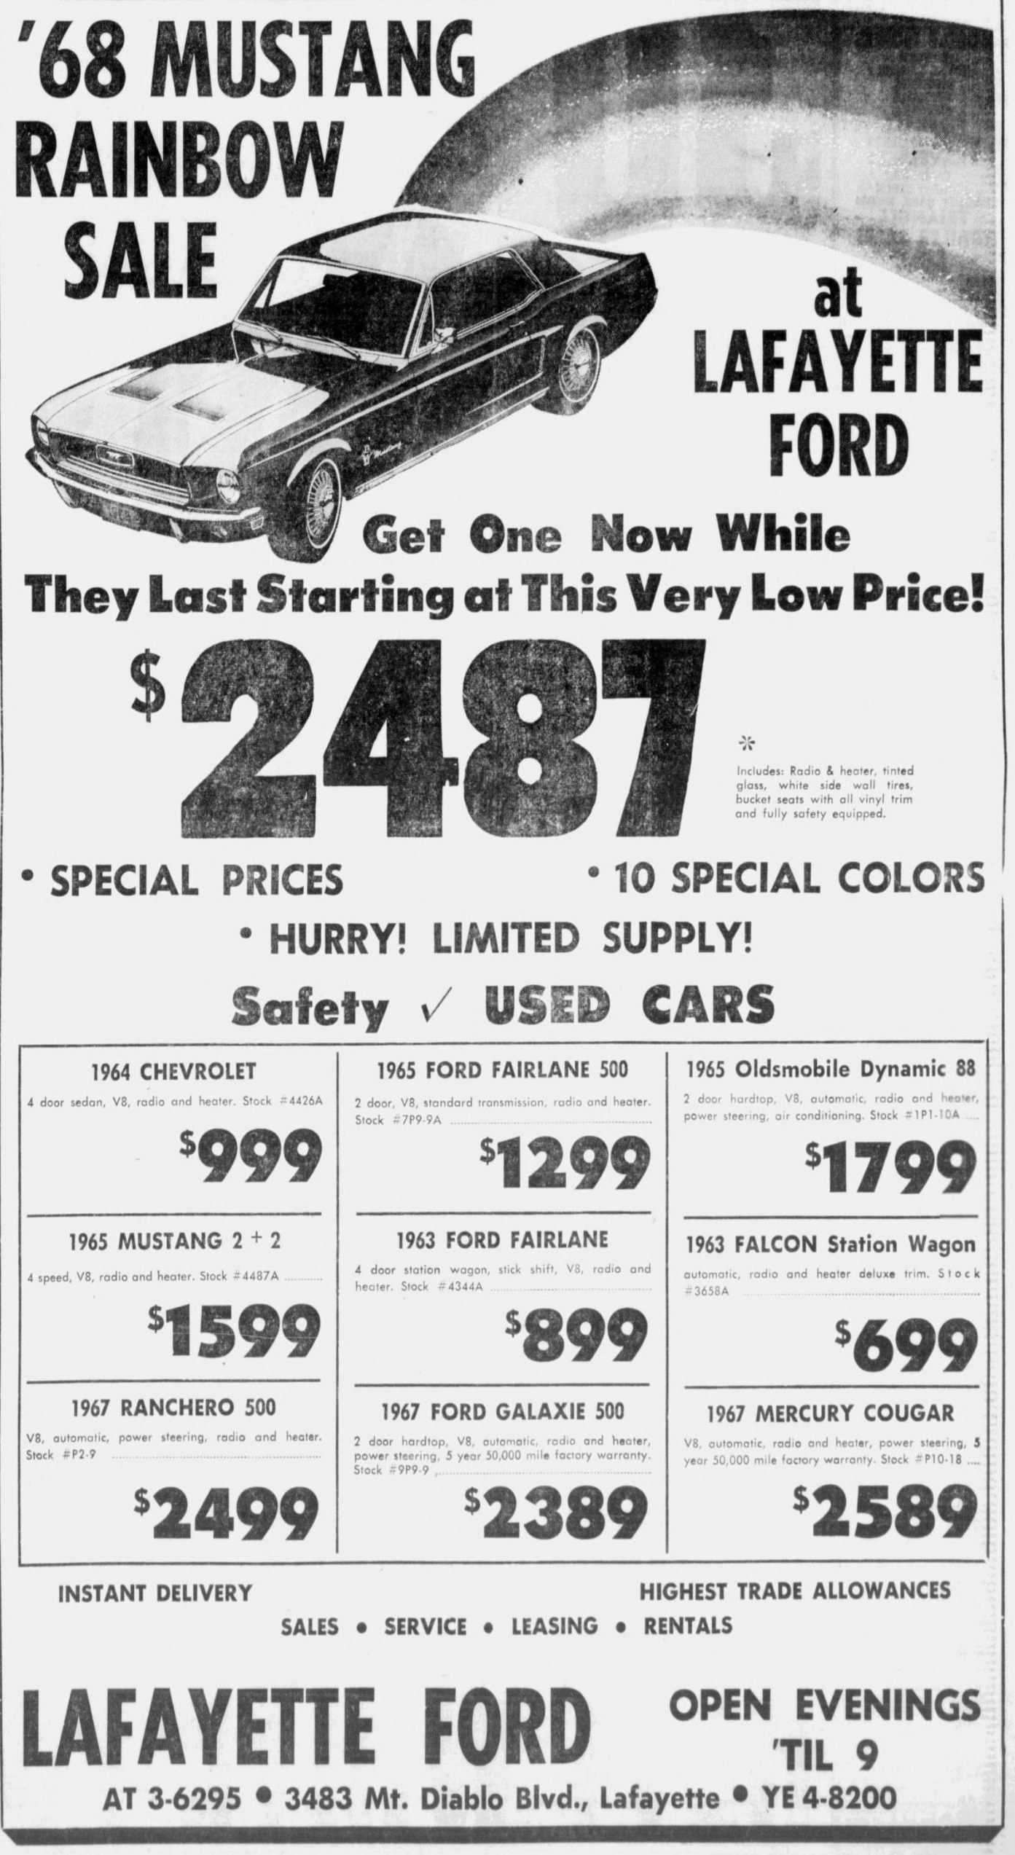

Exhibit A5. Rett-White Ford "30% reduction on 80 Mustangs now in stock"
Friday, February 16, 1968 | Relevance: Probable: Rainbow inventory
Page links: Contra Costa Times Feb 16 p. 42 (facing A4)
- What it says. "Only Rett White Ford can bring you these savings! 30% reduction in inventory on 80 Mustangs now in stock ... Fastbacks! Convertibles! Hardtops! ... Colors? You name it."
- Why it matters. Placed the day after the co-op ad by one of the two Rainbow dealers named in the county paper, it shows a nearby dealer heavily stocked with new Mustangs in every body style as the 10-color program opened. The ad does not use the word "Rainbow," so the link is an inference. The phone number, 932-1313, matches the April "Rainbow Specials" classifieds (A12).
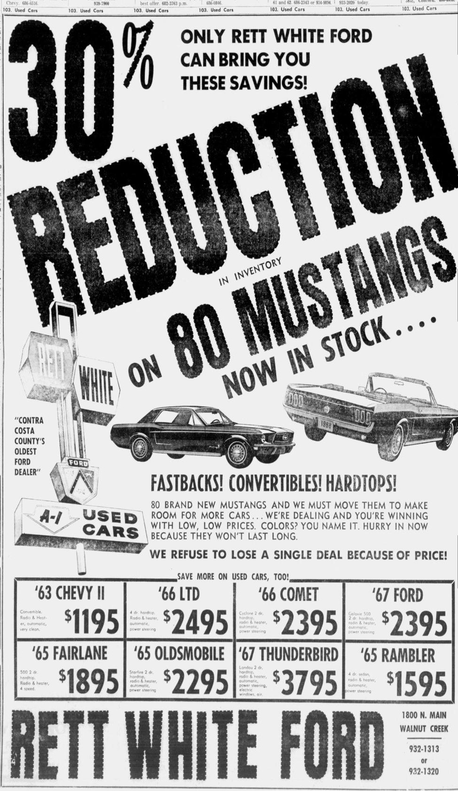

Exhibit A6. Bob West Ford, Folsom: "Yippee! Round-up of Rainbow Mustang values"
Thursday, February 15, 1968 | Relevance: Direct: the promotion
Page links: Folsom Telegraph Feb 15 p. 10
- What it says. Left: "Yippee! Round-up of Rainbow Mustang values at Bob West Ford's new corral! Choose from over 35 new Mustangs. Only in the West, only at Bob West can you get a better deal." Right: the small Ford co-op ad (A2) signed by Bob West Ford Sales on the same page.
- Why it matters. A small-town dealer held more than 35 new Mustangs for the sale. Dealers took on large Mustang stocks for this event, which helps explain why Rainbow cars could still be on lots weeks later.
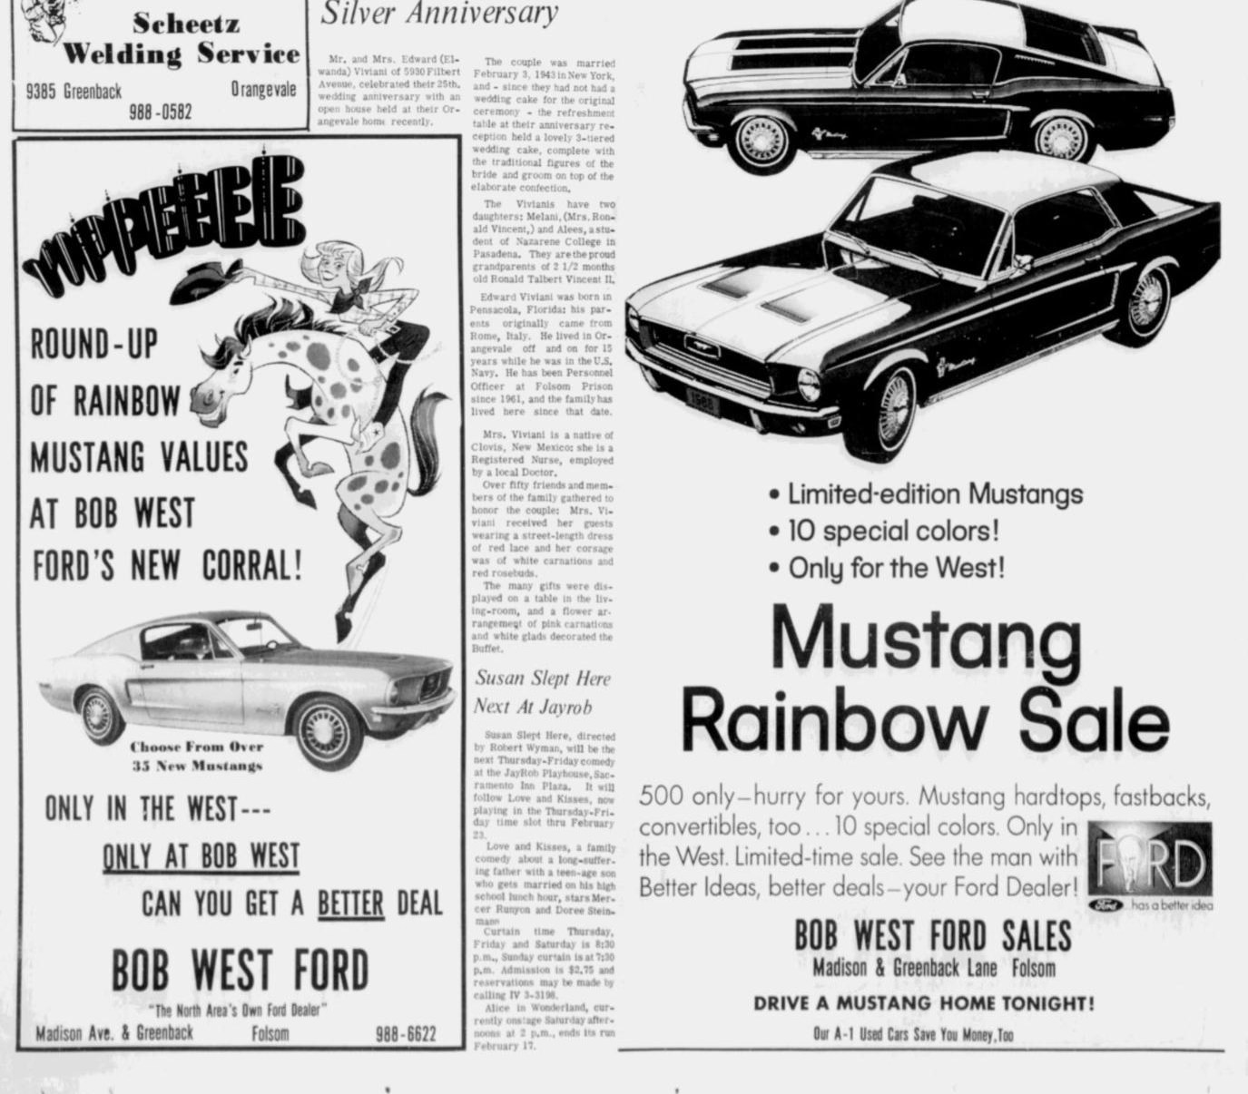

Exhibit A7. Bob Greene Company, Hanford: Mustang fastback "Special Paint"
Saturday, February 24, 1968 | Relevance: Related: a "special paint" Mustang offered for sale
Page links: Hanford Sentinel Feb 24 p. 45
- What it says. "Mustang Fastback #100900. Special Paint, V8, F70x14 wide oval tires, styled steel wheels, power steering, radio, heater, accent stripe, tinted glass, whitewalls. $3269.44."
- Why it matters for your car. Ten days after the launch, a dealer advertised a new Mustang by the words "Special Paint" rather than a color name, the same wording as your Marti report. The ad does not say Rainbow, so it is supporting context only. It also shows that a well-optioned V8 car could carry special paint, as yours did.
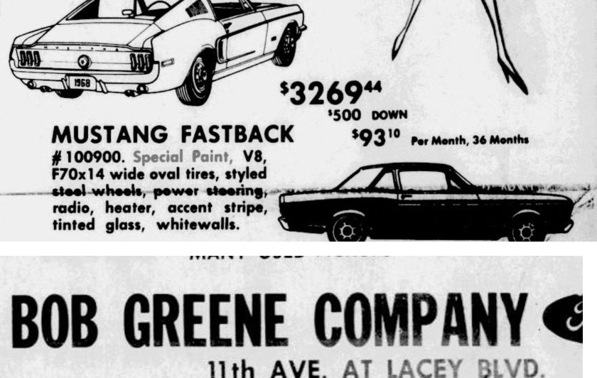

Exhibit A8. City Ford, Highland Park: "'68 Mustang Rainbow Sale, Every Color in the Rainbow!"
Thursday, February 29, 1968 | Relevance: Direct: the promotion in Southern California
Page links: Highland Park News-Herald & Journal Feb 29
- What it says. "City Ford's '68 Mustang Rainbow Sale. Every Color in the Rainbow! Available for immediate delivery at low-low-prices."
- Why it matters. Highland Park is in Los Angeles, Ford's Los Angeles district (DSO 71), so the promotion ran in Southern California as well as the San Jose district (DSO 72) your car was ordered in. Two weeks after launch, Rainbow cars were still offered for "immediate delivery."
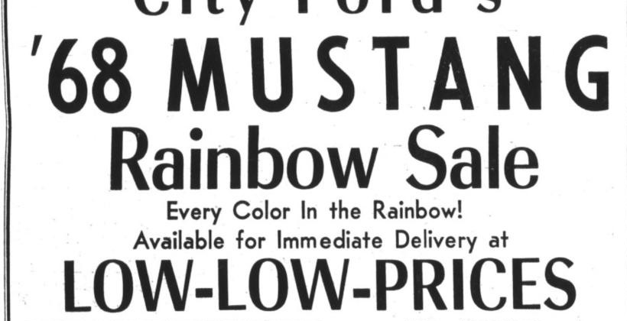

Exhibit A9. R.E. Barber Ford, Ventura: six "Rainbow Paint" Mustangs, including a "Candy apple gold" hardtop
Friday, March 1, 1968 | Relevance: Direct: dealer-listed Rainbow cars with colors and equipment
Page links: Ventura County Star Mar 1 p. 24
- What it says. A full-page ad: "March is Mustang Month ... over 50 new 1968 Mustangs ... 10 new Psycadelic Colors, available only on Mustang 1968." The detail shows six brand-new hardtops, each captioned "RAINBOW PAINT": (242) Candy apple gold, 289 V8, Cruisomatic, power steering, tinted glass, whitewalls; (232) Seamist turquoise, 289 V8, Cruisomatic, power steering, black vinyl roof; (213) Placid green, 289 V8; (233) Tahiti coral, 6-cylinder, Cruisomatic, black vinyl roof; (250) Peacock Blue, 6-cylinder, Cruisomatic, power steering; (244) Burnt red-orange, 6-cylinder.
- Why it matters for your car. This is the most detailed 1968 description of actual Rainbow cars found. It shows a Rainbow gold hardtop, "Candy apple gold," with a 289 V8, Cruisomatic and power steering, which is close to your car's drivetrain and options, and a Rainbow hardtop with a black vinyl roof (232), like yours. It also shows Rainbow cars were built in a wide range of equipment, from 6-cylinder cars to optioned V8s.
- Color names. The names here (Candy apple gold, Seamist turquoise, Placid green, Tahiti coral, Peacock Blue, Burnt red-orange) are not the names in today's hobby lists (Spanish Gold, Black Hills Gold, Madagascar Orange and so on). None of the hobby-list names appears in any newspaper in the collection for this period. Either the dealer used its own names or the published lists use names that were not used in 1968 advertising. A paint code match (such as WT3822) is therefore stronger evidence than a color name.
- Number in parentheses. The numbers (242, 232 and so on) appear to be the dealer's stock numbers.
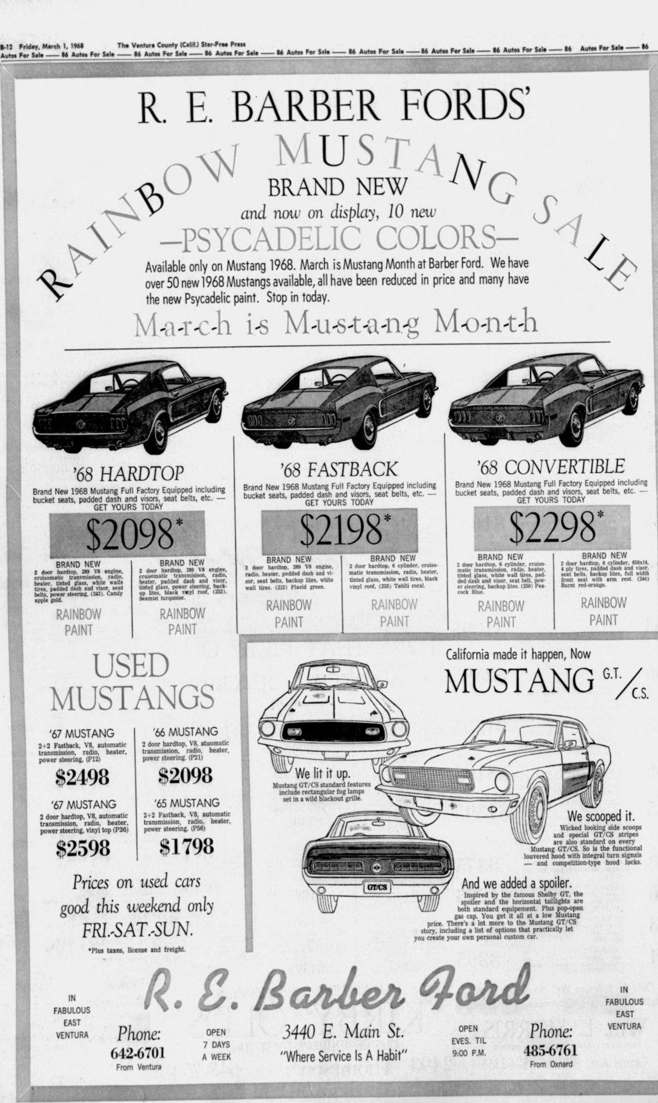
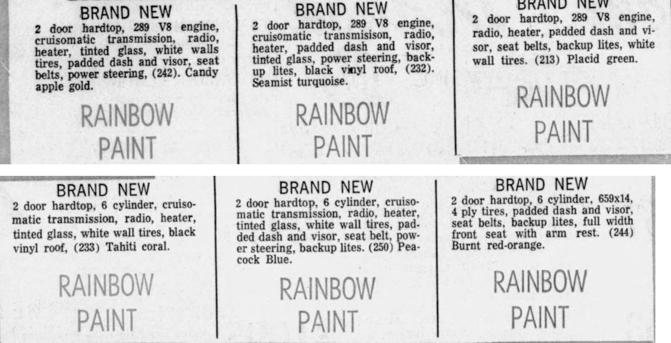

Exhibit A10. Bishop-Hansel Ford, Santa Rosa: '68 Mustang hardtop, "One of Our Rainbow Colors"
Friday, March 8, 1968 | Relevance: Direct: a Rainbow car still for sale three weeks after launch
Page links: Santa Rosa Press Democrat Mar 8 p. 6
- What it says. "'68 Mustang 2-Door Hardtop, Stock No. M-2528 ... Catch-up price of $2398. One of Our Rainbow Colors, 6 Cyl., Standard Trans."
- Why it matters. A Sonoma County dealer was still selling a Rainbow car by stock number three weeks after launch, at a base price, in base form (6-cylinder, manual). Together with A9, it shows Rainbow cars ranged from base cars like this to optioned V8 cars like yours.
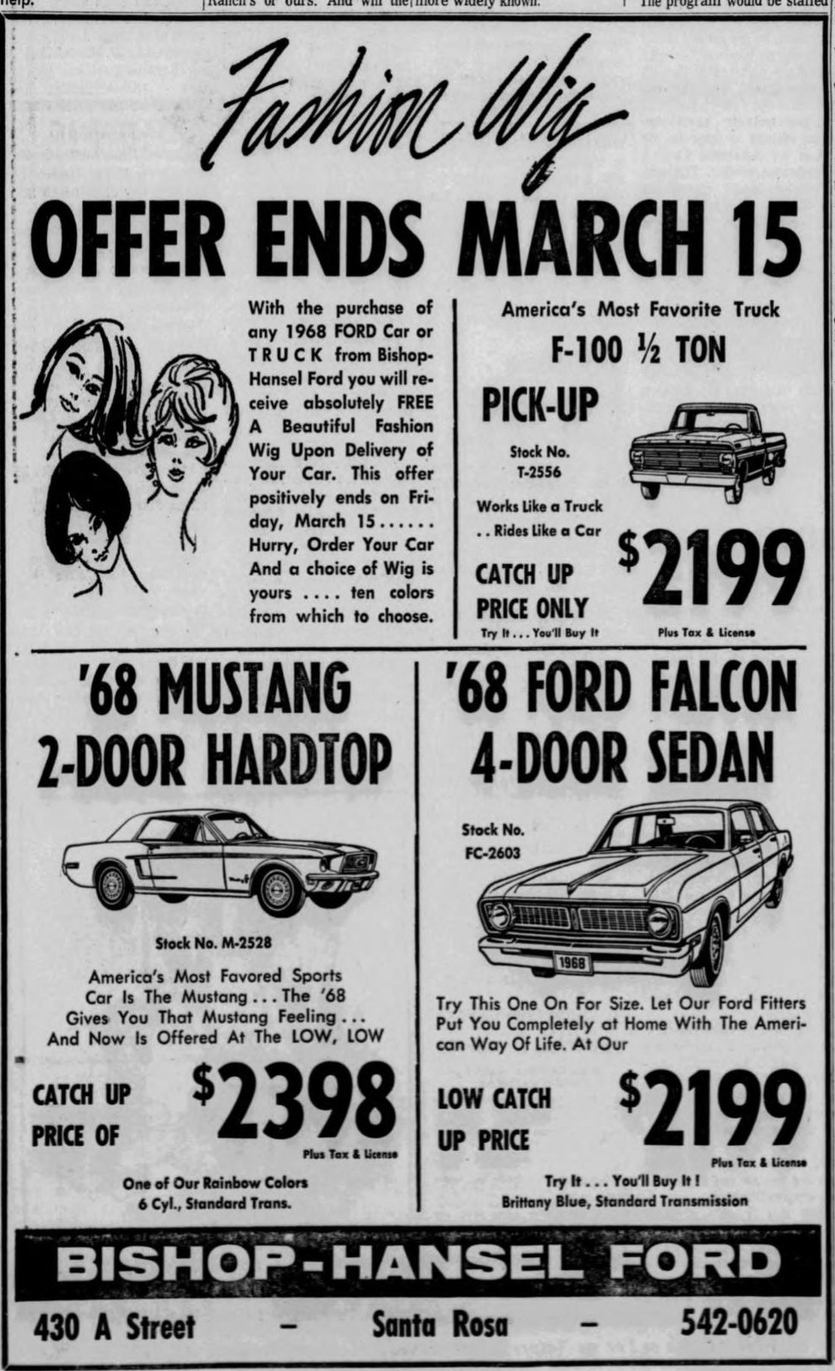

Exhibit A11. Sanderson's Ford Sales, Petaluma: "4th Annual Mustang Sale ... Rainbow Specials"
Tuesday, March 12, 1968 | Relevance: Direct: the promotion into March
Page links: Petaluma Argus-Courier Mar 12 p. 11
- What it says. "Two weeks - only once-a-year special factory prices. 4th Annual Mustang Sale! Now going on at Sanderson's Ford Sales: hardtops, fastbacks, convertibles, GT/CS models, Rainbow Specials."
- Why it matters. A dealer in the same region as yours was still advertising "Rainbow Specials" in mid-March alongside the GT/CS (C2). The two West Coast specials were sold side by side.
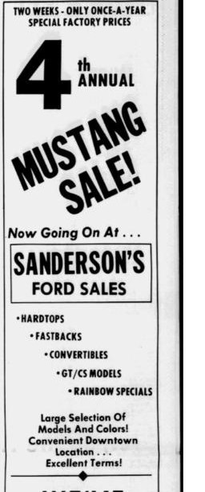

Exhibit A12. Rett-White "New '68 Mustangs, Rainbow Specials" classifieds
April 12-18, 1968 (five appearances) | Relevance: Direct: the promotion still running in April
Page links: Contra Costa Times Apr 12 p. 32 (shown); Apr 14 p. 43; Apr 16 p. 21; Apr 17 p. 65 (shown); Apr 18 p. 42
- What it says. "New '68 Mustangs. Rainbow Specials. Fully equipped ... $2950. No cash necessary. 932-1313. Ask for Chris only." On April 17 the price is $2947. The phone number is Rett-White Ford's (A5).
- Correction to earlier reports. Earlier reports quoted "$3047," taken from the computer-read text. The page images show $2950 and $2947.
- Why it matters for your car. Rainbow cars were still being sold as "specials" in Contra Costa County through April 18. Your car sold on May 2, so a Rainbow-ordered car still being on a Concord lot until then is plausible. About $2,950 for a "fully equipped" Rainbow car is useful price context.
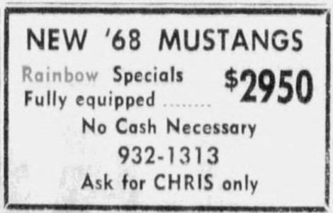
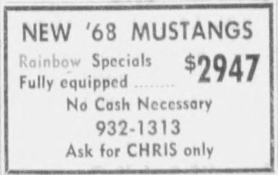

Part B. Your dealer: Earl Williams Ford, Concord Ford and SunValley Ford

Exhibit B1. Earl Williams Ford: "Concord Is FORD Country, Clean Sweep Sale"
February 14, 21 and 23, 1968 (Feb 14 is the day your car was built) | Relevance: Direct: your ordering dealer
Page links: Contra Costa Times Feb 14 p. 31 (shown); Feb 21 p. 46; Feb 23 p. 28
- What it says. A full-column used-car ad under the slogan "Concord Is FORD Country," with a "Clean Sweep Sale," signed "Earl Williams Ford, Salvio and East, Across from Post Office, Concord, Calif., 686-6600." Shown in three columns; read top to bottom, left to right.
- Why it matters. Your ordering dealer (72B023) was advertising under the Earl Williams Ford name the week your car was built. The February 23 ad is the last used-car ad signed Earl Williams Ford. The slogan "Concord Is FORD Country" appears to be the source of the store's next name, "Concord Ford" (B2).
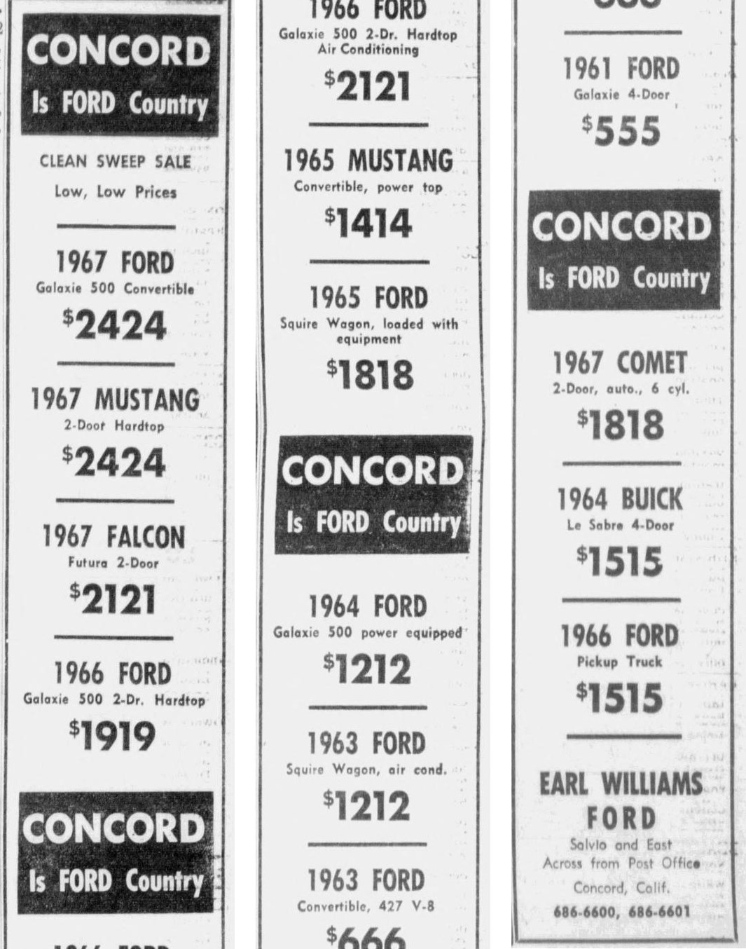

Exhibit B2. First "Concord Ford" listings
February 29, March 1 and March 4, 1968 | Relevance: Direct: your dealer's name change
Page links: Contra Costa Times Feb 29 p. 40 (shown); Concord Transcript Mar 1 p. 13; Concord Transcript Mar 4 p. 13
- What it shows. "Concord Ford, Across From Post Office, 686-6600," the same lot and phone number that were Earl Williams Ford six days earlier. Page 40 alone has eight Concord Ford used-car listings. The same style of listing appears in the Concord Transcript on March 1 (pp. 13-14), the first Transcript issue online, and on March 4. The yellow box is the archive's search highlight.
- Why it matters. The store's local name changed between February 23 and February 29, 1968, two weeks after your car was built and about nine weeks before it was sold. Ford's factory co-op ads kept the name Earl Williams Ford until late April (B5 and the table at the end of Part B), so both names were in use at once.
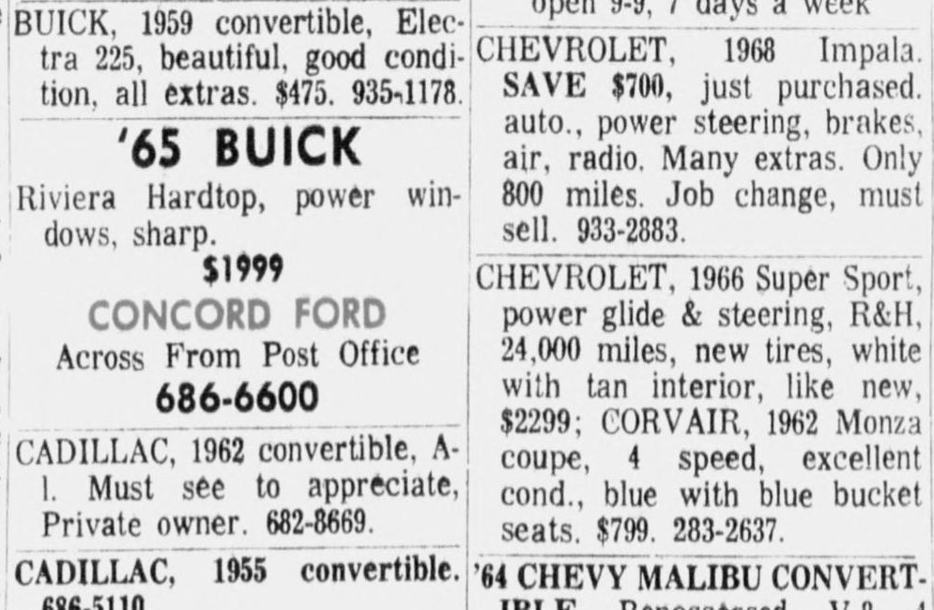

Exhibit B3. Concord Ford: "Rawley Grable or Chuck Hillery"
March 7-10, 1968 (four appearances) | Relevance: Direct: people at your dealer
Page links: Contra Costa Times Mar 8 p. 36 (shown); Contra Costa Times Mar 10 p. 44; Concord Transcript Mar 7 p. 15; Concord Transcript Mar 8 p. 16
- What it shows. Used-car listings signed "Concord Ford, Rawley Grable or Chuck Hillery, Across From Post Office, 686-6600." The same listings ran in both papers.
- Why it matters. It names the two men buyers were told to ask for in March 1968, within weeks of your car arriving. Rawley Grable later co-owned Sun Valley Ford; Chuck Hillery was a long-time salesman (and see B9).
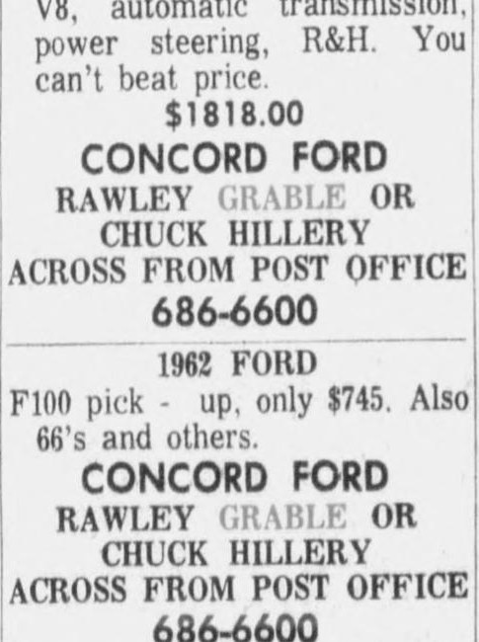

Exhibit B4. Legal notice: "Earl Williams Ford Sign Permit"
Thursday, March 7, 1968 | Relevance: Direct: your dealer's legal name in March
Page links: Concord Transcript Mar 7 p. 13
- What it says. Concord's Planning Commission would hear, on March 20, 1968, an application by Nelson Neon "for a Use Permit for installation of four free-standing signs on property located at 1881 Diamond Boulevard in Meridian Park," under the heading "Earl Williams Ford Sign Permit." (This clipping is from your own files; the page link is the archive copy.)
- Why it matters. A week after the store began advertising as Concord Ford, the business still dealt with the city as Earl Williams Ford, and it was planning signs for a new site on Diamond Boulevard. The same business also appears as a sponsor, under the Earl Williams name, in a Concord Trade Club listing on March 6 (Concord Transcript p. 3).
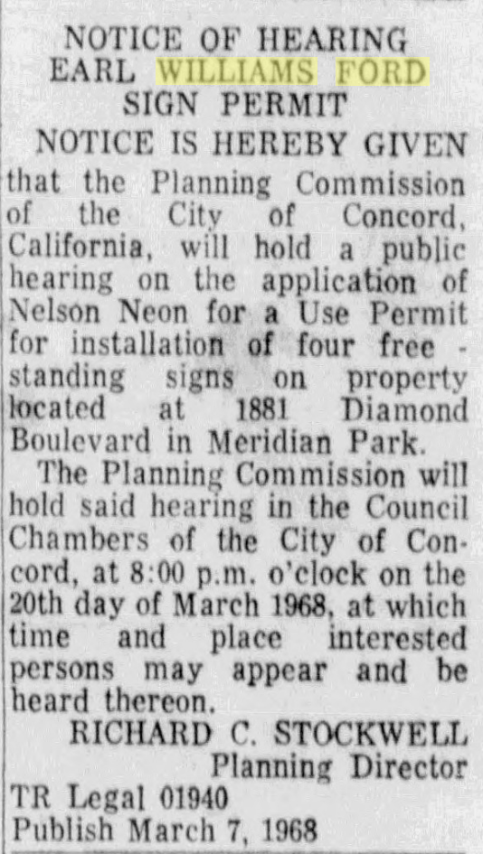

Exhibit B5. Earl Williams Ford co-op ad: "New low-priced Mustang Sprint"
March 12 and April 16, 1968 | Relevance: Direct: your dealer advertising Mustangs under its franchise name
Page links: Concord Transcript Mar 12 p. 9 (shown); Concord Transcript Apr 16 p. 11
- What it says. "New low-priced Mustang Sprint. Look at all the extras you get at special savings: GT stripe, special wheel covers, special exterior trim, flip-open gas cap ... Supply of Sprints is limited." Signed "Earl Williams Ford, 2395 Willow Pass Rd., Concord, Calif." The April 16 version adds a vinyl-roofed Fairlane.
- Why it matters for your car. These are Ford's factory co-op ads, which the dealer paid into and which carried the franchise name. Your dealer ran the national Mustang Sprint promotion and the West-only GT/CS promotion (C2) under the Earl Williams name, but in the Transcript issues online (from March 1) none of its co-op ads mentions Rainbow colors. The Rainbow co-op ads ran on February 13-22, before the Transcript's online run begins, so that gap remains.
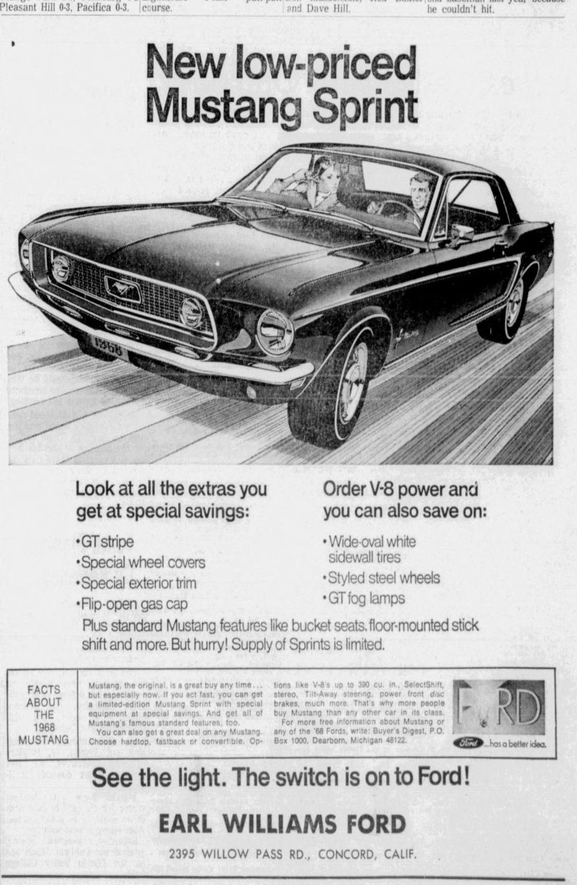

Exhibit B6. Concord Ford: "It's the Nuttiest Sale of the Year"
Friday, March 15, 1968 (same day in both papers) | Relevance: Direct: your dealer advertising a new 1968 Mustang hardtop
Page links: Contra Costa Times Mar 15 p. 33 (shown); Concord Transcript Mar 15 p. 19
- What it says. Concord Ford's first full-page display ad. Its featured car is a "New 1968 Mustang Hardtop: Cruisomatic, radio, heater, bucket seats, white walls, tinted glass, deluxe seat belts, wheel covers, power steering. Stock #65, $2747.99." It gives the new-car showroom at 2395 Willow Pass Rd and the used-car lot across from the post office.
- Why it matters for your car. This hardtop shares much of your car's equipment, but lists no air conditioning, vinyl roof or special color, so it is not identifiable as your car.
- Research tip. Dealers often wrote stock numbers on the car (grease pencil on the window sticker or under the hood). If one turns up on your car, compare it with the numbers in these ads (#65 here, #545 in B7 and B10, #176 in B11).
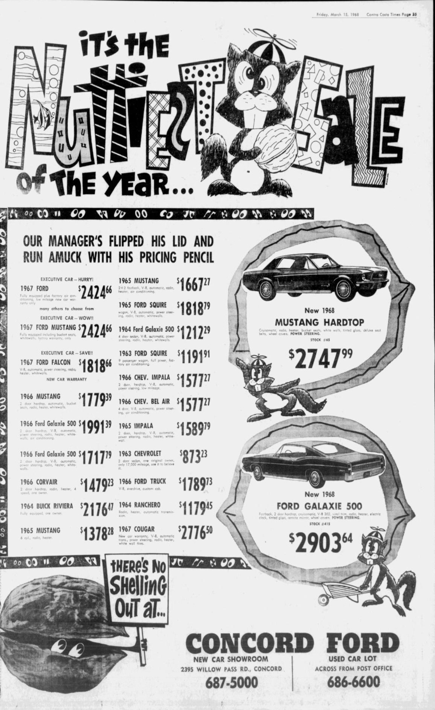
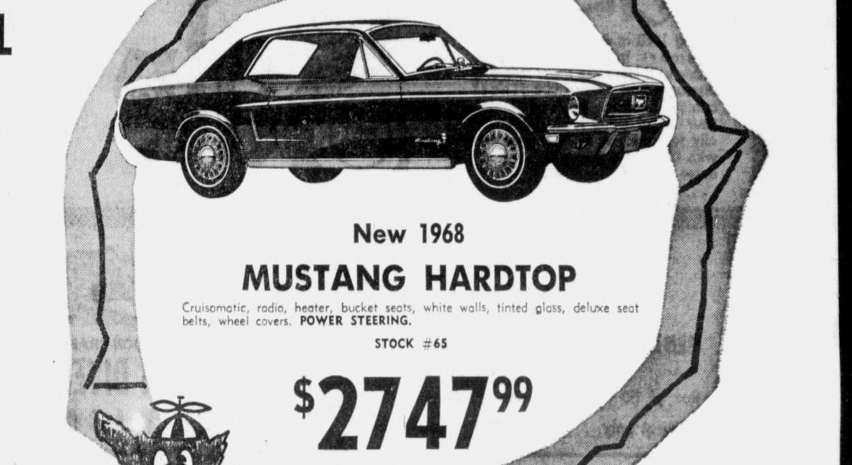

Exhibit B7. Concord Ford's "Savings Derby"
March 27 and 29, 1968 | Relevance: Direct: your dealer; staff list
Page links: Contra Costa Times Mar 29 p. 40 (shown); Concord Transcript Mar 27 p. 23; earlier display ad: CCT Mar 22 p. 43; and Concord Transcript Mar 21 p. 14
- What it says. "The Race Is On During Concord Ford's Savings Derby." The featured new Mustang is a California Special G/S V8, stock #545, $2767.89. Staff: salesmen Emery Erdy, Chuck Hillery, Ken Boyars, Don Head, Walt Madeiros, Dick Sargent, Ron Bradshaw and Lou Burmester; sales managers Vaughn Grable and Rawley Grable; fleet and truck manager Dick Palmer; insurance and credit, Robert Cope.
- Why it matters. This is the earliest staff roster found. It confirms the Grable brothers as sales managers while your car sat in inventory. The featured Mustang is a GT/CS (C2), not a Rainbow car.
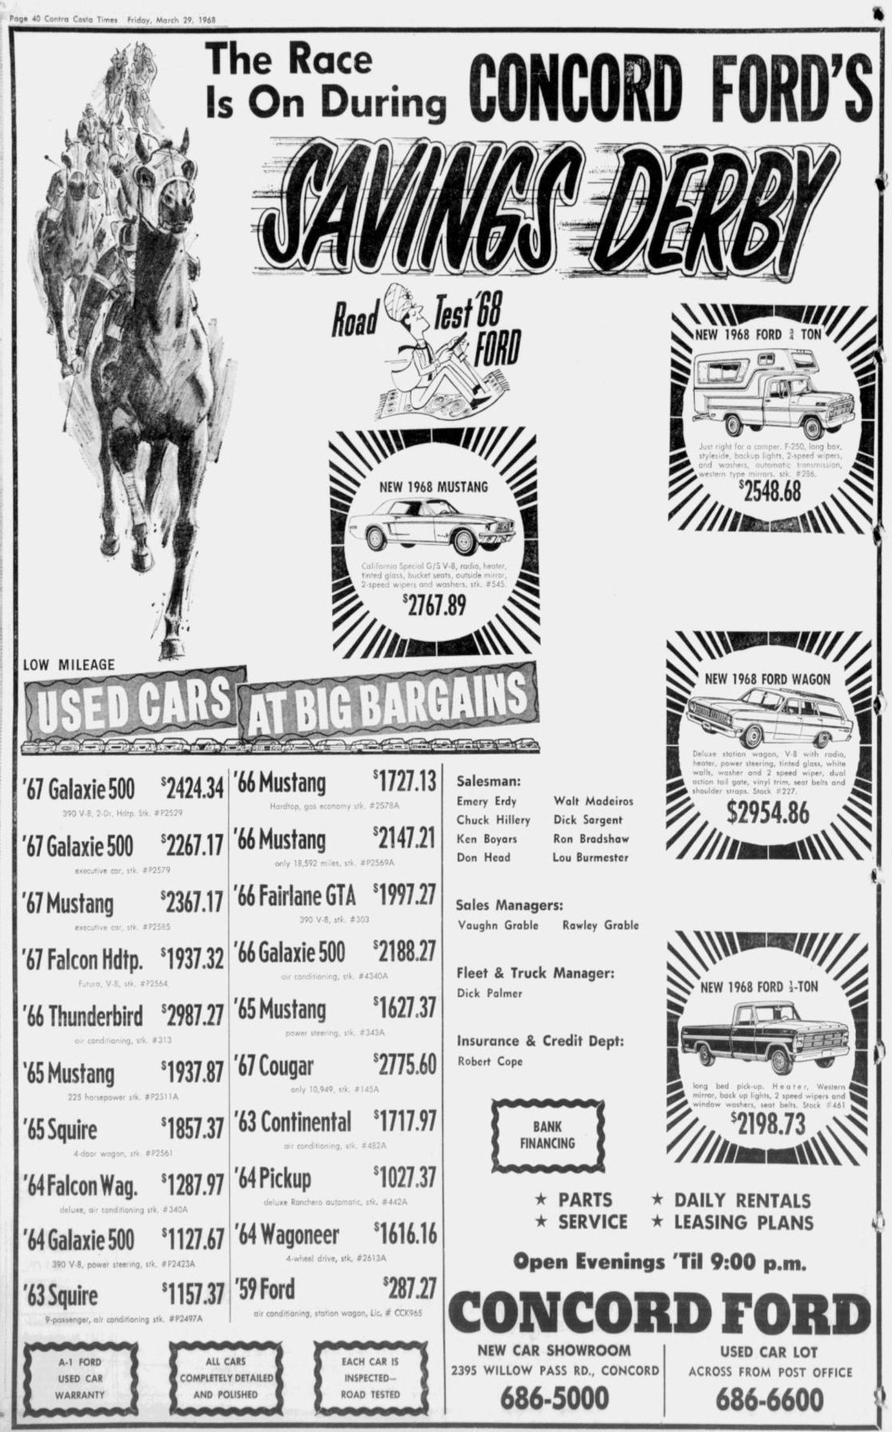

Exhibit B8. Telephone directory listing: "SunValley Ford, 2195 [sic] Willow Pass Rd"
April 1-3, 1968 | Relevance: Direct: earliest appearance of the Sun Valley Ford name
Page links: Concord Transcript Apr 1 p. 12
- What it shows. A business-directory listing: "SunValley Ford, 2195 Willow Pass Rd, 686-5000." The street number is a misprint for 2395; 686-5000 is the Concord Ford showroom number. The listing ran April 1, 2 and 3, then read "Concord Ford" again from April 4 to May 3.
- Why it matters. The earlier reports dated the first Sun Valley Ford mention to mid-May 1968. This listing shows the name was already in use, or planned, by April 1, while your car was in stock. It fits a dealership changing hands and names in spring 1968.
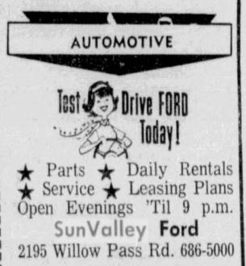

Exhibit B9. "Four Salesmen From Concord Earn Laurels"
Tuesday, April 9, 1968 | Relevance: Direct: ties your dealer to Ford's San Jose district
Page links: Concord Transcript Apr 9 p. 6
- What it says. "Four salesmen from Earl Williams Ford, Concord, were honored for outstanding sales performance during 1967 at a Ford 300-500 Club banquet ... in the Fairmont Hotel, San Francisco. James A. King, Ford Division's San Jose district sales manager, said Emery Erdy has been selected to receive the Top Hatter Award ... Kenneth Boyars, C. Hillery and Richard Sargent will receive 300-500 Club memberships."
- Why it matters for your car. A Ford district manager names the dealership as part of the San Jose district, matching the DSO 72 (San Jose) on your car's record. It also shows the newspaper still calling the store Earl Williams Ford in April. Erdy, Boyars, Hillery and Sargent were all on the staff while your car was in stock, so their families are people-leads.
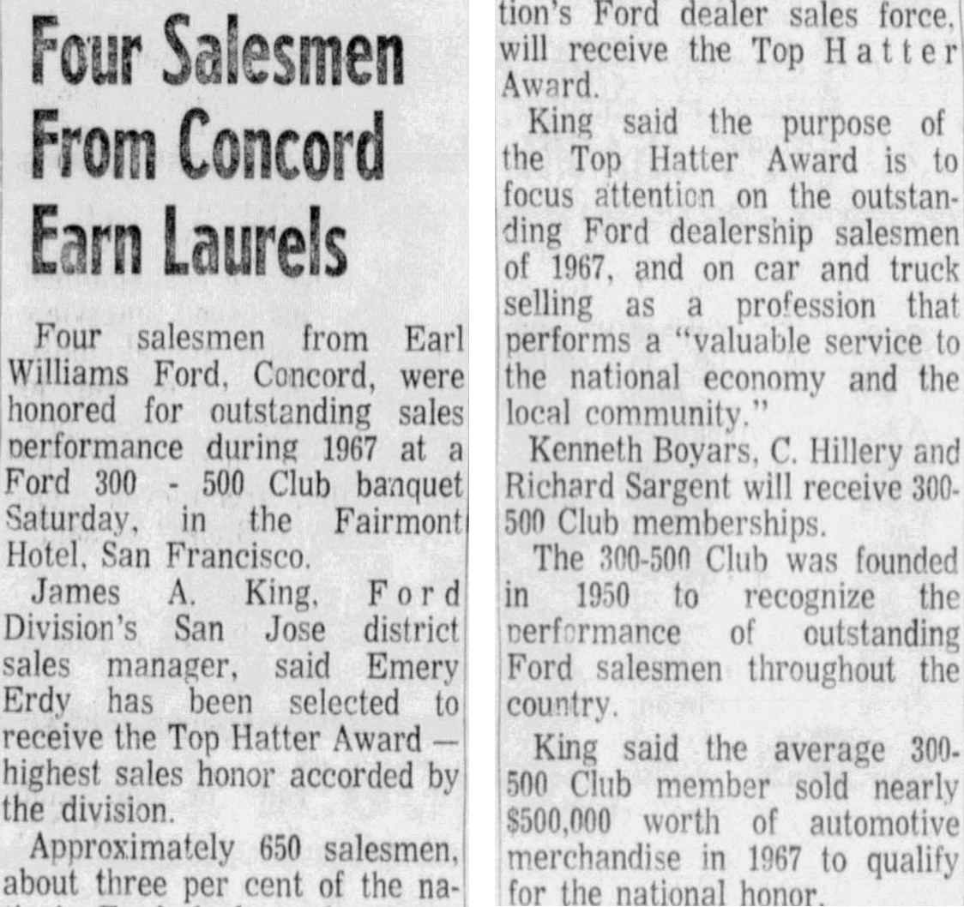

Exhibit B10. Concord Ford's "Easter Sale"
April 10 and 12, 1968 (similar ad April 3 and 5) | Relevance: Direct: your dealer
Page links: Contra Costa Times Apr 12 p. 35 (shown); Concord Transcript Apr 10 p. 19; similar: CCT Apr 5 p. 41; and Concord Transcript Apr 3 p. 23
- What it says. "Buy Now! Save Now! During Concord Ford's Easter Sale. 128 new cars in stock." The featured new Mustang is again the California Special G/S, stock #545, still unsold. Also featured: a Galaxie 500 hardtop with factory air and vinyl trim.
- Why it matters. Three weeks before your car sold, the store had 128 new cars on hand and was pushing them with weekly full-page ads in both papers. None of these ads mentions Rainbow colors or special paint.
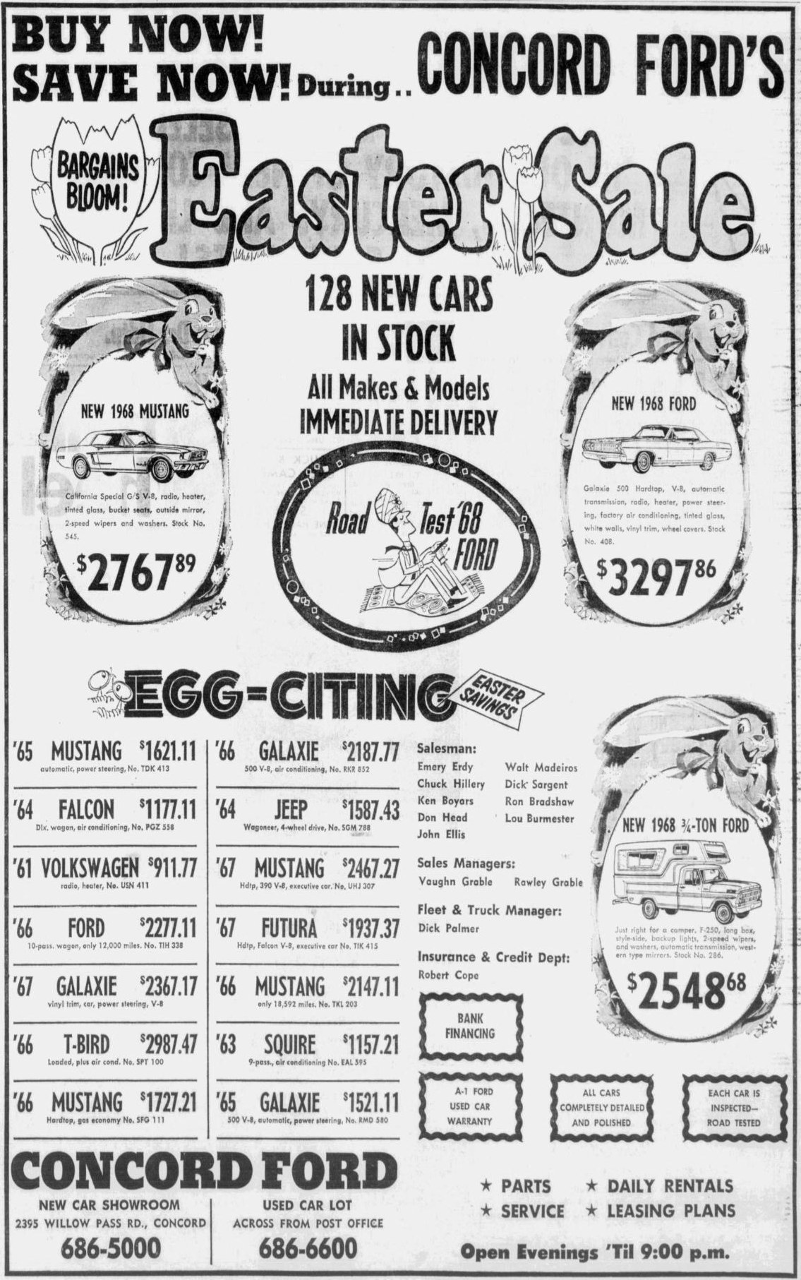

Exhibit B11. Concord Ford: "The Time Has Come for Outdoor Fun!"
April 17 and 19, 1968 | Relevance: Direct: your dealer; new staff name
Page links: Contra Costa Times Apr 19 p. 43 (shown); Concord Transcript Apr 17 p. 21 (first appearance)
- What it says. "128 new cars in stock ... Immediate delivery." The featured "New 1968 Mustang" is a 2-door hardtop, V8, automatic, radio, heater, whitewalls, tinted glass, bucket seats, wheel covers, #176, $2797.72.
- New staff name. Salesman Hugh Gildea appears for the first time, in the Concord Transcript on April 17.
- Why it matters. The featured hardtop has your car's body, engine and transmission but not its A/C, vinyl roof or power steering, so it is a different car. Your car was likely among the 128 new cars in stock.
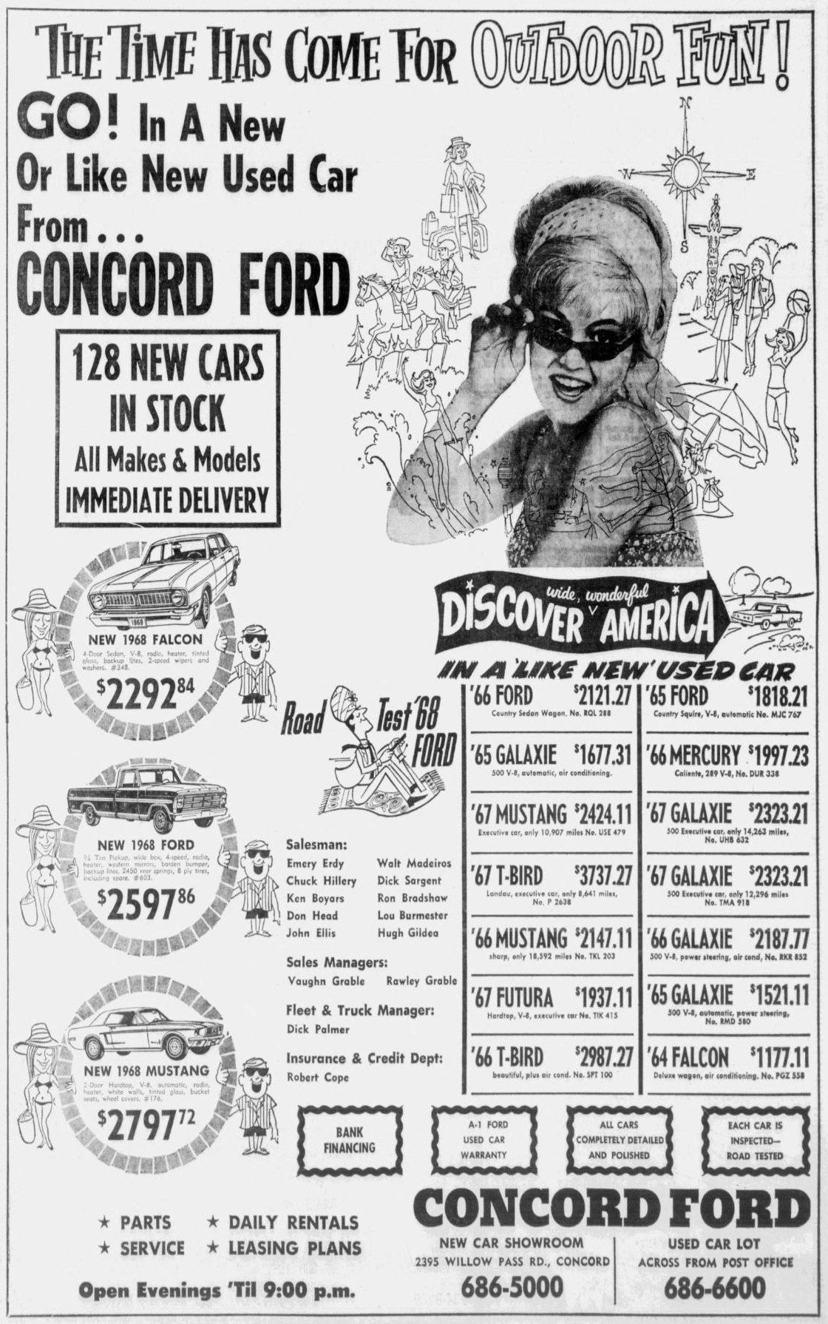

Exhibit B12. Lou Burmester: "Check With Me Before You Buy!"
Ran almost daily, April 9 - May 2, 1968 | Relevance: Direct: a salesman at your dealer when your car sold
Page links: Concord Transcript Apr 9 p. 17; Concord Transcript May 2 p. 17 (the day your car sold)
- What it says. "Lou Burmester. Any car, anywhere, any price. I can save you money. Concord Ford, 2395 Willow Pass Road, 686-5000." (Clipping from your files; the same ad ran on many days, shown once here.)
- Why it matters. Burmester was advertising himself as the Concord Ford salesman on the very day your car was sold, May 2, 1968. He is one of the more likely people to have handled the sale.
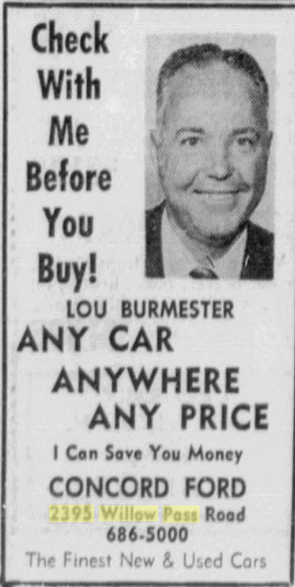

Exhibit B13. Concord Ford: "Let's Go!"
Thursday, April 25, 1968 (last display ad before your car sold) | Relevance: Direct: your dealer; final staff list
Page links: Concord Transcript Apr 25 p. 17
- What it says. 128 new cars; '68 Thunderbirds from $4113; '68 Mustangs "as low as $2537"; Torinos from $2623. The staff list adds J.P. "Jonesy" Jones.
- Why it matters. This is the store's last display ad found before May 2. It still advertises a large new-car stock and Mustangs at a discount, a week before your car was sold. No Rainbow or special-color wording appears.
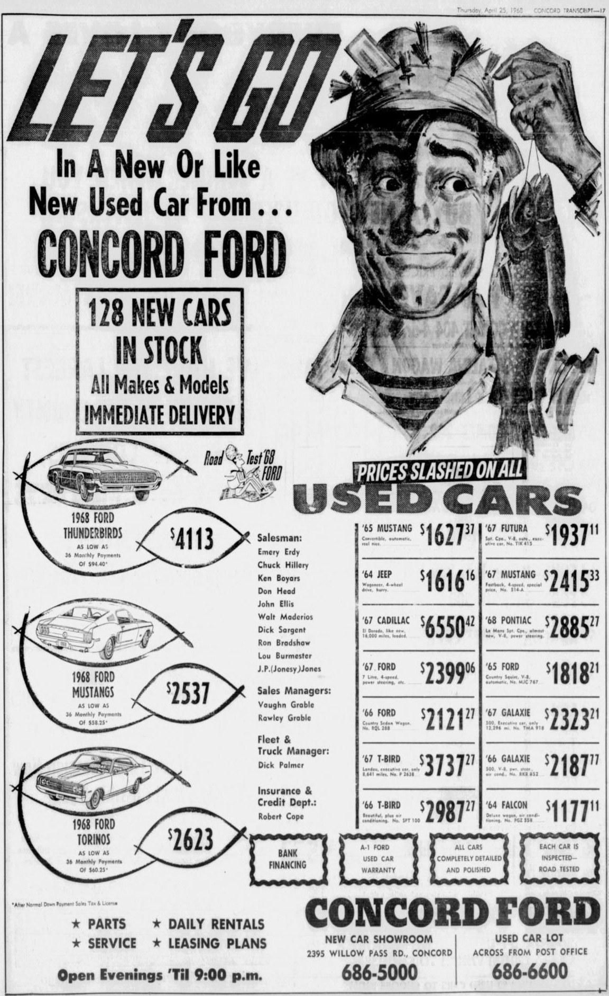

Other Earl Williams Ford co-op ads in the Concord Transcript
Ford factory co-op ads signed "Earl Williams Ford, 2395 Willow Pass Rd." None mentions Rainbow colors or special paint. Listed so every appearance is accounted for.
Date and page | Content | Page link
Mar 4 p. 14; Apr 1 p. 9 | Ford Rent-A-Car: "a sporty Mustang perhaps" | https://cdnc.ucr.edu/?a=d&d=CTC19680304.1.14
Mar 6 p. 3 | Concord Trade Club sponsor listing, Earl Williams Ford | https://cdnc.ucr.edu/?a=d&d=CTC19680306.1.3
Mar 12 p. 9; Apr 16 p. 11 | Mustang Sprint (Exhibit B5) | https://cdnc.ucr.edu/?a=d&d=CTC19680312.1.9
Mar 21 p. 9; Mar 28 p. 9; Apr 4 p. 7 | Mustang GT/CS "California Special" (Exhibit C2) | https://cdnc.ucr.edu/?a=d&d=CTC19680321.1.9
Apr 11 p. 9 | Ford co-op ad; content not legible in the scan | https://cdnc.ucr.edu/?a=d&d=CTC19680411.1.9
Apr 25 p. 10 | "Just right for the West ... Air-conditioned Ford Fastbacks! Vinyl-roofed Fairlanes!" plus a Kezar Stadium thrill show | https://cdnc.ucr.edu/?a=d&d=CTC19680425.1.10

Part C. Context: other Mustang specials, colors and oddities

Exhibit C1. Lafayette Ford: "WOW ... '68 Mustangs as low as $2398"
March 15 and 17, 1968 | Relevance: Context
Page links: Contra Costa Times Mar 17 p. 39 (shown); Mar 15 p. 32
- What it says. "Lafayette Ford is loaded with exciting new 1968 Fords ... WE NEED ROOM!" It offers '68 Mustangs "as low as $2398," $89 below its $2487 Rainbow price a month earlier.
- Why it matters. A Rainbow dealer was still overstocked with new Mustangs in mid-March. The black vinyl roof and SelectAire in this ad belong to the LTD, not a Mustang.
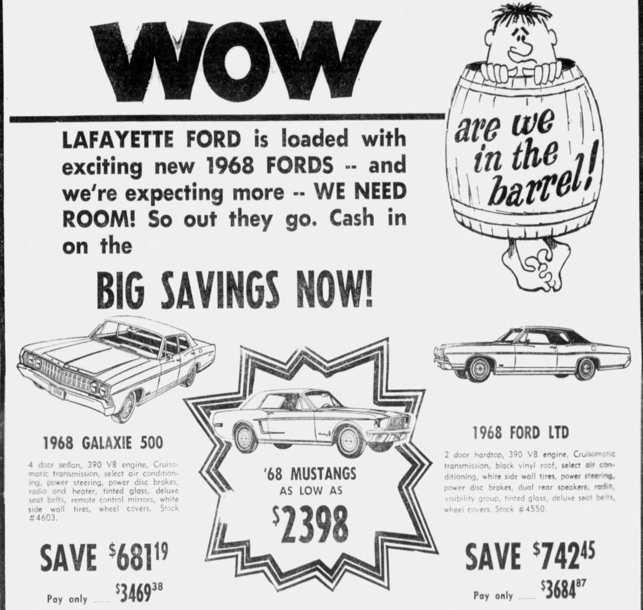

Exhibit C2. The other West-only special: Mustang GT/CS "California Special"
March 1 - April 5, 1968 (ads and articles in five papers) | Relevance: Context: a parallel promotion your dealer did advertise
Page links: Contra Costa Times Mar 22 p. 26 (shown); Concord Transcript Mar 21 p. 9 (shown); CTC Mar 28 p. 9; CTC Apr 4 p. 7; CCT Mar 8 p. 40; CCT Apr 5 p. 15; Ventura County Star Mar 1 p. 25; Palos Verdes Peninsula News Mar 13; article: Santa Rosa Press Democrat Mar 1; article: Napa Valley Register Mar 13 p. 20
- What it says. "Driving California wild! Mustang GT/CS ... Drive a new California Special at your Ford Dealer's now." In the Contra Costa Times it is signed by Rett-White and Lafayette; in the Concord Transcript (second image) it is signed by Earl Williams Ford, three times (Mar 21, Mar 28, Apr 4). Barber Ford (Ventura) and a Palos Verdes dealer (a "lime-gold" GT/CS, Mar 13 and 17) ran their own GT/CS ads.
- Press coverage. The Napa Valley Register (Mar 13) reported that the GT/CS was sold only in California sales districts, was built at the San Jose plant and cost $194 more. The Santa Rosa Press Democrat (Mar 1) covered a GT/CS display at Bishop-Hansel Ford.
- Why it matters for your car. Your dealer took part in this West-only special under the Earl Williams name, and stocked one (stock #545, B7 and B10). That makes it plausible the same dealer took part in the Rainbow promotion a few weeks earlier, even though no Rainbow ad from it has been found. Not being named in a county-paper co-op ad (as in A1) does not show a dealer stayed out.
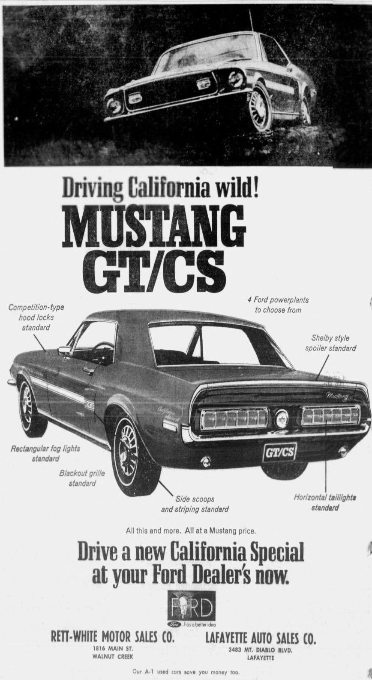
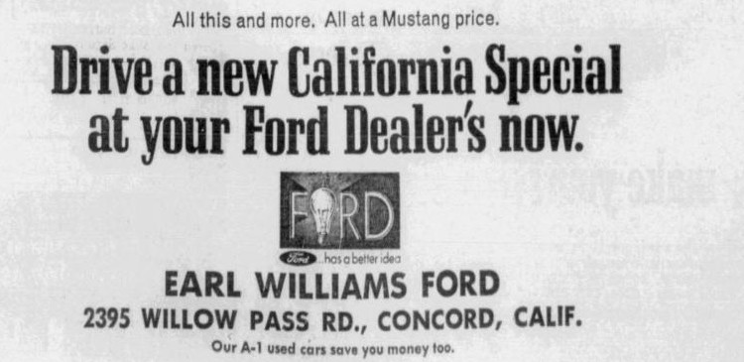

Exhibit C3. Curt Carter Ford: '68 Mustang hardtop "finished in Sunlit Gold"
April 7 and 12, 1968 | Relevance: Context: a regular-production gold
Page links: Contra Costa Times Apr 7 p. 58 (shown); Concord Transcript Apr 12 p. 17
- What it says. Curt Carter Ford, Martinez: a '68 Mustang hardtop with V8, automatic, power steering, radio, heater and tinted glass, "finished in Sunlit Gold. #C-28. List price $3317," on sale for $2875. The same ad ran in the Concord Transcript on April 12.
- Other Sunlit Gold Fords. Sunlit Gold also appears on a 1968 LTD (Ventura County Star, Feb 23 and Mar 3) and a 1968 Falcon (San Bernardino Sun, Mar 3). It was a regular 1968 Ford color.
- Why it matters for your car. A gold 1968 Mustang in Concord was not automatically a special-paint car. Your Marti report's "Special Paint" entry already rules out a regular color like Sunlit Gold, but the paint test should still compare your surviving original paint against Sunlit Gold as well as WT3822, to confirm the surviving coat is the factory paint.
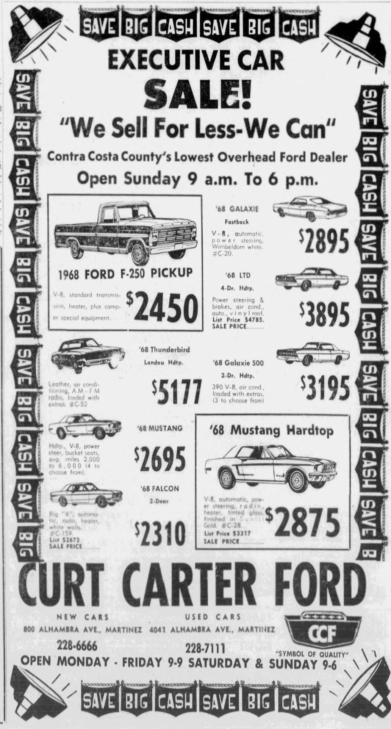

Exhibit C4. Rett-White: "1968 Mustangs, Choice of Colors & Style"
Thursday, April 25, 1968 | Relevance: Context
Page links: Concord Transcript Apr 25 p. 16
- What it says. "1968 Mustangs. Choice of Colors & Style. Priced for spring from $2438, #3701."
- Why it matters. A week before your car sold, the nearest Rainbow dealer was still clearing new Mustangs and selling on color choice, a week after its last "Rainbow Specials" classified (A12).
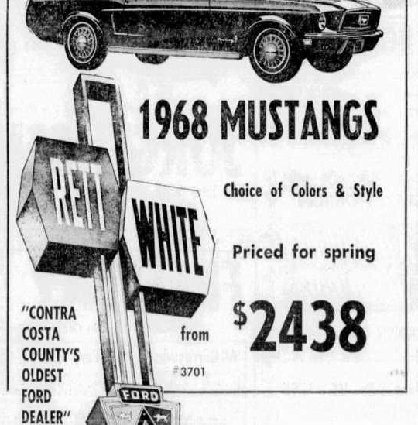

Exhibit C5. "Mustang, new 1968, won in contest"
March 13 and 14, 1968 | Relevance: Minor curiosity
Page links: Contra Costa Times Mar 13 p. 39 (shown); Mar 14 p. 33
- What it says. "MUSTANG, new 1968, won in contest, R&H, license paid, $2700. 682-8997 after 5 p.m." The 682 prefix is a Concord/Pleasant Hill exchange.
- Why it is included. Nothing ties it to your car (yours was sold through the dealer on May 2 under order type STOCK), but it is worth knowing if another local 1968 Mustang story comes up.
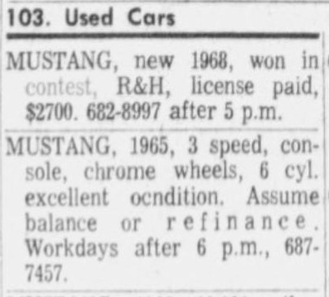

Sources
All links open the archived page in the California Digital Newspaper Collection (cdnc.ucr.edu). Paper codes: AGVHR Arroyo Grande Valley Herald-Recorder; AJ Auburn Journal; CCT Contra Costa Times; CTC Concord Transcript; CWR Cloverdale Reveille; ER Chico Enterprise-Record; FT Folsom Telegraph; HPNHJ Highland Park News-Herald & Journal; HS Hanford Sentinel; LGT Los Gatos Times; LNM Lincoln News Messenger; MT Madera Tribune; MVR Mill Valley Record; NVR Napa Valley Register; OT Oakland Tribune; PAC Petaluma Argus-Courier; PVPN Palos Verdes Peninsula News; RBDN Red Bluff Daily News; RPT Roseville Press-Tribune; SCS Santa Cruz Sentinel; SRPD Santa Rosa Press Democrat; SWTN Sebastopol Times; TP Tracy Press; VCS Ventura County Star.
- Exhibit A1: CCT 1968-02-15 https://cdnc.ucr.edu/?a=d&d=CCT19680215.1.13; OT 1968-02-14 https://cdnc.ucr.edu/?a=d&d=OT19680214.1.46; LGT 1968-02-14 https://cdnc.ucr.edu/?a=d&d=LGT19680214.1.12; SCS 1968-02-15 https://cdnc.ucr.edu/?a=d&d=SCS19680215.1.5; RPT 1968-02-15 https://cdnc.ucr.edu/?a=d&d=RPT19680215.1.5; NVR 1968-02-15 https://cdnc.ucr.edu/?a=d&d=NVR19680215.1.16; PAC 1968-02-21 https://cdnc.ucr.edu/?a=d&d=PAC19680221.1.13
- Exhibit A2: AGVHR 1968-02-15 https://cdnc.ucr.edu/?a=d&d=AGVHR19680215.1.7; MT 1968-02-14 https://cdnc.ucr.edu/?a=d&d=MT19680214.2.62; MVR 1968-02-14 https://cdnc.ucr.edu/?a=d&d=MVR19680214.2.57; RBDN 1968-02-14 https://cdnc.ucr.edu/?a=d&d=RBDN19680214.1.10; SWTN 1968-02-15 https://cdnc.ucr.edu/?a=d&d=SWTN19680215.1.9; CWR 1968-02-15 https://cdnc.ucr.edu/?a=d&d=CWR19680215.1.6; AJ 1968-02-15 https://cdnc.ucr.edu/?a=d&d=AJ19680215.1.27; LNM 1968-02-15 https://cdnc.ucr.edu/?a=d&d=LNM19680215.1.6; FT 1968-02-15 https://cdnc.ucr.edu/?a=d&d=FT19680215.1.10; TP 1968-02-16 https://cdnc.ucr.edu/?a=d&d=TP19680216.1.7; ER 1968-02-22 https://cdnc.ucr.edu/?a=d&d=ER19680222.1.10
- Exhibit A3: NVR 1968-02-13 https://cdnc.ucr.edu/?a=d&d=NVR19680213.1.1; NVR 1968-02-15 https://cdnc.ucr.edu/?a=d&d=NVR19680215.1.15
- Exhibit A4: CCT 1968-02-16 https://cdnc.ucr.edu/?a=d&d=CCT19680216.1.41
- Exhibit A5: CCT 1968-02-16 https://cdnc.ucr.edu/?a=d&d=CCT19680216.1.42
- Exhibit A6: FT 1968-02-15 https://cdnc.ucr.edu/?a=d&d=FT19680215.1.10
- Exhibit A7: HS 1968-02-24 https://cdnc.ucr.edu/?a=d&d=HS19680224.1.45
- Exhibit A8: HPNHJ 1968-02-29 https://cdnc.ucr.edu/?a=d&d=HPNHJ19680229.2.105
- Exhibit A9: VCS 1968-03-01 https://cdnc.ucr.edu/?a=d&d=VCS19680301.1.24
- Exhibit A10: SRPD 1968-03-08 https://cdnc.ucr.edu/?a=d&d=SRPD19680308.1.6
- Exhibit A11: PAC 1968-03-12 https://cdnc.ucr.edu/?a=d&d=PAC19680312.1.11
- Exhibit A12: CCT 1968-04-12 https://cdnc.ucr.edu/?a=d&d=CCT19680412.1.32; CCT 1968-04-14 https://cdnc.ucr.edu/?a=d&d=CCT19680414.1.43; CCT 1968-04-16 https://cdnc.ucr.edu/?a=d&d=CCT19680416.1.21; CCT 1968-04-17 https://cdnc.ucr.edu/?a=d&d=CCT19680417.1.65; CCT 1968-04-18 https://cdnc.ucr.edu/?a=d&d=CCT19680418.1.42
- Exhibit B1: CCT 1968-02-14 https://cdnc.ucr.edu/?a=d&d=CCT19680214.1.31; CCT 1968-02-21 https://cdnc.ucr.edu/?a=d&d=CCT19680221.1.46; CCT 1968-02-23 https://cdnc.ucr.edu/?a=d&d=CCT19680223.1.28
- Exhibit B2: CCT 1968-02-29 https://cdnc.ucr.edu/?a=d&d=CCT19680229.1.40; CTC 1968-03-01 https://cdnc.ucr.edu/?a=d&d=CTC19680301.1.13; CTC 1968-03-04 https://cdnc.ucr.edu/?a=d&d=CTC19680304.1.13
- Exhibit B3: CCT 1968-03-08 https://cdnc.ucr.edu/?a=d&d=CCT19680308.1.36; CCT 1968-03-10 https://cdnc.ucr.edu/?a=d&d=CCT19680310.1.44; CTC 1968-03-07 https://cdnc.ucr.edu/?a=d&d=CTC19680307.1.15; CTC 1968-03-08 https://cdnc.ucr.edu/?a=d&d=CTC19680308.1.16
- Exhibit B4: CTC 1968-03-07 https://cdnc.ucr.edu/?a=d&d=CTC19680307.1.13
- Exhibit B5: CTC 1968-03-12 https://cdnc.ucr.edu/?a=d&d=CTC19680312.1.9; CTC 1968-04-16 https://cdnc.ucr.edu/?a=d&d=CTC19680416.1.11
- Exhibit B6: CCT 1968-03-15 https://cdnc.ucr.edu/?a=d&d=CCT19680315.1.33; CTC 1968-03-15 https://cdnc.ucr.edu/?a=d&d=CTC19680315.1.19
- Exhibit B7: CCT 1968-03-29 https://cdnc.ucr.edu/?a=d&d=CCT19680329.1.40; CTC 1968-03-27 https://cdnc.ucr.edu/?a=d&d=CTC19680327.1.23; CCT 1968-03-22 https://cdnc.ucr.edu/?a=d&d=CCT19680322.1.43; CTC 1968-03-21 https://cdnc.ucr.edu/?a=d&d=CTC19680321.1.14
- Exhibit B8: CTC 1968-04-01 https://cdnc.ucr.edu/?a=d&d=CTC19680401.1.12
- Exhibit B9: CTC 1968-04-09 https://cdnc.ucr.edu/?a=d&d=CTC19680409.1.6
- Exhibit B10: CCT 1968-04-12 https://cdnc.ucr.edu/?a=d&d=CCT19680412.1.35; CTC 1968-04-10 https://cdnc.ucr.edu/?a=d&d=CTC19680410.1.19; CCT 1968-04-05 https://cdnc.ucr.edu/?a=d&d=CCT19680405.1.41; CTC 1968-04-03 https://cdnc.ucr.edu/?a=d&d=CTC19680403.1.23
- Exhibit B11: CCT 1968-04-19 https://cdnc.ucr.edu/?a=d&d=CCT19680419.1.43; CTC 1968-04-17 https://cdnc.ucr.edu/?a=d&d=CTC19680417.1.21
- Exhibit B12: CTC 1968-04-09 https://cdnc.ucr.edu/?a=d&d=CTC19680409.1.17; CTC 1968-05-02 https://cdnc.ucr.edu/?a=d&d=CTC19680502.1.17
- Exhibit B13: CTC 1968-04-25 https://cdnc.ucr.edu/?a=d&d=CTC19680425.1.17
- Exhibit C1: CCT 1968-03-17 https://cdnc.ucr.edu/?a=d&d=CCT19680317.1.39; CCT 1968-03-15 https://cdnc.ucr.edu/?a=d&d=CCT19680315.1.32
- Exhibit C2: CCT 1968-03-22 https://cdnc.ucr.edu/?a=d&d=CCT19680322.1.26; CTC 1968-03-21 https://cdnc.ucr.edu/?a=d&d=CTC19680321.1.9; CTC 1968-03-28 https://cdnc.ucr.edu/?a=d&d=CTC19680328.1.9; CTC 1968-04-04 https://cdnc.ucr.edu/?a=d&d=CTC19680404.1.7; CCT 1968-03-08 https://cdnc.ucr.edu/?a=d&d=CCT19680308.1.40; CCT 1968-04-05 https://cdnc.ucr.edu/?a=d&d=CCT19680405.1.15; VCS 1968-03-01 https://cdnc.ucr.edu/?a=d&d=VCS19680301.1.25; PVPN 1968-03-13 https://cdnc.ucr.edu/?a=d&d=PVPN19680313.2.123; SRPD 1968-03-01 https://cdnc.ucr.edu/?a=d&d=SRPD19680301.1.13; NVR 1968-03-13 https://cdnc.ucr.edu/?a=d&d=NVR19680313.1.20
- Exhibit C3: CCT 1968-04-07 https://cdnc.ucr.edu/?a=d&d=CCT19680407.1.58; CTC 1968-04-12 https://cdnc.ucr.edu/?a=d&d=CTC19680412.1.17
- Exhibit C4: CTC 1968-04-25 https://cdnc.ucr.edu/?a=d&d=CTC19680425.1.16
- Exhibit C5: CCT 1968-03-13 https://cdnc.ucr.edu/?a=d&d=CCT19680313.1.39; CCT 1968-03-14 https://cdnc.ucr.edu/?a=d&d=CCT19680314.1.33
- Search starting point (your link): CDNC browse, Contra Costa Times, 7 Feb - 2 May 1968

