1968 Mustang Special Order Research
Evidence-Supported Status Report | Revision 6 | VIN 8R01C142219 | 27 October 2026
This revision replaces the earlier reports. Revision 2 added the period newspaper clippings in Rainbow of Colors Articles.docx and an independent check of each earlier claim. Revision 3 adds searches of the California Digital Newspaper Collection (Concord Transcript, Contra Costa Times and other papers), which date the dealership's ownership change. Revision 4 traces the people: when Earl Williams opened the dealership, when the Grable brothers took over its management (May 1967, eight months before your car was ordered), and where they went afterwards. Revision 5 adds corrections and new detail from a page-by-page image review of the Contra Costa Times, February 7 to May 2, 1968 (the companion keyword-search document). Revision 6 adds the findings from searches of Facebook and the Vintage Mustang Forum that strongly support the history (details in the companion Facebook_VMF_Findings.docx). It keeps the owner's edits to Revision 4: the changes table is removed and the next-step statuses are as updated by the owner, with Revision 6 additions marked "Rev. 6."

Executive conclusion
Documented. 8R01C142219 is a San Jose-built 1968 Mustang hardtop with factory special paint ("Ford # unknown") under special order 72-1188, scheduled 16B (February 16, 1968). Earl Williams Ford of Concord (dealer 72B023) ordered it for stock on January 23, 1968, and it was sold on May 2, 1968.
Probable. The car was ordered for the February 1968 West Coast special-paint promotion that Ford advertised as the "Mustang Rainbow Sale." Its order number sits among documented Rainbow orders scheduled for the same day. The January "Color of the Month" promotion is a less likely alternative that cannot yet be ruled out.
Plausible, not proven. The original color was Ford special paint WT3822, called Spanish Gold in Rainbow research and Black Hills Gold in the Color of the Month promotion. The only evidence so far is a visual identification by a restoration shop. An instrument match of protected original paint is still needed.
New from the period newspapers. Ford's "Mustang Rainbow Sale" ran in the Contra Costa Times on February 15 and 16, 1968, naming Rett-White Ford (Walnut Creek) and Lafayette Ford, not Earl Williams Ford. The Concord Transcript, where Earl Williams Ford placed its Ford ads, is online for 1968 except January and February, the Rainbow launch weeks. The online issues from March through June carry no Rainbow ad, but they do date a change of ownership: the dealership traded as "Concord Ford" from February 29, 1968, switched to "Sun Valley Ford" between May 3 and May 13, and by October 1968 was owned by Vaughn Grable. Your car was sold on May 2, in the last days of the "Concord Ford" name.
New in Revision 4: the Grables ran the store when your car was ordered. Earl Williams opened his Ford dealership at 2395 Willow Pass Road in July 1963. From May 24, 1967, Earl Williams Ford ads announce that brothers Vaughn and Rawley Grable, formerly of an Alameda Ford dealer, were "back home in Contra Costa" and "running the show," with Chuck Hillery and others. On January 25, 1968, two days after your car's order was received, an Earl Williams Ford ad told buyers that "Vaughn and Rawley Grable have a better idea for 1968." So the stock order for 72-1188 was almost certainly placed by the Grable management team, not by Earl Williams personally. Vaughn Grable later owned Sun Valley Ford, then Concord Toyota (1971-1978 at least).
New in Revision 5: corrections from the page images. A page-by-page image review of the Contra Costa Times for February 7 to May 2, 1968 corrects the Rett-White "Rainbow Specials" price to $2,950 and $2,947 (not $3,047). It dates the last Earl Williams Ford used-car ad to February 23, under the slogan "Concord Is FORD Country," six days before "Concord Ford" first appears. It adds salesman Hugh Gildea to the staff list and records the three new Mustangs Concord Ford advertised (stock #65, #545, #176), none matching your car. It also flags a regular-production Sunlit Gold Mustang sold locally, which the paint test should rule out. No Earl Williams Ford or Concord Ford ad in that paper mentions Rainbow or special colors.
New in Revision 6: the neighboring orders, from owners online. The owner of order 72-1187, the number just before yours, posted his Marti report on Facebook in reply to your request: 8R01C139349, a San Jose C-code hardtop with "Special Paint, Ford # unknown," a black vinyl roof, order type STOCK and the same 16B (February 16) schedule, ordered January 25, 1968 by Kleinman Cole Ford of Oakland; he reports it is Madagascar Orange and sits between two other Madagascar Orange coupes. On the Vintage Mustang Forum, a 72-1192 door tag (8R01J142233, 16B) puts a Sierra Blue order only 14 serial numbers after yours, and a 72-1192 owner reports original Sierra Blue paint and a Marti report tying the car to the Rainbow of Colors. Jeff Speegle, a long-time special-paint researcher, wrote in April 2026 that these promotion cars were ordered "all the same color" in large groups under one DSO. Together these strengthen the Rainbow reading for 72-1188; the grade stays Probable because no record yet names 1188's color or program.
Work in progress. A paint analysis by a restoration shop is scheduled, and the Contra Costa County Historical Society has been asked to search its microfilm of the missing January-February 1968 Concord Transcript issues.

1. How to read the evidence grades
Grade | Meaning
Proven | Supported by a primary record: Ford/Marti data, a data plate, or a dated period newspaper.
Probable | Several independent lines of evidence agree, but no direct record exists.
Plausible | Consistent with the evidence but resting on one weak or indirect source.
Speculative | A lead only; the key links are unverified.
Unresolved | No usable evidence yet.

2. Core facts from the Marti report
Item | Record | Grade
Identity | VIN 8R01C142219; 1968; San Jose (R); 2-door hardtop (65A); C-code 289-2V V-8 | Proven
Paint and trim | Blank paint code, "Special Paint, Ford # unknown"; 2A black vinyl standard bucket seats | Proven
Order | DSO 721188: "San Jose Ordering District under Paint or Tire Order # 1188." Order type STOCK. DSO item # 5783 | Proven
Dates | Order received 1/23/68; serialized 2/2; bucked 2/12; built and released 2/14; scheduled 2/16 (16B); sold 5/2/68 | Proven
Dealer | Dealer 72B023, Earl Williams Ford, 2395 Willow Pass Rd, Concord | Proven as ordering dealer; retail sale there very likely
Equipment | Black vinyl roof, SelectAire A/C, power steering, AM radio, tinted glass, electric clock, wheel covers, heavy-duty suspension, FR70X14 wide-oval radial whitewalls; 2.79 axle; C4 automatic | Proven
Statistics | 5,063 1968 hardtops with special paint; 13,902 hardtops ordered from DSO 72 | Proven, but these count every special-paint car, not one promotion or color

Marti's dealer field records the ordering dealer. Because this was a stock order placed for the dealer's own inventory, the retail sale almost certainly took place there, but no sales document has been seen.

3. The Rainbow Sale in period newspapers
Date (1968) | Paper | Dealer | What the ad says | Grade
Feb 7 | Sacramento Bee | Suburban Ford, Auburn | "10 specially new, turned-on colors." Earliest Rainbow ad known to MustangAttitude | Proven (reported by MustangAttitude)
Feb 13 | Napa Valley Register, p. 1 | Sullivan Ford, Napa | "Mustang Rainbow Sale Now On!!!" | Proven (CDNC search, Rev. 3)
Feb 14 | Ukiah Daily Journal | Underwood Ford | "Limited edition Mustangs, 10 special colors! Only for the West! Mustang Rainbow Sale" | Proven (reported)
Feb 14 | Madera Tribune; Mill Valley Record | Not shown in search results | Ford ad: "10 special colors! Only for the West! Mustang Rainbow Sale, 500 only - hurry for yours" | Proven (CDNC search, Rev. 3)
Feb 15 | Contra Costa Times, p. 13 | Rett-White Ford, Walnut Creek; Lafayette Ford, Lafayette | Ford co-op ad: "500 only, and only in the West ... in 10 special Western Rainbow colors. Hardtops, fastbacks, convertibles. Limited-time event." | Proven (clipping in hand; Exhibit A)
Feb 16 | Contra Costa Times, p. 41 | Lafayette Ford | "'68 Mustang Rainbow Sale ... starting at this very low price! $2487 ... 10 special colors ... Hurry! Limited supply!" Includes radio and heater, tinted glass, whitewalls, bucket seats | Proven (clipping in hand; Exhibit B)
Feb 15 | Folsom Telegraph; Auburn Journal; Napa Valley Register | Bob West Ford, Folsom; others | "Rainbow Mustang values at Bob West Ford"; "Mustang Rainbow Sale"; Ford co-op text "10 special Western Rainbow colors" | Proven (CDNC search, Rev. 3)
Feb 16 | Modesto Bee; Valley News and Green Sheet | Griswold & Wight; Galpin Ford | "Mustang Rainbow Sale, 10 special colors"; "Rainbow Sale" | Proven (reported)
Feb 29, Mar 7 | Highland Park News-Herald & Journal | City Ford | "68 Mustang Rainbow Sale. Every color in the rainbow!" | Proven (CDNC search, Rev. 3)
Apr 12-18 (5 days) | Contra Costa Times classifieds | Rett-White Ford, Walnut Creek (phone 932-1313) | "New '68 Mustangs, Rainbow Specials, fully equipped ... $2950 [Apr 12; $2947 Apr 17] ... No cash necessary ... Ask for CHRIS only" (prices read from page images, Rev. 5) | Proven (page images, Rev. 5)

What this means for the car
- Program terms confirmed first-hand. The February 15 Contra Costa Times ad states the terms directly: 500 cars, ten colors, Western states only, all three body styles, for a limited time.
- Timing fits pre-ordered stock. Your car was ordered January 23, about two weeks before the earliest known ad. That fits a dealer ordering inventory ahead of the launch. The research transcript reports that MotorTrend found the same pattern on another Rainbow car ordered January 30 (not re-checked).
- Earl Williams is missing from the county co-op ad. The February 15 Ford ad in the county's main daily named only two dealers. Earl Williams Ford placed its Ford co-op ads in the Concord Transcript, so the open question is whether the Transcript ran its own version of the Rainbow ad naming Earl Williams.
- The key Transcript issues are not online. The California Digital Newspaper Collection has the Concord Transcript from September 1966 to February 1978, but January and February 1968 are missing; searches for "Concord," "Mustang" and "Rainbow" return nothing for those months, while the same searches find the known ads in the Contra Costa Times. The online Transcript issues from March through June 1968 carry no Rainbow ad from any dealer. The February issues survive on microfilm, and the Contra Costa County Historical Society has been asked to search them.
- The promotion ran into April locally. Rett-White Ford was still advertising "Rainbow Specials" five times between April 12 and 18, 1968, at $2,950 and then $2,947, so a Concord dealer could have sold a Rainbow car in early May. (Earlier revisions quoted $3,047, an OCR misreading.)
- No Rainbow wording in any Concord dealer ad (Rev. 5). A page-by-page image check of every Earl Williams Ford and Concord Ford ad in the Contra Costa Times from February 7 to May 2, 1968 found no mention of Rainbow, special colors or special paint, and none of the Rainbow color names appears in any car ad in that paper.

4. Earl Williams Ford: dealer history
Date | Source | Finding
Jul 19-20, 1963 | Contra Costa Times, Jul 19, 1963, p. 3 | Earl Williams Ford opens at 2395 Willow Pass Rd. Profile: San Jose State psychology graduate, Stanford Graduate School of Business master's, military personnel officer 1953-55; with a San Jose Ford dealer 1956-61, then a used-car lot and a Viking mobile-home franchise. Wife Judy; children Gregory and Candi. A great-uncle, also Earl Williams, had lived on Bonifacio St, Concord, for 43 years
Nov 26, 1964 | Contra Costa Times, p. 1 | Earl Williams announces a million-dollar dealership complex in Meridian Park, next to the Pontiac agency
1963-1965 | Oakland Tribune classifieds | Vaughn Grable hires salesmen for an Alameda Ford dealer at 1650 Park St ("21 years Ford dealer in East Bay"; phone 523-2745)
1966 | Shelby invoice (eBay listing) | Earl Williams Ford of Concord invoiced for a 1966 Shelby
May 24-28, 1967 | Contra Costa Times, May 25, 1967, p. 35 | "Beautiful to be back home in Contra Costa": Vaughn Grable, Rawley Grable, Chuck Hillery, Pat Adams, Jay Gannett and Doug Carrico, "Homecoming Specials," signed "Concord's Franchised Ford Dealer, Earl Williams Ford, 2395 Willow Pass Rd"
May-June 1967 | Contra Costa Times; Oakland Tribune | Same team advertises as the "Straight Shooters"
Jul 2, 1967 | Contra Costa Times, p. 40 | "The Grable Bros are back. Vaughn and Rawley are running the show," Earl Williams Ford, 686-5000
Jan 23, 1968 | Marti report | Your car's order received
Jan 25, 1968 | Contra Costa Times, p. 42 | Earl Williams Ford ad: "Concord Ford Country ... Vaughn and Rawley Grable have a better idea for 1968 ... buy direct from managers," listing managers Boyars, Bradshaw, Erdy, Hillery and Sargent
Feb 14, 21 and 23, 1968 | Contra Costa Times, pp. 31, 46, 28 | Earl Williams Ford used-car column, "Concord Is FORD Country ... Clean Sweep Sale," signed "Earl Williams Ford, Salvio and East, Across from Post Office, Concord ... 686-6600, 686-6601" (Exhibit C shows Feb 21). Feb 23 is the last used-car ad signed Earl Williams Ford (Rev. 5); the slogan appears to be the source of the "Concord Ford" name
Feb 29, 1968 | Contra Costa Times, p. 40 | Earliest "Concord Ford" name found as the dealer's trading name, six days after the last "Earl Williams Ford" used-car ad
Mar 1, 1968 | Concord Transcript, pp. 13-14 | "Concord Ford" used-car ads, "Across From Post Office, 686-6600" (the first Transcript issue online after the January-February gap)
Mar 6, 1968 | Concord Transcript, p. 3 | Chamber of Commerce Trade Club sponsors photo. Earl Williams Ford is listed as an additional sponsor; Earl Williams himself is not among the men pictured or named
Mar 7, 1968 | Concord Transcript, p. 13 | Legal notice: Nelson Neon applies for a use permit for four free-standing signs at 1881 Diamond Blvd, Meridian Park, for Earl Williams Ford; hearing March 20, 1968 (Exhibit F)
Mar 7-8, 1968 | Concord Transcript | Used-car ads: "Concord Ford, Rawley Grable or Chuck Hillery (across from Post Office)"
Mar 12, 1968 | Concord Transcript, p. 9 | Ford co-op ad, "New low-priced Mustang Sprint," Earl Williams Ford, 2395 Willow Pass Rd
Mar 21, Mar 28, Apr 4, 1968 | Concord Transcript | Three Ford co-op ads for the Mustang GT/CS California Special, Earl Williams Ford, 2395 Willow Pass Rd
Mar 15, 1968 | Contra Costa Times, p. 33 | First Concord Ford full-page display ad ("Nuttiest Sale of the Year"): new 1968 Mustang hardtop, Cruisomatic, power steering, stock #65, $2747.99 (Rev. 5)
Mar 29 and Apr 12, 1968 | Contra Costa Times, pp. 40, 35 | Concord Ford "Savings Derby" and "Easter Sale": new 1968 Mustang California Special G/S, stock #545, $2767.89; staff list with Vaughn and Rawley Grable as sales managers; "128 new cars in stock" (Rev. 5)
Apr 19, 1968 | Contra Costa Times, p. 43 | "Concord Ford": new-car showroom at 2395 Willow Pass Rd, 686-5000; used-car lot across from the Post Office, 686-6600; "128 new cars in stock"; new 1968 Mustang hardtop, V-8, automatic, stock #176, $2797.72; full staff list, adding salesman Hugh Gildea (Exhibit D; Rev. 5)
April 1968 | Concord Transcript (Apr 3 or Apr 25) | Salesman ad: "Lou Burmester ... Concord Ford, 2395 Willow Pass Road, 686-5000" (Exhibit E)
Apr 25, 1968 | Concord Transcript, p. 10 | Ford co-op ad ("See the light"), Earl Williams Ford, 2395 Willow Pass Road
Apr 4-May 3, 1968 | Concord Transcript business directory | "Concord Ford, 2395 Willow Pass Rd, 686-5000 ... Leasing plans, open evenings 'til 9 pm"; last "Concord Ford" listing May 3
May 2, 1968 | Marti report | Your car sold
May 13, 1968 | Concord Transcript, p. 12 | Earliest "Sun Valley Ford": same directory listing, 2395 Willow Pass Rd, 686-5000
May 14, 1968 | Concord Transcript, p. 16 | Photo caption: building under construction in Meridian Park, next to Buchanan Field, "for a new Ford agency under the direction of Vaughn Grable," who says it will be one of the most modern agencies in the county
May 16, 1968 | Concord Transcript, p. 8 | Last Ford co-op ad found under the Earl Williams Ford name
Jul 3, 1968 | Concord Transcript, p. 21 | Full staff roster, two months after your car's sale: salesmen Emery Erdy, Chuck Hillery, Ken Boyars, Don Head, John Ellis, Walt Madeiros, Dick Sargent, Ron Bradshaw, Lou Burmester, J.P. "Jonesy" Jones, Charlie Scudder and Jim Corbett; sales managers Vaughn Grable, Rawley Grable and Marvin Mikel; fleet and truck manager Dick Palmer; insurance and credit, Robert Cope
Jul-Aug 1968 | Concord Transcript | Sun Valley Ford used cars at Salvio and East, opposite the post office; new cars at 2395 Willow Pass Road, 686-5000
Sep 18-27, 1968 | Contra Costa Times; Concord Transcript | Rawley Grable described as Sun Valley Ford manager; new showrooms and service facilities "along Concord Ave"
Oct 1, 1968 | Concord Transcript, p. 60 | "Vaughn Grable - Owner, Sun Valley Ford"
Jan 20, 1969 | Concord Transcript (reported in the research transcript; not re-checked) | "Sun Valley Ford, 1881 Diamond Way, 686-5000"
Feb 19-25, 1969 | Concord Transcript | Rawley Grable named "co-owner of Sun Valley Ford"
1971-1978 | Contra Costa Times; Concord Transcript | Vaughn Grable ("17 yrs Ford dealer") runs the new Concord Toyota, still listed there in October 1978
1997 | Lithia Motors press release | Sun Valley Ford Volkswagen Hyundai of Concord, owned by Edmund Bartlett, agreed to be sold to Lithia
Today | California DCA license record | Future Ford Lincoln of Concord, 2285 Diamond Blvd, (925) 686-5000

Findings
- The Grables managed the store from May 1967 (Proven). Ads signed by Earl Williams Ford from May 24, 1967 name Vaughn and Rawley Grable as the team "running the show." Vaughn Grable had been hiring salesmen for an Alameda Ford dealer in 1963-1965, which explains the "back home in Contra Costa" wording. Your car's January 23, 1968 stock order was therefore placed while the Grables ran sales, and the January 25 ad shows them promoting the 1968 line two days later.
- A change of ownership in spring 1968 (Probable). The last used-car ad under "Earl Williams Ford" found in the Contra Costa Times is February 23, 1968, under the slogan "Concord Is FORD Country"; "Concord Ford" appears from February 29, and "Sun Valley Ford" from May 13, while Ford's factory co-op ads kept the franchise name "Earl Williams Ford" until mid-May. Vaughn Grable was directing the new building by May 14 and was named as owner by October 1; Rawley Grable was co-owner by February 1969. This points to the Grables buying the franchise from Earl Williams around late February 1968 and renaming it in two steps. No sale announcement has been found; it may be in the missing January-February Concord Transcript issues.
- Your car sold at the turning point. It was ordered on January 23 under Earl Williams Ford, with the Grables managing, and sold on May 2, the last week of the "Concord Ford" name. Whoever handled the sale was most likely on the team listed in the April 19 and July 3, 1968 ads.
- Earl Williams himself (Documented, 1963). His 1963 opening profile gives the details that make an obituary search possible: San Jose State and Stanford business school graduate, born around 1930, wife Judy, children Gregory and Candi, earlier with a San Jose Ford dealer. No obituary has been found online. He does not appear in the 1968 ads, which fits an owner who had handed day-to-day running to the Grables before selling.
- New-Mustang stock at the dealership (Rev. 5). Concord Ford's display ads featured three new 1968 Mustangs between March 15 and April 19: hardtop stock #65, California Special G/S stock #545 (still unsold after two weeks) and hardtop stock #176. None lists your car's air conditioning or vinyl roof, and none is described in a special color, so none is identifiable as your car. A dealer stock number found on the car (grease pencil, window sticker) could be checked against these.
- Move to Diamond Boulevard (Probable). Earl Williams Ford applied for signs at 1881 Diamond Blvd in Meridian Park in March 1968; Grable's new building was going up in Meridian Park in May; and by January 1969 Sun Valley Ford was at 1881 Diamond with the same 686-5000 number. Sunvalley Shopping Center opened nearby in August 1967, which likely explains the new name (an inference).
- One phone line, 58 years. The 686-5000 number is proven for April 1968 and today, and its continuity through Sun Valley Ford is probable. It is now used by Future Ford of Concord, which says it opened in 2004.
- People leads. The April 19 Concord Ford ad names the staff who could have handled your car: salesmen Emery Erdy, Chuck Hillery, Ken Boyars, Don Head, John Ellis, Walt Madeiros, Dick Sargent, Ron Bradshaw and Lou Burmester; sales managers Vaughn and Rawley Grable; fleet and truck manager Dick Palmer; and Robert Cope in insurance and credit. The same ad adds salesman Hugh Gildea, not in earlier lists (Rev. 5). By June and July the list also included J.P. "Jonesy" Jones, Charlie Scudder, Jim Corbett, John Kane and sales manager Marvin Mikel (spelled Mikles in one ad). The 1967 team also included Pat Adams, Jay Gannett and Doug Carrico. No obituaries for any of them were found online; Section 10 lists the channels most likely to reach families.

5. Special orders 72-1185 to 72-1194
Order | Cars on record | Sched. | Color evidence | Grade
1185 | At least 2 plates (axle codes 5 and 2); one car sold in Honolulu | 16B | Yellow. MustangAttitude: "possibly Whipped Cream." An older list credited to Mustang Monthly (July 1998) pairs 1185 with Dandelion Yellow | Probable yellow; name disputed
1186 | 8R01T141534 (six-cylinder, 3-speed) | 16B | None | Proven special paint; color unresolved
1187 | 8R01J139475 plus two other plates; 8R01C139349 (Marti report posted by its owner: C-code hardtop, black vinyl roof, 4-speed, STOCK order received Jan 25, 1968, built Feb 6, dealer 72B020 Kleinman Cole Ford, Oakland, sold Jul 19, 1968; Rev. 6) | 16B | Madagascar Orange, surviving cars; owner says 139349 sits between two consecutive Madagascar Orange coupes (Rev. 6) | Probable (strong)
1188 | 8R01C142219 (this car) | 16B | Gold, by visual inspection only | Proven special paint; color plausible
1189 | None found | - | None | Unresolved
1190 | 8R01C138813, 8R01C138859 (ISOM) | 06B | Pink: older list gives "Hot Pink - 1190"; a "Pink" note in the Production Guide is reported but not seen | Probable pink; program uncertain
1191 | None confirmed | - | An earlier "Salmon" claim could not be reproduced | Unresolved
1192 | 8R01C (partial VIN); 8R01J142233 (door tag posted 2007: 65A, paint blank, 2B, 16B; Rev. 6) | 16B | Sierra Blue; Paul Swanson Ford, San Jose. A 1192 owner reports original Sierra Blue found under the repaint and a parchment vinyl roof on his Marti report (Rev. 6) | Probable (strong)
1193 | 8R01J14xxxx | 16B | Probably Poppy Green (WT7034); since repainted | Plausible
1194 | At least 3 configurations (2G and 2Y trim plates; 8R01C140918 with 2A) | 16B | Olive Green; Lou Gerard Motors, Redding | Probable

What the block does and does not show
- A strong pattern. Eight of the ten numbers have a special-paint car on record, and every number with an identified color carries a Rainbow-list paint. An unrelated one-off order is unlikely for 1188.
- Not one dealer's display set. 1187 went to Kleinman Cole Ford in Oakland (Rev. 6), 1192 to Paul Swanson Ford in San Jose and 1194 to Lou Gerard Motors in Redding, so the ten numbers are not one dealer's ten-color order. The evidence fits better with each number being one dealer's order of several cars in a single color. If that holds, 72-1188 was Earl Williams Ford's own order, and any sister 1188 cars were likely sold in the Concord area in the same color. This is a hypothesis, but it now has expert support: Jeff Speegle wrote on the Vintage Mustang Forum (April 2026) that promotion cars were ordered "all the same color" in large groups under one DSO, and that finding another car with the same DSO is the way to learn a car's color (Rev. 6).
- Your car sits in the Rainbow build cluster (Rev. 6). The 72-1192 hardtop 8R01J142233 is only 14 serial numbers after your 142219, and both were scheduled 16B. Forum and Facebook owners report that Rainbow cars were painted in batches and turn up within a few serial numbers of each other (1187 sits between two other Madagascar Orange coupes). Serial numbers near 142219 are therefore the best place to look for a sister car in your color.
- Not one schedule date. 1190 was scheduled February 6, ten days before the others.
- Order number is not a color or a VIN position. Known pairs are out of sequence: 1190 is VIN 138813/138859, 1187 is 139349 and 139475, 1194 is 140918, 1186 is 141534, 1188 is 142219 and 1192 is 142233. Order dates are not strictly in number order either: 1187 was received January 25, two days after 1188 (Rev. 6).
- Database limits. The In Search of Mustangs (ISOM) records and the 2007 Swedish forum transcription both come from the Smart/Haskell Mustang Production Guide data, so they are one source, not two. ISOM also omits known cars, so a "no record" result proves nothing.

6. Rainbow of Colors or Color of the Month?
Points toward Rainbow of Colors | Points toward Color of the Month
Scheduled 16B alongside documented Rainbow orders 1187 and 1192-1194. The 1187 Marti report matches yours in plant, body, engine, special paint, black vinyl roof, STOCK order type and schedule (Rev. 6) | Ordered January 23, in the month when Black Hills Gold (WT3822) was the featured Color of the Month paint
Ordered through DSO 72, the San Jose district where Rainbow cars were sold | Color of the Month paints have turned up on cars ordered outside Denver, including Los Angeles order 71-0778 (Passionate Pink, scheduled 07B)
A stock order by a dealer in the county where the Rainbow Sale was advertised on February 15-16 | The neighboring pink order 1190, scheduled 06B, fits the February Color of the Month better than the Rainbow launch
WT3822 appears on the 13-color Rainbow paint list (1969 Ditzler supplemental bulletin) and the Sherwin-Williams "Rainbow of Colors - 1968 Mustang" fleet list | A June 1968 Ford letter listing the four Color of the Month paints carries a Denver-district header, but cars in those paints are known from other districts

Assessment: Rainbow of Colors is more likely, mainly because the order sits with documented 16B Rainbow orders in the San Jose district and the Color of the Month is tied chiefly to Denver. Grade: Probable, not proven. The name follows the program: "Spanish Gold" if Rainbow, "Black Hills Gold" if Color of the Month. The underlying paint would be WT3822 either way.

7. The original color

Evidence for WT3822
- Restoration shop. A shop visually identified the surviving old paint as Black Hills Gold or Spanish Gold, without instrument testing. The owner believed it was Black Hills Gold beforehand, so the shop may not have been independent. Treat this as consistent evidence, not confirmation.
- Paint lists. WT3822 is on the Rainbow paint lists. Ford's fleet description is "Brown Poly," a brown metallic. MustangAttitude gives the cross-references PPG/Ditzler 23019, DuPont 6762D and Sherwin-Williams 1864.
- Comparator car. Mal Hillier's hardtop (VIN 8R01C142***, San Jose, special order 71-0781, scheduled 23B) had its original trunk paint professionally matched to WT3822. It shares a San Jose build, C-code hardtop body, special paint, automatic and a vinyl roof with your car (white roof against your black). Its published listing does not show A/C or an Exterior Decor Group, so the earlier "similarly equipped" claim is not supported; your Marti report lists no Exterior Decor Group either.

Limits
- "Spanish Gold" is MustangAttitude's name for WT3822, chosen because it is the only gold among nine reported Rainbow names. It is not from a Ford document.
- No record ties order 1188 to WT3822.
- A visual call on 58-year-old paint cannot reliably separate WT3822 from other period golds and browns.
- Regular-production gold Mustangs were on sale locally: Curt Carter Ford, Martinez, advertised a '68 Mustang hardtop "finished in Sunlit Gold" on April 7, 1968 (Contra Costa Times, p. 58). Sunlit Gold is a standard 1968 color, not a Rainbow paint, so the paint test must rule it out (Rev. 5).
- San Jose-built cars did not get a buck tag, so the WT paint number will not be found there; it can appear at the bottom of the build sheet (often marked as a special order) or in the special-order paperwork Ford placed in the glove box (Vintage Mustang Forum, Jeff Speegle and owners, 2001-2009; Rev. 6).
Grade: Plausible. What would prove it: protected original paint matched by spectrophotometer to WT3822 / PPG 23019, keeping the scan, Delta-E value, layer-stack photos and a sample; or a Marti identification from a paint chip. Marti has done this for other Rainbow cars, such as Beatnik Blue WT8095 under order 71-0784. On the Vintage Mustang Forum (2004 and 2006) Kevin Marti offered to identify a fingernail-size chip of original paint from the trunk or rear inner wheel wells against Ford's 1968 special paint chip book at no charge and rerun the report; confirm the current terms (Rev. 6).

8. How many Rainbow cars?
- 500: Proven as the advertised allocation. The February 15, 1968 ad says "500 only."
- 589, 286 and 293: unproven. These figures come from readings of Marti statistics in a magazine article and auction listings. Marti's special-paint figures count every special-paint car, so they cannot isolate one promotion; your own report shows 5,063 special-paint 1968 hardtops.
Use "500 advertised; final total unknown."

9. Ownership and provenance
Period | What is known | Grade
1968 | Ordered by Earl Williams Ford of Concord; sold May 2, 1968. First owner unknown | Proven (sale); unresolved (owner)
1968-c. 2000 | No information | Unresolved
c. 2000-2010 | Per Ryan's listing, the car sat for more than ten years on a "Fred Astaire Ranch" in California, and he bought it there in 2010; described as an "inland California car" | Speculative (oral history only)
2010s | Ryan Chrys owned it in Denver, used it in The Rough Cuts music videos, and sold it to you | Proven (direct knowledge)

The "Fred Astaire Ranch" lead
- Documented Astaire property. Fred Astaire's known horse farm was Blue Valley Ranch in Chatsworth (San Fernando Valley), 10901 Melvin Ave. The Chatsworth Historical Society says its last mention is from 1968, so it was not an Astaire property in 2000-2010.
- Santa Ynez/Lompoc "Rebalot Farm" hypothesis. Rebalot Stable did exist: its horse Total Departure, trained by D. Wayne Lukas, finished 20th in the 1983 Kentucky Derby. The claimed 1989 Los Angeles Times article on a former Astaire ranch and the 2009 forum post have not been re-verified. Lompoc is also near the coast, a mild mismatch with "inland California."
Grade: Speculative. The DMV records and the seller's name from Ryan are the best ways to settle it.

10. Next steps, in priority order
# | Task | What it can settle | Status
1 | Paint analysis. Sample protected spots where factory paint is likeliest to survive: under the vinyl roof and its moldings, behind the edges of the door data plate, under the rear-window and quarter trim, and the trunk drop-offs. Photograph the layer stack, scan with a spectrophotometer against WT3822 / PPG 23019 and against other 1968 golds (Sunlit Gold, which a Martinez dealer was selling on a '68 Mustang in April 1968, and Lime Gold) to rule them out, and keep a chip for Marti | The original color | Scheduled
2 | Hunt for paperwork in the car during the work: a build sheet (under or behind the rear seat springs, under the carpet, on top of the fuel tank, inside door panels), a buck tag, a dealer stock number in grease pencil (compare with Concord Ford's advertised stock #65, #545 and #176), dealer-emblem holes on the trunk lid, a license-plate frame, and old registration or inspection stickers. Marti says a build sheet can name the special paint in its remarks. San Jose cars have no buck tag; also photograph the firewall and shock towers for factory chalk or paint numbers before stripping (Rev. 6) | The paint number; the dealer; early owners | On going
3 | Historical Society microfilm search of the Concord Transcript, January 2-February 29, 1968: the Ford "Mustang Rainbow Sale" ad and its dealer names, any Earl Williams/Concord Ford ads, and any notice of the Grable takeover | Rainbow participation; the date of the ownership change | Requested
4 | Ask Marti Auto Works how many cars were built under DSO 721188, and whether it will identify the paint from a chip. A known researcher has noted that Marti can give the count for a special DSO on request. Kevin Marti has offered on the Vintage Mustang Forum to identify a chip free from the 1968 special paint chip book (Rev. 6) | Size of the 1188 batch; the paint number | New
5 | California and Colorado DMV reports. Also ask Colorado whether it kept the surrendered California title or title application from Ryan's registration; that document would name the 2010 California seller | The owner chain from 1968 to 2010 and the "ranch" seller | Waiting
6 | Ask Ryan for the seller's name and town, the bill of sale, a title copy, old messages, photos from the 2010 pickup, and any old California plates. Also freeze-frame his music videos for plates and trim | The ranch question; earlier plate numbers; how the car looked before restoration | Done: he has nothing……
7 | Ask owners of 721185, 721187, 721192 and 721194 for the order-received date, order type, dealer and DSO item # on their Marti reports | Whether each order number is one dealer's single-color order, and how the January 23 date compares | In progress: 721187 received from its owner on Facebook; a 721192 owner found on the Vintage Mustang Forum (johnofcamas) (Rev. 6)
8 | Order a standard or deluxe Marti report on 8R01T141534 (721186) | Its ordering dealer | Done
9 | City of Concord Planning file: March 20, 1968 hearing, 1881 Diamond Blvd | Owner and tenant names; the date of the move | Open
10 | Submit the car to MustangAttitude and In Search of Mustangs, and post a "looking for DSO 72 1188 / Earl Williams Ford / Concord Ford cars" request on the Vintage Mustang Forum, ConcoursMustang (Jeff Speegle has fleet paint books) and classic Mustang Facebook groups | Unpublished sister 1188 cars | Open: posted on facebook. Replies so far: the 1187 owner and two experts; no 1188 car yet (Rev. 6)
11 | Benson Ford Research Center (The Henry Ford): ask whether 1968 San Jose district promotion bulletins, Ford Dealers Advertising Fund "Rainbow Sale" material, or dealer franchise files for Concord survive | Primary Ford records of the promotion and the dealership change | Requested
12 | Obituary searches for Earl Williams (born c. 1930; wife Judy; children Gregory and Candi) and for Vaughn and Rawley Grable, Chuck Hillery, Lou Burmester, Hugh Gildea and the rest of the roster: FamilySearch (free; Social Security Death Index and obituary index), the Contra Costa County Library's NewsBank access (Contra Costa Times from 1995), Find a Grave, and the San Jose State and Stanford GSB alumni offices for Earl Williams | Names of family members who may hold dealership papers or photos | Open
13 | Concord Toyota (Vaughn Grable's later dealership) and Future Ford of Concord (heir to the 686-5000 line): ask whether either has old dealership photos, staff contacts or records, or a long-time employee who knew the Grables | Contact with Grable family; dealership photos | Long shot
14 | Historical Society, wider ask: Concord Transcript and Contra Costa Times notices of Earl Williams selling the franchise (January-March 1968), and any clipping file on Earl Williams Ford, Concord Ford, Sun Valley Ford or the Grables | The exact ownership-change date; photos of the 1968 lot | Requested
15 | Ask the 1187 owner (Brad Djatek Oehrlein) for the serial numbers of the two Madagascar Orange coupes beside his car, and any other 72-11xx cars he knows; ask the 1192 owner (johnofcamas, Vintage Mustang Forum) for his order-received date, dealer and DSO item # | The batch pattern; whether each order number was one dealer's order | New (Rev. 6)
16 | Post your serial number on the Vintage Mustang Forum and ConcoursMustang asking for San Jose cars near 8R01C142219 with a blank paint code, and check the registries for neighbors | A sister car in your color | New (Rev. 6)

11. Bottom line
The car's factory special paint, its order 72-1188 and its ordering dealer are documented. Its place in the February 1968 Rainbow of Colors ordering is probable: the timing, the district and the neighboring orders all point that way, but no record names 1188 as a Rainbow order, and the January Color of the Month remains a weaker alternative. WT3822 (Spanish Gold / Black Hills Gold) is a plausible color resting on a visual call, and the paint match is the test that matters most. The newspaper evidence now shows that the Grable brothers were running Earl Williams Ford from May 1967, so they placed your car's January 1968 stock order, and it dates the dealership's change to Concord Ford to the week of February 23-29, 1968 and then Sun Valley Ford under Vaughn Grable, placing your car's sale on May 2, 1968, at the turning point. It has not shown Earl Williams Ford advertising the Rainbow Sale; the missing January-February 1968 Concord Transcript issues, now being searched on microfilm, are the remaining place that ad could be. Owners online have since added the strongest support so far for the Rainbow reading: the neighboring order 72-1187 matches your car point for point on its Marti report and is reported as Madagascar Orange, and a 72-1192 Sierra Blue order sits 14 serial numbers from yours. Finding another car under 72-1188, or a paint-chip identification, would settle the color.

Sources
- Elite Marti Report for VIN 8R01C142219 (owner's copy).
- Rainbow of Colors Articles.docx: owner's clippings from the California Digital Newspaper Collection (CDNC), with these original links:
  - Contra Costa Times, Feb 15, 1968, p. 13 (Ford co-op Rainbow Sale ad)
  - Contra Costa Times, Feb 16, 1968, p. 41 (Lafayette Ford Rainbow Sale)
  - Contra Costa Times, Feb 21, 1968, p. 46 (Earl Williams Ford listing)
  - Contra Costa Times, Apr 19, 1968, p. 43 (Concord Ford)
  - Concord Transcript, Mar 6, 1968, p. 3 (Trade Club sponsors)
  - Concord Transcript, Mar 7, 1968, p. 13 (sign permit notice)
  - Concord Transcript, Mar 12, 1968, p. 9 (Mustang Sprint)
  - Concord Transcript, Mar 21, 1968, p. 9 (GT/CS)
  - Concord Transcript, Mar 28, 1968, p. 9 (GT/CS)
  - Concord Transcript, Apr 4, 1968, p. 7 (GT/CS)
  - Concord Transcript, Apr 3, 1968, p. 23 (Lou Burmester / Concord Ford)
  - Concord Transcript, Apr 25, 1968, p. 10 (Earl Williams Ford)
  - Concord Transcript, Apr 25, 1968, p. 16 (Lou Burmester / Concord Ford)
- Revision 3 searches of the California Digital Newspaper Collection, including:
  - Concord Transcript, 1968 issue calendar (January-February not online)
  - Concord Transcript, Mar 1, 1968, p. 13 (Concord Ford used cars)
  - Concord Transcript, May 13, 1968, p. 12 (first Sun Valley Ford listing)
  - Concord Transcript, May 14, 1968, p. 16 (Vaughn Grable new Ford agency)
  - Concord Transcript, Oct 1, 1968, p. 60 (Vaughn Grable, owner, Sun Valley Ford)
  - Contra Costa Times, Apr 17, 1968, p. 65 (Rett-White "Rainbow Special")
  - Contra Costa Times, Apr 12, 1968, p. 32 (Rett-White "Rainbow Specials" $2950, Rev. 5)
  - Contra Costa Times, Feb 14, 1968, p. 31 (Earl Williams Ford "Concord Is FORD Country," Rev. 5)
  - Contra Costa Times, Feb 23, 1968, p. 28 (last Earl Williams Ford used-car ad, Rev. 5)
  - Contra Costa Times, Mar 15, 1968, p. 33 (Concord Ford, Mustang stock #65, Rev. 5)
  - Contra Costa Times, Mar 29, 1968, p. 40 and Apr 12, 1968, p. 35 (Concord Ford, stock #545, Rev. 5)
  - Contra Costa Times, Apr 7, 1968, p. 58 (Curt Carter Ford, Sunlit Gold Mustang, Rev. 5)
- Revision 4 searches of the California Digital Newspaper Collection:
  - Contra Costa Times, Jul 19, 1963, p. 3 (Earl Williams Ford opening and profile)
  - Contra Costa Times, Nov 26, 1964, p. 1 (Meridian Park dealership plan)
  - Oakland Tribune, Jan 29, 1963, p. 30 (Vaughn Grable, Ford dealer, 1650 Park, Alameda)
  - Oakland Tribune, Dec 8, 1964, p. 34 (Vaughn Grable hiring Ford salesmen)
  - Contra Costa Times, May 25, 1967, p. 35 ("Back home in Contra Costa," Earl Williams Ford)
  - Contra Costa Times, Jul 2, 1967, p. 40 ("The Grable Bros are back")
  - Contra Costa Times, Jan 25, 1968, p. 42 ("Concord Ford Country," Grables)
  - Contra Costa Times, Feb 29, 1968, p. 40 (earliest "Concord Ford")
  - Concord Transcript, Jul 3, 1968, p. 21 (Sun Valley Ford staff roster)
  - Concord Transcript, Feb 19, 1969, p. 4 (Rawley Grable, co-owner)
  - Concord Transcript, Feb 25, 1969, p. 14 (Rawley Grable, co-owner)
  - Contra Costa Times, Feb 28, 1971, p. 58 (Vaughn Grable, Concord Toyota)
  - CDNC search: "Vaughn Grable," 1950-1999 (70 results)
- MustangAttitude: 1968 Rainbow of Colors research
- MustangAttitude: Ford Mustang special order numbers
- MustangAttitude: 1968 Color of the Month
- MustangAttitude: Suburban Ford ad, Sacramento Bee, Feb 7, 1968 (picture search)
- MustangAttitude: Mal Hillier Spanish Gold hardtop
- MustangAttitude: Passionate Pink 71-0778 car
- The 1968 Mustangs: special order paints and promotions (Mustang Monthly list)
- AllFordMustangs: 721185 owner thread
- SAAC Forum: DSO 720477 Paint or Tire Order
- Lithia Motors: acquisition of Sun Valley Ford (1997)
- Future Automotive Group history
- California DCA: Future Ford Lincoln of Concord license record
- Wikipedia: Sunvalley Shopping Center
- Chatsworth Historical Society: Fred Astaire and Blue Valley Ranch
- Wikipedia: 1983 Kentucky Derby
- Revision 6: Facebook and Vintage Mustang Forum sources (full list in Facebook_VMF_Findings.docx):
- Facebook, Vintage Mustang Forum group: your 72-1188 post; 72-1187 owner reply and Marti report (Oct 26, 2026)
- Facebook: 72-1187 Marti report image (8R01C139349)
- Facebook, ConcoursMustang group: your post; Tim Morrison on build date and batches
- Vintage Mustang Forum: help decode weird VIN# (8R01J142233, 721192), 2007
- Vintage Mustang Forum: '68 Parchment Vinyl Top Color (721192 owner johnofcamas), 2018
- Vintage Mustang Forum: Pink 1968 Story in WSJ ("DSO 1192 ... Sierra Blue"), 2024
- Vintage Mustang Forum: Jeff Speegle on promotion cars ordered in one color per DSO, April 2026
- Vintage Mustang Forum: Kevin Marti, special paint chip identification, 2004
- Vintage Mustang Forum: Kevin Marti and Jeff Speegle, 2006

Exhibits
Clippings from the owner's Rainbow of Colors Articles.docx.
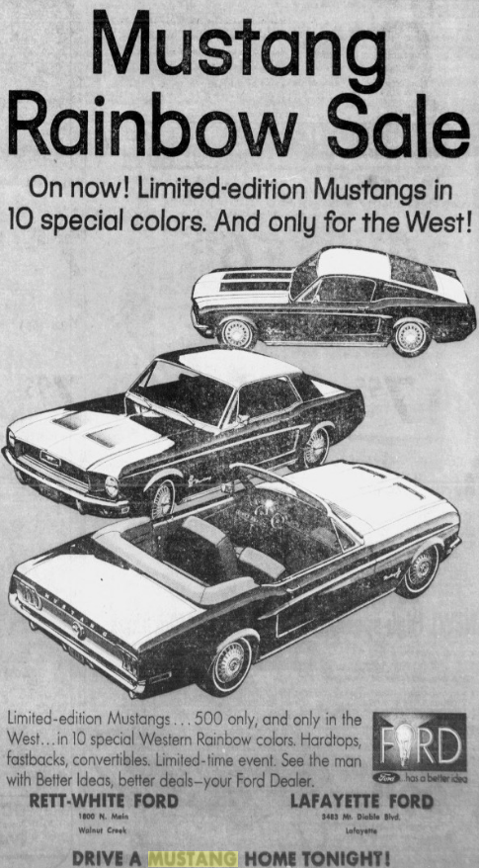  Exhibit A. Ford "Mustang Rainbow Sale" co-op ad naming Rett-White Ford and Lafayette Ford. Contra Costa Times, February 15, 1968, p. 13. | 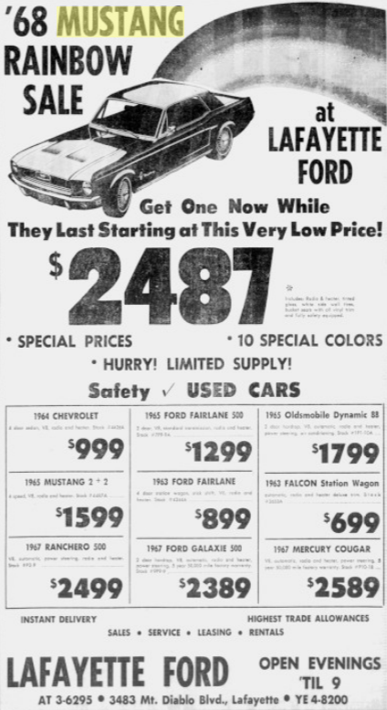  Exhibit B. Lafayette Ford "'68 Mustang Rainbow Sale," 10 special colors. Contra Costa Times, February 16, 1968, p. 41.
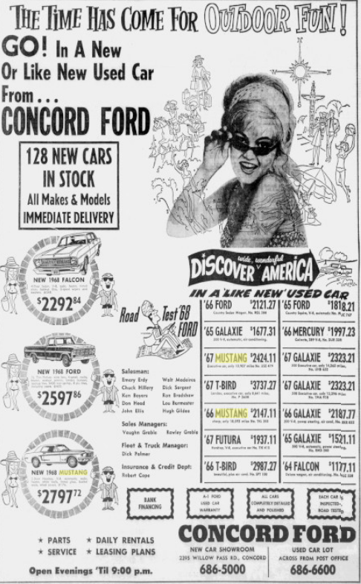  Exhibit D. "Concord Ford," new-car showroom 2395 Willow Pass Rd, 686-5000; used-car lot across from the Post Office, 686-6600. Contra Costa Times, April 19, 1968, p. 43. | 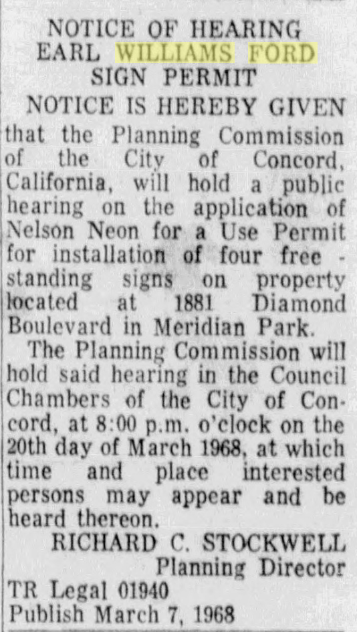  Exhibit F. Notice of hearing: Earl Williams Ford sign permit, four free-standing signs at 1881 Diamond Boulevard. Concord Transcript, March 7, 1968.
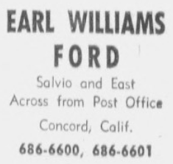  Exhibit C. Earl Williams Ford, Salvio and East, across from the Post Office, 686-6600. Contra Costa Times, February 21, 1968, p. 46. | 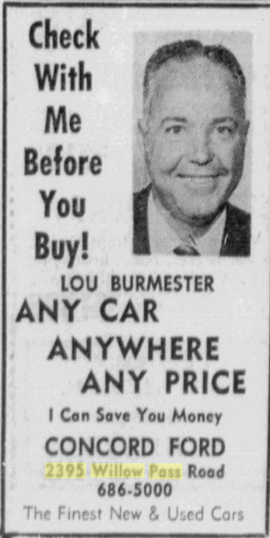  Exhibit E. Salesman Lou Burmester, Concord Ford, 2395 Willow Pass Road, 686-5000. Concord Transcript, April 1968.

