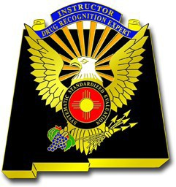
New Mexico Drug Recognition Expert Program

AGENDA
DRE Committee Meeting
September 12th, 2022 @ 0900-1400 (tentative end time)
Marriott Uptown Las Cruces Ballroom
Albuquerque, New Mexico

Call to Order

- Welcoming Remarks and Introduction
  - All
- Approval of Minutes of March 7th, 2022 Meeting
    - Voting Item
- Committee Seats
  - Vacated Judges Seat. (Retired Judge Tina Garica has vacated her seat) Suggestion for a Judge replacement.
  - Central Region DRE Instructor Alternate for Captain Holt. Recommendation Lt. J. Reedy Rio Rancho Police Department.
  - Central Region DRE Alternate for Josh Montano. (Zak Herbst vacated) Recommendation Harvey Johnson Albuquerque Police Department.
  - Southern Region DRE Alternate Still looking for Recommendation from Fabian Fernandez.
    - Voting Item
- Lasworth Reminder
  - Reminder to DRE/DRE Instructors
  - Discussion from Brett Barnes
- 2022 DRE School
  - Pre-School April 4-5, 2022
  - DRE School April 6-15, 2022
  - Certification trip 1 April 27-May-1, 2022
  - Certification trip 2 May 4-8, 2022
- DRE Instructor School in New Mexico
  - Discussion (put on hold until 2024)
- DRE Instructor Applications
  - Discussion (one application received)
- NMDRE Program Status Update
  - DRE’s and DRE Instructors
  - Review 2020/2021 evaluations
  - Recertification Training conducted
  - 2023 Recertification Training
  - Aride FY22 discussion for 2023 locations
  - National updates
- Updates/Concerns/Suggestions for Improvement
  - DRE/DRE Instructors in the Field
  - NMDOT
  - TSRP
  - ADA
  - US Attorney
  - Judicial
  - Defense
  - SLD
  - SFST/SWTC
- Date/Time/Location next meeting
  - ALL
- ADJOURN
    - Voting Item

