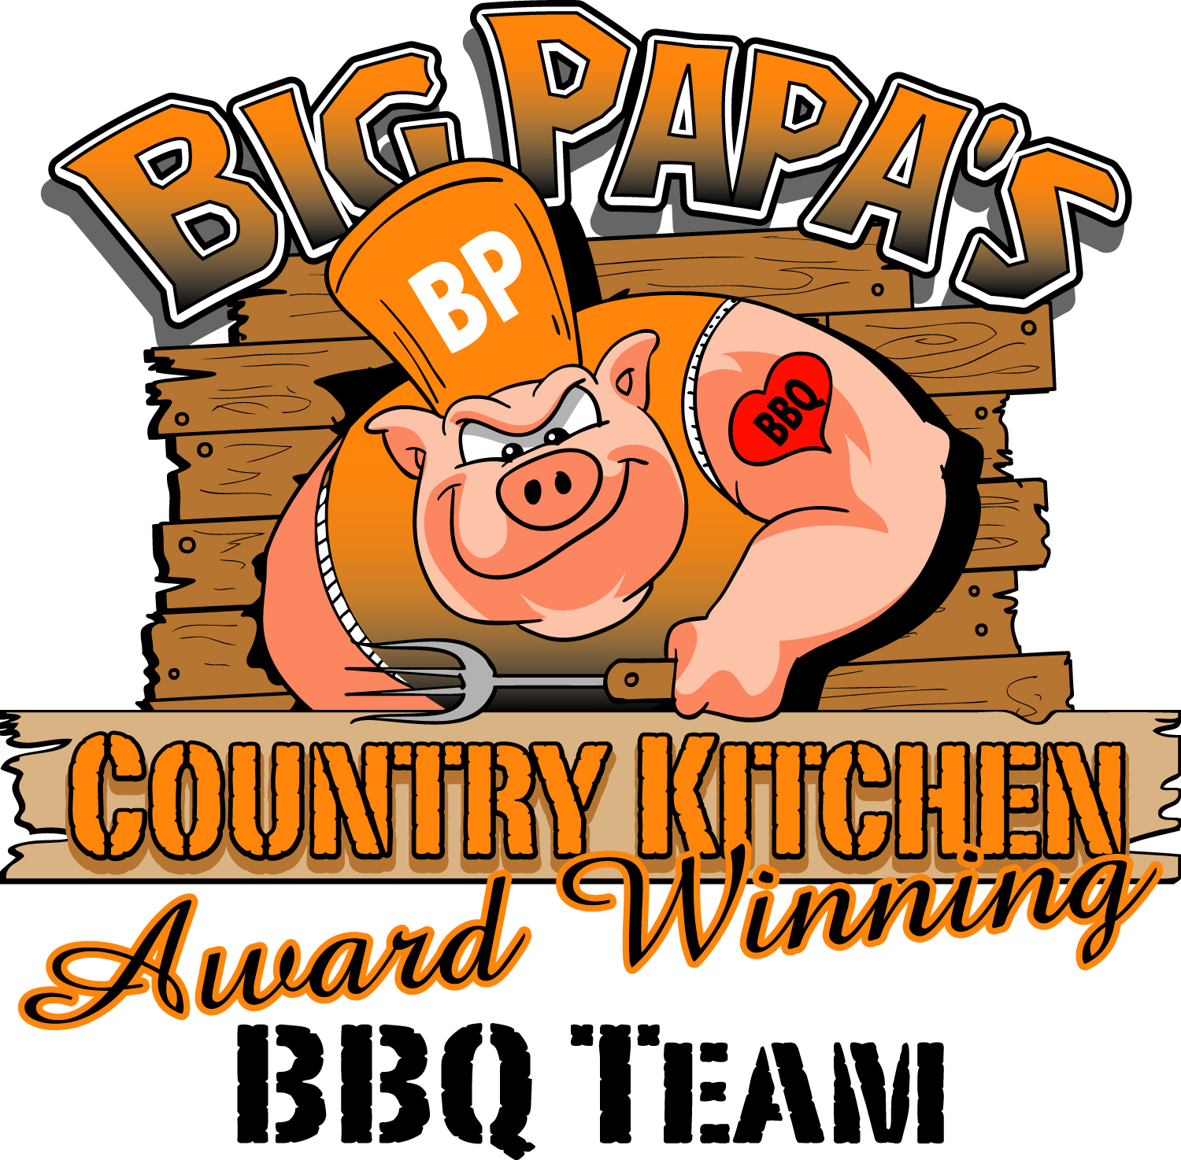
Backyard BBQ Class

Hosted by:
Dana “Big Papa” Hillis, Professional BBQ Pitmaster

Come learn how to backyard BBQ from the best! Big Papa will demonstrate cooking 2 appetizers, 2 meats, 2 side and dessert on several different smokers and a dutch oven. Bring your appetite! Coke Products and waters available.
Sauce and Rubs Available for Purchase
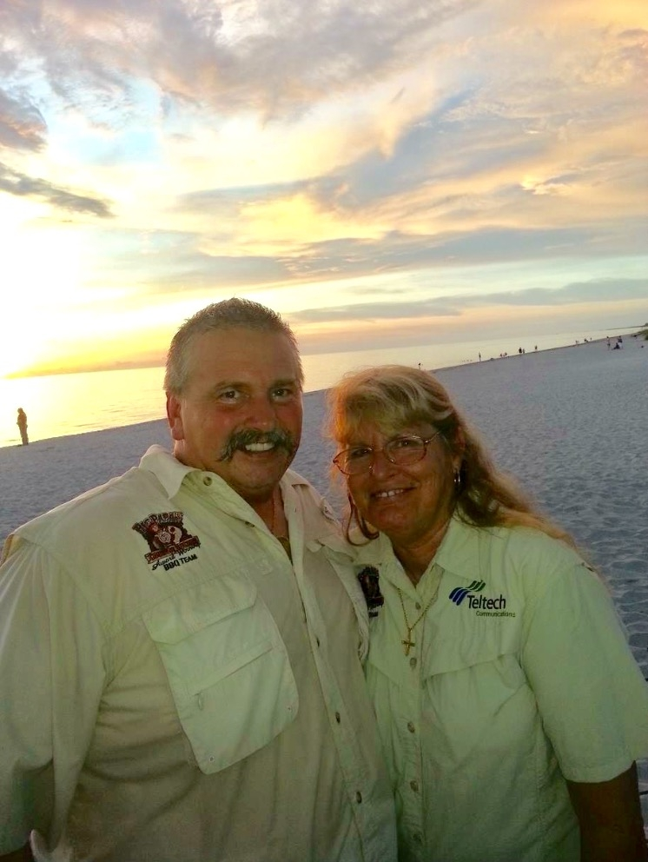
Date: October 26, 2024
Time: 10:00am – 4:00pm
Cost: $99.00 per person
Location: 2731 2nd Street NE
Naples, Fl 34120

Get enrolled quickly as classes fill up fast! Forms to enroll are online at bigpapascountrykitchen.com or call (239) 240-5961.

