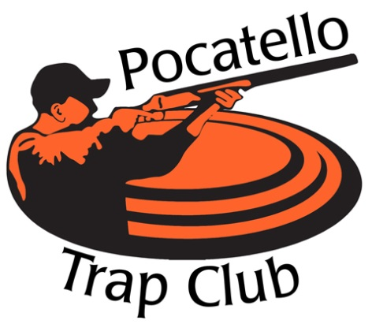

***Save the Dates!!!***

* ***Saturday, January 26th***
* ***Saturday, February 23rd***
* ***Saturday, March 23rd***

Come join US for our

**Winter/Spring Fun Shoots**

All Shoots will start at 11am

*Prizes will include: meat and a variety of gift baskets*

*Purchase a guarantee ticket and if you don’t win,*

*The Trap Club will give you a prize*

The trap club is located ½ mile east of the Pocatello Airport Terminal, next to the Speedway!

Everyone is Welcome!!!

***Follow us on*** [***www.pocatellotrapclub***](http://www.pocatellotrapclub) ***& like us at “Pocatello trap club” on Facebook***