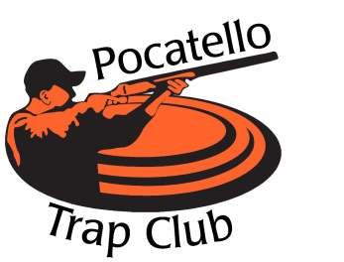
Pocatello Trap Club RV Reservation and Payment Form
The Pocatello Trap Club hosts Several Shoots each year.
Please use this form to submit your RV reservation(s) and payment(s).
Fill out separate forms for each shoot.

Pocatello Trap Club has 66 RV spots for RV’s Only,
- (10) 50amp grass spots, (48) 30amp grass spots, & ( 8 ) 30amp gravel spots
- All spots with power and water hookups. We also ask if you have generators, bring just in case.
- Daily fee is $20.00
**Dry Camp spots are Free and at first come/first serve bases located in mowed down dry grass where generators are needed if desired and water available to fill tanks with hose at club house.**
Make Your RV Reservation Now!! (Please print legible)
Name: __________________________________________________________________
Mailing Address:__________________________________________________________
Phone #:________________________________________
Email address:____________________________________________________________
Number of nights: _________ What shoot coming in for: ________________________
Length of RV:_________________ How many onboard A/C units: _________
**Sites will be Assigned based on above & size of RV and will be assigned out prior to each shoot; site map will be posted on clubhouse doors prior to bigger shoots i.e. State and Gun Shoots.**
Please mail checks to: Pocatello Trap Club Attn: RV Reservations
P.O. Box 2091 Pocatello, Idaho 83206

Credit/Debit Card Card Number: _____________/____________/_____________/____________
Visa or MasterCard Expiration: Month/Year _______/_______ CVV: _______
Address w/zip code: _____________________________________
Name on card:__________________________________________________________________
Signature:______________________________________________ Amt. to Charge:$__________
Please note: Payment early for each shoot will Guarantee you have a reserved spot, refunds given up to 2 weeks prior to each shoot if needed. No carry overs to following year if no show. This will ensure that the RV Wait list is reduced down for bigger shoots (State and Gun Shoot) and can be filled.
Contact ptc@pocatellotrapclub.com for your RV questions or needs.

