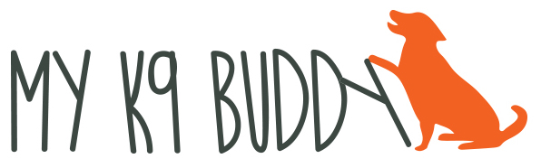
717-476-2449 www.myk9buddy.net

ENRICHMENT

Keeping your dog physically stimulated and in shape is an important part of dog wellness, but it is also crucial to provide mental stimulation and enrichment for your dog. What is enrichment? It’s a way to add stimulation to a dog’s life to prevent boredom. This will tire your dog out and prevent destructive behavior. Enrichment activities don’t have to be expensive (although they can be!) but should be engaging and fun for the dog.

Puzzles and toys: If you search “food puzzles” on the internet, you’ll get thousands of hits. Some of the puzzles can be very expensive and your dog may or may not enjoy them. An easy puzzle is placing some kibble in the wells of a muffin tin and covering them with tennis balls. Some DIY ideas are here: https://www.pinterest.com/explore/dog-enrichment/. Feeding all their food out of puzzles or slow feeders, not only slows down mealtimes but also helps them use their brain to get their food.

Sniffing games: Every dog has a nose and loves to sniff! Utilize it to make your dog’s day more exciting. The easiest way to do this is to take a handful of your dog’s food and toss it into your yard. If you have multiple dogs, only do this with one dog at a time. Allow your dog 10 – 15 minutes to sniff around to find all the food. Join them and point out the ones they miss. For more of a challenge, start by putting a treat in plain sight and encouraging them to find it. Progress to harder and harder hiding places while the dog is in another room.

Enrichment walks: While I’m a huge believer in loose leash walking, there’s also a place for just allowing the dog to sniff. The best idea is to loose leash walk to an area where the dog would like to sniff (a field, a place where many other dogs have been) and release them to “be a dog”. Follow them through the area, allowing them to go where they wish, within reason. Going to new and different areas (hiking trails, lakes, or a different neighborhood) will also spice up your walks.

Training: A few minutes of training several times a day also is a great way to use your dog’s brain. It doesn’t have to be sit, down and come when called (although you should work on them!) but teaching tricks is a great way to train in a fun way!

Most of these ideas won’t take a lot of your time but will give you a happier, calmer dog!

