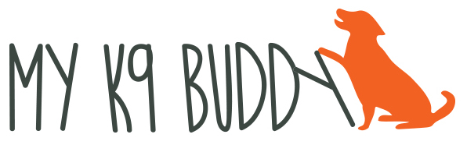
410-476-2449 www.myk9buddy.net

GO TO PLACE TRAINING

Teaching a dog to go to a certain place and relax can be very useful. It can be used to prevent begging at the table, jumping on people as they enter the house or to calm a high energy dog.

- Find a mat or very portable dog bed. If you have a puppy that is still chewing, a rubber doormat works well.
- Sprinkle some treats on the mat so that the dog is drawn to it.
- Once they’ve enjoyed the treats, toss a treat off to get them to leave. Say a release word (done, free, ok, break) as you toss the treat.
- Wait and see if they will come back to the mat. When they do, use your bridge word (good, yes) and give them a few more treats.
- Start to give the treats in such a way that your dog will lie down in order to get the treat. (Hold the treat between their front feet and don’t give it until they lie down).
- Reward the down with treats between their front feet on the mat a few times, then release.
- Encourage the dog to curl (lay with their hip rolled) so they are comfortable. Reward the curled position.
- Sit in a chair next to the mat and relax. As the dog remains in the relaxed position, start lengthening the time between treats.
- Continue practicing until the dog can stay in position for 2 or 3 minutes with you next to them. Feel free to watch TV while you’re waiting!
- Slowly start to add distance between you and the mat by moving the chair farther away. Reward while you’re sitting (throw treats at the dog on the mat)

Sending to the mat:
- Once your dog understands that the mat is a wonderful thing, stand a foot away from the mat. As the dog moves towards the mat, say your cue (go to place, go to mat, mat, go to bed). Make sure you time the cue to coincide with the dog moving toward the mat.
- If they don’t go immediately to the mat, move closer and look at the mat. Say the cue with any movement toward the mat and reward as soon as they step on the mat.
- Progress by slowly moving farther and farther away from the mat until you can send them from anywhere.

Adding distractions to mat work
Once they are going to the mat and staying there reliably, add distractions such as walking to the door, touching the door knob, turning the door knob, opening the door, having people walk in the door. You can also work on sitting at the table, eating a cracker, drinking a glass of water and then trying small meals and working up to Thanksgiving dinner! Add your distractions slowly, always rewarding the dog on the mat for success. If you’re not successful twice at a step, break it down into smaller steps.

