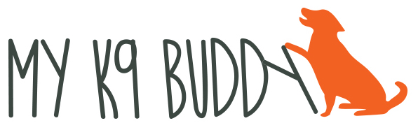

HOMEWORK – ORIENTATION

- Name game – say the dog’s name and give a treat, ball, toy, dinner, etc. We are building a positive association between the dog’s name and a reward.
- Bridge – say the your “bridge” work (yes, good) and give the dog a treat. Once your dog begins to get excited when you say the word, start to use the work to mark behaviors you like.
- Doggie Zen – hold treats in each hand away from your body. On the first day reward the dog when it looks away from the treat. Say “good” as the dog looks away and before you give the treat. On the rest of the days wait for the dog to look at your eyes. Remember to say “good” when the dog looks at your eyes and before you give the treat. This exercise is to teach the dog to give up what they want to get what they want. If is also teaching them to look to you for a reward. It’s best to start this exercise in a non-distracting place. Work on this exercise for a maximum of 5 minutes.
- Look for the good things that your dog is doing and reward them either verbally, with a pet or a quick treat
- Begin to work on exchanges – encourage your dog to bring things to you for a reward (toy or food).

REMEMBER THAT THE REWARD MUST BE IMPORTANT TO THE DOG!!

SET YOUR DOG UP FOR SUCCESS IN ALL THINGS!

“Dogs learn by association” Turid Rugaas

