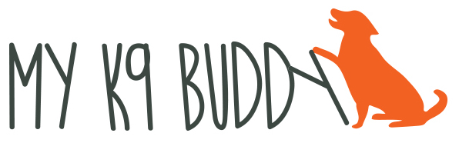
717-476-2449 www.myk9buddy.net

HAND TOUCH

Step 1: Put one hand behind your back. Bring it out and place it in front of your dog’s nose. Most dogs will touch it with their nose to find out why you put your hand out. Say “good” or “yes” or click the instant you feel whiskers, nose, or tongue on your hand. Drop a treat into the hand that the dog touched.
Step 2: When your dog is successfully tapping his nose to your palm when it’s right in front of him, begin to present your palm slightly to the right or left. Then present a little higher or a little lower.
Note: If the dog doesn’t move toward the hand within 2 seconds, pull your hand away and put it behind your back. Get your dog’s attention and the present the hand again, very close to his face.
Step 3: When your dog is good at tapping his nose to your hand no matter if it’s high, low, to the right or to the left, then present your hand again and pull your hand forward a few inches as your dog reaches toward your hand. The goal is that your dog will take a step or two while following your hand.
Step 4: Begin to move your hand further so the dog has to take several steps to follow your hand.

Thanks to Laurie Luck at Smart Dog University

