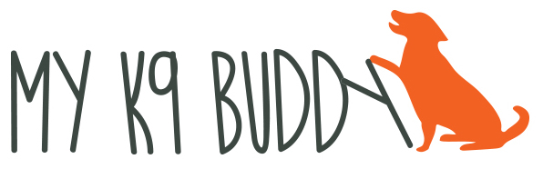
717-476-2449 www.myk9buddy.net

KEEPING YOUR DOG A HEALTHY WEIGHT

In the beginning of training, we use lots of different kinds of food to reward and motivate our dogs. How do we keep them from becoming a trained fat dog? When training at home, use a portion of the amount of food that you would normally feed them as your rewards during training. If your dog needs something more interesting, put the dry dog food into a plastic bag and then add something more interesting and stinky that will make the dry food more interesting. When you come to class, you’ll need to bring something that your dog thinks is great so that they are motivated to work in a more distracting environment.

On class days, feed your dog less at their regular meals so that the number of food rewards that they get in class doesn’t exceed their regular number of calories for the day. Don’t forget the treats that you use when you’re training outside the house! Those calories add up too.

How do you know if your dog is overweight? You should be able to feel their ribs and the spines of their back bone easily. If you can’t, it’s time for a diet! You can replace part of their food with pumpkin or green beans for a filling, healthy, low calorie substitute. If your dog likes them, you can use pieces of apple or chicken breast for training. This will help reduce the overall calories. Also, be sure that you’re feeding your dog the right amount of food. Remember that dog food manufacturers are in the business of selling dog food. The amounts of food that they recommend to feed are generally too much for the average dog. Let your dog’s body determine how much is enough.

