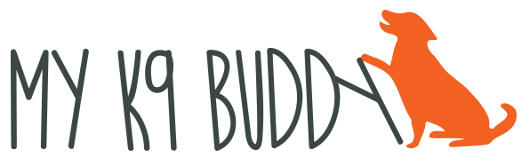
717-476-2449

KEYS TO POSITIVE DOG TRAINING

“Obedience” is all about your relationship with your dog. Take the time to develop a good, healthy relationship with your dog and all the rest will follow. Here are some ways to “grow” your relationship:

- Pro-actively look for and reinforce desired behaviors
- Develop strong relationships with trust and quality interaction
- Provide mental stimulation and challenges
- Reinforce correct behavior. Ignore and redirect incorrect behavior
- Find what is reinforcing to the dog
- Open a “relationship bank” and keep it full
- Set up the environment for success

Operant conditioning is an important way to help your dog understand that there are consequences to his behavior – whether they are good or bad. For example:

- When your dog does something and something good start, this behavior is more likely to INCREASE.
- When your dog does something and something bad stops, this behavior is more likely to INCREASE.
- When your dog does something and something bad starts, this behavior is more likely to DECREASE.
- When your dog does something and something good stops, this behavior is more likely to DECREASE.

You can use this knowledge of learning behavior to effect how your dog learns. Your dog will learn that he can “control” his environment by making the right choices. Dogs do what works and what has the best result for them.

Be very careful in trying to use the “something bad starts” approach – very often using aversives will have long term side effects; at the very least you will have lost some of your dog’s trust in you.

