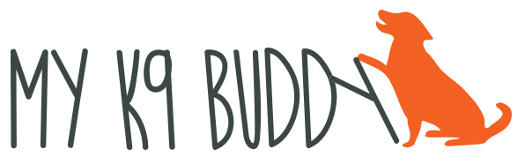
717-476-2449

WEATHER POLICIES

Winter – If there is any possibility of ice or snow on the roads, please check the My K9 Buddy Facebook page, your email or the message on the above number. Cancellation announcements will be made as early as possible.

Summer – If the temperature is predicted to be above 90, daytime classes will be cancelled. Evening classes may be held so be sure to check the above sources.

If class is cancelled due to weather, 6 week classes will have a make up class built into the schedule. Levels classes students that are attending twice a week, may choose to skip that week. If weather is continuously bad, the instructor may make an exception.

HOLIDAY POLICIES

My K9 Buddy will be closed on New Years Day, Memorial Day, July 4th, Labor Day, Thanksgiving Day and Christmas Day. Other closures will be announced prior to the holiday.

REFUND POLICIES

There will be no refunds after the second class of the session/pass. Other refunds will be determined on case by case basis. A six week package of classes must be used within 3 months of orientation, a twelve week package must be used within 5 months.

EQUIPMENT RECOMMENDATIONS

Harnesses – Sensible (available from My K9 Buddy)
Balance
Freedom

Head collars – Gentle Leader (available from Amazon)
Snoot Loop
Dogs with Love (available from Amazon)

LEVEL 1 TIMES

Monday at 3 pm Puppy (8 to 20 weeks) -
Tuesday at 7 pm Monday at 6 pm
Wednesday at 7 pm
Thursday at 6 pm

