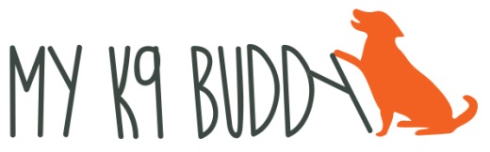
is hosting
JEAN WILKINS
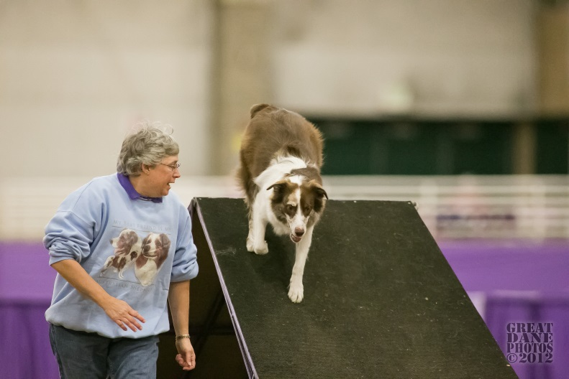
November 16, 2019 – Introduction to Distance
Teaching a dog distance skills not only helps during runs but also increases their confidence. Jean feels that there is a place for distance work, not only in FAST, Gamblers, Chances or Jackpot classes but also in certain places on course that helps YOU get to where you need to be without trying to hurt yourself racing your dog. Some people want to just get their dog off their ankle and others want lots more distances. Jean will show you some skills to achieve your goal and have fun with your dog.
Dec. 14, 2019 – Advanced Distance Skills
Now that your dog is comfortable with being away from you, how do you control them? Jean will be helping you work on more actual skills for FAST/Gamblers/Jackpot sends as in how to set up for and execute them when running the class. She’ll also be challenging you and your dog for longer distances and to perform discriminations at a distance.
Come with positive attitudes (yes your dog can move away from you), toys to throw, food containers that throw and/or targets and we will see what we can learn together

ABOUT THE PRESENTER
Jean has been competing in agility since 1992 with her Norwegian Elkhounds and Rescue Aussies. She has also run over 25 other dogs and over 15 different breeds. Jean participates in USDAA; AKC, and NADAC, earning top titles in all 3 venues with different dogs. Jean has worked with dogs that struggle with distance as well dogs that excel at distance.

Jean Wilkins Workshops Registration Form
Make checks payable and mail to:
My K9 Buddy, 2424 Albert Rill Rd, Hampstead, MD 21074
FMI: marta@myk9buddy.net
The workshop is limited to 10 working teams and 10 auditing spots. Workshop will be held from 9 – 4:30 pm with a 30 minute lunch. The cost of the workshop is $130 for a working team and $65 for an auditor. Fees for a working spot are non-refundable unless your spot is able to be filled. Working spots will be filled by first received registration form and payment.

Name________________________________________________________
Address______________________________________________________________________________
Email Address________________________________________ Phone #_________________________
Dog’s Name_____________________ Breed______________________________ Jump Height_______
Introduction to Distance: Working spot ______Auditing spot ________
Advanced Distance Skills: Working spot ______ Auditing spot _________

Assumption of Risk, Release and Indemnity
Please read the following Release of Liability carefully and sign your name in the space provided.
I agree that My K9 Buddy, LLC has the right to refuse this application for any reason it deems sufficient.
I hereby acknowledge that I have voluntarily applied to participate in the dog training workshop with My K9 Buddy, LLC and Jean Wilkins. I am aware that there are inherent risks and hazards involved in activities with and around dogs and I am participating in the workshop with knowledge of these potential risks.
In order to participate in this My K9 Buddy, LLC sponsored workshop, I, being fully informed of such risks, agree as follows:
- to assume all risks of such workshop or activities
- to release My K9 Buddy, LLC ,and Jean Wilkins from any and all claims which I or my assigns may have that may result from such workshops or activities, including those relating to personal injury to myself, my dog(s), dogs in my charge, members of my family or guests and those relating to damage to property, in each case caused directly or indirectly by acts that might occur in or in relation to the Jean Wilkins workshop: and
- indemnify, defend, and hold My K9 Buddy, LLC and Jean Wilkins harmless from all damage, loss, liability or expense, whether arising from negligence or any other reason or cause whatsoever, including legal costs and lawyer’s fees, which result from any damage caused directly or indirectly by myself or dog(s) which I own or handle.

X___________________________________________________ Date_________________
Signature

