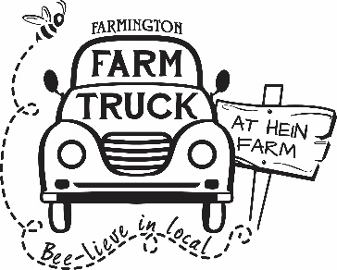

David & Martha Hein Agriculture Scholarship

**Farmington, CT has long been an agricultural town and the Hein family has been part of that for the last**

**200 years. David and M artha Hein, long time Farmington residents and Farmington High School sweethearts, were involved in the farming of the land until 2019. In 2019 David Hein was injured and has been unable to continue farming. The farming torch was passed to Jennifer Villa, owner of Farmington Farm Truck in October o f 2020 and she now owns and runs the farm. Jennifer Villa, also a long time Farmington resident, wanted to recognize and honor the agricultural contributions of David and Martha Hein while also supporting and encouraging Farmington students choosing an agriculturally related career path. In 2020, funded by sales of a commemorative ornament, the last of the Hein Farm popping corn and a donation from The Farmington Farm Truck at Hein Farm, the David and Martha Hein Agriculture Scholarship was created. Each year, specific items are sold seasonally to benefit the scholarship and Farmigton Farm Truck also contributes to the annual scholarship fund.**

**The annual agriculture scholarship is awarded to a Farmington High School student interested in pursuing agriculture, or a related field , as a career.**

Your Name ______________________________________

Address _________________________________________ Phone Number _____________

Elementary School attended _____________________________ Number of years ____________

Major/career goals _______________________________________________________________

______________________________________________________________________________

________________________________________________________________________________

Highest SAT score _____________ Highest ACT score _____________

Did your family complete the FAFSA? Yes_______ No________

If yes, what is your Expected Family Contribution (EFC) $_________

If you have been offered any financial aid from colleges or scholarships from outside sources, please indicate from whom and amount.

________________________________________________________________________________

________________________________________________________________________________

________________________________________________________________________________

Have you made a decision about where you are attending college? If so, where?_____________________________________________________

Mother's Name: _________________________ Occupation: ______________________ Father's Name: _________________________ Occupation_______________________

Sibling's Names & Ages:____________________________________________________________

_______________________________________________________________________________

Volunteer Activities:

Name of Organization(s) Dates Hours per week

Contributed

________________________________________________________________________________ ________________________________________________________________________________ ________________________________________________________________________________ ________________________________________________________________________________ ________________________________________________________________________________

Work Experience:

Name of Employer(s) Dates Hours per week

Worked

________________________________________________________________________________ ________________________________________________________________________________ ________________________________________________________________________________ ________________________________________________________________________________ ________________________________________________________________________________

**If you have any unusual circumstances that you think the awards committee should consider, please explain *briefly***

_________________________________________________________________________________________________________________________________________________________________________________________________________________________________________________________________________________________________________________________________________________________________________________________________________________________________________________________________________________________________________________

**Please write a short essay about why you are interested in agriculture and what you hope to work towards in your agricultural pursuits**  .

I agree that if I do not attend school next year, any aid received will be returned.

_________________________ ______________________________

STUDENT'S SIGNATURE PARENT'S SIGNATURE

|  |
| --- |
| Mail the completed form to: |
| Farmington Farm Truck |
| 303 Meadow Road |
| Farmington, CT 06032 |

**Applications due b y March 30th, 2023.**

**Recipient will be chosen by the scholarship review committee *by may 1st, 2023..***