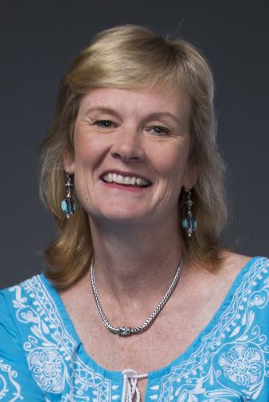

**CENTER COURT WITH JACKIE MACMULLAN**

*A fundraiser to benefit the Pentucket Kiwanis Club of Haverhill Charities and the Buttonwoods Museum  
A portion of the proceeds will be donated to the Haverhill High School Athletic Program*

AUGUST 29th, 2018 at DiBURRO’S  
**Appetizers & Dinner - Speaker - Sports Memorabilia Silent Auction**

*Jackie is a television analyst for ESPN, a senior writer for* [*ESPN.com*](http://espn.com/) *and a correspondent for WHDH Boston. She worked as a writer for Sports Illustrated and for the Boston Globe, where she was the first full-time female sports columnist in the history of the paper. She has won numerous national writing awards, and has written four books: Bird Watching (1999), Geno: In Pursuit of Perfection (2006), and New York Times Best Sellers: When The Game Was Ours (2009), Shaq Uncut (2011).*

**SPONSORSHIPS** *(Mail form and payment by July 17, 2018)*

___ **I am the contact for an event Sponsor. Sponsorships are $1,200 and include:**

*\* 10 Tickets * Recognition at event * Sponsor’s banner hung at event \**

*\* Sponsor’s name on fliers and signs * Preferential table placement \**

**TICKETS & DONATIONS** *(Reserve seat by August 21, 2018)*

**__** **I would like to attend the dinner. Please reserve ______ tickets at $80 each.**    
  
 __ **I would like to make a donation. My donation of $______ is enclosed.** 

**CONTACT AND PAYMENT INFORMATION**   
Name___________________________________________ Organization________________________  
Address____________________________________________________________________________ City____________________________________ State_________ Zip____________  
Email __________________________________________Phone ____________________________   
 Meal Choices: ______ Steak Tips ______ Chicken Primavera  
Total Enclosed $_____________ ( M***ake check payable to Pentucket Kiwanis Club)  
 Please mail completed form & check to:   
Buttonwoods Museum | 240 Water Street | Haverhill, MA. 01830 For more info call 978-886-0905*** * *