Ty’s Tees Order Form
www.tystees.com
IN HANDS DATE
------------------------

Client  Address City | Contact  State | Zip | Project  Phone
Email Address
□ T-Shirt □ Sweatshirt | □ Polos □ Caps | □ Bags | □ Outerwear □ Other

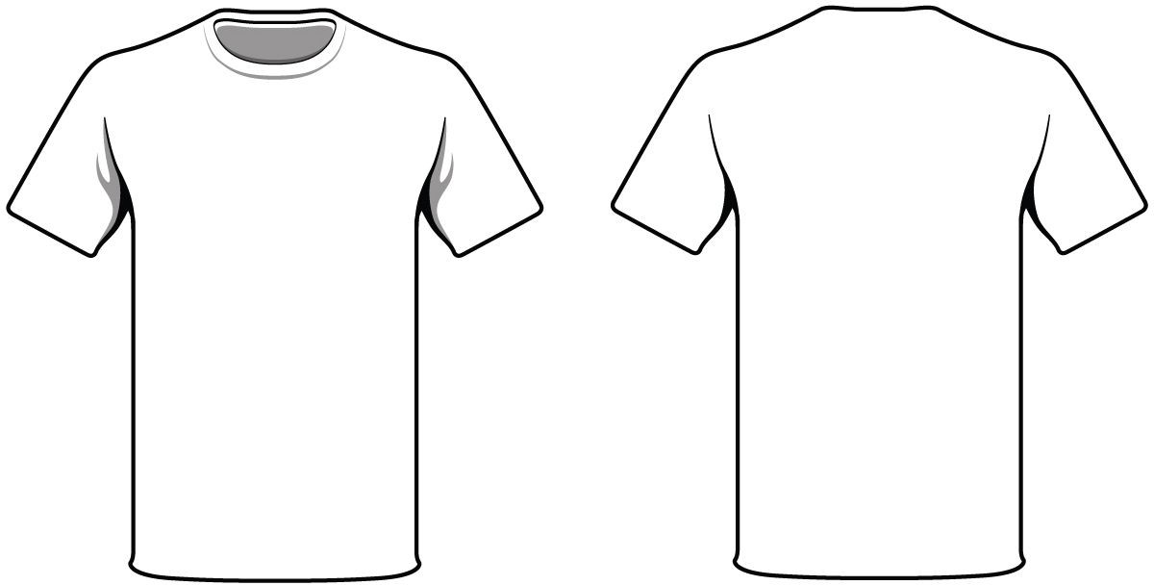

Style Number/Color
Kids Ladies Adult XS SM MD LG XL 2X 3X 4X Total

NO SETUP CHARGE
$25 per screen | $50 custom ink
Dark Garments add $0.10 for flashing

Please allow 10 days for completion from the date artwork is approved
RUSH CHARGES 3 day add 25%
ART CHARGE $50 per hour
EMAIL tystees@comcast.net
WEBSITE www.tystees.com

