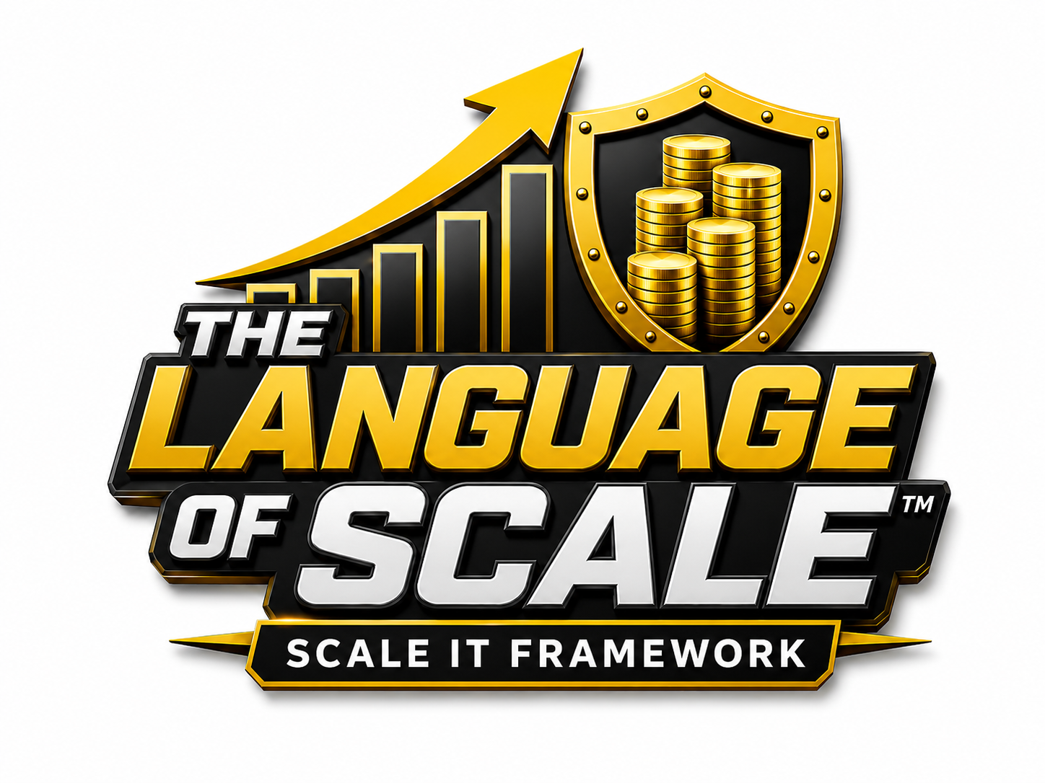

Value Creation Conversation Template

Change your language, and you’ll change your value and the quality of your advisors.

To pitch your business effectively, you must be able to hold a 5-Dimensional Conversation, one that proves your business is not just operational… it’s valuable
This template will guide you through the 5 core dimensions of a Value Creation Conversation. Fill in the (Create Your Conversation Blank) with your Business Name and start using the value creation language in your business conversations.

1. VALUE CREATION TERMS
Purpose: Communicate the financial fundamentals and core metrics of value.
Create Your Conversation:
Example Conversation: “My business generates consistent revenue, maintains healthy profit margins, and has a strong SDE. But more importantly, we’re building real value measured not just in dollars, but in systems, positioning, and transferability.”
Keywords: Massive Value, Valuation, Revenue, Profit Margin, SDE

2. VISION + POSITIONING
Purpose: Demonstrate where your business is headed and how it's uniquely positioned.
Create Your Conversation:
Example Conversation: “We’re positioned to lead within our niche. Our vision is tied to long-term trends, and our strategic positioning gives us a competitive edge in both market share and valuation potential.
Keywords: Strategic Positioning, Scalability, Exit Strategy, Market Differentiation, Vision

3. OWNERSHIP & OPERATIONS
Purpose: Highlight operational efficiency and owner independence.
Create Your Conversation:
Example Conversation: “We operate under an absentee-owner model, with SOPs and systems in place. Our KPIs are tracked consistently, and the business is built to scale without heavy owner dependency.”
Keywords: Absentee Owner Model, SOPs, Systems & Processes, KPIs, Transferable Value

4. FINANCIAL & GROWTH
Purpose: Show performance, scalability, and long-term financial potential.
Create Your Conversation:
Example Conversation: “We’ve scaled from $600K to $1.4M in the last 3 years, maintaining a 25% profit margin. Our CLTV is $3,200 and our valuation multiple is tracking 3.5–4x, supported by our growth trajectory and strong recurring revenue.”
Keywords: CLTV, Valuation Multiple, Asset Under Management, Recurring Revenue, Enterprise Value, Growth Trajectory

5. BRAND & MARKET INFLUENCE
Purpose: Emphasize your brand strength and market authority.
Create Your Conversation:
Example Conversation: “Our brand equity is strong backed by reputation, customer loyalty, and strategic content. We have a clear value proposition, and we’re investor-ready with clean reporting, consistent messaging, and a proven track record.”
Keywords: Brand Equity, Value Proposition, Investor Readiness, Customer Loyalty, Moat

Congratulations you have completed the first step to understanding the language of the funders playbook.
Here’s an example of a Scale Value Creation Conversation:
“We’re not simply building a profitable company. We’re building Massive Value.”
Over the past three years, our Revenue has grown from $1.2 million to $2.1 million, while maintaining a 22% Profit Margin and approximately $425,000 in SDE Seller’s Discretionary Earnings. Based on our performance and market opportunity, we’re continually monitoring our Valuation and the factors that can increase it.
Our Strategic Positioning is focused on becoming the preferred provider in our market. We’re a Purpose-Driven company with clear Market Differentiation and a Value Proposition built around solving a specific customer problem better than our competitors.
We’re also building for Scalability. Our Systems & Processes and documented Standard Operating Procedures SOPs allow us to deliver consistently as we grow. We track Key Performance Indicators KPIs across sales, operations, customer retention, and profitability.
Most importantly, we’re reducing owner dependency and moving toward an Absentee Owner Model. That creates Transferable Value, because the company can continue performing under new ownership or leadership.
Financially, approximately 65% of our sales are Recurring Revenue, giving us predictable cash flow. Our Growth Trajectory puts us on pace to exceed $3 million in revenue within three years. We also track our Customer Lifetime Value—CLTV and the Assets Under Management—AUM relevant to our business model.
Our growing Brand Equity, customer loyalty, reputation, and strategic relationships have created a Business Moat that is difficult for competitors to duplicate.
All of these factors strengthen our Investor Readiness, support a stronger Valuation Multiple, and ultimately increase our Enterprise Value.
And although we're not necessarily looking to sell today, we have an Exit Strategy.
We’re building this company as if we will sell it because a business built to be sold is also a business built to create Massive Value.

