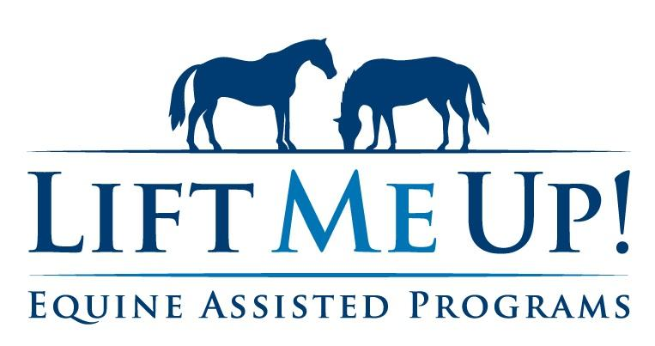

2026 Summer Session Registration Info

The Lift Me Up! Summer 2026 therapeutic horseback riding session will begin Monday, July 13, 2026 and run through Sunday, August 9, 2026. It will be a 4-week session.

Also remember that LMU is an inclusion program. Siblings & family are welcome to take lessons as well.

Register for Summer Session by July 3, 2026. Payment should accompany registration. Payments received after July 14, 2025 will be charged a $25 late fee and by your signature below, you authorize the addition of the late fee to your total if applicable.

Rider(s)___________________________________________________

□ Group lessons: Mon - Fri. July 13 – Aug 3  (4 weeks) $320.00/student  □ Group lessons: Sat. July 18 – Aug 8  (4 weeks) $340.00/student | □ Private lessons: Mon - Fri. July 13 – Aug 3  (4 weeks) $400.00/student  □ Private lessons: Sun. July 19 - Aug 9  (4 weeks) $420.00/student

Riders with outstanding balances must bring the balance current to ride Summer Session

