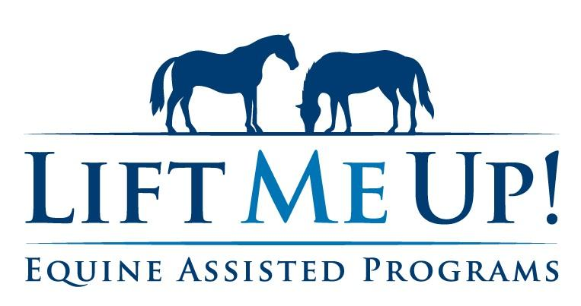

2026 Fall Session Registration Info

The Lift Me Up! Summer 2026 therapeutic horseback riding session will begin Tuesday, September 8, 2026 and run through Friday, December 18, 2026. It will be a 12-14-week session.

Also remember that LMU is an inclusion program. Siblings & family are welcome to take lessons as well.

Register for Fall Session by August 18, 2026. Payment should accompany registration. Payments received after September 15, 2026 will be charged a $25 late fee and by your signature below, you authorize the addition of the late fee to your total if applicable.

Rider(s)___________________________________________________

□ Group lessons: Monday  (13 weeks) $1040.00/student  □ Group lessons: Tuesday-Thursday  (14 weeks) $1120.00/student  □ Group lessons: Saturday  (12 weeks) $1020.00/student | □ Private lessons: Tuesday-Thursday  (14 weeks) $1400.00/student  □ Private lessons: Friday  (13 weeks) $1300.00/student  □ Private lessons: Sunday  (12 weeks) $1260.00/student

Riders with outstanding balances must bring the balance current to ride Fall Session

