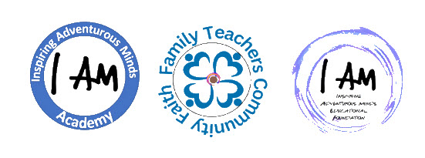

Inspiring Adventurous Minds Educational Foundation
Photo and Likeness Disclaimer

By enrolling in I AM Academy, hosted by Inspiring Adventurous Minds Educational Foundation, you hereby grant IAMEF the right to use your or your child’s photograph, image, likeness, and voice in all forms of media for advertising, marketing, promotional, and any other lawful purposes.
You understand and agree that your or your child’s photograph, image, likeness, and voice may be used without compensation or additional approval from you. You further understand and agree that IAMEF may modify or alter the photograph, image, likeness, and voice for creative purposes.
You release and discharge IAMEF, its representatives, employees, and all persons acting under its permission or authority, from any claims, liabilities, or demands arising out of or in connection with the use of your and/or your child’s photograph, image, likeness, and voice, including any claims for defamation, invasion of privacy, or infringement of your rights of publicity.

Parents name: ____________________________________________
Parents signature: _________________________________________
Date: ___________________________________________________

