Meeting of Lazy Bend Homeowners
January 28, 2021

Call to Order: 19:09

EC Members in Attendance:
Frank Eichstadt
Dennis Grounds
Mike Lewis
Christina Tuma
Paul Boswell

Jill Pierce
Don Bobyk

Introductions by Frank, including a welcome to any new residents
Call was done remotely by Google Meet – video issues

In attendance On the phone:
Jill Alwyn
Don Bobyk
Elaine Gajewski
Jeff & Hedy Wolpa
Susan Torney
Mike Verra
Ken Hutchinson
We do not have a quorum
RE: Budget
This means that the 25% of lots (and the majority of such) will not be met. Frank to look into whether the budget can be approved by the EC, or whether we can operate under a continuing resolution.
Approval of Previous Minutes
Mike summarized previous minutes
Moved (Priscilla), Seconded (Paul), No Discussion or Objections
The homeowners meeting minutes from July were reviewed with the group.
Note that because there is not a quorum that the minutes cannot be approved

Treasurer's Report
- Dennis Grounds presented

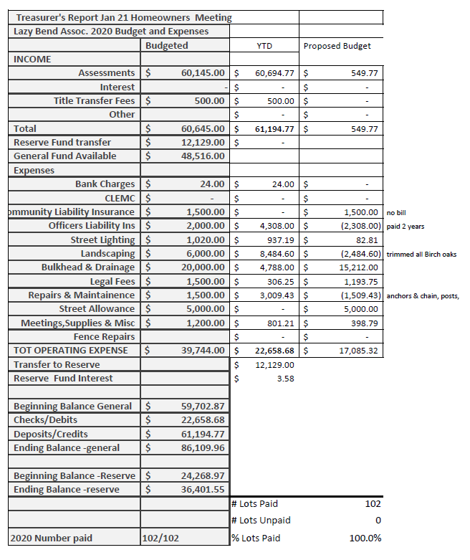

- We are ahead on the budget, largely due to low bulkhead payouts
- Question from group re: road upgrades and whether there would be a special assessment for road repair.
- Budget numbers submitted for the record;
- Should we continue without significant deviations, we will be in a good position monetarily;
- One change – currently we are adding the 0.01 per square foot – if we use this same contribution to the reserve fund we would be right at the $50k budget for the reserve account;
- Approval of minutes moved by Christina, seconded by Priscilla, all presented voted in favor

Bulkhead Committee
Mike Veraa presented
- 3 projects in the planning stage
- Goal is a bulkhead survey in 2021
- Estimate of projects for 2021 is 5-7 bulkheads
- Question from Elaine to clarify the responsibility of the homeowner; Mike Verra clarified that there is a reimbursement of 20% available
- Frank: the survey was initially done to inform the EC to be able to estimate our potential expenses on reimbursement. The surveys were shared with the homeowners, but it was noted that there is no obligation to share this with anyone beyond the homeowner. Frank is going to discuss with Gregg & Gregg about the use of this survey and the information from this. Additionally, the homeowner is encouraged to get a professional assessment if there is a conflicting opinion on the Lazy Bend Survey.
- Motion to approve by Frank; seconded by Susan , all approved (no opposition)

ACC
Paul presented.
- 4 Harbor – approved for new stairs.
- 83 – new construction on lot
- 10 – color change of building
- 15 Harbor – new deck
- 10 Harbor – pool construction
- 95 Bayou – solar panels (regulated by state)
- 22 Harbor – stairs, deck, fence
No requests were rejected, no deviations granted.

Birch Street Bridge Update
- Frank attended latest meeting.
- The bridge that is currently being replaced was going to be derated by TX-DOT, which would have made it not useable for emergency vehicles (the timing o the construction is very good)
- 75 days more of construction; puts completion date at April 14th, 2021
- Large equipment was on-site last week, and was only for a day, even though we anticipated multiple days.
- The current clearance is at least one foot more than previous bridge
- The pilings were unable to be removed, so they are going to the alternate plan of a diver cutting the pilings at the mud line (so the center will be clear)
- Steel bulkhead wing walls will be installed (along with additional rip-rap) for clear boundaries and soil retention.
- As the project nears completion, Galveston county, CLS, Lazy Bend, etc. will be meeting to coordinate the end of the project and the right of way of that road to CLS. We (Lazy Bend) want to clearly define the ownership and maintenance responsibility of the right-of-way. It is anticipated that the annexation process will be lengthy because of TX laws, but we will know more after this meeting.
- The discussion continued to make to and provide clear definition of responsibility of the preservation of the trees, the maintenance of lawns, and the maintenance of bridges
- It was noted that we do not anticipate CLS trying to annex Lazy Bend and that has not been part of the discussion

Other Business – Topics from the Floor

Dry stack boat storage
This property has recently been sold to new owners. The new owners met with Frank; seemed motivated to improve the property, share costs on things like boat maintenance; anticipate new retail shop on site, fuel dock. Subjectively they seem like there are in for the long haul (not a quick turn for investment). The topic of the shore, etc. was not discussed. Paul added that that owners intend to expand their docks, potentially on the side of Lazy Lane – Paul suggested that having a visual barrier may be beneficial.

Policy Update:
Short Term Rentals – Frank has been looking into this and noted a couple things: our community is full of single family homes, and we need to get clarity on the rules before we place restrictions on things like short term rentals. Second, if we choose to impose citations/fines/etc. do we have legal process that are inline with current TX state law. It was noted that this topic is still under discussion with our attorneys and is currently without resolution.

Election: The three candidates ( Dennis Grounds, Don Bobyk, and Jill Pierce) were elected unanimously – there were 16 in person, 19 absentee, and a total of 35 total votes were cast

The meeting was adjourned at 20:12

