Dear potential sponsor,
It all started with a passion for music and a vision of our kids in marching band.
Our mission as parent volunteers of the North Valleys Band Boosters is to support the NV High School Band Program and Students by providing the means to represent the school in events outside the community, promote the Panther Pride, and to provide the band and each member with the tools they need to achieve the highest degree of music literacy.
Over the last couple of months, the NVHS Band has traveled to multiple schools performing at local competitions, hauling all needed equipment, musical instruments and gear in a donated trailer that is dire need of repair and refreshing. We are asking for your support to repair the current trailer, wrap it with the North Valley’s High School theme along with purchasing an additional trailer to support the growing bands’ equipment.
Generous contributions from our local Northern Nevada businesses along with friends, family and loved ones will ensure our North Valley’s High School Band can show off its Panther Pride.
How can you help? You can help by making donations of services or monetarily. Check out our sponsorship levels on the next page. We also have a wishlist on our website. www.northvalleysbandboosters.com

Thank you in advance for supporting the North Valleys Band Boosters and Band Students of North Valleys High School.

Best Wishes,

Melissa Kinsman
President of the North Valleys Band Boosters
North Valleys High School Band Booters is a 501c(3) nonprofit organization

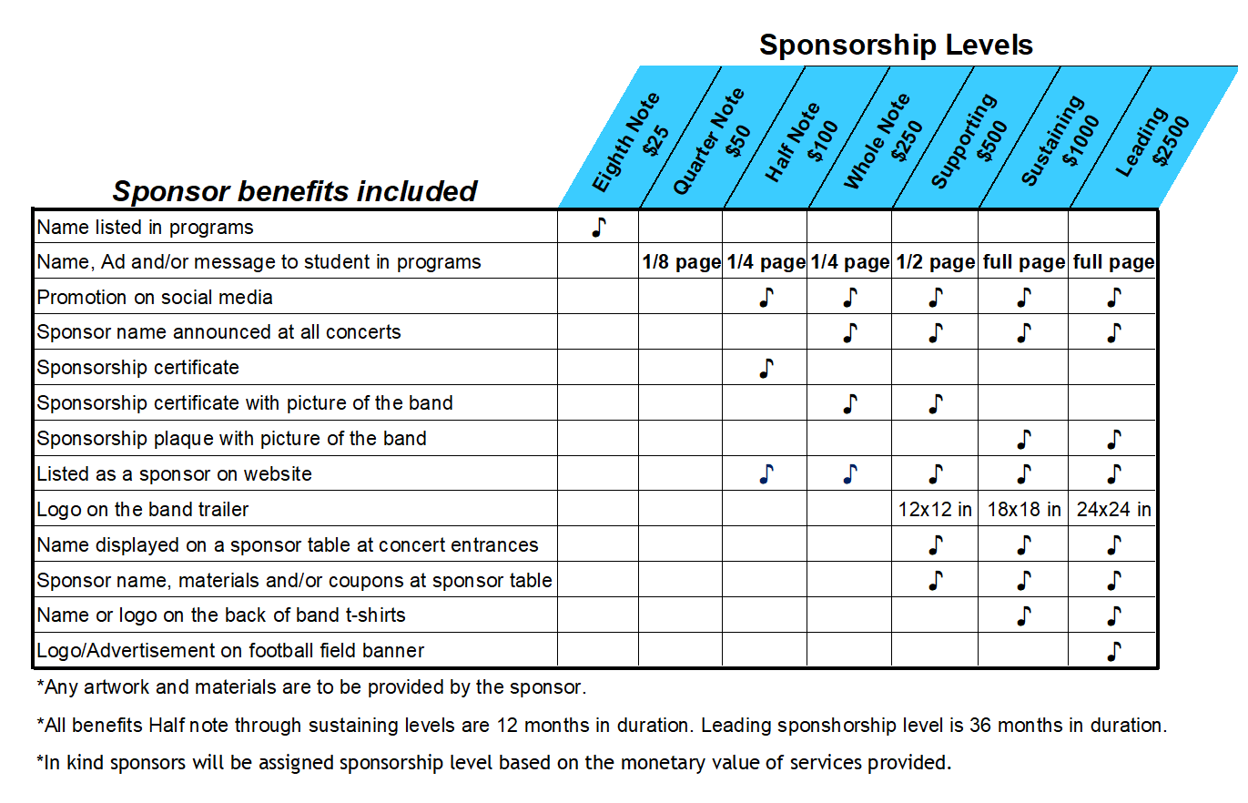

Sponsor Name: __________________________________ Contact Name:____________________________________
Sponsorship level:_________________________________
Address: _________________________________________________________________________________________
Phone: ____________________________ E-mail:________________________________________________________

Payments through PayPal can be made on our website: www.northvalleysbandboosters.com

Checks can be made payable to North Valleys Band Boosters and mailed to the following address:
North Valleys Band Boosters
c/o Travis Dunkley
3100 Mill Street Suite 106
Reno, NV 89502
Completed forms as well as any logos or artwork to be used for promotion can be emailed to info@northvalleysbandboosters.com

