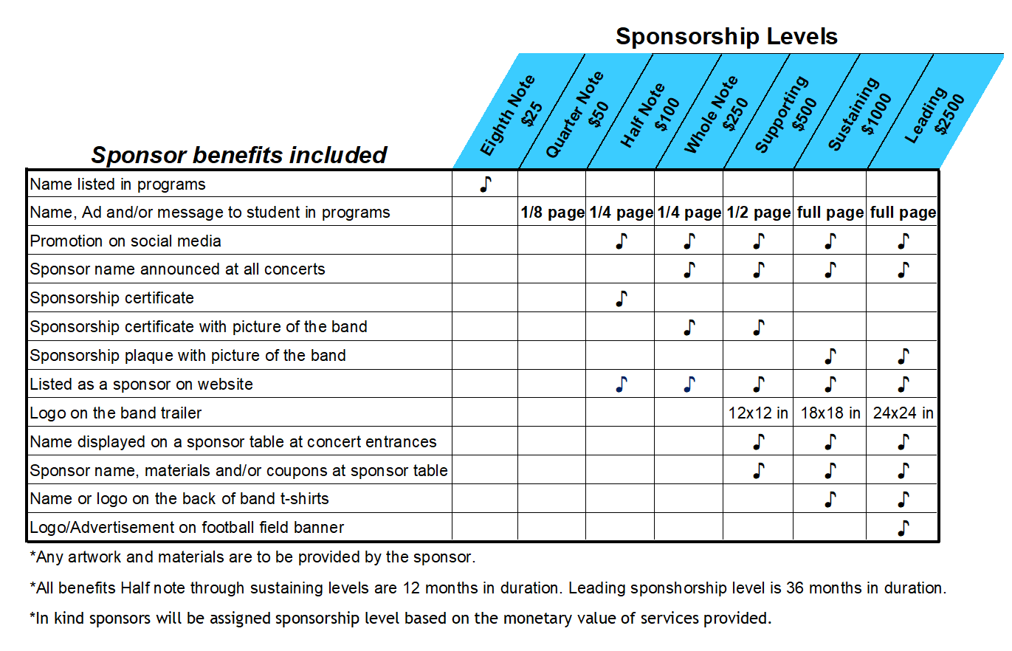

Sponsor Name: __________________________________ Contact Name:____________________________________
Sponsorship level:_________________________________
Address: _________________________________________________________________________________________
Phone: ____________________________ E-mail:________________________________________________________

Payments through PayPal can be made on our website: www.northvalleysbandboosters.com

Checks can be made payable to North Valleys Band Boosters and mailed to the following address:
North Valleys Band Boosters
c/o Travis Dunkley
3100 Mill Street Suite 106
Reno, NV 89502
Completed forms as well as any logos or artwork to be used for promotion can be emailed to info@northvalleysbandboosters.com

