Teachers, we need your help!

Our Boon Supply fundraiser launches today, and we’re excited to easily raise funds for our school with their simple platform and eco-friendly items. The fundraiser is entirely online, meaning there will be very little work for you. No order forms to manage, no cash or checks to collect, no product to distribute! You can view a two-minute video explaining how simple this fundraiser is here: Boon Kick-Off Video

Here’s how you can help:
- Remind the students to participate. They can even help us without selling anything by focusing on the Send and Share key steps below.
- Acknowledge students that have participated and celebrate their success.
- Keep it fun – create friendly competition and make sure they understand why fundraising is important.

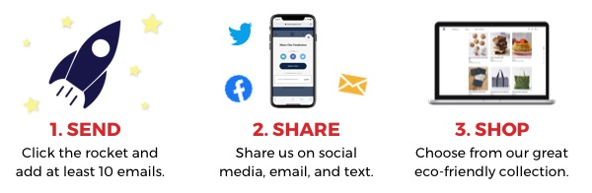

As a thank you for your help, Boon Supply is offering some great teacher incentives:
- Any teacher who achieves 50% participation in their class will earn a $100.00 Boon Supply shopping spree
- If you achieve 75% participation, you will receive a $150.00 Boon Supply shopping spree
- See the fantastic eco-friendly items at www.boonsupply.com/xxxxxxx

That’s all there is to it! We appreciate all you do and thank you for your support of our fundraiser!

