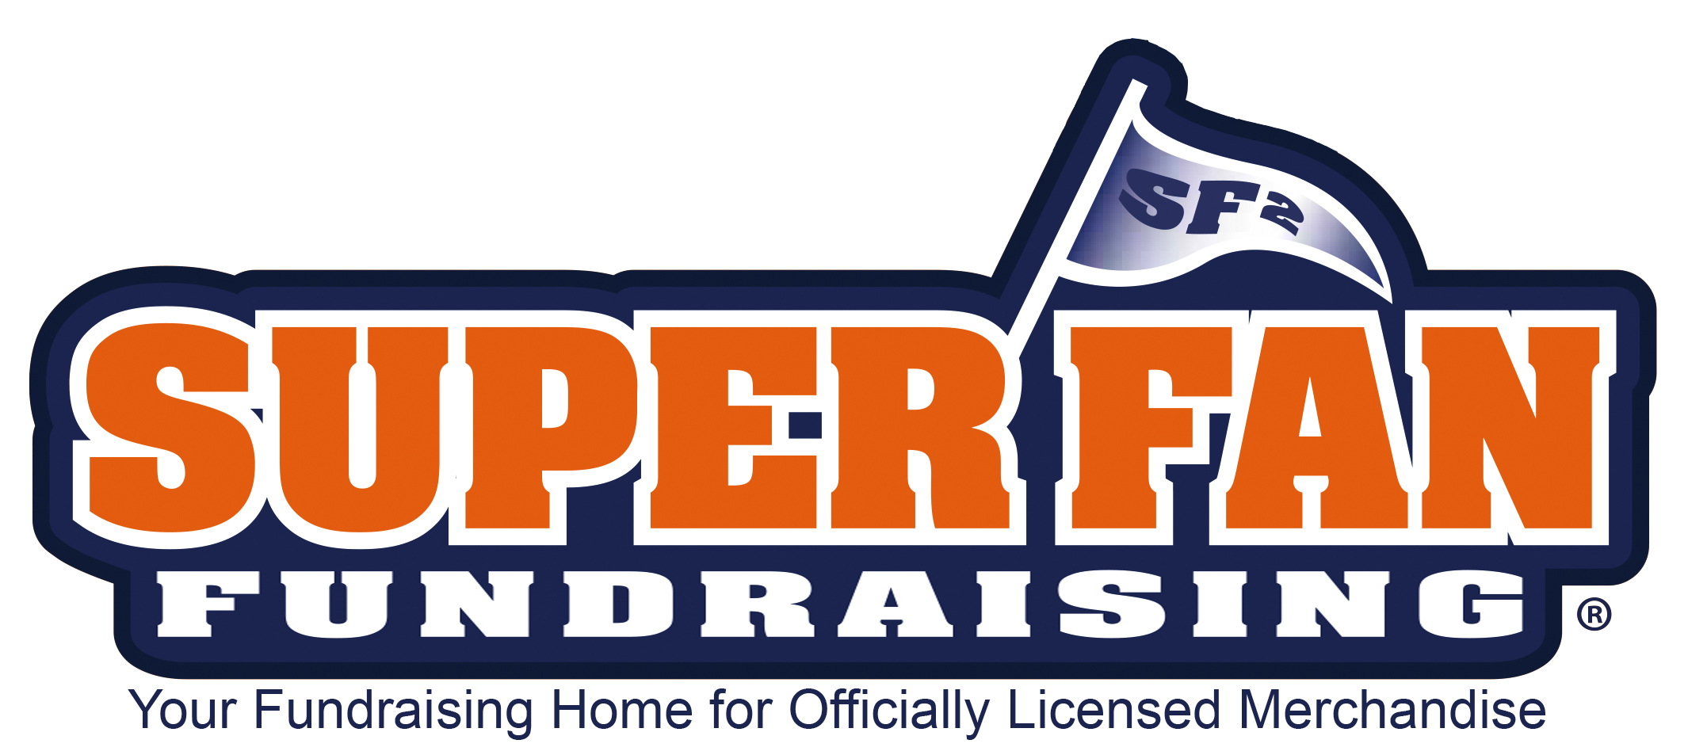

TERVIS & SPORTS ITEMS FUNDRAISER
**This Is Your Parent Letter**

The Dukes
We Are Raising Money For Our Organizations Expenses!
Item Goal – 5 Items Per Kid



2 Ways To Support!
Option 1: Traditional Catalog Sales (Pictured Above)
Option 2: Visit Our Online Store!
Want Your Order Quicker? Ship Direct to Your Home- Buy Online!
Online Store Instructions:
Step 1: Visit:
http://blackhole.superfanfundraising.com/team_members/registration
** (Type Exactly As Shown Above) **
Step 2: Enter Participant Full Name, Email – Receive Your Link & Send to Family and Friends

Tips:
Send Your Customized Link to 15 People | Give Reminders! People May Forget | Post Your Link to Social Media

Who will support you?
Grandma & Grandpa, Aunt & Uncle, Cousins, Neighbors, Family Friends, Co-Workers, Religious Members

Catalog Order Instructions:
On the back page of the catalog, please print each buyer’s name and collect money upfront.

Accept Debit and Credit Cards →

Checks made payable to:
Sammy Alonzo
(You do not have to collect Sales Tax)

Wrap Up: After order taking, please return the order form and payment to team volunteers on time to ensure timely delivery.

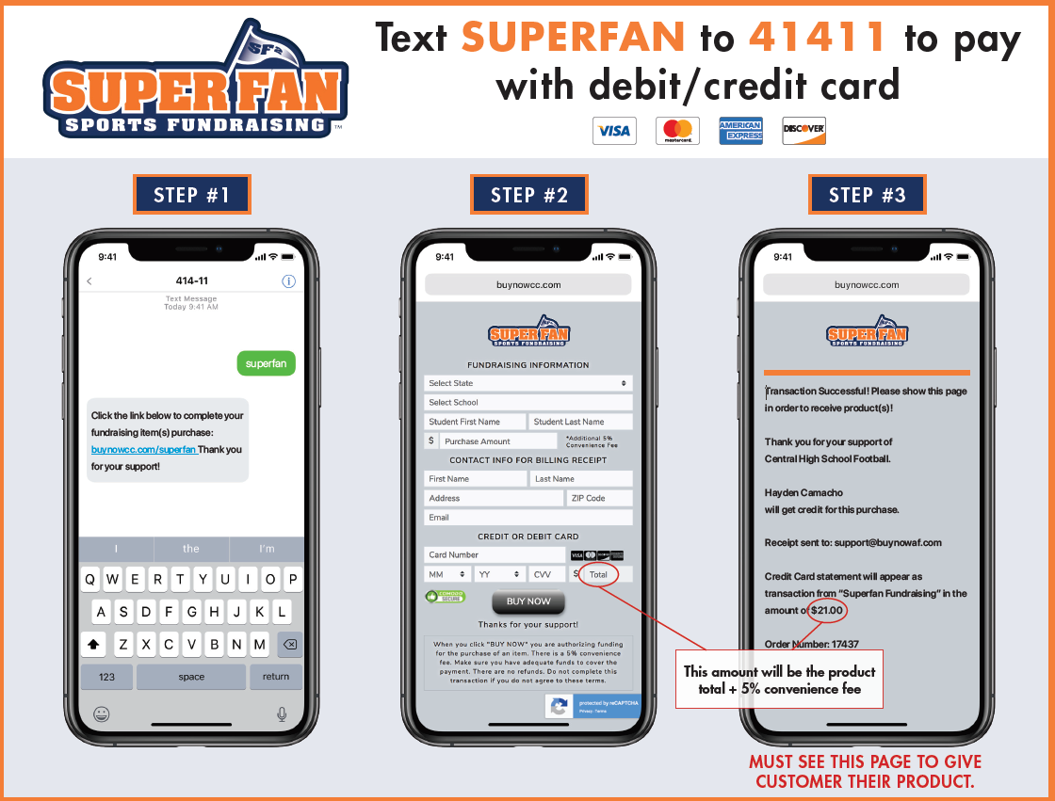

Sale Ends: Sept 23
Order Delivery: 3-5 Weeks Shipment Upon Receipt of Order Forms
WE WOULD GREATLY APPRECIATE YOUR SUPPORT
Questions?
Call Toll Free: 855-602-7990 – Press 5
Info@SuperFanFundraising.com

