Our School

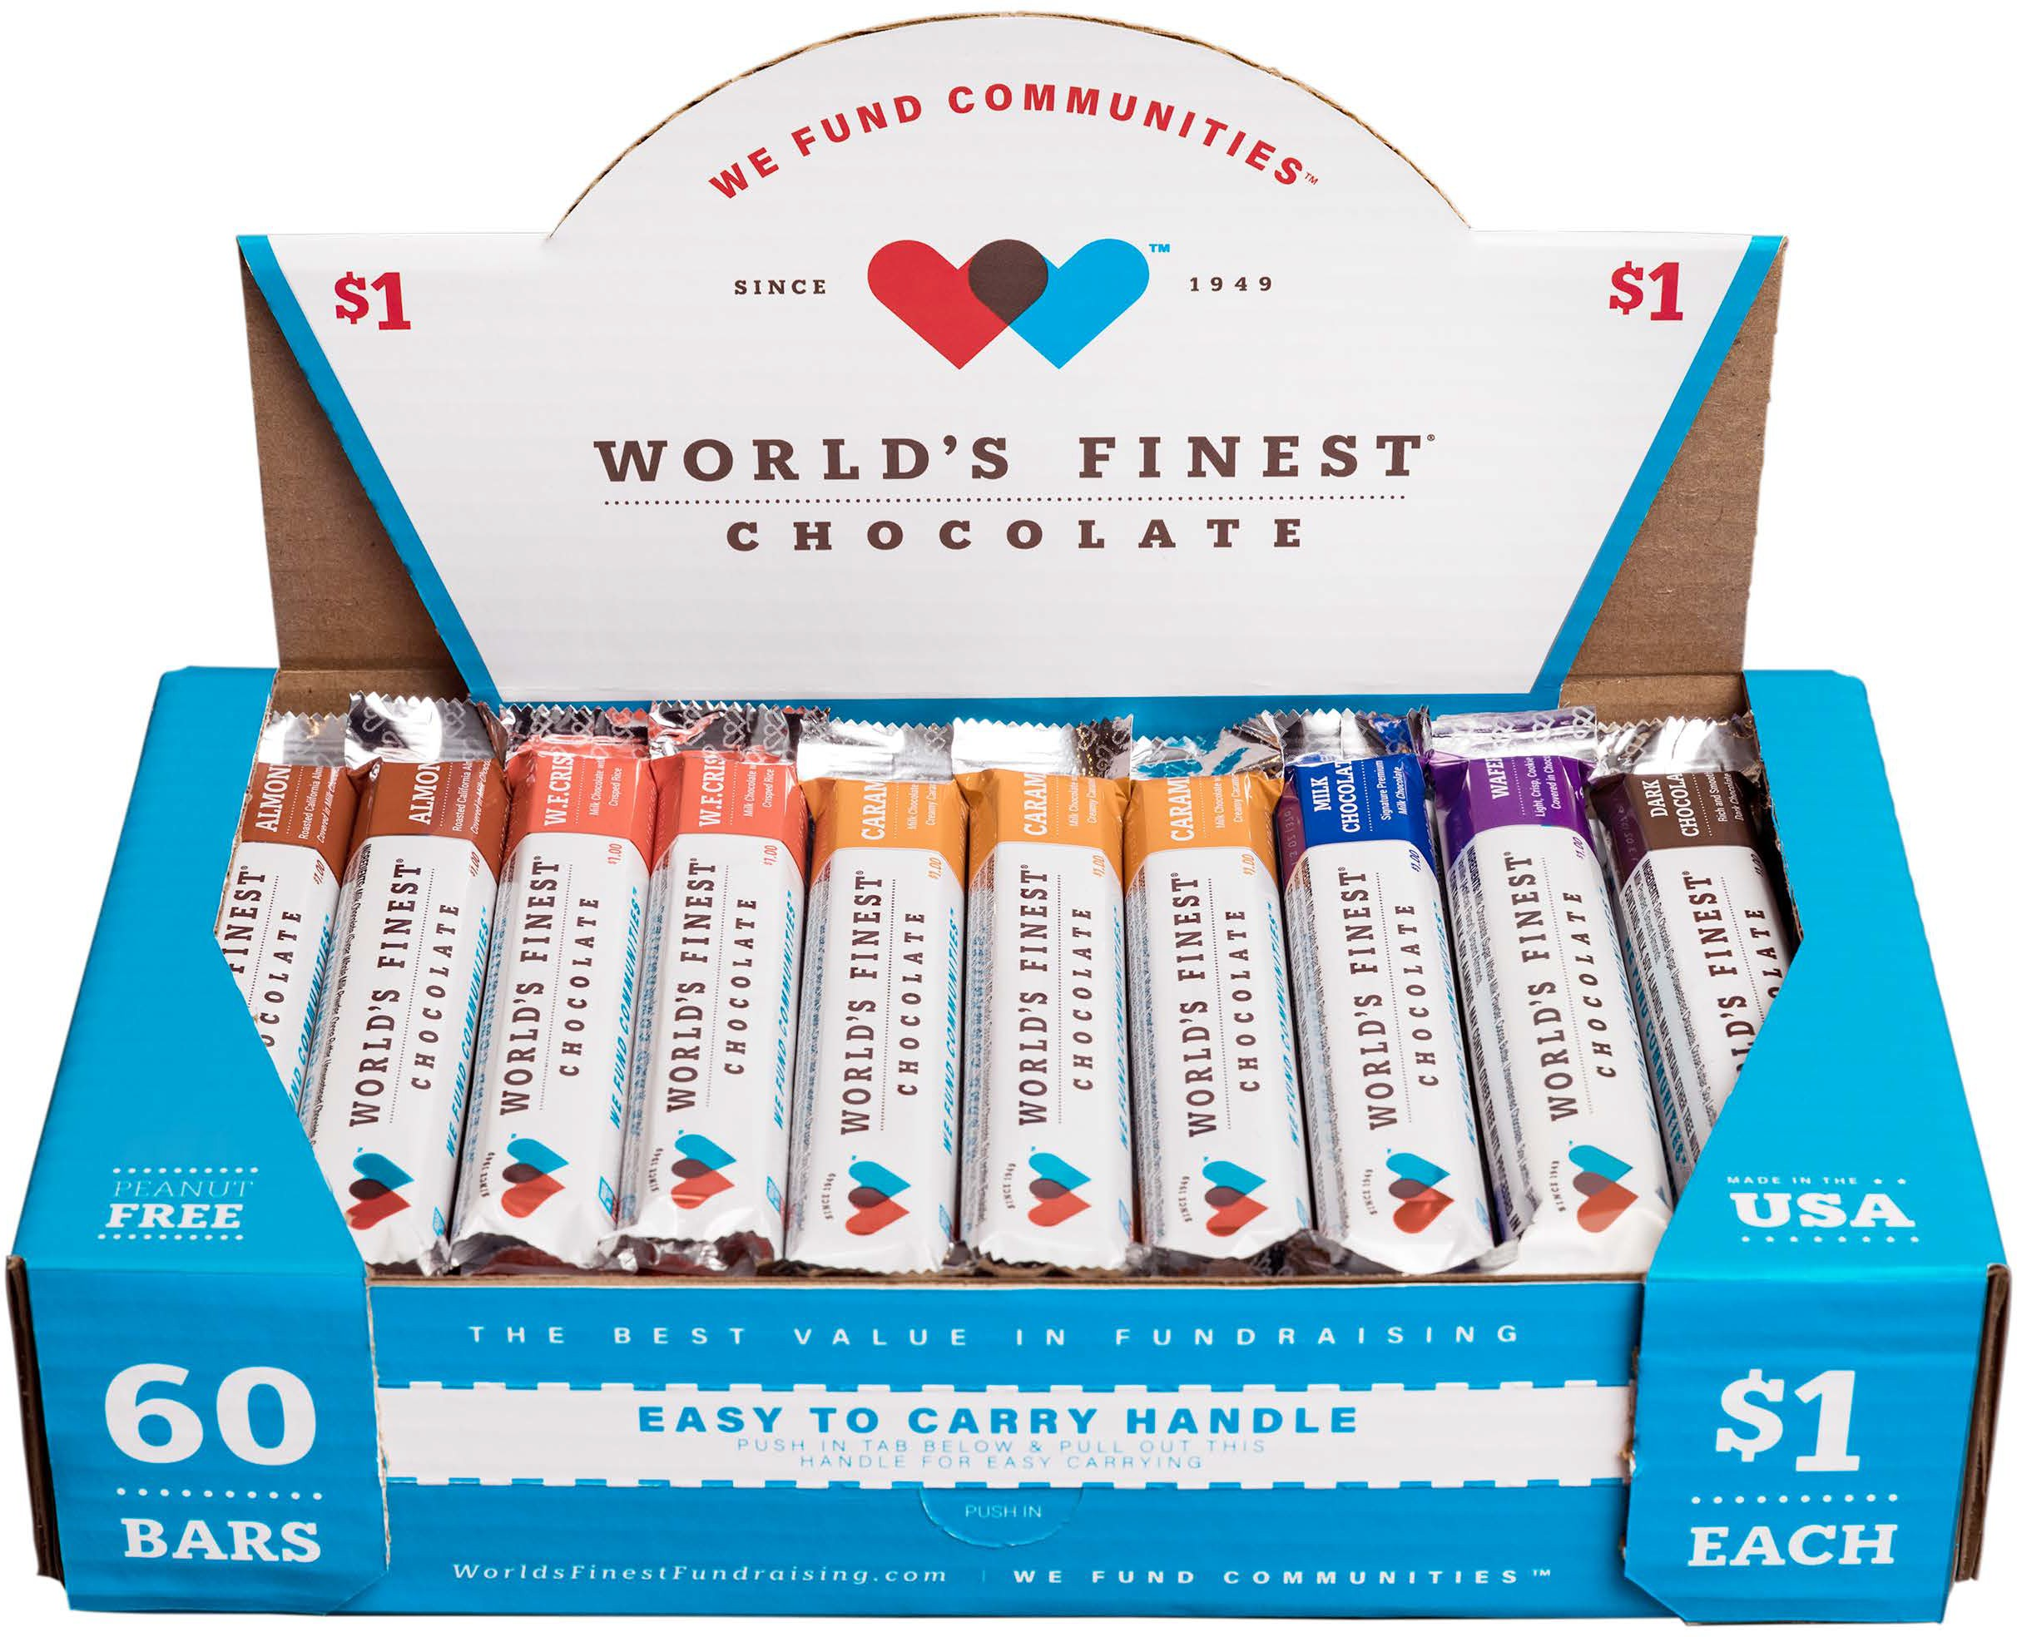

**Important Dates:**

**START: TODAY**

**END: _________**

You can make a difference! Help us raise money for our school by selling 1 or more boxes of 60 assorted $1.00 World’s Finest® Chocolate Bars. Selections include: Almond, Crisp, Caramel, Wafer, Milk Chocolate and Dark Chocolate.

Step 1. Return the chocolate check out form (below) tomorrow. Step 2. Pick up your first box of chocolate

Step 3. Pay for your first box and get another box to keep earning prizes

AND help our school even more.

I would like to check out 1 box. I understand I am responsible for selling EACH, ENTIRE box and paying $60.00 per box to the school no later than the END DATE on _________________

Each chocolate box must be paid before additional chocolate boxes may be checked out.

Please do not turn in coins with payment. cash, checks and money orders only.

*Thanks for your support of our students, teachers and school!*