___________________________________
World’s Finest Chocolate Fundraiser

Please support our Fundraiser. Money raised helps our students
with the costs of our upcoming event ______________________________
We need your help!

World’s Finest Chocolate items sell for $1.00 each
Each box contains 60 items including: Milk Chocolate Bars, Almond Bars, WF Crisp Bars, Caramel Bars, Dark Chocolate Bars.
SUPER VALUE – Each bar has a FREE membership to our Coupons Website with 100’s of deals across the country.

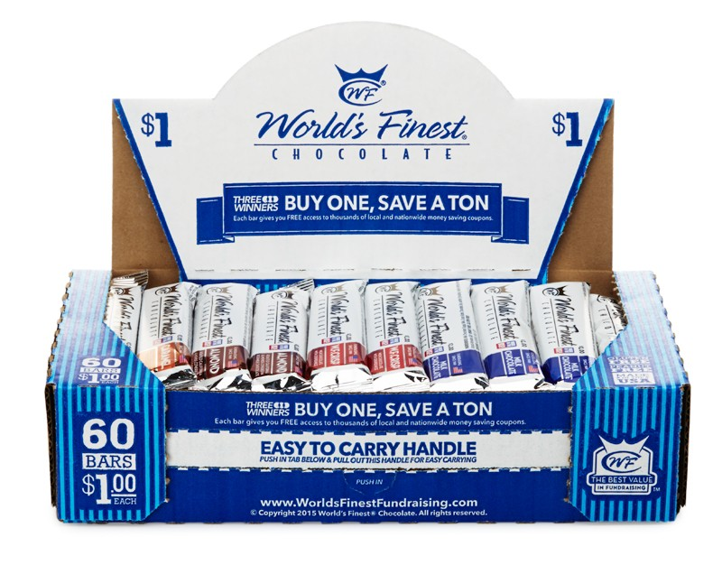




If you are able to participate, please return the permission form below to your teacher ASAP.
After you sell your initial box and/or boxes, you can take your money back to school and pick up more chocolate!

IMPORTANT DATES TO REMEMBER ABOUT OUR SALE:
____________________________ – Chocolate Sales will start.
_______________________ – Sale Ends and all Money is Due.
----------------------------------------------------------------------------
World’s Finest Chocolate Sale Parent Promissory Note
Return to your teacher by __________________________________ to participate.
Parents and students, by agreeing to participate, you are agreeing to:
- Be responsible for the product your student is taking home. The chocolate will melt if not properly stored. Keep under 72 degrees, out of direct sunlight and away from all pests and heat.
- No chocolate can be returned if not sold due to health codes. Sell ALL the chocolate that is checked out to you.
- Return the money from the sales of the chocolate to the School by _____________________________.
- Return $60.00 for each box sold and you can get more boxes to help our school even more!

Student Name: _____________________________________ Date: ___________________

Teacher Name: _____________________________________ Grade: __________________

Parent/Guardian Name: _____________________________ Phone # __________________

Parent/Guardian Signature: ________________________ Email: _______________________
Thank you VERY MUCH for your support of our organization!

