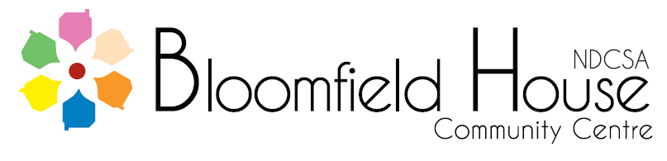
Bloomfield Room Rental Rates & Sports Facilities Charges April 2022

Room | Casual Hourly Charge | Members Hourly Charge
Playschool Room | £14.50 | £10.50
Classroom 1 | £14.50 | £10.50
Classroom 2 | £14.50 | £10.50
Classroom 3 | £14.50 | £10.50
Classroom 4 | £14.50 | £10.50
Classroom 5 | £16.00 | £11.50
Dining Room | £16.00 | £11.50
Jackson Room | £16.00 | £11.50
Seminar Room | Full day £145 Half day £80 or hourly – evenings only £25.00 per hour (no hourly rate daytime)

Sport | Hourly Rate – all users should be members
 | Adult | Junior
Fitness | £5.00 per hour  £15.00 Induction  £30.00 Monthly Rate  £75.00 for 3 Months  £125.00 for 6 Months  £215.00 for 12 months | £25.00 Junior Rate 16 – 18 yrs (still in education)
Squash (20 minute sessions) | £3.00 members only | £2.75
Badminton, Table Tennis | £ 5.00 per person  Max £20.00 per court | £3.50  Max £14.00 per court
Tennis | £9.00 daytime only
 | Adult casual group | Member group/junior
Sports Hall per hour | £25.00 | £20.00
Recreation Hall | £40.00 full hall | £30.00 full hall
 | £27.00 half hall | £23.00 half hall

