HISTORY OF THE 91st

91st Space Wing
Currently Headquartered at Minot Air Force Base (AFB), North Dakota, the 91st Space Wing is one of three operational Intercontinental Ballistic Missile (ICBM) wings in the Air Force. An Air Force Space Command unit, the wing is under the control of Twentieth Air Force, headquartered at F. E. Warren AFB, Wyoming. But it wasn’t always so…………
The direct history of the wing begins with the activation of the 91st Strategic Reconnaissance Wing in 1948. However, upon its activation, Strategic Air Command (SAC) bestowed the history of the 91st Bombardment Group, with its extensive WWII combat experience, on the new wing. Bestowal of history is explained in "A Guide to Air Force Lineage and Honors," by Charles A. Ravenstein.
In addition, the 91st Space Wing's three operational missile squadrons have their own proud WWII heritage. The squadrons, the 740th, 741st, and 742d missile squadrons, became part of the 91st when the 91st Strategic Missile Wing replaced the 455th Strategic Missile Wing at Minot AFB. When assigned to the 455th Bomb Group in WWII, the three units, along with the 743d Bomb Squadron, flew B-24 bombers against Axis targets from Cerignola, Italy, earning two Distinguished Unit Citations and contributing enormously to the Allied strategic bombing campaign in Europe. The group also supported the Allied drive up the Italian peninsula, as well as the Normandy invasion and the invasion of southern France. With their own WWII history and that of their three squadrons, the 91st Operations Group has historical ties to two distinguished bomb groups that fought and won on two different European fronts, flying the two most famous types of WWII bomber aircraft, the B-17 and the B-24.

91st Bombardment Group
The Army Air Corps activated the 91st Bombardment Group on 15 April 1942 and assigned the group to the Eighth Air Force. The group relocated to a number of bases before moving to England in the fall of 1942. An unfortunate accident in bad weather caused the loss of one aircraft and seven lives when one of the aircraft crashed en route.
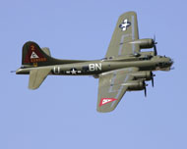
After their arrival, the group operated for a time from an airfield at Kimbolton. The field had been built for light bombers, not the 91st Bomb Group's heavy B-17s, which tore up the runway. Problems with the field resulted in the group flying only three practice missions from Kimbolton.

On 13 October 1942, Brigadier General Newton Longfellow, Commander, 1st Bombardment Wing, mentioned to the 91st Bombardment Group commander, Colonel Stanley T. Wray, that he was considering moving the group to Bassingbourn. The general wanted Colonel Wray to look at the base before a final decision was made. When Colonel Wray saw the excellent facilities and location of Bassingbourn, he moved the group's aircraft and equipment to the base as quickly as possible. In spite of General Longfellow's ire at the unexpected (and unauthorized) move, he allowed the group to stay at Bassingbourn, and the group had a new home.
The 91st Bombardment Group began flying B-17 bombing missions against German targets the following month, attacking submarine facilities near Brest, France. Mechanical failures caused all but eight of the group's aircraft to turn back. The results of the bombing conducted by the aircraft that made it through were disappointing. Still, all aircraft returned from the wing's first combat mission, and one crew claimed the destruction of an enemy fighter, which attacked the formation before British escort fighters rendezvoused with the group. Once the group entered combat, they flew several missions a week, gaining a reputation with their contemporaries and building a proud history.
The Shoo Shoo Shoo Baby (originally named Shoo Shoo Baby), now in the USAF Museum, has an interesting history all its own. The crew was forced to set the aircraft down in Sweden in May 1944, after suffering flak damage on a bombing mission to eastern Germany (present-day Poland). Because it was the only country on the Baltic Sea not occupied by or in sympathy with the Axis powers, several other allied bombers had also landed or crashed in Sweden, where they knew they could expect humane treatment. Following the rules of the Geneva Convention, as a neutral country the Swedish government interred the crew and aircraft for the duration of the war, just as they did with other combatant aircraft and crews who landed on their soil.

Saab, the Swedish Aerospace and Auto Company, modified the Shoo Shoo Shoo Baby and flight-tested it immediately after the war, preparing it for civilian use. The plane next saw service in Denmark, where she was used as a civilian airliner for Danish Airlines with the name Stig Viking until October 1947. In March 1948, the aircraft was renamed again and returned to military service, this time by the Danish Army. As the Store Bjorn, it saw service with various branches of the Danish military until 1952, when it was retired from the Royal Danish Air Force. In May 1955, the aircraft was transferred to the French National Geographic Institute, where it served as a photographic platform until July 1961.
Found abandoned in a farmer's field in 1968, the French government donated the Shoo Shoo Shoo Baby to the US Air Force Museum at Wright-Patterson Air Force Base, Ohio, in 1972. After extensive restoration at Dover AFB, Delaware, which lasted from 1978 to 1988, she was put on display at the museum, complete with her 91st Bombardment Group 'triangle A' markings. The triangle indicated the 1st Bombardment Wing, and the A identified the aircraft as a 91 BG plane. Actually, the Shoo Shoo Shoo Baby, like all of the group's B-17Gs, was not painted while in service with the 91st, but required a paint job to conceal the extensive restoration work made necessary by her previous modifications.

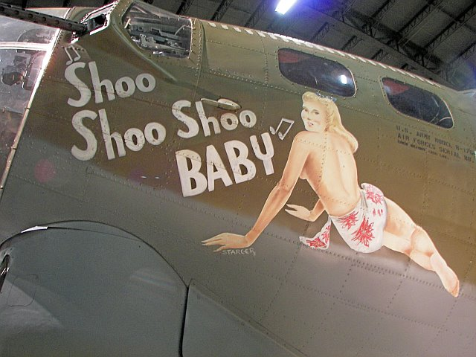

Also assigned to the 91st Bombardment Group's 324th Bombardment Squadron was the Eighth Air Force's most famous aircraft, the Memphis Belle; one of the first B-17s to complete 25 missions without losing a crew member and the first to be sent back to the US. The 'magic number' of 25 (increased later in the war to a high of 40) was the point when the Army Air Forces allowed bomber crews to return to stateside duty.
After carrying a documentary film crew with them on their last combat mission, the Belle and her crew returned to the states, where they toured the country selling war bonds before being assigned to training units where they shared their experience with new crews. The Belle's pilot, Major Robert Morgan, later flew several B-29 missions in the Pacific Theater. Unfortunately, the aircraft's notoriety did not save it from being nearly destroyed by neglect and vandalism in the years after the war while on display in Memphis, Tennessee. Finally, in the 1980s, when a feature film was made about the Belle and her crew, a successful drive to save the aircraft resulted in a new enclosed and protected home for the restored Memphis Belle, now proudly displayed in Memphis.

(Beginning in September 2005, the Belle was readied for its final trip – to the National Air Force Museum at Wright Patterson AFB, Ohio, where it is now housed.)
Although the Memphis Belle's crew was sent home before any other Eighth Air Force crew, the aircraft herself flew far fewer total combat missions than many of the group's planes. One example was the 323rd Bomb Squadron's nine-o-nine, which completed 140 combat missions before the end of the war. Unfortunately, as just one of a great number of surplus bomber aircraft returning to home after the war, the War Department sold the nine-o-nine as scrap in late 1945.
Combat missions later in the war earned the 91st Bombardment Group two Distinguished Unit Citations. The first honored the group for "...extraordinary heroism, determination, and esprit de corps" in action against Germany. On 4 March 1943, the group successfully attacked a railroad-marshaling yard in Hamm, Germany, successfully bombing their target despite adverse weather and heavy enemy air opposition.
The 91st earned its second citation for a mission into central Germany on 11 January 1944. As part of a massive Eighth Air Force mission to bomb aircraft factories vital to the Nazi war effort, the group's bomber force overcame fierce resistance from German interceptors and dropped over half its bombs within 1000 feet of their targets. While certainly not acceptable by today's standards, this was an impressive achievement in 1944. Nearly all units participating in this mission suffered heavy casualties, later attributed to an increased resistance from the Luftwaffe, which sent all fighters at its disposal against the attack, including night fighters which rarely operated in large numbers against daylight raids.
As the war progressed, the 91st Bombardment Group's bombers supported the Allied push into occupied Europe. On 6 June 1944, the group's B-17s bombed German gun emplacements and troop concentrations near Omaha Beach, among other invasion-related missions. When German forces counterattacked in the Battle of the Bulge, the group flew hundreds of sorties to bolster the
besieged Allied forces. As the allies continued their march through France toward Germany, B-17s from the 91st Bombardment Group assisted their advance by bombing airfields, bridges, railroad lines, troop concentrations, and other vital enemy targets. In addition, the 91st continued its strategic bombing efforts against Axis targets throughout Western and Northern Europe.
When Germany finally capitulated in May 1945, the group continued to fly sorties, evacuating prisoners of war from Germany and Austria to England in preparation for their final trip home. Several of the group's aircraft were modified, exchanging bomb bays, sights and guns for 30 passenger seats. While probably not very comfortable, to a newly released POW a small seat on a noisy and cold B-17 probably felt like flying-first class.
Crews from the 91st Bombardment Group flew four of these missions, bringing Allied prisoners back to Bassingbourn and other bases in England for transportation home. Flying 110 sorties, the group brought back 2,451 former POWs, including 1,115 British, 122 French, 1 Polish, and 1,213 American personnel. Among the American prisoners were over 200 members of the 91st Bombardment Group captured by the Germans and their allies during the war. Several of these prisoners accompanied the group's ground echelon as the first group of them returned home aboard the Queen Elizabeth in May 1945.
While the 91st became famous during and after the war, the group's glory came at a high human cost. Along with the 197 B-17 aircraft lost on combat missions, over 600 men lost their lives and over 1,150 spent time as prisoners of war. These numbers include only combat losses; the group lost additional crews and aircraft on training missions and in transit from the United States to England.
Nearly all of the 91st returned to the United States by the end of June 1945 in preparation for leave, discharge, or redeployment to the Pacific. When the use of two atomic weapons made the redeployment unnecessary, the group's personnel were reassigned to other units or discharged, and the Army Air Forces inactivated the 91st Bombardment Group on 7 November 1945. The group had remained in the thick of the action during its two and one half years of combat, earning two Distinguished Unit Citations and six battle streamers. Still, the 91st had not finished making history. Late in 1947, the Air Force activated the group and redesignated it the 91st Reconnaissance Group, assigned to the newly established 91st Strategic Reconnaissance Wing, which existed, at the time, only on paper.

91st Strategic Reconnaissance Wing

On 10 November 1948, the Air Force activated the 91st Strategic Reconnaissance Wing and assigned it to Strategic Air Command. The wing's first station was McGuire AFB, New Jersey, and its mission was to fly global strategic reconnaissance missions with an emphasis on aerial photography and mapping. The 91st Reconnaissance Group functioned as the operational component of the wing. During this period the wing flew B-17s, RB-17s, TRB-17s, B-29s, TB-29s, and TRB-29s. In October 1949 the wing moved to Barksdale AFB, Louisiana. Here the wing flew reconnaissance missions with B-17s, RB-17s, RB-29s, B-45s, RB-45s, B-50s, and RB-50s. From both bases, the wing flew missions throughout the Americas, updating aerial maps and taking pictures of regions hit by floods and earthquakes to assist aid agencies in determining the scope of the problem and the best way to assist those affected by the disasters.
Shortly before the Korean War began in 1950, the Air Force detached the 91st Strategic Reconnaissance Squadron and deployed it to Japan, where it remained for the duration of the war. Attached to the Far East Air Force (FEAF)
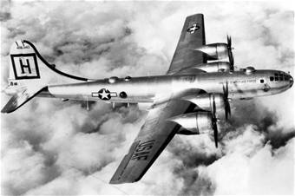
Bomber Command, the squadron flew RB-29s on reconnaissance missions over North Korea and surveillance missions over the Sea of Japan. The unit lost seven aircraft to MiGs.
Although at least one RB-29 was credited with the destruction of a MiG-15, the squadron's aging propeller-driven aircraft proved vulnerable to the enemy's faster jet fighter aircraft. As a result, the 91 SRW's 323d SRS sent a 3-plane detachment of the reconnaissance version of the Air Force's first multiengine jet bomber aircraft, the RB-45C. Because no other reconnaissance wing in the Air Force flew the RB-45, the wing continued to provide maintenance and logistical support to the detachment, even though the Far East Bomber Command had operational control of the detachment.

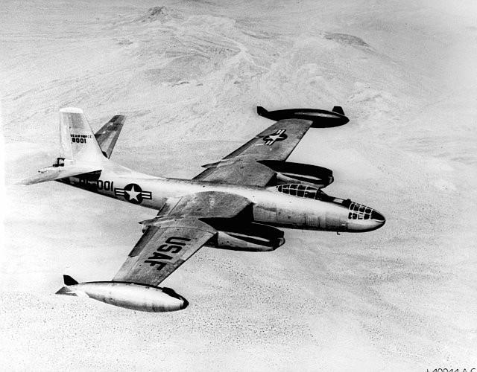
Flying from bases in Japan, the detachment flew reconnaissance missions over Korea. One RB45C with a four man crew was lost in combat. After being chased out of Korea and fired upon twice by up to five North Korean MiG-15s during daylight missions, the RB-45s were restricted to flying night missions. Unfortunately, the switch to night missions only caused new problems for the reconnaissance crews. When the RB-45s opened their bomb bay doors to drop flash bombs to light the target*, the aircraft vibrated too much for its camera to get a clear picture. The problem was really not surprising, since the aircraft had been designed for strategic bombing with nuclear weapons and adapted for the reconnaissance role. The 91st was treading new ground with their attempt to use the aircraft in a nighttime photoreconnaissance role.
Despite its problems, the detachment remained in Japan until the end of hostilities, flying their last mission, a leaflet drop, on 27 July 1953. Although they stopped flying combat reconnaissance missions, the crews continued to fly missions to map the land and sea areas around Japan and Korea from 1952 until the end of the war.
On 14 July 1951, another 91 SRW unit made history when a 91st Air Refueling Squadron KB-29P (boom-equipped) tanker made the first air-to-air refueling of a bomber-type aircraft under combat conditions. The tanker was TDY at Yokota and refueled a 91 SRW RB-45C aircraft over Korea. The refueling came about as a result of numerous refueling tests and experiments conducted by the 91st with modified B-29 aircraft.

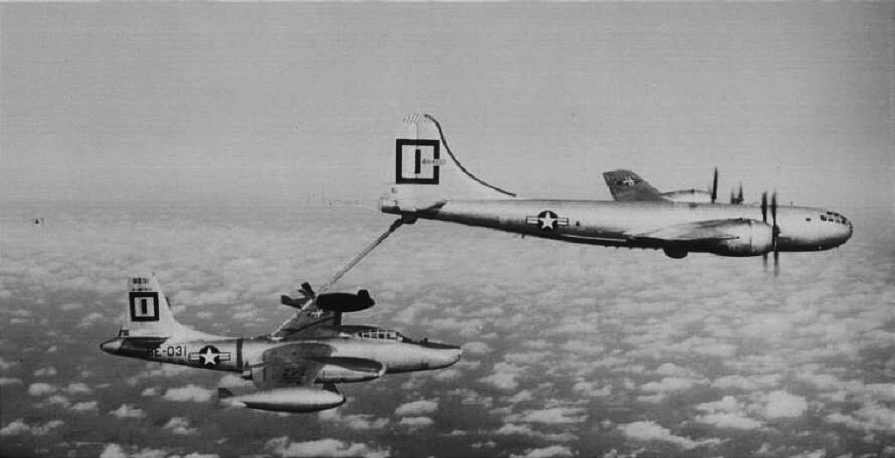
On 29 July 1952, a 91st Strategic Reconnaissance Wing RB-45C, commanded by Major Louis H. Carrington (an enlisted pilot in WWII), made the first non-stop transpacific flight of a multiengine jet bomber from Elmendorf AFB, Alaska, to Yokota AFB, Japan. Major Carrington and his crew made the 3,640-mile flight in 9 hours and 50 minutes. This flight, made possible by two KB-29P in-flight refuelings, earned Major Carrington and his 2-man crew the Mackay Trophy for 1952.
All of the aircraft deployed to Korea remained under the operational control of FEAF; therefore the 91 SRW did not share the battle honors earned by the detached 91 SRS, which included the Republic of Korea Presidential Unit Citation. The 91 SRS and its RB-29s never rejoined the 91 SRW, instead being assigned to a tactical reconnaissance wing after their Korean service ended.
Back home, the wing began a secondary mission in aerial refueling in 1950, first using the KB-29P, as mentioned above, and later, another refueler descended from the B-29, the KC-97. In addition to testing new and better methods of aerial refueling, the wing also tested several different armament systems and reconnaissance techniques using their RB-45Cs. The wing moved to Lockbourne AFB, Ohio, in September 1951, and continued their reconnaissance and aerial refueling missions.
The 91 SRW remained active at Lockbourne as a reconnaissance wing, acquiring the more advanced RB-47 reconnaissance aircraft and KC-97 tankers, flying reconnaissance and refueling missions around the world. Besides the detachment in Japan, the wing also maintained detachments equipped with RB-45s, and later RB-47s, in England and other countries.

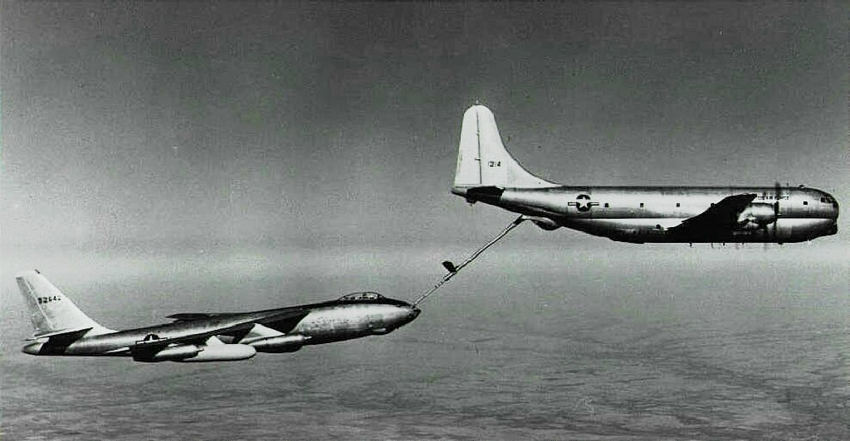

During the early and mid 1950s, the U.S. grew increasingly apprehensive concerning the Soviet Union's development of advanced weapons including aircraft, air defense radar & missile systems, and atomic bombs. The Berlin Airlift and Korean War increased the level of mistrust on both sides; however, the closed Soviet society made gathering intelligence about the development of new weapons very difficult and greatly concerned the US and its allies.
In an effort to obtain information about weapons development and deployment, the USAF conducted regular routine reconnaissance missions near the Soviet land borders or just outside the 12-mile limit defining international waters. In most cases, the planes were forbidden to fly into Soviet airspace, but in a few cases the need for information outweighed the risk of overflight and a plane was sent into the Soviet Union.
One such flight occurred on 8 May 1954. The US Air Force had strong suspicions that the Soviets were getting ready to deploy a follow-on to the MiG-15 and needed to find out for sure. Additionally, the USAF's Strategic Air Command needed to know how many Soviet long-range bombers were stationed at the northern bases on and near the Kola Peninsula. As a result, a flight of three RB-47E reconnaissance planes took off from RAF Fairford in England. Two of the Stratojets flew as airborne spares and turned back before the overflight began; however, one plane penetrated Soviet airspace near Murmansk. The plane flew over numerous Soviet airfields and naval facilities conducting photographic reconnaissance and making radarscope images of the various facilities. The RB-47E continued to Arkhangelsk before turning west and heading back to England.
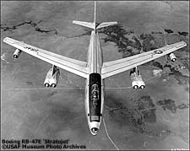
The USAF plane was intercepted by MiG fighters after being over Soviet territory for about 50 miles. Initially, MiG-15s were spotted, but a short time later a flight of MiG-17s appeared. The operational deployment of the MiG-17 was a significant surprise to the three men in the RB-47 and they knew they were in trouble since the new fighter was capable of reaching the RB-47 and attacking.
When the MiG-17s climbed to approximately the same altitude as the reconnaissance plane (38,000 feet) they opened fire*. The Soviet fighters each made single shooting passes at the USAF plane. The RB-47 was equipped with a tail gun controlled by the copilot and returned fire but did not hit any Soviet plane. One MiG was able to hit the Stratojet with several rounds and caused moderate damage to the wing and fuselage. Before the MiGs were able to shoot down the USAF plane, it crossed the border into Finland and the MiGs broke off the attack. However, during the attack the RB-47's fuel tanks were hit and the plane nearly ran out of fuel before it was met by a Boeing KC-97 tanker for in-flight refueling. The RB-47E landed safely in England a short time later.
When the reconnaissance data from the RB-47 was analyzed, it was determined that the Soviets did not have any long-range bombers stationed at its northern bases. The confirmation of the operational deployment of the MiG-17 was another significant outcome of the flight. The great need for reliable information on Soviet weapons development and deployment combined with the great risk of overflights of Soviet territory prompted President Eisenhower to propose the "Open Skies" treaty in mid-1955. President Eisenhower was concerned the overflights by military aircraft would be considered an act of war by the USSR and only approved a few flights. In 1956, after the Soviets rejected the "Open Skies" treaty proposal, the US Central Intelligence Agency created a secret reconnaissance program using the Lockheed U-2. The CIA conducted overflights of the Soviet Union into the early 1960's when the U-2 flown by Francis Gary Powers was shot down in May 1960.
Because the RB-47E was over Soviet territory, it was a spy flight and a legitimate military target. If the Soviets had shot the plane down, it would have created an international incident to the detriment of the United States. This was the situation when the CIA U-2 was shot down over Sverdlovsk on 1 May 1960.
Photo/Overflight Information courtesy of the US Air Force Museum
Now for the rest of the story – That RB-47E was from the 324th SRS, 91st Strategic Reconnaissance Wing. The aircrew was:
A/C Hal Austin C/P Carl Holt Nav. Vance Heavilin (D)
The crew chief – Phil Van Deusen

On 8 November 1957, after nine years of eventful service, the Air Force inactivated the 91st Strategic Reconnaissance Wing.
91st Bombardment Wing
The wing remained dormant until its activation on 15 November 1962. The Air Force redesignated the wing as the 91st Bombardment Wing and stationed it at Glasgow AFB, Montana. Equipped with B-52 bombers and KC-135 tankers, the wing trained in strategic bombardment and aerial refueling as a member of
the SAC nuclear deterrent force.
As the US Air Force increased its use of strategic bombers in Vietnam, the 91st and other wings equipped with B-52D aircraft played an important role in the war. After realizing the limitations of the B-52F aircraft they originally deployed to Guam in support of the strategic bombing effort, SAC began sending the bombers of one 'cadre' B-52D wing and another B-52 wing to Guam to form the 4133rd Bombardment Wing (Provisional). In 1966, the wing deployed all but a small caretaker force from Glasgow to the western Pacific. Over 1,300 people made the journey as the wing sent 17 B-52s to Anderson AFB, Guam, and 10 KC-135s to Kadena AB, Okinawa. On Guam the bombers took on the role as the cadre for the 4133 BW(P). On Okinawa, the wing's tankers became part of the 4252d Strategic Wing(P), refueling strategic and tactical aircraft throughout the Pacific theater. The wing's combat mission entailed bombing North Vietnamese transportation routes, supply lines, staging areas and training bases, and providing air support to American and South Vietnamese ground forces.
The wing flew its first Southeast Asia mission on 11 September 1966, and from then until late March 1967 flew over 1,000 bomber sorties against North Vietnamese targets. The wing began redeploying to Glasgow in March 1967, and flew its final combat mission for this deployment on 27 March. The last of the wing's people and aircraft returned to Glasgow on 5 April 1967 where
the wing had already resumed its strategic alert commitment.
The wing continued to support the Vietnam War, sending individual bomber and tanker crews and aircraft to units in the Pacific. In February 1968, the wing again demonstrated its readiness and quick reaction capability. After North Korea seized the US Navy reconnaissance ship USS Pueblo and her crew,
the wing deployed to Okinawa as part of an American show of force. While deployed this time, the wing flew several Arc Light missions, providing tactical bombing support to US and South Vietnamese ground forces. In the most notable of these missions, 91 BMW B-52s dropped their bombs on enemy troop positions near the besieged Marine Corps fire support base at Khe Sanh, at times bombing North Vietnamese positions within 1/6 mile of the base perimeter.
The 91st Bombardment Wing earned four Air Force Outstanding Unit Awards, yet, however heroic the wing's exploits, the Pueblo deployment marked the end of an era for the wing. In November 1964, only two years after the wing's activation, the Department of Defense announced that due to force structure adjustments, Glasgow AFB would close in June 1968. Fortunately for the wing, the Air Force did not inactivate the wing when Glasgow AFB closed, but redesignated it as the 91st Strategic Missile Wing. The redesignation came about as a result of an effort by SAC to retain the numbers of units with the most distinguished histories. Using a set of criteria that considered battle participation, time in existence, unit decorations and other characteristics, the command decided which of its wings would be inactivated and which would carry on their history, if not
their current mission.
91st Strategic Missile Wing

On 25 June 1968 the 91st Strategic Missile Wing moved without personnel or equipment to Minot AFB, North Dakota. The wing absorbed the personnel, equipment and operational units from the 455th Strategic Missile Wing, which was inactivated concurrent with the move of the 91 SMW. The wing's new mission was to maintain three squadrons of Minuteman I Intercontinental
Ballistic Missiles (ICBMs) in a constant state of readiness.
In 1971 the 91 SMW moved to the forefront of the SAC missile force by becoming the first wing to convert to the Minuteman III ICBM. The Minuteman III's multiple independently targeted reentry vehicles (MIRVs) tripled the wing's striking power and greatly enhanced US deterrent capability. In 1976, the wing's missile fleet underwent the command data buffer (CDB) modification that allowed missile combat crews to retarget missiles from the launch control centers and gave national leaders a force highly responsive to changing strategic priorities. Rivet MILE, the Minuteman Integrated Life Extension program, began as a 9-year program to renovate and update missile facilities. The program was successful in keeping an aging weapon system from becoming an outdated one, and it continues to modernize and improve missile facilities and support equipment today.
91st Missile Wing
On 1 September 1991, Strategic Air Command (SAC) restructured the entire command, redesignating the 91 SMW as the 91st Missile Wing (91 MW) and assigning it to the Twentieth Air Force (20 AF). When the Air Force inactivated SAC, Tactical Air Command (TAC) and Military Airlift Command (MAC) in 1991, the newly activated Air Combat Command (ACC) took control of the nation's ICBM force, including the 91st Missile Wing. On 1 July 1993, the wing's command structure again changed when the Air Force realigned the 91st from Air Combat Command (ACC) to Air Force Space Command (AFSPC). The men and women of the 91st Missile Wing, known as the "Rough Riders," took the changes in stride, keeping missiles on alert and maintaining their mission of deterrence.
The wing's infrastructure again changed in 1993 with the realignment of the Air Force's helicopter detachments from Air Mobility Command (AMC) to ACC. Detachment 7, 37th Air Rescue and Recovery Squadron, located at Minot AFB, was assigned to the 91st Operations Group on 1 February 1993. On 1 May 1993 Air Combat Command redesignated the detachment the 54th Rescue Flight, carrying on the history of the 54th Rescue Squadron. The 54th moved to AFSPC with the rest of the wing on 1 July 1993.
During the summer of 1994, the Air Force again changed the structure of the wing, inactivating its two subordinate groups and redesignating the unit as the 91st Missile Group. The change occurred to comply with a Chief of Staff Air Force (CSAF) directive to implement his concept of "one base - one wing
- one boss." However, the establishment of the unit as a group-level organization expanded the commander's span of control to such a degree that it proved potentially harmful to mission effectiveness and efficiency. Recognizing these factors, Air Force Space Command again redesignated the unit, returning it to its previous status as a wing on 1 February 1996. Concurrent with the return to wing status, the Air Force activated the 91st Operations Group and the 91st Logistics Group.
On 1 July 1997, the Air Force redesignated the 91st Security Police Squadron as the 91st Security Forces Squadron. They made the change as part of an Air Force-wide move to recognize the changing mission of the security forces from police functions to force protection.

91st Space Wing
Another name change for the 91st occurred on 1 October 1997 when Air Force Space Command redesignated the 91st Missile Wing the 91st Space Wing. The command made this change to better describe the present and future mission of the command and its wings. No change in mission occurred with the name change. The very latest name change occurred on 1 May 1998, when AFSPC
redesignated the 54th Rescue Flight the 54th Helicopter Flight. The name change, part of a command-wide change, was made to better describe the unit's actual mission, which consisted mainly of ICBM support rather than rescue operations.
Also in 1998, Air Force Space Command activated the 791st Maintenance Squadron at Grand Forks AFB, North Dakota to sustain one third of the inactivated 321st Missile Group's ICBM facilities for possible use in National Missile Defense (NMD). When, in mid-1998, government leaders decided to use a different system for NMD, the squadron's mission changed to dismantlement of the facilities, harvesting usable components for use in the remaining Minuteman wings. After the squadron, while maintaining a spotless safety record, finished their dismantlement task, AFSPC officially inactivated the unit on 14 July 2000.
At the beginning of 2003 the 91st again underwent a direct Air Force Space Command change when the 91st Security Force Group activated with three subordinate squadrons assigned to it. The 791st Missile Security Forces Squadron and 91st Security Support Squadron activated with the 91st Security Forces Squadron changing its designation to the 91st Missile Security Forces Squadron as directed by Air Force Space Command.
Since coming to Minot Air Force Base, the 91st has earned eight Air Force Outstanding Unit Awards and a variety of other honors, including numerous Air Force-level, Major Command-level and Numbered Air Force-level awards. On 28 August 1997, Gen Howell M. Estes III, commander, AFSPC, presented Colonel Anarde with Air Force Space Command's inaugural Gen Thomas S. Moorman, Jr., Trophy as the best wing in the command for 1996. The wing again won the Moorman Trophy in 2003. The wing was recognized as the best ICBM wing in both Air Force Space Command, winning the Williams Trophy in 1998, 2000 and 2003. US Strategic Command also recognized the wing as the best ICBM wing in that command, awarding the 91 SW the Omaha Trophy in 1998, 2000, 2002 and 2003. Last but not least, the wing's competition teams have
brought home the Blanchard Trophy for best ICBM team five times, winning for two consecutive years for the first time in the wing's history in 2000 and 2001.
While the designation has changed many times, the heritage of the 91st Space Wing spans over half a century of defending our country, a mission the wing continues to perform with the same dedication as the 91st Bombardment Group's Ragged Irregulars, so many of whom paid the ultimate price for their country's freedom.

Compiled by:
TSgt Laurence W. Schomaker
91st Space Wing Historian

Edited, and pictures and RB-47E Overflight section added, by:
James (Jim) F. Bard, Jr., Captain, USAF, Retired
Secretary, 91st Strategic Reconnaissance Wing Association

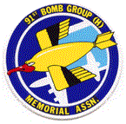
Patch of the 91st Bomb Group (H) Memorial Association

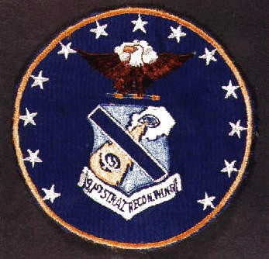
Patch of the 91st Strategic Reconnaissance Wing

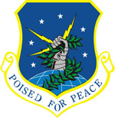
Shield of the 91st Space Wing

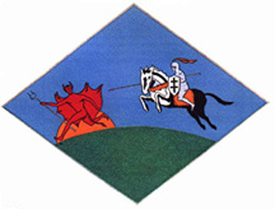

Patch of the 91st Strategic Reconnaissance Squadron

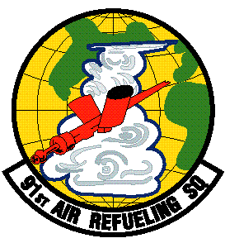

Patch of the 91st Air Refueling Squadron

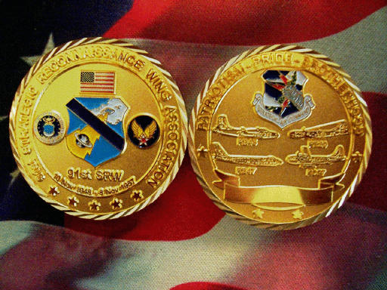
91st SRW Association Challenge Coin
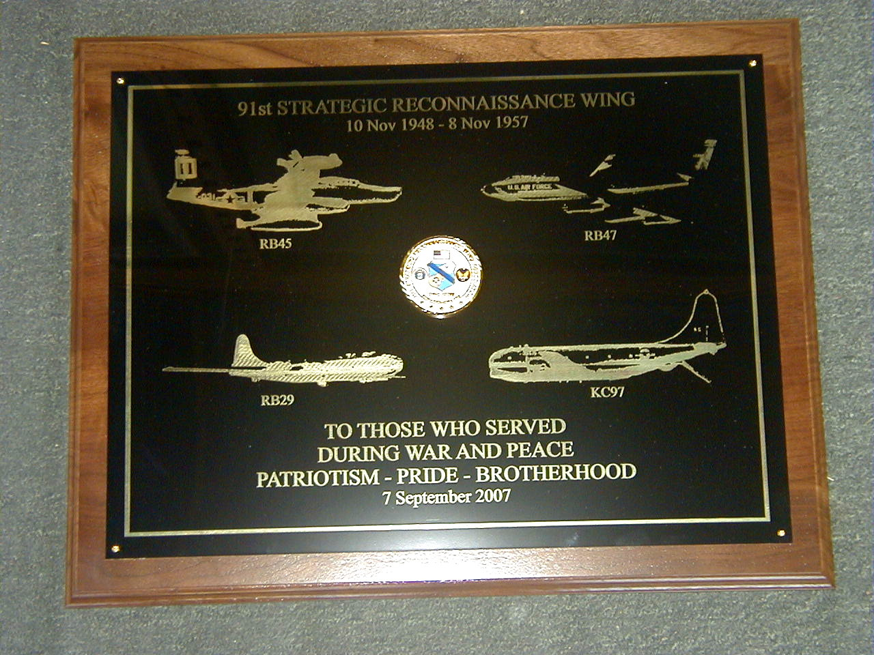

91st SRW Memorial Plaque
Presented at Minot AFB
7 September 2007

Displayed in the Rough Rider Room
A room dedicated to the memory of all 91st units.

