Juana Ruperta, a Story of Courageous Achievement
Juana came to the Student Residence in Sorata, Bolivia, to enter 7th grade as her home school went only to 6th grade. She walked 6 hours every Sunday from her home to Sorata to be able to attend high school; then she walked home on Friday to help her family farm.
Juana graduated in December 2014, and is now a Bolivian Quaker Education Fund scholarship student, in her fourth year of a 5 year university course in nursing.

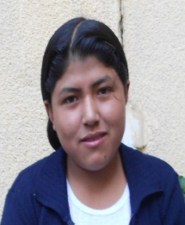

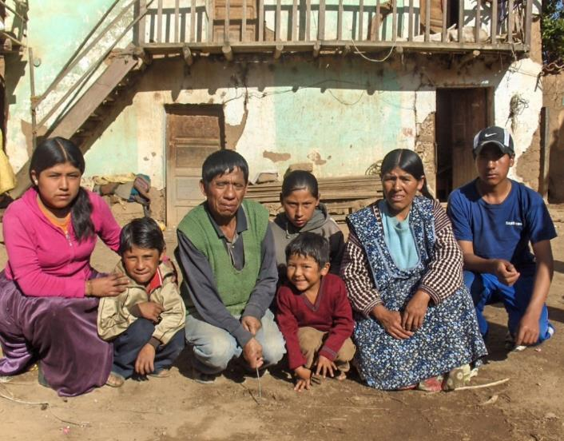

Her younger brother Fidel (far left in photo) and sister Ricarda (center) each joined Juana at the Student Residence when they entered 7th grade. Fidel graduated in December, 2016, and is now studying metallurgical engineering. Ricarda also plans a professional career. The current social transformation in Bolivia is ending 5 centuries of marginalization of the indigenous majority and offers new opportunities for their future. Many parents who had little education themselves are committed to seeing their children become professionals.
A story of commitment
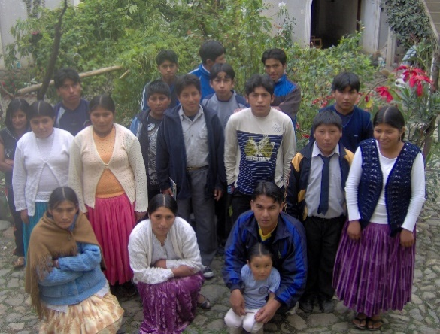
At the start of the school year in 2009, Juana’s father (below left) and another parent from the same village left home in the rain at 2:00 a.m. to walk--and sometimes run – over mountain trails to the town of Sorata. They wanted to arrive before we posted the list of accepted students to make certain their 7th grade daughters were on the list. Fortunately they were!
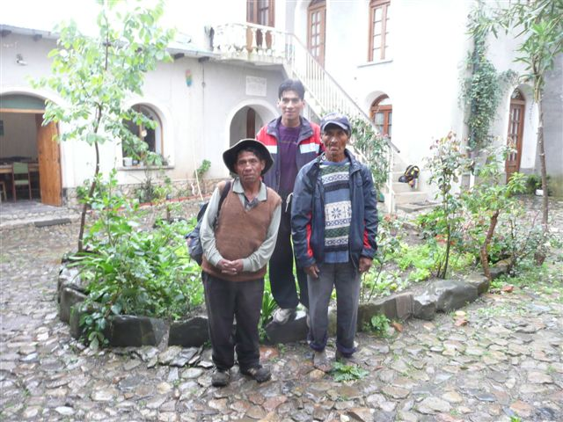
Painfully shy at first, by 8th grade Juana felt at home in the Student Residence and had excellent achievement in school.

In 2010, when a group of Quaker Study Tour volunteers hired a pickup truck to take us to Juana’s community, we found a group of Friends waiting to hear two itinerant pastors lead Meeting for Worship. Like most Bolivian Friends who constitute the world’s third largest Quaker population, they are indigenous Aymara, living in severe rural poverty. Their village had no cars, no paved streets, no stores, no bus transportation and few services, so moving to Sorata involved initial culture shock for many students.

Satisfying Learning
Juana graduated from high school with an outstanding academic record that entitled her to enter university without the entrance exam. With the help of a Bolivian Quaker Education Fund scholarship, she is deeply immersed in her 4th year of nursing study at the Universidad Pública in El Alto La Paz. She likes all her classes, but says her favorites are the hands-on courses. In a lab science class in her first year, she enjoyed learning to take blood pressure and other vital signs and understand their meaning. One lab class assignment was to bring in a stool sample from a child, then analyze it under the microscope and identify the parasites it contained. The assumption behind this assignment speaks strongly of the need for health and hygiene education in Bolivia, as in much of Latin America.
When Juana began regular practicum rotations in a local hospital, she was deeply moved by the nights she spent assisting in the neonatal ward and the delivery room.
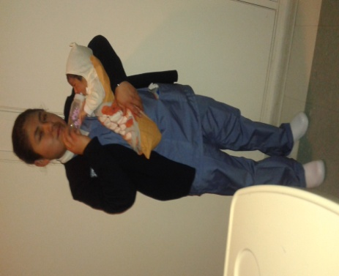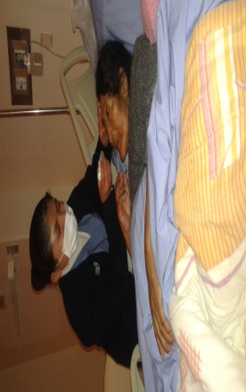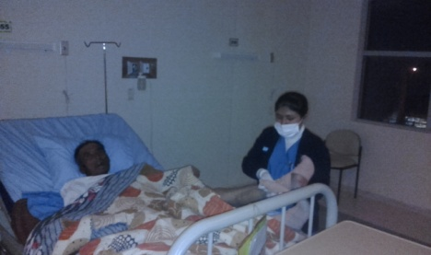
She commented that it was distressing to see “how mothers suffer to bring us into this world, but a beautiful joy to see the babies.”
I remember Juana Ruperta as a new seventh grader who was so timid she only spoke in whispers when adults were present. At a luncheon our 2015 Study Tour members shared with BQEF scholarship students in La Paz, Juana, then a university freshman, was the first speaker to address the group. She was calmly eloquent in expressing her dedication to service and her appreciation for the educational support she has received. It is immensely satisfying to see her as a self-confident young woman with a bright future. Her story is a sample of the remarkable achievements of many young people who have access to education that was not available to their parents.
All of us at WALJOK join Juana and many other students and families in expressing deep appreciation to those who share in supporting education for a brighter future. If you’d like to be part of this life-changing education or sponsor a student, please contact us.
The WALJOK Foundation 8290 Appian Way, Sebastopol, CA 95472 info@waljok.org

