m
SPECIAL
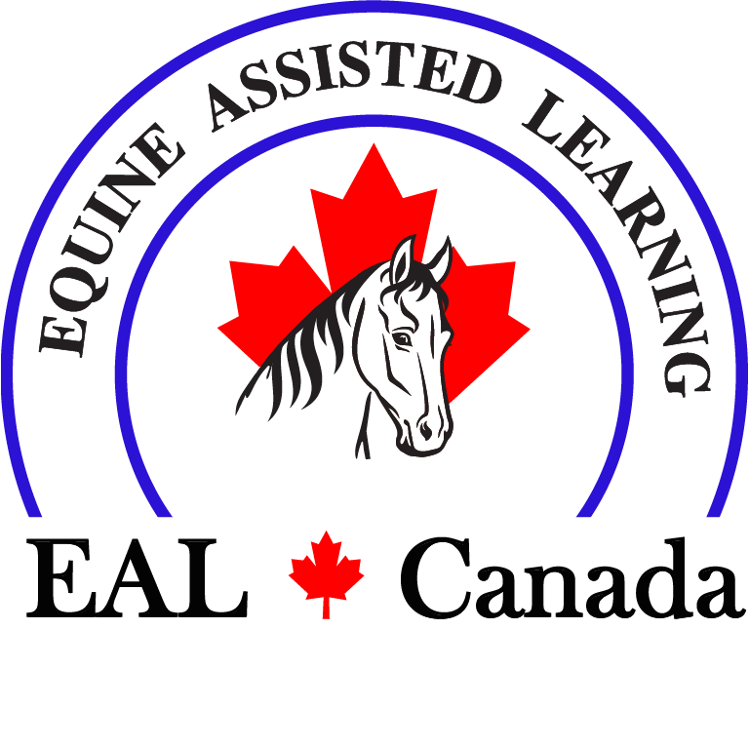
Equine Assisted Personal Development Coach Course

Registration Information (Form must be printed and emailed)
NAME ………………………………………………………………………………………………….……………………………..
ADDRESS ………………………………………………………….…………………………………….…………………………..
CITY …………………..……………….……….…….. PROV………………..……. PCODE………………...…………………
CELL…………..……………………………...……………...E-MAIL………………………………………………………………

Please indicate the course you wish to attend
- May 17 – 21, 2021 Host: Paradise Acres Ranch, Sturgeon County, AB (Full)
- June 14 – 18, 2021 Host: Robinson Arena, Stettler, AB
- July 19 - 23, 2021 Host: Higher Trails Equine, Millarville AB (near Calgary)
- September 13 – 17, 2021 Host Higher Trails Equine Millarville AB (near Calgary)

Price and Payment Options: Recognizing there will be a great need for EAL Services because of COVID-19, we are offering our courses at a reduced rate at this time.
Normal Price: $2730 ($2600 plus $130 tax). Reduced rate: $2100 plus tax ($2205)

Please chose your payment method:

Upon Registration: $2205.00 including GST (or)

Deposit of $500 (and) Payment plan for balance of $1705 (including GST)

Contact EAL Canada to arrange payments. Email info@ealcanada.com or call one of the numbers below.

Payment Methods

Credit Card visa M/C (Number can also be given over the phone)

Credit Card # ……………………………………………………………..… Expiry Date……………… CVC…………

E-Transfer: info@ealcanada.com (there is no need for a password – it is auto-deposit)

How to Register
Complete the form then scan/take a photo and email to Info@ealcanada.com or give us a call and we will take the information over the phone.

Further Information Phone 403-874-6284 or 587-481-6284
.
Cancellation Policy: Full refund less $300 processing fee up to one month prior to course. No refund if cancelling within the month prior to the course. If EAL Canada cancels a course due to COVID, a full refund will be issued.
January 2021
__

