Robert and Mary were members of an outward-looking, civic-minded generation born between 1648 and 1673. The grandparents of this generation were essentially the Puritan "firstcomers" generation of William Bradford and Ann Hutchinson types, and their grandchildren were the liberty generation of Thomas Paine and Patrick Henry types. This generation was the first in America to be secular optimists. They were the first generation to be mostly native-born. They were the first generation to include large numbers of non-English {German, French Huguenot, and African} members. As America’s first generation of veterans, they received the first war service pensions {in the form of land grants} from colonial assemblies they dominated. The sewing jack oak wood box and its items were passed down to their sons; each received an item from the box.

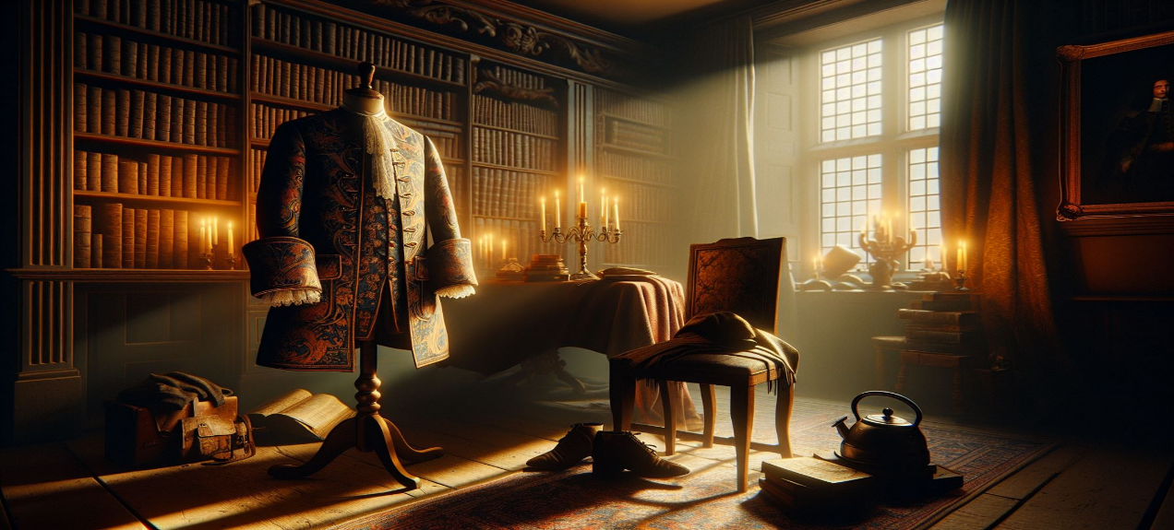Joseph, born in 1695, received a thimble, needle, and a third of the thread from the stacked thread spool. Robert John received the other thimble and a third of the thread from the stacked thread spool, and William Coates received the rest of the thread and the stacked wound spool. Joseph Josiah Coates received the cross-wound spool, a needle, and the jack oak box. Joseph Coates was born in 1695 in Lynn, Massachusetts. He married first Hopestill Elliot. Joseph was a carpenter and lived on the Boston Road in Lynn, Massachusetts, for several years. His wife becomes aware of the family heirloom but never uses the thread. His second wife, Margaret Ramsdell, used the thread to sew jacket buttons. Her husband, Joseph Josiah, died in 1772. She sewed some buttons onto her son's New Jersey militia jacket two years before she passed. He was moved to Sussex County, New Jersey, at a stockade house near the Delaware River. The war was ramping up, and skirmishes were bordering New York and New Jersey. The Coates family had bought some land for their service in the war effort. The son, Walter Joseph Coats, was aware of the Revolutionary War. He was only 15 and was preparing to fight the battles. He knew of other Coates’ cousins who signed up as drummers. He had no knowledge that his mother had sewn his buttons onto his jacket or mended some of the coat using the remaining threads. Currently, Americans were mainly against any English rule. Some feared this war, and some fled to Canada. The Revolutionary War had begun, and most daily lives were interrupted. During this time, families had to be ready to pack up their necessary items and move. At age 21, Walter Joseph marries Rachel Elizabeth Swayze. They had five children together. He wasn't home mostly but out serving his country by fighting or scouting for the Continental Army. There were always colonial troops moving through the New Jersey and Sussex County land to and from points of conflict. Walter Joseph was a good fighter and was wounded in a 1777 battle at Saratoga County, New York. He saw the surrender of a British General to George Washington. He also fought in the Battle of Monmouth Courthouse in New Jersey in 1778. He was reenlisted in 1777 for 3 years and placed at West Point, New York. Joseph was placed in the Corps of Invalids, a separate branch of the Continental Army. It was composed of Continental Army veterans who had become physically unfit for field duty but could still usefully serve as guards for magazines, hospitals, and similar installations. Also, he was well versed in mathematics and other educational knowledge, which he helped in the West Point Academy teaching.

In 1779, Major John Hardin arrived to lead some troops as marksmen. With him were his wife, daughters, and some relatives who came to the area to support their father. As strange as love can be, Joseph Coates had a relationship with Margaret Hardin. This woman was a cousin to Major John Hardin. Margaret Hardin knew this sewing box and had yet to learn of its promise a few years before Joseph died in 1799. She was fretting about her family and one day, she left to help her cousins and family who were leaving the area return to Kentucky. She hastily packed her belongings and left for Kentucky to avoid being seen again. She hurriedly took the last cross-wound thread spool and needle from the jack oak box. Phillip, the brother of Joseph, oversaw caring for Joseph’s children until they could take possession of the lands and homestead owned by their father as soon as William turned 21. Several years ago, around 1782, a cousin of the Coates family, and many had made New Jersey their home, met up with Phillip Coats at the crossing of the new Dingman’s Ferry. Most of these Coates were Quakers who settled around Burlington, New Jersey. Not knowing the history of the old jack oak box, he gave it to his cousin, Henry William Coates b. 1710 d.1784. This branch of the Coates were devout Quakers.

The Quakers believe that all lives are equal and precious in the eyes of God. Women and men are spiritual equals. All can have direct experience of the Divine individually and in shared worship. There are many ways to name their experiences, such as God, Christ, Spirit, Inward teacher, Inward light, and seed. But whatever the name, the knowledge of the Divine is universal, ongoing, and available to everyone. The life and teachings of Jesus are an example of faithfulness to God. Paying attention to and following the Divine changes us. They try to live out their convictions every day in our actions. They look for the Divine in every person they meet. Their guiding principle is love. An inward light can lead them to God; if a person lets their life be guided by this inward light, they will have a total relationship with God. They believe in the separation of Church and State as well as being against weapons of war and slavery. You don't need a priest or any other kind of spiritual intercessor; you don't need to perform any type of ritual. When you need to hear from God, you will. You should share a message when the spirit has a message for you. Friends believe God’s revelations have never stopped, and God may reach out to any one of us anytime.

They didn't realize that the special weaver tools and thread introduced to the Coates family, who practiced their Quaker faith, enhanced the inner light. Looking for the Divine in every person they met was more complicated than the Coates had anticipated. Henry William Coate was the son of Marmaduke and Mary Sumner Skinner Coate. His parents lived in Curry Rivel, Kent, England. In his will, Marmaduke named his wife Mary, sons William, Thomas, and Henry, and daughters Rachel and Mary. He had written down some history of the family. He wrote that the original name of Coate first appeared in written records in the highlands of Scotland between 800 and 1000 AD as Coutts, Coats, and Coates. The family is from a sept or sub-clan of the Farquharson Clan, which branched from the Shaw Clan in Scotland. He writes that our family history begins in Somerset, England, the home of Camelot. Once occupied by the Romans, Somerset is claimed to be the birthplace of Christianity in England. Legends claim that Saint Joseph of Arimathea brought the Holy Grail to Glastonbury after the crucifixion and built the first church there in AD 60. A Celtic monastery was set up at Glastonbury before the Saxon conquest. Saint Patrick is believed to have been buried in Glastonbury. In 1191, the bones of King Arthur and Queen Guinevere were uncovered and reburied at Glastonbury Abbey.

What he knew and passed on to his children were the 3 cross-wound spools of thread he had acquired from Glastonbury Abbey. One of the cross-wound spools went to a Coutts cousin who descended from the ancient Scottish Pics. These Scottish people had elaborated and ritual tattoos all over their bodies to be their culture and beliefs. These Coutts families went on to set up a bank and became known as the bankers of British royalty.

The Coutts branches of this family received great fortunes but only suffered negative consequences for their failure to uphold the requirements of the thread and needle. Here is what happened in this branch.

No matter the occasion, unless it is a formal official ceremony, the Queen invariably carries a neatly folded umbrella, even though she always drives in a covered carriage. Whenever she stops anywhere, a canopy is provided. Princess Mary has the same umbrella habit as her mother. Queen Victoria likewise was seen with a parasol or umbrella, but she always had hers open, and it was said that it was lined with chain malls to warn off attempts on her life by bomb throwers. The romantic career of the Coats/Coutts family, the thread millionaires, has been running to its end with the death of no fewer than five members during the past two years. The years were 1912-1914. Each member has left a large fortune through which the British exchequer has been enriched by some $6 million!

Because the ritual and respect of the sacred thread and needle were not honored or upheld, the death of James Coutts in March 1912 left a fortune of nearly 10 million dollars without any provisions for its disposition. Then, six months later, Archibald Coutts passed away, leaving a sum of almost 7 million dollars. In January 1913, Sir James Coutts died, leaving nearly 9 million dollars, and a few weeks later, P. M. Coutts, a son of James, died, leaving 1 million dollars. The fifth death, which was that of Peter Coutts in September 1914, left another fortune of $12 million, making the total fortune of the deceased over 40 million dollars. None of the Coutts family members who died left anything to charity. The present-day Coutts family, the same family who only spell their name with two T', were awaked by this bizarre occurrence, and the youngest descendant, Drummond Money-Coutts, declined to take up this same banking career and became a Magician who upholds the tradition of the thread and needle. If he upholds the rituals, his life will be blessed.

Another cross-wound spool went to his eldest son, Thomas Marmaduke Coates b. 1579 d. 1652 {9th great grandfather} and the third cross-wound spool went to his younger son, Henry C “The Elder” Coate b 1595 d 1662. Henry's name appeared as the Elder of Burton in the Drayton {Somerset} parish when his daughter married John Podgen in 1654. He names in his will, among them Marmaduke and John. He wrote his will on August 8th, 1661, in Hambridge, Curry Rivel Parish, England, and is listed by Yeoman. He writes to my son, Henry, I leave “wearing apparel jackets, and one pair of boots and 20 pounds. He goes on to my son John, “four score pounds and one bedstead over the entry and several furniture; to the rest of the goods and chattels I leave for Marmaduke who is the executor of my estate. The three sons all became Quakers through marriages in some cases, and some of the daughters. They attended the small Kingsbury Episcopal Monthly Meeting. They all had interconnections as their children married. The fact that the will remains means that Henry the Elder Coates was considered one of the wealthy, and his will had been transcribed in another place, saving it from the bombings in WWII.

One son, John Marmaduke Coates, married Elizabeth Humphries on December 29th, 1663. The furniture he received in his father’s will include the cross-wound spool inside the sewing box. He was the father of Samuel Coates b.1670 d.1723. Samuel Coates discussed family history with Phillip Coats. After speaking to Phillip about the history of the box and the items within, he left to return to Burlington, New Jersey, where he had acquired a great deal of land. He is descended from Marmaduke Coates, born in 1611 in Somersetshire, England, where he died in 1689. He was one of the earliest {Friends} Quakers who suffered imprisonment for his religious beliefs. Most of the years between 1670 and 1685 were spent in prison. His wife, Edith, and son, Marmaduke Jr., also were imprisoned. His son, Marmaduke Jr, was born in 1631 and married in England; Anne Pole, like his father, a devout Quaker, suffered similar severe persecution. He was" imprisoned for meeting" on Dec.11, 1683, for failing to pay tithes on August 17th, 1689, and was prosecuted again for tithes in 1702 and 1710. He emigrated to America in 1713, according to the Burlington Quaker meeting minutes. He was an Oxford man, first settling in Pennsylvania. He was William Penn's private secretary for a while. He moved to Burlington Co., New Jersey, about 1715 and had a farm of about 1000 acres on the north side of the road from Pemberton Juliustown. Henry and his wife, Esther Coates, practiced Quakers in Kingston Township, Huntington County, New Jersey. 1756, Henry wrote the Governor of New Jersey, expressing fear over the conflict with the Indians. Henry's father, Samuel Coates, was born in 1670 in Sumersetshire, England. He immigrated to Pennsylvania with his father, John Coates, in 1685. John Coates gave his son, Henry, 200 acres of land he purchased in 1689 from Israel Taylor. Samuel sold the inherited land in 1699 after John Coates's death and relocated to Burlington County, New Jersey. Samuel Coates had written that he was residing near his first cousin, Marmaduke Coates, who settled in the Burlington County area in 1717. Samuel Coates had a brother, James 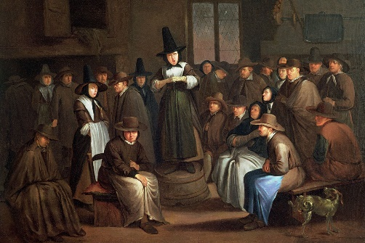Coates, who came to Philadelphia with his brother, Henry, after their father, John, and their uncle, Samuel. In Quaker minutes,

Samuel Coates had signed a testimony “not to sell hard liquors, such as rum, to the Indians. He also was responsible for surveying and laying out a cart path from Newton, New Jersey, to the ferry house at Dingman's Ferry along the Delaware River. Samuel Coates was a carpenter and surveyor and began a ferry service called {Coate’s Ferry} from Sussex County, New Jersey side named Dingman to the Pennsylvania side of the Delaware River.

On the opposite side was a ferry service run by John Wells called Well's Ferry on the Pennsylvania side. As time passed, near the start of the American Revolutionary War, these ferry services were called Coryell's Crossing, where General George Washington crossed the Delaware River. As depicted in the famous painting. The first Ferry across the Delaware River at New Hope was opened in 1722 by John Wells. On December 8th, 1776, Lord Cornwallis was on the Delaware River's New Jersey side, seeking boats to cross the river. But the Revolutionary troops had destroyed all ships on that side, leaving nothing for Cornwallis to find. His army is said to have shot across the river in frustration. When the Van Sant House at the corner of South Main and Mechanic streets was renovated, British musket balls were found in the wood, probably fired by Cornwallis's troop.

With the capture of Philadelphia in September 1777, Coryell's Ferry was one of the few safe rivers crossing points. In June 1778, Gen. Washington's troops used the Ferry for three days to cross the river on the way to Monmouth Courthouse, NJ, where they battled the troops of General Sir Henry Clinton. After Samuel died in 1723, his land on the hill along York Road went to his sons, William, John, and Henry. His will was written on November 22nd, 1723. It listed his wife, Mary Saunders., and his children, John, Henry, William, Marmaduke, Samuel, and Elizabeth. In his will, he is referred to as Samuel Coates, Gentleman of Amwell, Huntington County, New Jersey. He bequeathed 200 acres to John, 200 to Henry, and the remaining to William. His executors were John and Henry.

The inventory of his estate on December 23rd, 1723, included a clock, a bible, and other books. Within the Bible was a tiny thread lodged between two pages. Coates intentionally placed the thread there. The page contained the words, “I tell you the truth, it is hard for a rich man to enter the kingdom of heaven. Again, I tell you, it is easier for a camel to go through the eye of a needle than for a rich man to enter the kingdom of God." When the disciples heard this, they were greatly astonished and asked, 'Who can be saved?' Jesus looked at them and said, 'With man, this is impossible, but with God, all things are possible.'

In 1728, John Coates sold his tract of 200 acres of land given to him by his father to John Purcell. In 1732, he sold another 30 acres to John Holcombe. It is the home built by John Holcombe, where George Washington stayed twice during the American Revolutionary War. This 1732 deed indicates the land's border property of Henry W. Coates and William Coates. The William Coates’ property was the property of John Coate’s first cousins, Phillip Coates b. 1729 and Walter Joseph William Coates b. 1750, father of our William P Coates b. 1781. The Coates were Quakers, but some were removed from the Quaker meetings because they failed to uphold the rules of the Quakers. For one, some Coates took up arms to fight, and some Coates joined but only drummers or flag carriers, so as not to hold weapons of war. Our Corp. Walter Joseph Coates was part of the West Point Corp of Invalids. This group of American Revolutionaries consisted of those who were well-educated in mathematics and had training in combat operations. They may have been injured, which prevented them from participating in any physical combat actions.

Henry William Coates, a son of Samuel Coates and Mary Saunders Coates, was born June 14th, 1702. He married Esther Wilson in 1731. Henry and his wife had several children during their marriage and lived until age 81. Upon his death, Henry passed the sewing box on to his son, Marmaduke Coates b. 1738. He had received one of the cross-wound thread and needle from his father, which his wife had used to sew buttons on jackets and bows on bonnets. They, too, had cats as protectors upon their arrival in Pennsylvania and named two of them after tools, words, and actions of the weaver, thread, and Knittens. Marmaduke Coates's mother, Esther, died in 1735 when he was incredibly young. Henry Coates and his three sons relocated from New Jersey to New Garden, Guilford County, North Carolina, recorded by a certificate dated July 14th, 1757, when Marmaduke was in his early twenties. Life in North Carolina must have been turbulent. There were several complaints against Henry and the two sons, James, and Marmaduke, while they attended the New Garden Quaker meetings. Both had been punished by the Quaker Meeting in 1761. The family then moved to Bush River, near Newberry, South Carolina, without permission from the Quaker meeting in North Carolina. For this action, the Coates family was disowned by the Society of Friends. In 1762, Marmaduke became aware of a young Quaker named Mary Jane Coppock, an Indian hostage, perhaps living in Georgia. The most extensive reference for this story suggests they had been friends during childhood. Mary Jane must have held an uncommon attraction for Marmaduke, or he felt a strong obligation as a Quaker to rescue her from the Indian captives. Either way, he ransomed her for a horse, bridle, and saddle and married her in 1762. Mary Jane was 19, and Marmaduke was in his late twenties. Because of Mary Jane’s experience with the Indians, she was invaluable to her family and the other early pioneers who had to learn to coexist with the Indian neighbors. Eventually, Marmaduke, Mary, and their children were accepted again into the Society of Friends in Bush River meeting. With the advent of the American Revolutionary War, the Pacific Quakers had to decide if and how they would participate. Marmaduke agreed to house and supply soldiers of the colonial army for which he was paid. This was probably a controversial act in his Quaker community, where there was a strong dislike of violence. Because he was paid, his offspring were considered descendants of a Revolutionary War soldier, though he probably never fought in the war. He was reimbursed for supplies as late as 1787. After the war, the Quakers contributed to the economy of South Carolina, where cotton and slavery increased. Because Quakers did not tolerate slavery, most of the large community of Quakers left the state and migrated North to New Jersey, Pennsylvania, and Ohio. Marmaduke Coates was a hearty man used to challenging work, including traveling great distances. Even at an advanced age, in 1804, when he was close to age 70, he traveled with his wife of 42 years and most of their children and families from South Carolina to Newton Township in Miami County, Ohio. His oldest sons Moses, Henry, and Samuel had scouted the Ohio region. They reported that it was a fit place for the Quaker family to continue to grow and prosper away from the legal slavery they and their religion abhorred. Mary had continued to sew the buttons on jackets and mend socks with the weaver tools passed down for generations. It paid off well since Marmaduke went on to live another 20 years in Newton Township and see his sons and daughters settle and contribute to the growth of Miami County, Ohio. He is buried in Union Cemetery, located within the original land grant

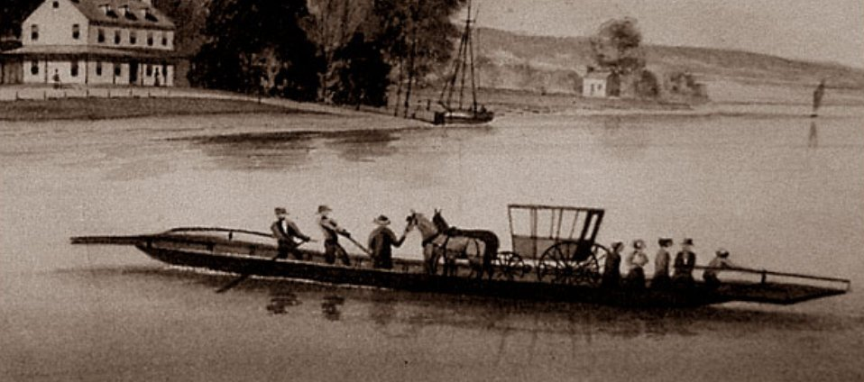Phillip Coates was deathly ill and, in 1776, bequeathed his land and belongings to Joseph and Margaret Hardin Coates. William P. Coats, the first son born to Margaret and Joseph Coats, inherited the land and homestead of his father and uncle near Newton, Sussex County, New Jersey. His father had died away from the homestead when William P. Coats was only 13. He had just turned 21, and Phillip’s estate had already sold the land to him for $100. The swampy land led to the Delaware River's boundaries at Dingman Point. The large acreage of Sussex County near Newton and Walpack extended from the Sussex County Courthouse to the edge of Dingman Ferry crossing on the Delaware River on the New Jersey side. He married Jane Jenny Hooey on October 25th, 1804. William did enlist in the 1812 militia while he remained in New Jersey. Jane’s family resided in and around Newton, New Jersey. Her brother, John Hooey, settles in and inherits the old Hooey homestead and farmland.

William and Jane, after hearing of the Neighbors who had purchased a great deal of farmland in the Ohio territory to lead a contingency of pioneers to the valleys of Ohio to restart anew, decided that they, too, would sell their property and join the Neighbors journey to Ohio. The Lenape Delaware Indians who resided near and around the property also relocated to the Ohio territory. The expansion of colonial settlers forced them to leave the area. Lenape and the Quakers did cooperate with each other. However, they could not leave at the same time the Neighbors would leave because they had to sell the farmland in Sussex County, and Jane was pregnant with a child when the Neighbor's wagon train was departing. In the summer of 1816, beginning in April, folks would describe a severe weather event as "a summer that never happened." An extreme cold spell engulfed the area of North America. Crops failed, and fruit tree blossoms were destroyed by frost. Livestock also froze to death in places. Dark clouds would form and block out the sun as it was a long winter. Jane Hooey Coats blamed it on her miscarriage of her baby Mary. Sheep and livestock died from the cold as well. What had happened? In March 1815, a volcano erupted in the Philippines in Asia. It was such a horrendous explosion that it created so much ash that it blocked out the sun and impacted the weather in America. William P. and his wife Jane were ready to move on from New Jersey.

In 1817, William and Jenny Jane Hooey Coats packed up their remaining belongings, and along with Jane's brother Mark and his wife, they chose to travel by Ox-driven wagons to land guaranteed to them in the Tuscarawas and Guernsey Counties. Jane had given birth to her child, Isaac. He was only 4 months old when they departed. Before their departure out West, Rebecca Coates, who was married to John Maxwell and was helping to send off her brother, had opened an old cedar chest containing the old uniform of Corporal W. Joseph Coates. When she attempted to remove the uniform, the threads of the uniform deteriorated so severely that they began to fall apart.

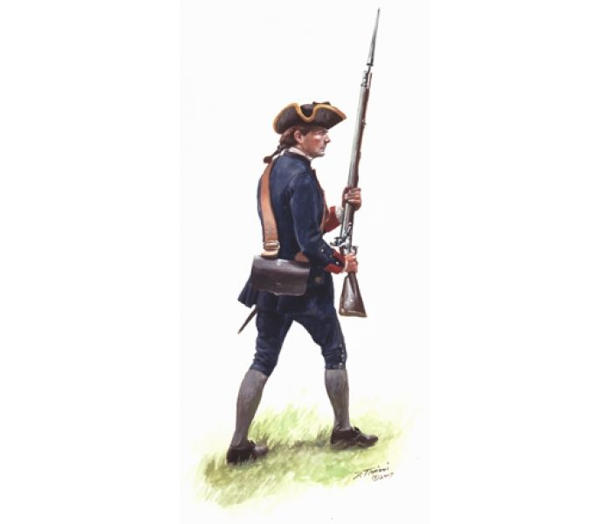

“Oh, lord, the uniform is in bad shape and falling apart,” Rebecca said in a disappointing tone. Jenny said it had definitely been through the mill. William would want it to be kept in this condition.

Besides, it won’t last much longer. Rebecca and Jenny decide it should be buried and marked as sacred on their land before departing.

The next day in early March 1817, a day before they were to leave in a driven wagon, the women had chosen a section of their former land near a large oak tree, next to a small gravestone, marking the burial grave of Jane and William's daughter Mary Jane who was stillborn in 1816. They decided to bury the uniform and have a ceremony right there.

The whole family gathered that day to watch and participate in the burial of Joseph Coates’ Revolutionary War uniform. Present was William P Coats and Jane, his wife, Rebecca Coats Maxwell, and her husband, John, Mark Hooey/Hovey, and his wife, Mary Vandermark, Rev. who, neighbors, who. All the children of William and Jane were also present. James, age 9; Nancy, age 11; Nellie, age 12; Ruth, age 7; Prudence, age 6; her sister, Cynthia, age 5; William Peter, Jr., age 4; Jane, age 2; and only 4 months old, Isaac, helps closely to his mother's breasts.

The Reverend begins by saying, Our Father who art in heaven, holy be thy name, thy kingdom come, thy will be done, on earth as it is in heaven…. the minister reads the lord’s prayer…

Most in attendance shed tears because it was the last time they would see this land and the last time they would remember those who came before…

The Reverend continues his sermon, "God's works remain forever. What does the worker gain from his toil? I have seen the burden God has laid upon the sons of men to occupy them. He has made everything beautiful in its time. He has also set eternity in the hearts of men, yet they cannot fathom the work that God has done from beginning to end. Know there is nothing better for them than to rejoice and do good while they live and that every man should eat and drink and find satisfaction in all his labor—this is the gift of God. I know that everything God does lasts forever; nothing can be added to or removed from it. God does it so that they should fear Him. What exists has already been, and what will be has already been, for God will call to account what has passed.

“From Dust to Dust” …the minister pauses, “Furthermore, I saw under the sun that there is wickedness in the place of judgment, and in the place of righteousness, there is wickedness. I said, "God will judge the righteous and the wicked since there is a time for every activity and every deed." I told myself, "As for the sons of men, God tests them so that they may see for themselves that they are but beasts.” The fates of both men and beasts are the same: As one dies, so dies the other—they all have the same breath. Man has no advantage over the animals since everything is futile. Cats may have nine lives, but all go to one place; all come from dust and return to dust. Who knows if the spirit of man rises upward, and the animal's soul descends into the earth? I have seen that there is nothing better for a man than to enjoy his work because that is his lot. For who can bring him to see what will come after him? Amen.” The Reverend finishes his sermon.