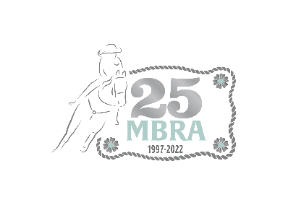
2022 Season Sanctioning Application

MANITOBA BARREL RACING ASSOCIATION
Box 509 Austin, Manitoba ROH OCO
mbrasecretary@hotmail.com

MBRA Sanction Form
As a host you are required to:

1. Send the sanction application to the MBRA office at least 14 days in advance of your jackpot. Hosts found not in compliance or in violation of the rules will lose their hosting privileges for 12 months from the time of the offence.

- Submit your $10 sanction fee for the jackpot and collect a $2 prize fund fee for every horse entered (peewees are exempt). Charge a minimum $10.00 entry fee for Open, Youth and Select divisions.

- You must payout 70% of the entry fees collected. Please note below what your hold back is.

- If you need to cancel your event, the MBRA office must be notified as soon as possible, or you will be charged the $10.00 sanction fee.

- Please be aware of the MBRA Rules posted on the website.

- You must request competitors to present their membership card when entering to ensure all participants are active members.

- Hosts cannot accept payment of memberships at their jackpots.

SUBMITTING RESULTS – Results must be submitted to the office within seven days of the jackpot. Results and payout must be sent to the office.

- A list of every horse & rider entered in each category and mandatory fees is required for the jackpot to be considered complete.

- Results will be accepted by e-mail or Canada Post. Fees can be paid by e-transfer to mbrasecretary@hotmail.com or cheque.
Event Details: Please print clearly: Please try to ensure all information is as accurate as possible to avoid multiple changes to the website.

Name of Jackpot / Series:

Jackpot Date(s) & Start Time(s):

Double Header : Yes No Dress Code: Yes No Toonie Runs: Yes No

Please select the divisions you are offering: Open Select Youth Peewee

Added Money : Open-$ Youth-$ Select-$ Peewee-$

Entry Fees : Open-$ Youth-$ Select-$ Peewee-$

Payout day of the jackpot Payout will be mailed out: What is your hold back:

Location / Directions:

Name of Contact(s):

Phone Number(s):

In order to have my jackpot / series sanctioned. I agree to send in all necessary monies (sanction fee & prize fund) and documentation (horse & rider combinations) within seven days of the jackpot.

Signature:
If you are requesting a deviation of payout please submit your application with the sanction form.
Please send your sanction form in prior to advertising it on social media so we can approve the sanction and have it posted on the website!

