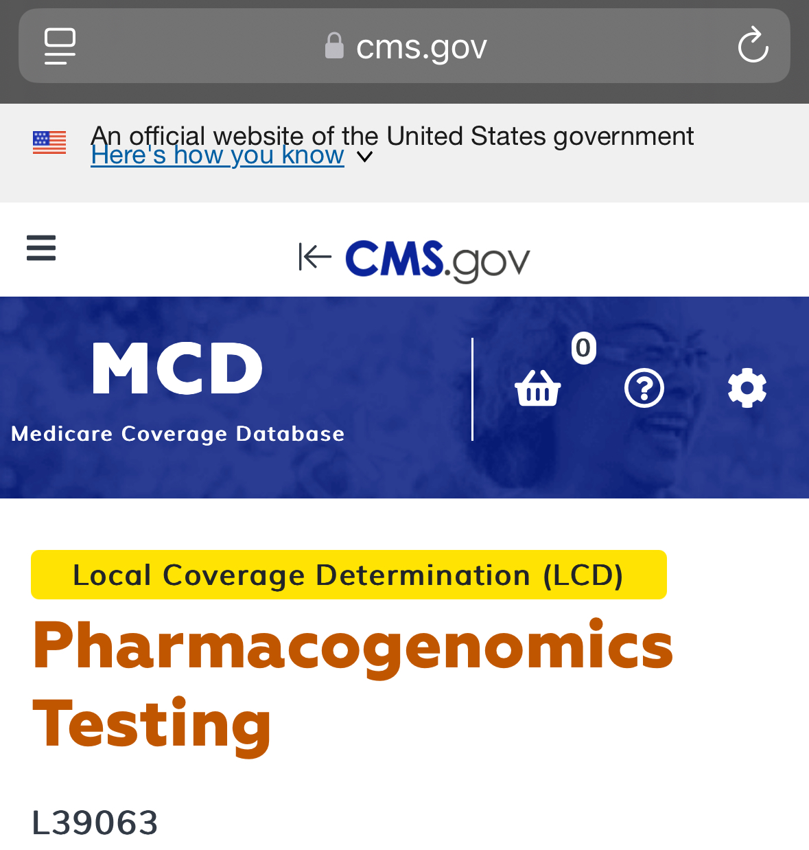
History/Background and/or General Information
Genetic testing holds the potential to provide great value in improving health outcomes for all individuals. The scope of this LCD includes testing to determine how genes affect the body's response to certain medicines, known as pharmacogenetic, or pharmacogenomic testing. Clinicians face a daunting task to individualize therapies to maximize beneficial outcomes and minimize adverse events and lack of effect. Pharmacogenomic (PGx) testing holds the hope of improved choice of drug therapy for multiple conditions for which drug therapy is appropriate.
(FDA) has acknowledged the significance of pharmacogenomics, with over 150 drugs now featuring pharmacogenetic information on their labels. This emphasizes the escalating necessity for healthcare providers to grasp and apply genetic data in their prescribing choices
1. Sample Collection:
- A DNA sample is collected, usually through a blood draw or a cheek swab (also known as a buccal swab).
2. Genetic Analysis:
  - The collected DNA sample is sent to a laboratory for analysis.

- This analysis helps determine how a person's genes might influence their response to specific medications.

3. Result Interpretation:
- The results are used to make informed decisions about medication management, including:
  - Predicting drug efficacy (whether a medication will work well for a person).
  - Determining the appropriate dosage of a medication.
  - Identifying potential adverse reactions or side effects.

4. Benefits of PGx Testing:
- Personalized Medicine: PGx testing helps tailor medication choices and dosages to individual genetic profiles, potentially leading to better treatment outcomes.
- Reduced Risk of Side Effects: By identifying individuals who may be at higher risk for adverse reactions, PGx testing can help prevent or mitigate potential harm.
- Improved Treatment Effectiveness: PGx testing can help ensure that medications are more likely to be effective for a particular individual.

