


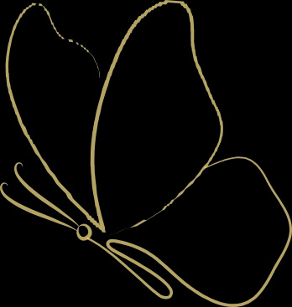

LAURA VONELLA
Multidisciplinary Visual Artist / Graphic Designer
931-220-6002

LauraVonella@gmail.com

Pennsylvania

SUMMARY

Multidisciplinary artist with three decades of creative expression. Experienced versatile skill set spanning traditional and contemporary art forms. Confident in typography, layout design, varied mediums and expressive art. Blending visual storytelling, emotions and fine art techniques to create engaging, impactful work. Recognized for developing original concepts and pushing creative boundaries across mediums.

EDUCATION PROFESSIONAL EXPERIENCE

McDANIEL COLLEGE
Bachelor’s degree in Art -emphasis Graphic Design Minors in Writing & Entrepreneurship
Department Honors 2025 GPA-3.9
MAGNA CUM LAUDE
Carroll County Career and Tech Center
Media and Communication 2001 - 2002
EXPERTISE
Photography & video editing | Mixed media | Visual storytelling | Page layout and spread design | Adobe- Photoshop, Illustrator, InDesign | Creative concept development | Attention to detail | Deadline management | Composition & color theory | Children’s book art and narrative | Multitasking | Collaborating with a team or working independently.
AFFILIATIONS

EXHIBITIONS
McDaniel’s Senior Capstone – Rice Gallery | Forthcoming
McDaniel’s Dept. honors – Rice Gallery | Forthcoming
McDaniel’s Undergraduate Art Show – Rice Gallery |2023
ART EXPERIANCE
- Author & Illustrator – “No Moo, That’s not for you.” - | Forthcoming 2026
- Aunt Fancy’s - Creating all products, design & advertising |
2018 – Present
- Icons of America art show advertising - Rice Gallery | 2023
- Stop motion PSA commercial- paper cut out creation | 2023
- McDaniel’s Contrast Literacy – “Covid” printed | 2023
- East Berlin C.C. - Teaching-stained glass |2022-Present
- Artwork displayed at Deja Brew & Dawg Gone Bees |2022
- Blockbuster - Marketing - Creating marketing | 2005-2009
- United States Army – Unit patch creation| 2008
- South Korea - Teaching English & Art in Dague & K-2 schools| 2003-2005

Pi Beta Kappa - Academic | Omicron Delta Kappa - Leadership | Sigma Alpha Pi - Leadership & Success - Treasurer | Sigma Tau Delta - Writing | P.I.E. Club - Innovation & Entrepreneurship

HONORS

McDaniel woman’s network panelist - 2026 | MAGNA CUM LAUDE - 2025 | Dean’s List - 2011-2025 | High Honors - 2011-2025 | Fred ’73 & Wanda Rudman Scholarship - 2021-2025 | Sandra Lynn Parise Memorial Scholarship- 2021-2025 | McDaniel transfer scholarship - 2021-2025 | McDaniel Scholarship luncheon speaker - 2024 | Runner-up in McDaniel’s Entrepreneurship and Innovation Challenge - 2022 | Singularly raised 35k for charity - 2020 | US Army Certificate of Appreciation for Unit logo design - 2010 | Peanut Festival -Blue ribbon - ceramics - 2009 | National Art Honor Society - 2001-2002

